A FULL STACK DEVELOPMENT CAPSTONE PROJECT

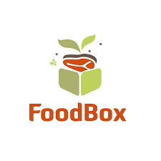

**Version History:**

|  |  |  |
| --- | --- | --- |
| 1. | **Author Name** | Ibtisam |
| 2. | **Purpose** | Specification of Project work |
| 3. | **Date** | 6/12/2022. |
| 4. | **Version** | 1.0 |
| 5. | **Contact** | ibtisam.mulla97@gmail.com |

**Introduction**

Foodbox is a restaurant chain that delivers food items of different cuisines at affordable prices. It was established in 2014 in Bengaluru, India. It had been serving fine all these years, however, the business analysts noticed a decline in sales since 2016. They found out that the online ordering of food items with companies, such as Swiggy and Foodpanda were gaining more profit by eliminating middlemen from the equation

**Project GitHub Link.**

|  |  |
| --- | --- |
| **Repository Name.** | FoodBox-Capstone-Project |
| **GitHub Link.** | https://github.com/ibtisam-mulla/Foodbox-capstone-project.git |

**Modules in the Project.**

a. Registration Page.

b. Login Page.

c. User Login.

d. Admin Login.

e. Dashboard.

f. Search Products.

g. Add Cart/View Cart.

h. View Previous Active Orders.

i. Payment Gateway Page.

j. Order Summary Confirmation Page.

**Technology used in the project work**

**Front End:**

* **VS Code:** As an IDE to design frontend of the application.
* **Git:** To connect and push files from the local system to GitHub.
* **GitHub:** to store the application code and track its version
* **HTML**
* **CSS3**
* **Bootstrap4**
* **TypeScript**
* **Angular**
  1. **Back End:**
* Eclipse IDE.
* Java Programming.
* Searching and Sorting
* Spring Boot DevTools.
* Spring Web and Spring Data JPA.

**File structure for frontend**

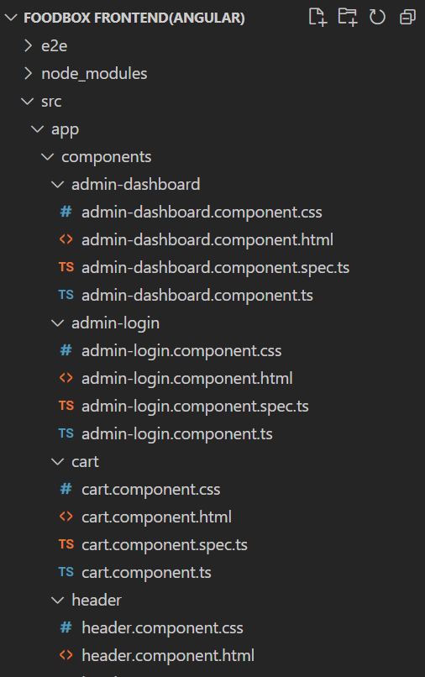

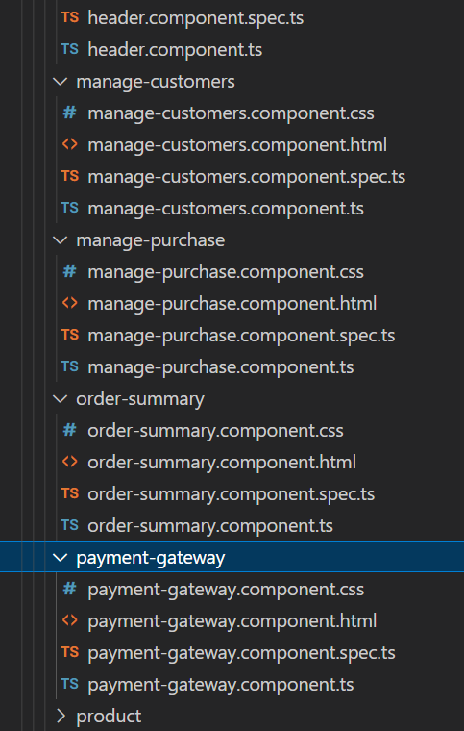

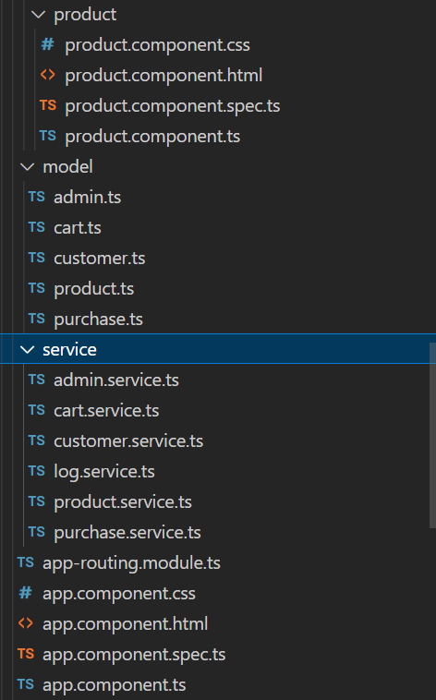

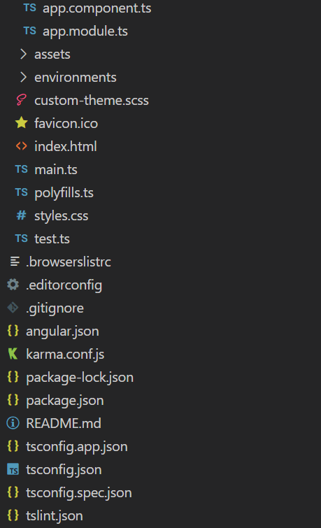

**File structure for backend**

