WEEK 3 – SELLER & INVENTORY MANAGEMENT SYSTEM
E-Commerce Database Management System
Prepared as a MySQL 8.x assignment submission.

1. Seller & Inventory Table Design
The system manages sellers, products supplied by sellers, and inventory quantities. Seller_Product is used to represent the Seller → Product relationship because one seller can supply many products and a product can be supplied by multiple sellers.
Table | Column | Data Type | Constraint
Seller | Seller_ID | INT | PK, AUTO_INCREMENT
Seller | Seller_Name | VARCHAR(100) | NOT NULL, CHECK
Seller | Email | VARCHAR(100) | NOT NULL, UNIQUE
Seller | Phone | VARCHAR(15) | NOT NULL, UNIQUE
Seller | Address | VARCHAR(255) | NOT NULL
Product | Product_ID | INT | PK, AUTO_INCREMENT
Product | Product_Name | VARCHAR(150) | NOT NULL
Product | Category | VARCHAR(100) | NOT NULL
Product | Price | DECIMAL(10,2) | NOT NULL, CHECK > 0
Seller_Product | Seller_ID | INT | PK, FK
Seller_Product | Product_ID | INT | PK, FK
Inventory | Inventory_ID | INT | PK, AUTO_INCREMENT
Inventory | Product_ID | INT | FK, NOT NULL
Inventory | Seller_ID | INT | FK, NOT NULL
Inventory | Stock_Quantity | INT | NOT NULL, CHECK >= 0
Inventory | Stock_Status | VARCHAR(20) | NOT NULL, CHECK
Inventory | Last_Updated | DATETIME | NOT NULL, DEFAULT/UPDATE

2. Updated ER Diagram
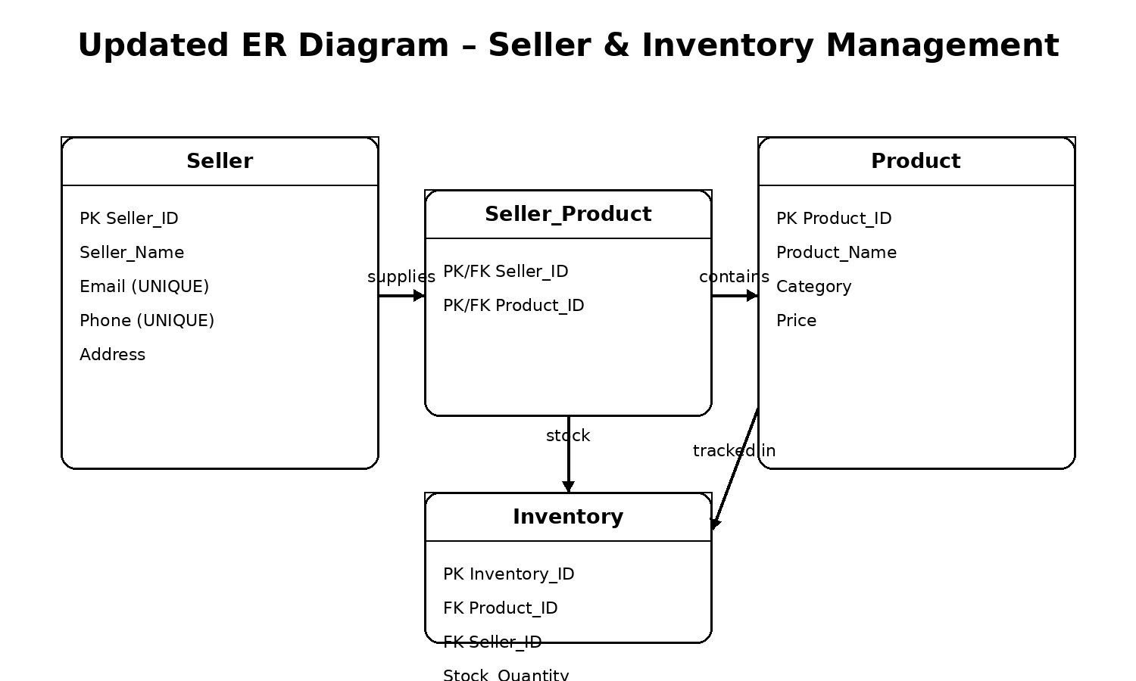
Relationships: Seller → Seller_Product → Product and Seller/Product → Inventory. Foreign keys maintain referential integrity.

3. Sample Seller & Product Data

Seller Data
ID | Seller Name | Email | Phone | Address
1 | TechWorld Supplies | techworld@gmail.com | 9876500011 | Chennai, Tamil Nadu
2 | Smart Choice Store | smartchoice@gmail.com | 9876500012 | Coimbatore, Tamil Nadu
3 | Digital Hub | digitalhub@gmail.com | 9876500013 | Madurai, Tamil Nadu
4 | Prime Electronics | primeelectronics@gmail.com | 9876500014 | Trichy, Tamil Nadu
5 | NextGen Traders | nextgen@gmail.com | 9876500015 | Salem, Tamil Nadu

Product Data
ID | Product Name | Category | Price
1 | HP Pavilion 15 | Laptop | 58999.00
2 | Dell Inspiron 15 | Laptop | 62999.00
3 | Lenovo IdeaPad Slim 3 | Laptop | 47999.00
4 | Logitech Wireless Mouse | Accessories | 1299.00
5 | HP USB Keyboard | Accessories | 899.00
6 | Samsung 24 Inch Monitor | Monitor | 11999.00
7 | Canon Wireless Printer | Printer | 15499.00
8 | JBL Bluetooth Speaker | Audio | 3499.00
9 | TP-Link WiFi Router | Networking | 2499.00
10 | Seagate 1TB External HDD | Storage | 5299.00

4. Sample Inventory Data
Inventory ID | Product | Seller | Stock | Status
1 | HP Pavilion 15 | TechWorld Supplies | 25 | Available
2 | Logitech Wireless Mouse | TechWorld Supplies | 8 | Low Stock
3 | Samsung 24 Inch Monitor | TechWorld Supplies | 15 | Available
4 | TP-Link WiFi Router | TechWorld Supplies | 0 | Out of Stock
5 | Dell Inspiron 15 | Smart Choice Store | 18 | Available
6 | HP USB Keyboard | Smart Choice Store | 7 | Low Stock
7 | JBL Bluetooth Speaker | Smart Choice Store | 0 | Out of Stock
8 | Seagate 1TB External HDD | Smart Choice Store | 22 | Available
9 | Lenovo IdeaPad Slim 3 | Digital Hub | 30 | Available
10 | Logitech Wireless Mouse | Digital Hub | 12 | Available
11 | Canon Wireless Printer | Digital Hub | 5 | Low Stock
12 | TP-Link WiFi Router | Digital Hub | 9 | Low Stock
13 | HP Pavilion 15 | Prime Electronics | 14 | Available
14 | Samsung 24 Inch Monitor | Prime Electronics | 4 | Low Stock
15 | Canon Wireless Printer | Prime Electronics | 0 | Out of Stock
16 | Seagate 1TB External HDD | Prime Electronics | 16 | Available
17 | Dell Inspiron 15 | NextGen Traders | 11 | Available
18 | Lenovo IdeaPad Slim 3 | NextGen Traders | 6 | Low Stock
19 | HP USB Keyboard | NextGen Traders | 20 | Available
20 | JBL Bluetooth Speaker | NextGen Traders | 0 | Out of Stock

5. Seller & Product Operations
Operation | SQL approach
Add seller details | INSERT INTO Seller (...) VALUES (...);
Assign products to sellers | INSERT INTO Seller_Product (Seller_ID, Product_ID) VALUES (...);
Display products supplied by each seller | JOIN Seller, Seller_Product and Product.
Count products supplied by each seller | GROUP BY Seller_ID and COUNT(Product_ID).
Update seller details | UPDATE Seller SET ... WHERE Seller_ID = ...;

6. Inventory Operations
Requirement | SQL condition / operation
Display available products | WHERE Stock_Quantity > 0
Find out-of-stock products | WHERE Stock_Quantity = 0
Find stock less than 10 | WHERE Stock_Quantity < 10
Update stock quantity | UPDATE Inventory SET Stock_Quantity = ...
Delete discontinued inventory | DELETE FROM Inventory WHERE ...

7. Inventory Analysis Report
• Total inventory records: 20
• Total available units: 222
• Out-of-stock records: 4
• Low-stock records (< 10): 10
• Average inventory quantity: 11.10 units
• Highest stocked product record: Lenovo IdeaPad Slim 3 – Digital Hub (30 units)
• Inventory records with stock available: 16

8. Important Report Queries
SELECT s.Seller_Name, COUNT(DISTINCT i.Product_ID) AS Products_In_Inventory, SUM(i.Stock_Quantity) AS Total_Stock FROM Seller s LEFT JOIN Inventory i ON s.Seller_ID=i.Seller_ID GROUP BY s.Seller_ID, s.Seller_Name;
SELECT SUM(Stock_Quantity) AS Total_Available_Units FROM Inventory WHERE Stock_Quantity > 0;
SELECT COUNT(*) AS Out_of_Stock_Records FROM Inventory WHERE Stock_Quantity = 0;
SELECT p.Product_Name, s.Seller_Name, i.Stock_Quantity FROM Inventory i JOIN Product p ON i.Product_ID=p.Product_ID JOIN Seller s ON i.Seller_ID=s.Seller_ID WHERE i.Stock_Quantity=(SELECT MAX(Stock_Quantity) FROM Inventory);
SELECT ROUND(AVG(Stock_Quantity),2) AS Average_Inventory_Quantity FROM Inventory;

9. Query Output Screenshots / Sample Outputs
The following tables represent the expected MySQL output after running the supplied SQL script. For the final classroom submission, these can also be replaced or supplemented with screenshots from MySQL Workbench/phpMyAdmin.
Seller | Products in Inventory | Total Stock
TechWorld Supplies | 4 | 48
Smart Choice Store | 4 | 47
Digital Hub | 4 | 56
Prime Electronics | 4 | 34
NextGen Traders | 4 | 37
Stock status summary:
Status | Records | Units
Available | 11 | 185
Low Stock | 5 | 39
Out of Stock | 4 | 0

10. Files Included in Submission
- Week3_Seller_Inventory_Management.sql – complete MySQL script
- Week3_Seller_Inventory_Documentation.docx – editable documentation
- Week3_Seller_Inventory_Documentation.pdf – PDF version
- ER_Diagram.png – updated ER diagram
- README.txt – execution and submission instructions

11. Execution Steps
- Open MySQL Workbench or another MySQL 8.x client.
- Open Week3_Seller_Inventory_Management.sql.
- Execute the script from the beginning. It creates SellerInventoryDB and all required tables/data.
- Run the report queries at the end to generate inventory analysis.
- Take screenshots of the query results if your instructor requires actual screenshots.
- Upload the SQL, DOCX/PDF, and ER diagram to your GitHub repository.

