
Slide 1-Module 1 start
Slide notes: Welcome to this module on developing energy budget and key performance criteria.

In this module, we’ll walk through each of the steps in the integrated zero energy design process.
Text Captions: 2
Developing Energy Budget and Key Performance Criteria

Developing Energy Budget and Key Performance Criteria

2
$$cpInfoCurrentSlide$$ of $$cpInfoSlideCount$$
START
START
START
Photo by Dennis Schroeder, NREL

Audio to be replaced with professional voice-over artist

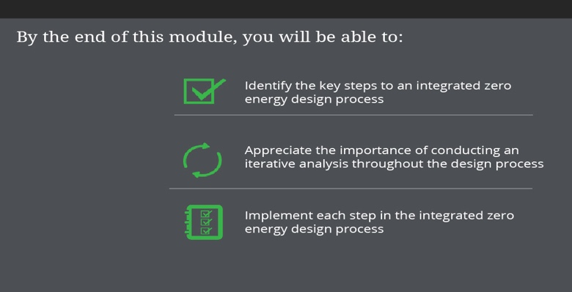
Slide 2-you will be able to
Slide notes: By the end of this module, you will be able to:

Identify the key steps to an integrated zero energy design process.
Appreciate the importance of conducting an iterative analysis throughout the design process.
Implement each step in the integrated zero energy design process.
Text Captions: Implement each step in the integrated zero energy design process

By the end of this module, you will be able to:
Identify the key steps to an integrated zero energy design process

Appreciate the importance of conducting an iterative analysis throughout the design process

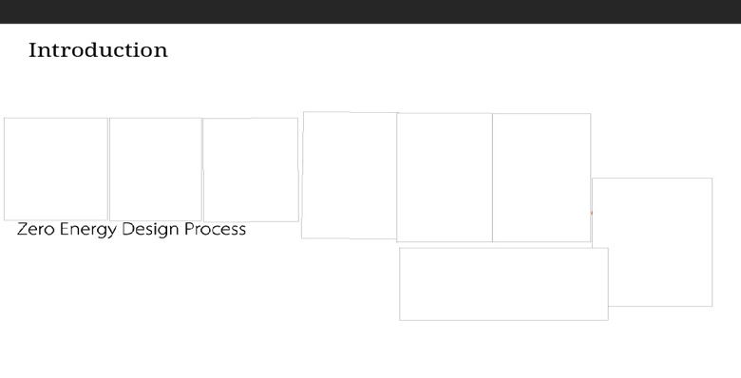
Slide 3-intro
Slide notes: For every zero energy design project, there are key steps to an integrated design process.

Text Captions: Introduction

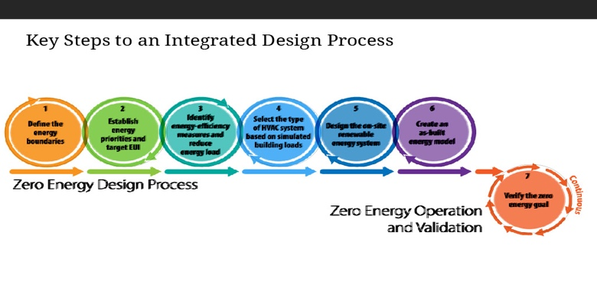
Slide 4-process charting
Slide notes: These steps are typically iterative, meaning that as each task is completed, they inform the subsequent and previous tasks, requiring additional rounds of analysis as information becomes more complete.

Select each step to learn more. Or select the next arrow to move through the steps in order.
Text Captions: Key Steps to an Integrated Design Process

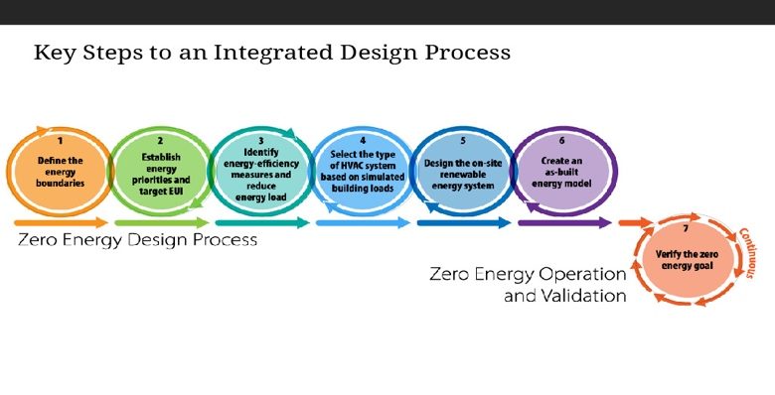
Slide 5-process home
Slide notes: These steps are typically iterative, meaning that as each task is completed, they inform the subsequent and previous tasks, requiring additional rounds of analysis as information becomes more complete.

Select each step to learn more. Or select the next arrow to move through the steps in order.
Text Captions: Key Steps to an Integrated Design Process

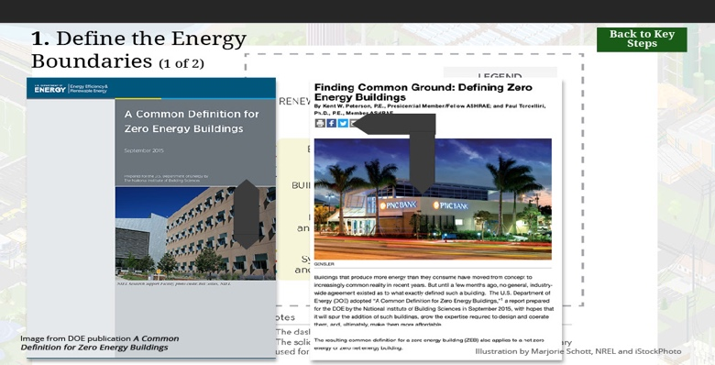
Slide 6-define the energy boundaries 1
Slide notes: The first step in the zero energy design process is to define your project’s energy boundaries.

The equation for the zero energy balance of a building or campus depends on the boundaries of energy consumption and energy generation of the facility. A boundary can be located at the building footprint, or more commonly, at the property line. Often the easiest point to establish the boundary is the point of billing—typically an electric meter (or collection of electric meters) or by fuel deliveries. One of the things to keep in mind when defining the energy boundary for your project is that you must be able to measure the flow of energy.

This graphic demonstrates the flow of energy within and across the boundary for a building. Dashed lines represent the energy transfer within the boundary, and solid lines represent energy transferred into or out of the boundary. For energy balance in a zero energy building, the energy transfer across the boundary is what ultimately gets measured.

Where energy consumption or generation are shared among buildings, the DOE definition for zero energy campus, zero energy portfolio, or zero energy community can be used. These other definitions are identical to the zero energy building definition, except the boundary is expanded. You can find more details on the energy boundary in the DOE publication A Common Definition for Zero Energy Buildings and in the High Performing Buildings article “Finding Common Ground: Defining Zero Energy Buildings”. Links to both of these articles can be found on the Resources section accessible through the menu, or at the end of this module.
Text Captions: 1. Define the Energy Boundaries (1 of 2)
Examples:
Building footprint
Property line

Multiple Buildings:
Zero energy campus
Zero energy portfolio
Zero energy community

Image from DOE publication A Common Definition for Zero Energy Buildings
Back to Key Steps
Back to Key Steps
Back to Key Steps
Illustration by Marjorie Schott, NREL and iStockPhoto

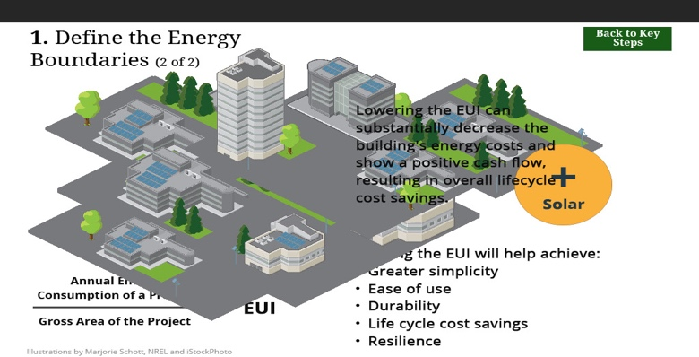
Slide 7-define the energy boundaries 2
Slide notes: The boundary of energy consumption frequently coincides with the physical boundary of the site, encompassing a single building, a single building with surrounding site area, a group of buildings on a site, or an entire campus. In all cases, the most critical recommendation is efficiency first and then meet the load with renewable energy. In other words, lower the energy use intensity (EUI) before adding renewable energy. As we introduced in Module 1, the EUI is the annual energy consumption of the project divided by the gross area of the project not including any renewable generation.

Lowering the EUI will help achieve greater simplicity, ease of use, durability, life cycle cost savings, and resilience. There are pathways to meet multiple of these “goals” with the same strategies. Lowering the EUI can substantially decrease the building’s energy costs and show a positive cash flow, resulting in overall lifecycle cost savings. It can also work harmoniously with creating buildings that are more durable, resilient, and simple to operate and maintain.
Text Captions: 1. Define the Energy Boundaries (2 of 2)
Annual Energy Consumption of a Project
Gross Area of the Project
=
EUI
Lower the energy use intensity (EUI) before adding renewable energy

+
Solar
EUI
Lowering the EUI will help achieve:
Greater simplicity
Ease of use
Durability
Life cycle cost savings
Resilience
Illustrations by Marjorie Schott, NREL and iStockPhoto

Lowering the EUI can substantially decrease the building's energy costs and show a positive cash flow, resulting in overall lifecycle cost savings.
Back to Key Steps
Back to Key Steps
Back to Key Steps

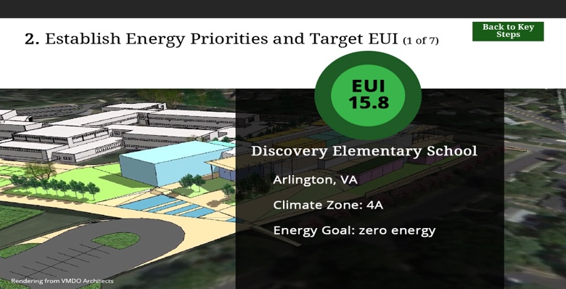
Slide 8-step2 first
Slide notes: The definition of the energy boundary should go hand-in-hand with establishing priorities for maximizing energy-efficiency.
Text Captions: 2. Establish Energy Priorities and Target EUI (1 of 7)
Discovery Elementary School
Arlington, VA
Climate Zone: 4A
Energy Goal: zero energy

Rendering from VMDO Architects

EUI
15.8
Back to Key Steps
Back to Key Steps
Back to Key Steps

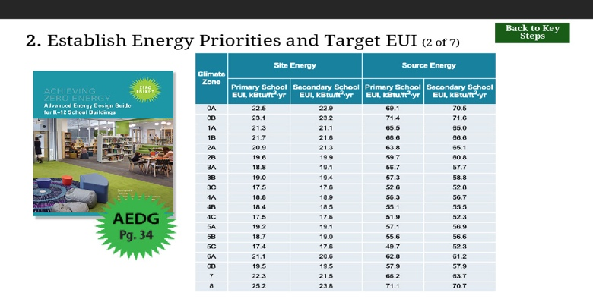
Slide 9-Establish Energy Priorities and Target EUI 2
Slide notes: One of the most critical steps in creating a zero energy building is to establish the EUI for the project, which involves evaluating the project parameters to determine a feasible target.

For school buildings, there are recommended targeted EUIs for both site and source energy included in the AEDG. We’ve also included this table in the resources link for your reference. These targeted EUIs are a function of climate zone and are based on simulation analysis done for the AEDG.

Keep in mind that you will need to conduct further analysis and energy modeling if you plan to include energy loads that were not included in the AEDG EUI calculations. For the K-12 AEDG, examples of energy loads that were not part of the EUI calculations include: swimming pools, ice rinks, and television quality lighting for sports fields.
Text Captions: 2. Establish Energy Priorities and Target EUI (2 of 7)
Back to Key Steps
Back to Key Steps
Back to Key Steps

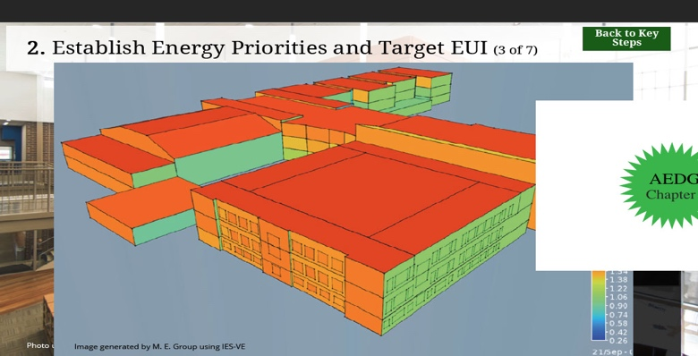
Slide 10-Establish Energy Priorities and Target EUI 3
Slide notes: When establishing an energy goal, first create a list of large energy uses that are not typical of the building type. For example, in schools, normal school occupancy is included along with computer labs, IT infrastructure, some food preparation, and typical office equipment. If a school has some intense loads, such as a pottery kiln, lights for a sports stadium, swimming pool, or hockey rink—these loads are not in the EUI’s provided in the table from the previous slide.

Sometimes buildings operate longer hours than what is “typical.” Again, for the school comparison, there are allowances for the offices to be open year-round as well as some night/weekend uses for sports and auditorium facilities. A small number of classrooms are scheduled in the summer—but for the most part, the building is not fully conditioned in the summer. Using the base line conditions, an energy model should be created to show compliance with the E U I targets—then the model should be changed to account for these additional energy uses.

Include best practices for these extra-ordinary loads when setting the goals.
Text Captions: 2. Establish Energy Priorities and Target EUI (3 of 7)
DEARING ELEMENTARY SCHOOL
Pflugerville, TX
Climate Zone: 2A
Predicted EUI = 19 kBtu/ft2•yr
Actual EUI = 23.58 kBtu/ft2•yr

EUI
23.5
Photo used with permission from Stantec

Create a list of large energy uses that are not typical of the building type, such as:
Pottery kiln
Lighting for a sports stadium
Swimming pool
Hockey rink

Image generated by M. E. Group using IES-VE
Back to Key Steps
Back to Key Steps
Back to Key Steps

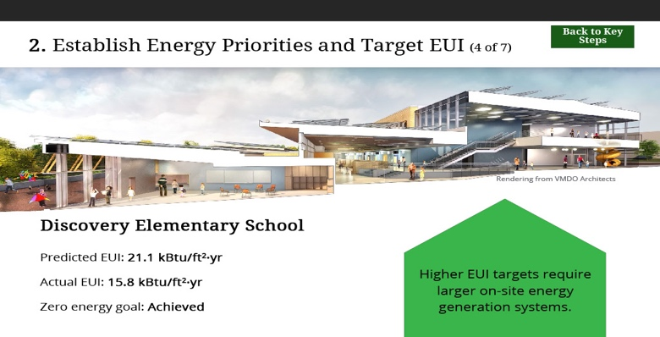
Slide 11-Establish Energy Priorities and Target EUI 4
Slide notes: It’s important to create realistic EUI targets; however, higher EUI targets will require larger on-site energy generation systems in order to achieve zero energy.

The targets presented in the examples in the AEDG are achievable and yet are a stretch from typical construction. In many cases, these targets can be reduced by an additional 20% to provide an advanced tier for efficiency, which also means less costs for the on-site renewable energy system.
Text Captions: 2. Establish Energy Priorities and Target EUI (4 of 7)
Discovery Elementary School
Predicted EUI: 21.1 kBtu/ft2·yr
Actual EUI: 15.8 kBtu/ft2·yr
Zero energy goal: Achieved

Rendering from VMDO Architects

Higher EUI targets require larger on-site energy generation systems.
Back to Key Steps
Back to Key Steps
Back to Key Steps

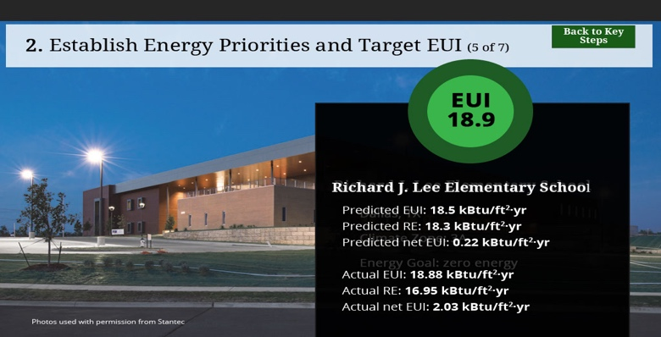
Slide 12-Establish Energy Priorities and Target EUI 5
Slide notes: When you develop and establish your target E U I, it is helpful to demonstrate that the EUI is feasible by providing actual examples of similar buildings or schools that have published low EUI’s. These case studies provide actual data of schools that can achieve the E U I.
Text Captions: 2. Establish Energy Priorities and Target EUI (5 of 7)
Richard J. Lee Elementary School
Dallas, TX
Climate Zone: 3A
Energy Goal: zero energy

Richard J. Lee Elementary School

Predicted EUI: 18.5 kBtu/ft2·yr
Predicted RE: 18.3 kBtu/ft2·yr
Predicted net EUI: 0.22 kBtu/ft2·yr

Actual EUI: 18.88 kBtu/ft2·yr
Actual RE: 16.95 kBtu/ft2·yr
Actual net EUI: 2.03 kBtu/ft2·yr
EUI
18.9
Photos used with permission from Stantec

Back to Key Steps
Back to Key Steps
Back to Key Steps

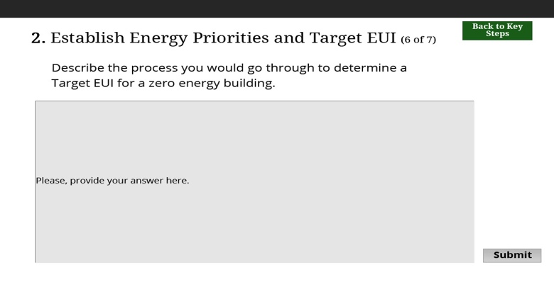
Slide 13-Establish Energy Priorities and Target EUI 6
Slide notes: Describe the process you would go through to determine a Target E. U. I. for a zero energy building.
Text Captions: 2. Establish Energy Priorities and Target EUI (6 of 7)
Back to Key Steps
Back to Key Steps
Back to Key Steps
Describe the process you would go through to determine a Target EUI for a zero energy building.


Slide 14-Establish Energy Priorities and Target EUI 7
Slide notes: At a fundamental level, Arlington County district officials believed that integrating environmental stewardship with learning environments would give their schools a competitive edge. So as the district began to think about building Discovery Elementary, officials looked around for other models. One project caught their attention: a LEED Gold, highly efficient elementary school in nearby Manassas Park. So as the district issued a call for proposals, it reached out to the Manassas Park architect with a challenge: “Give us one of those, but make it better.”

After modeling an E.U.I. of 19 thousand British Thermal Units per square foot per year the design team settled on a target E.U.I. of 21 thousand British Thermal Units per square foot per year due to uncertainty surrounding how the building would actually be used during after-school hours. Since this was the first project between Arlington Public Schools and this particular design team, setting the target E.U.I. 10% higher than the modeled E.U.I. allowed room for error.
Text Captions: 2. Establish Energy Priorities and Target EUI (7 of 7)
Discovery Elementary School:

Modeled EUI = 19 kBtu/ft2•Yr

Target EUI = 21 kBtu/ft2•Yr

Photos by Lincoln Barbour
Back to Key Steps
Back to Key Steps
Back to Key Steps

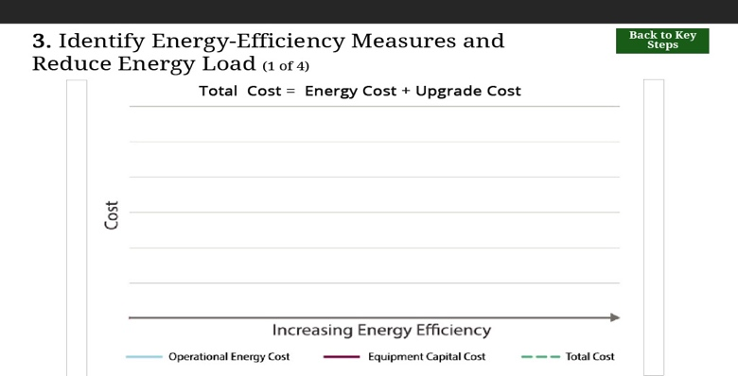
Slide 15-step3 first
Slide notes: Finding synergies through the integrated design of all components impacting the energy demands and energy production of the building is an essential strategy to achieve the low E U I’s required for a successful zero energy project. These synergies allow the cost to be brought down to make zero energy feasible. In particular, reducing the loads through an efficient envelope can reduce heating and cooling needs to the extent that the mechanical system, and consequently also the electrical service, can be reduced significantly.

The left side of the graph is the base case building that has the heating cost in blue, and the cost to upgrade the technologies in green. The sum of these two lines is the red total cost. In most cases the cost of upgrading technologies costs money—with the hope that the energy costs decrease faster and that the total cost of ownership decreases. HOWEVER, if the envelope improves such that equipment can be downsized or eliminated, the upgrade costs can drop significantly to the point that the total costs is less than the total cost of doing nothing. Often after this, the upgrade costs climbs dramatically and the energy costs cannot offset the increase in the upgrades.

We’ll cover energy-efficiency measures (EEM) and integrated strategies that have been shown to be effective to achieve these target E U I’s for each climate in later modules.

Text Captions: 3. Identify Energy-Efficiency Measures and Reduce Energy Load (1 of 4)

Total Cost = Energy Cost + Upgrade Cost

Back to Key Steps
Back to Key Steps
Back to Key Steps

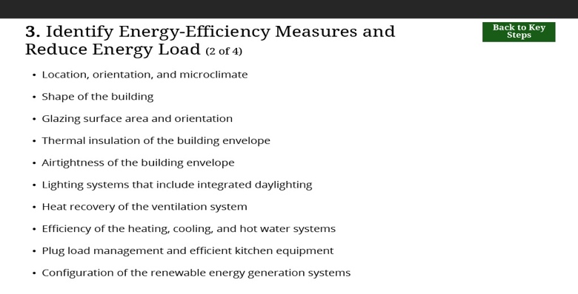
Slide 16-Identify EEMs 2
Slide notes: There are some major components to be considered when identifying energy-efficiency measures.

Location, orientation, and microclimate.
Shape of the building.
Glazing surface area and orientation.
Thermal insulation of the building envelope.
Airtightness of the building envelope.
Lighting systems that include integrated daylighting .
Heat recovery of the ventilation system.
Efficiency of the heating, cooling, and hot water systems.
Plug load management and efficient kitchen equipment.
Configuration of the renewable energy generation systems.
Text Captions: 3. Identify Energy-Efficiency Measures and Reduce Energy Load (2 of 4)
Location, orientation, and microclimate

Shape of the building

Glazing surface area and orientation

Thermal insulation of the building envelope

Airtightness of the building envelope

Lighting systems that include integrated daylighting

Heat recovery of the ventilation system

Efficiency of the heating, cooling, and hot water systems

Plug load management and efficient kitchen equipment

Configuration of the renewable energy generation systems

Back to Key Steps
Back to Key Steps
Back to Key Steps

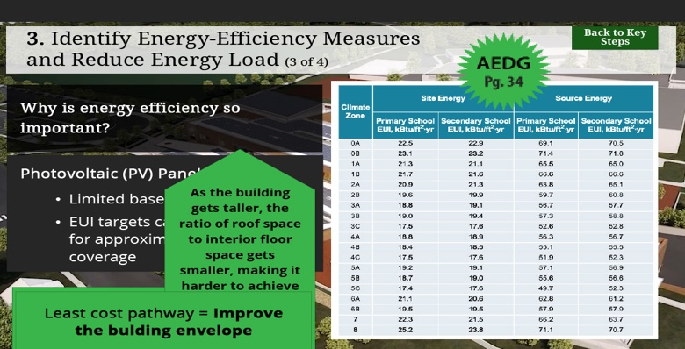
Slide 17-Identify EEMs 3
Slide notes: Why is energy efficiency so important?

Trying to create a zero energy building without putting energy efficiency first is often not achievable. The most common renewable energy source available to most sites is solar energy, which can be captured with photovoltaic panels. For more information on this technology, please see Module 9. The amount of available solar energy is limited based on location, which limits the amount of energy that can be collected on or near the building. This becomes a limiting factor to bound the E U I target for the building, since zero energy buildings cannot consume more energy than they generate with on-site renewables. As an example, the E U I targets presented here can be offset by photovoltaic panels for approximately 50% roof coverage.

For buildings where on-site renewable energy generation is restricted due to shading from nearby buildings or trees, buildings can be designed to be zero energy ready by meeting the E U I targets as shown in this table. Energy efficiency designed into the building will save energy and money for the life of the building even if renewables cannot be deployed during construction. Also note that As the building gets taller, the ratio of roof space to interior floor space gets smaller, making it harder to achieve the required energy balance. A 2-story building needs twice as much roof area covered by renewables as a 1-story building. In general, the numbers provided in this table can create a zero energy building that is 2-3 stories tall. Any taller than this, and additional ground-mounted solar panels would be needed.

Energy efficiency also has other benefits, like how it is “saving” energy the majority of the time, whereas photovoltaic panels only offer about 5 hours a day of rated energy output. Typically, a least-cost pathway to achieving energy efficiency is to improve the building envelope. This also makes the building less susceptible to weather conditions, and buildings that are well insulated can sustain a comfortable temperature without external power, which is important for resilience.

Creating a building with an E U I indicated by the table shown here will create a built environment that can power itself and achieve progress toward minimizing the consumption of fossil fuels.
Text Captions: 3. Identify Energy-Efficiency Measures and Reduce Energy Load (3 of 4)
Why is energy efficiency so important?
Image from video https://www.youtube.com/watch?time_continue=18&v=VelwDwTEABw
Back to Key Steps
Back to Key Steps
Back to Key Steps
Photovoltaic (PV) Panels
EUI targets can be offset by PV for approximately 50% roof coverage
Limited based on location
Efficiency saves energy 24 hours a day
As the building gets taller, the ratio of roof space to interior floor space gets smaller, making it harder to achieve the required energy balance.

Least cost pathway = Improve the bulding envelope

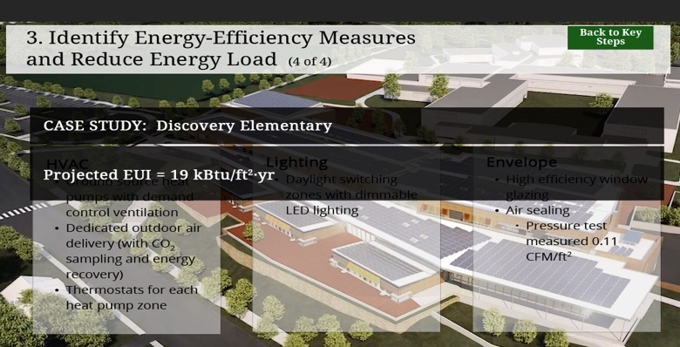
Slide 18-Identify EEMs 4
Slide notes: The project team for Discovery Elementary knew that the School District wanted high-performance systems in the building, so this was set as a baseline throughout all design and modeling. Some key energy efficiency and sustainability features that were chosen include:

H V A C
Ground source heat pumps with demand control ventilation.
Dedicated outdoor air delivery (with CO2 sampling and energy recovery).
Thermostats for each heat pump zone.
Lighting.
Daylight switching zones with dimmable L E D lighting.
Envelope.
High-efficiency window glazing.
Air sealing.

Pressure test of the building measured an air leakage rate of 0.11 cubic feet per minute per square foot of envelope.

These features, along with all other building attributes, were incorporated into six different energy models to compare possible architectural layouts of the building. In these models, energy consumption was evaluated based on the amount of solar PV that would be needed to meet the zero energy goal. Once the owner and A and E team settled on a design, another model was completed to simulate monthly energy consumption in the building. This data is critical, as it established the projected E U I ( nineteen thousand British Thermal Units per square foot per year) and created a baseline to compare with actual performance once the building reached occupancy.
Text Captions: 3. Identify Energy-Efficiency Measures and Reduce Energy Load (4 of 4)
CASE STUDY: Discovery Elementary
HVAC
Ground source heat pumps with demand control ventilation
Dedicated outdoor air delivery (with CO2 sampling and energy recovery)
Thermostats for each heat pump zone

Lighting
Daylight switching zones with dimmable LED lighting

Envelope
High efficiency window glazing
Air sealing
Pressure test measured 0.11 CFM/ft2

Projected EUI = 19 kBtu/ft2·yr
Back to Key Steps
Back to Key Steps
Back to Key Steps

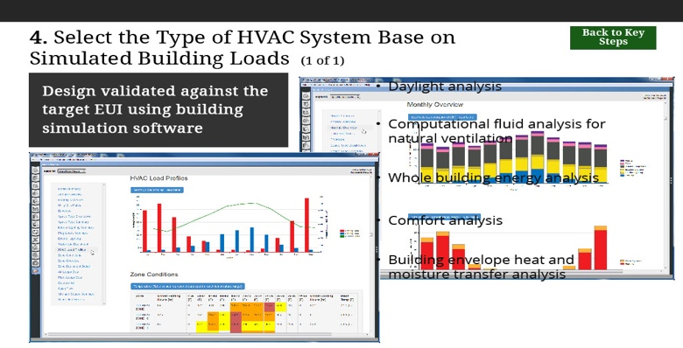
Slide 19-step4 HVAC 1
Slide notes: The E U I serves as a target for the design. Design validated against the target EUI using building simulation software. While a variety of simulation tools can be used, from simple shoebox models to complex analyses, the objective is to show that the design meets the target.

These analyses can include daylight analysis, computational fluid analysis for natural ventilation, whole building energy analysis, comfort analysis of individual spaces, and analysis of detail assemblies for heat and moisture transfer.

As the project moves through the design process, the building simulations provide guidance for design decisions that are used to determine the layout, to choose among alternatives, and to uncover opportunities for additional enhancements.
Text Captions: 4. Select the Type of HVAC System Base on Simulated Building Loads (1 of 1)
Confirm Through Building Simulation
Design validated against the target EUI using building simulation software
Computational fluid analysis for natural ventilation
Daylight analysis
Whole building energy analysis
Comfort analysis
Building envelope heat and moisture transfer analysis
Back to Key Steps
Back to Key Steps
Back to Key Steps

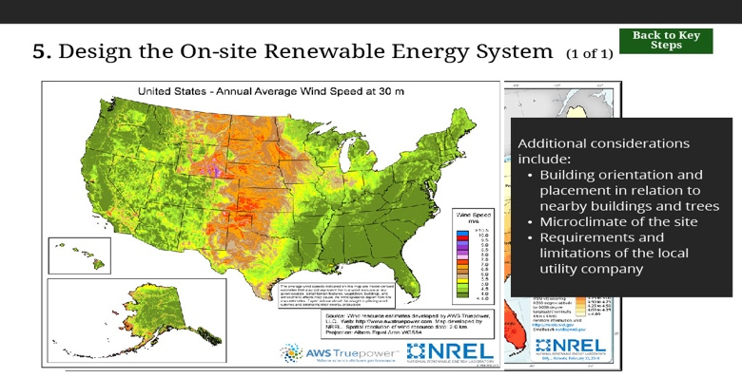
Slide 20-step5 RE first
Slide notes: Conduct an analysis of potential renewable energy sources that can be used to generate energy on site and calculate the potential quantity of energy that can be generated.

Especially where opportunities for renewable energy generation are limited, this step may start the process rather than end it, by generating a maximum E U I that can be supported by the available renewable energy production.

Additional considerations that need to be factored in when calculating on-site renewable energy potential include: building orientation and placement in relation to nearby buildings and trees, microclimate of the site including localized cloud cover and fog, and requirements of the local utility company. Further detail on the information to consider when analyzing renewable energy potential are discussed in Module 9.
Text Captions: 5. Design the On-site Renewable Energy System (1 of 1)
Additional considerations include:
Building orientation and placement in relation to nearby buildings and trees
Microclimate of the site
Requirements and limitations of the local utility company
Back to Key Steps
Back to Key Steps
Back to Key Steps

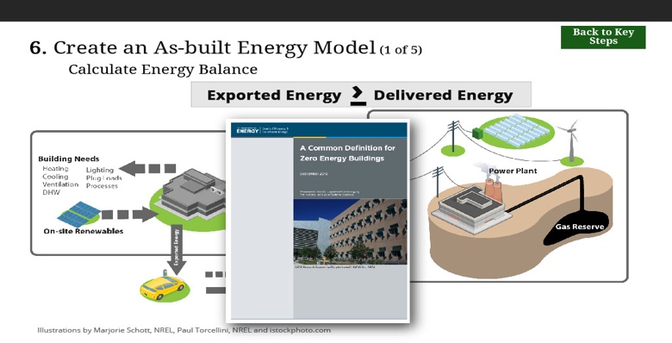
Slide 21-step6 first
Slide notes: Once quantities for energy consumption and energy generation have been established, the energy factors must be applied to determine if the energy generation is adequate to meet the definition of zero energy. Details on how to calculate the energy balance are provided in DOE’s A Common Definition for Zero Energy Buildings.

Site boundaries of energy transfer for zero energy accounting are illustrated in this figure.
Text Captions: Illustrations by Marjorie Schott, NREL, Paul Torcellini, NREL and istockphoto.com

Exported Energy
Delivered Energy
›
6. Create an As-built Energy Model (1 of 5)
Calculate Energy Balance
Back to Key Steps
Back to Key Steps
Back to Key Steps

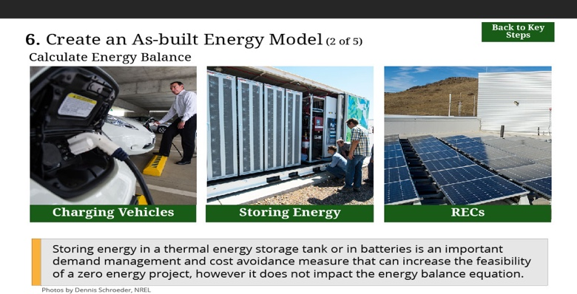
Slide 22-Create an As-built Energy Model 2
Slide notes: There are several points worth noting in regard to the calculation of the energy balance and the determination of zero energy performance. Select each item to learn more.
Text Captions: 6. Create an As-built Energy Model (2 of 5)
Charging Vehicles
Charging Vehicles
Charging Vehicles
Charging Vehicles
Storing Energy
Storing Energy
Storing Energy
Storing Energy
RECs
RECs
RECs
RECs
Energy used for charging vehicles is counted as energy exported from the site.
A project must retain the renewable energy certificates (RECs) in order to take credit for the renewable energy generation that is required to achieve zero energy status.
Storing energy in a thermal energy storage tank or in batteries is an important demand management and cost avoidance measure that can increase the feasibility
of a zero energy project, however it does not impact the energy balance equation.
Photos by Dennis Schroeder, NREL

Calculate Energy Balance
Back to Key Steps
Back to Key Steps
Back to Key Steps

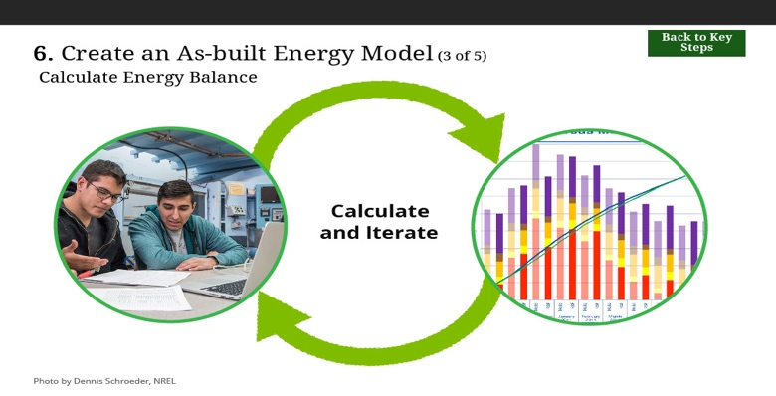
Slide 23-Create an As-built Energy Model 3
Slide notes: The energy balance calculation will occur at numerous intervals throughout the design process, leading to further refinements of the project, with additional energy-efficiency measures included if necessary to lower the E U I until it meets the energy generation potential. Typically, a margin of error is recommended to ensure meeting the target.

Buildings tend to use slightly more energy than is predicted and the renewable generation source produces a little less than was expected.
Text Captions: 6. Create an As-built Energy Model (3 of 5)
Calculate
and Iterate
Photo by Dennis Schroeder, NREL

Calculate Energy Balance
Back to Key Steps
Back to Key Steps
Back to Key Steps

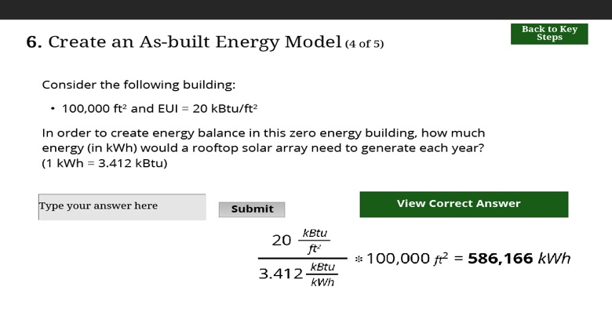
Slide 24-Create an As-built Energy Model 3
Slide notes:
Text Captions: 6. Create an As-built Energy Model (4 of 5)
Consider the following building:
100,000 ft2 and EUI = 20 kBtu/ft2
In order to create energy balance in this zero energy building, how much energy (in kWh) would a rooftop solar array need to generate each year? (1 kWh = 3.412 kBtu)
View Correct Answer
View Correct Answer
View Correct Answer
View Correct Answer
Back to Key Steps
Back to Key Steps
Back to Key Steps

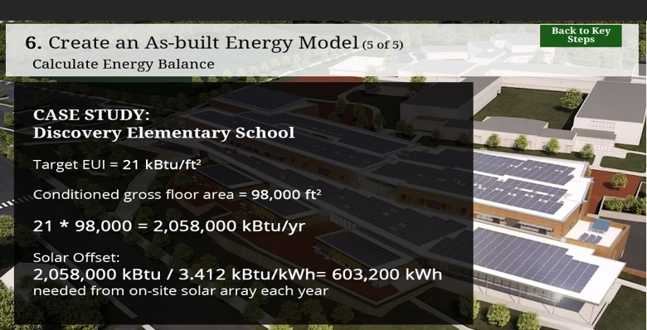
Slide 25-Create an As-built Energy Model 5
Slide notes: Creating a productive learning environment at Discovery Elementary was the first priority, which meant the design team paid close attention to the solar orientation of the building. The rooftop solar array was only analyzed after an architectural layout was chosen that provided high levels of natural light and allowed for efficient flow of people through the building.

A high level approximation of that analysis is shown on screen. Detailed analysis by the engineering team showed that to produce the 603,200 kWh required, a 496 kW PV system was needed. The design team then designed the roof to accommodate this system.
Text Captions: 6. Create an As-built Energy Model (5 of 5)

CASE STUDY:
Discovery Elementary School

Target EUI = 21 kBtu/ft2

Conditioned gross floor area = 98,000 ft2

21 \* 98,000 = 2,058,000 kBtu/yr

Solar Offset:
2,058,000 kBtu / 3.412 kBtu/kWh= 603,200 kWh needed from on-site solar array each year
Calculate Energy Balance
Back to Key Steps
Back to Key Steps
Back to Key Steps

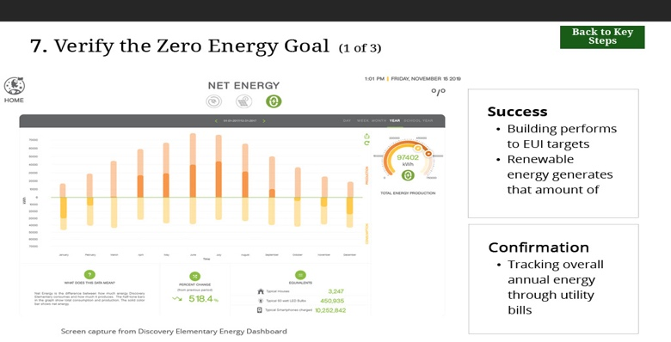
Slide 26-step7 first
Slide notes: Zero energy is an operational goal and as a result, success is obtained when the building actually performs to the EUI targets that have been specified and the renewable energy is shown to generate that amount of energy.

The simplest confirmation is based on tracking of overall annual energy through utility bills. All-electric buildings are easier to verify because if the total purchased energy over the course of a year is zero, then the building should be zero. Various entities offer programs to validate these results. Information on these emerging protocols can be found on the Zero Energy Building Resource Hub website and Zero Energy Schools Accelerator Page. Links to these pages can be found on the resources tab.
Text Captions: 7. Verify the Zero Energy Goal (1 of 3)
Success
Building performs to EUI targets
Renewable energy generates that amount of energy

Confirmation
Tracking overall annual energy through utility bills
Screen capture from Discovery Elementary Energy Dashboard
Back to Key Steps
Back to Key Steps
Back to Key Steps

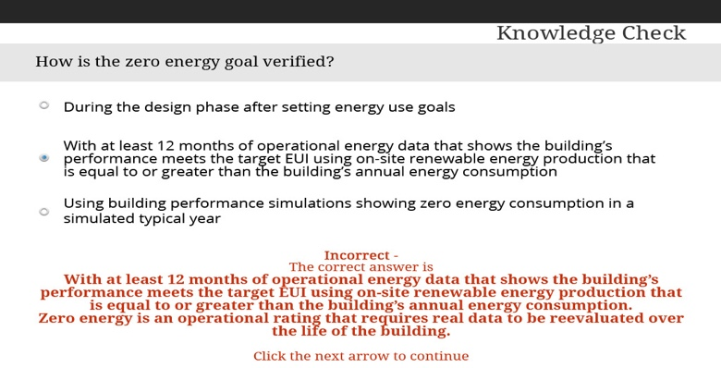
Slide 27-verify goal?
Text Captions: Knowledge Check
How is the zero energy goal verified?
Using building performance simulations showing zero energy consumption in a simulated typical year
You must answer the question before continuing.
Correct - Click the next arrow to continue.
Incorrect -
The correct answer is
With at least 12 months of operational energy data that shows the building’s performance meets the target EUI using on-site renewable energy production that is equal to or greater than the building’s annual energy consumption. Zero energy is an operational rating that requires real data to be reevaluated over the life of the building.

Click the next arrow to continue

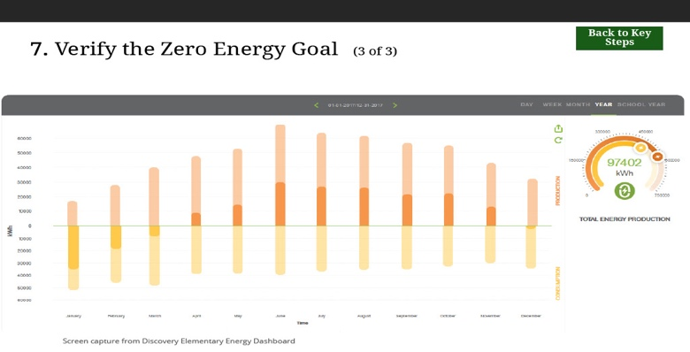
Slide 28-Verify energy goal 3
Slide notes: At Discovery Elementary, the zero energy goal has been verified through the school’s online Energy Dashboard. This system provides hourly, daily, weekly, monthly, and yearly views of historical energy consumption and on-site energy generation data. Here, you can see calendar year 2017, when the school actually ended up being energy positive. The graph shows energy production as orange bars above the x-axis and energy consumption as yellow bars below the x-axis. Monthly energy balance varied, but over the year, the school generated 97,402 kilowatt hours more than it consumed.
Text Captions: 7. Verify the Zero Energy Goal (3 of 3)
Back to Key Steps
Back to Key Steps
Back to Key Steps
Screen capture from Discovery Elementary Energy Dashboard

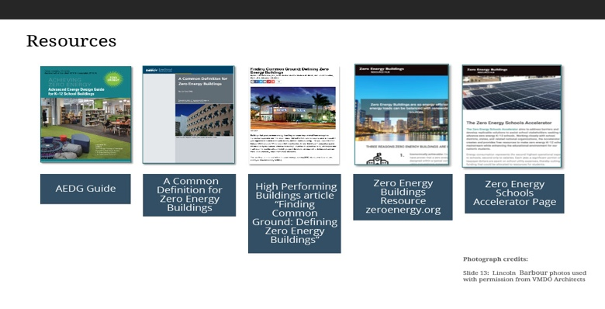
Slide 29-resources
Slide notes: To learn more about developing energy budgets and key performance criteria, the following resources are available.
Text Captions: Resources
AEDG Guide
AEDG Guide
AEDG Guide
A Common Definition for
Zero Energy Buildings
A Common Definition for
Zero Energy Buildings
A Common Definition for
Zero Energy Buildings
High Performing Buildings article “Finding Common Ground: Defining Zero Energy Buildings”
High Performing Buildings article “Finding Common Ground: Defining Zero Energy Buildings”
High Performing Buildings article “Finding Common Ground: Defining Zero Energy Buildings”
Zero Energy Buildings Resource zeroenergy.org
Zero Energy Buildings Resource zeroenergy.org
Zero Energy Buildings Resource zeroenergy.org
Zero Energy Schools
Accelerator Page
Zero Energy Schools
Accelerator Page
Zero Energy Schools
Accelerator Page
Photograph credits:

Slide 13: Lincoln Barbour photos used with permission from VMDO Architects

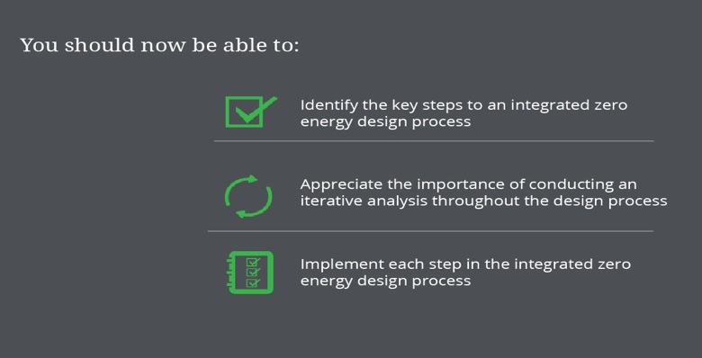
Slide 30-you will be able to
Slide notes: You should now be able to:

Identify the key steps to an integrated zero energy design process.
Appreciate the importance of conducting an iterative analysis throughout the design process.
Implement each step in the integrated zero energy design process.
Text Captions: Implement each step in the integrated zero energy design process

You should now be able to:
Identify the key steps to an integrated zero energy design process

Appreciate the importance of conducting an iterative analysis throughout the design process

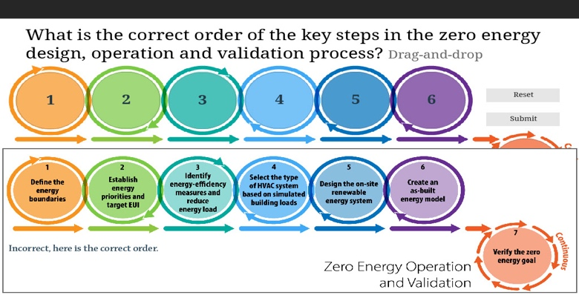
Slide 31
Slide notes: Drag and drop the steps of the zero energy design process into their proper locations in the cycle
Text Captions: What is the correct order of the key steps in the zero energy design, operation and validation process? Drag-and-drop
1
2
3
4
5
6
7
Define the energy boundaries
Establish energy priorities and target EUI
Design the on-site renewable energy system
Verify the zero energy goal
Identify energy-efficiency measures and reduce energy load
Select the type of HVAC sytem based on simulated building loads
Create an as-built energy model
Submit
Submit
Submit
Good job!

Incorrect, here is the correct order.
Reset
Reset
Reset

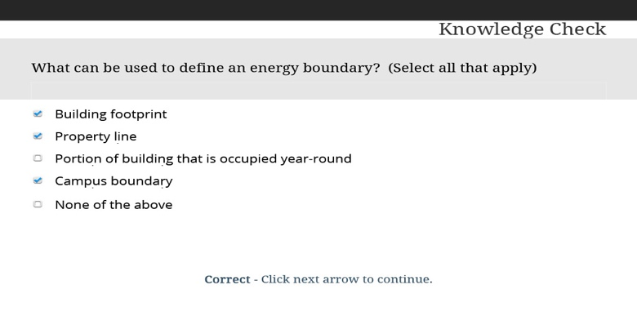
Slide 32-energy boundary?
Slide notes: What can be used to define an energy boundary? Select all that apply.
Text Captions: Knowledge Check
What can be used to define an energy boundary? (Select all that apply)
None of the above Incorrect - The correct answers are building footprint, property line and campus boundary

Click next arrow to continue.
Correct - Click next arrow to continue.

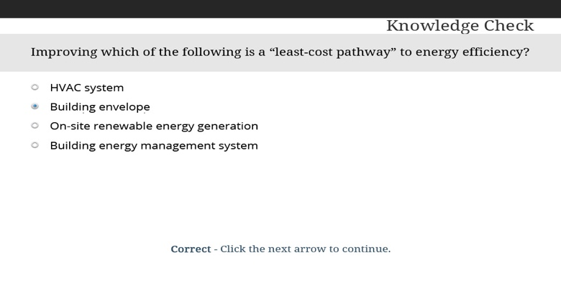
Slide 33-least cost pathwaay?
Slide notes: Select the correct answer.
Text Captions: Knowledge Check
Improving which of the following is a “least-cost pathway” to energy efficiency?
Building energy management system

Incorrect - The correct answer is building envelope
Click the next arrow to continue.
Correct - Click the next arrow to continue.

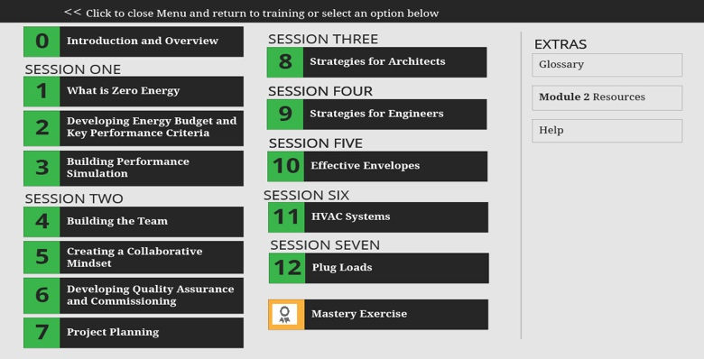
Slide 34-Menu
Text Captions: << Click to close Menu and return to training or select an option below
0
0
0
Introduction and Overview
Introduction and Overview
Introduction and Overview
1
1
1
What is Zero Energy
What is Zero Energy
What is Zero Energy
2
2
2
Developing Energy Budget and Key Performance Criteria

Developing Energy Budget and Key Performance Criteria

Developing Energy Budget and Key Performance Criteria
3
3
3
Building Performance Simulation
Building Performance Simulation
Building Performance Simulation
SESSION ONE
SESSION THREE
8
8
8
Strategies for Architects
Strategies for Architects
Strategies for Architects
SESSION FOUR
9
9
9
Strategies for Engineers
Strategies for Engineers
Strategies for Engineers
SESSION FIVE
10
10
10
Effective Envelopes
Effective Envelopes
Effective Envelopes
SESSION SIX
11
11
11
HVAC Systems
HVAC Systems
HVAC Systems
SESSION SEVEN
12
12
12
Plug Loads
Plug Loads
Plug Loads
Mastery Exercise
Mastery Exercise
Mastery Exercise
EXTRAS
Module 2 Resources
Module 2 Resources
Module 2 Resources
SESSION TWO
4
4
4
Building the Team
Building the Team
Building the Team
5
5
5
Creating a Collaborative Mindset
Creating a Collaborative Mindset
Creating a Collaborative Mindset
6
6
6
Developing Quality Assurance and Commissioning
Developing Quality Assurance and Commissioning
Developing Quality Assurance and Commissioning
7
7
7
Project Planning
Project Planning
Project Planning
EXTRAS
SESSION FOUR
SESSION FIVE
Glossary
Glossary
Glossary
Help
Help
Help

