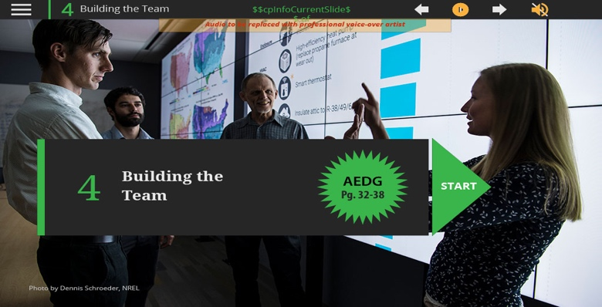
Slide 1-Module 4 Start
Slide notes: Welcome to this module on building the team.

In this module, we’ll discuss your role in being a champion for zero energy design, key characteristics to look for when identifying experts, and different techniques and methods you can use to get all team members focused on the goal of zero energy.

The most important key to achieving a zero energy building and maintaining its performance is finding individuals with the vision, passion, persistence, and powers of persuasion to be a champion and lead the project through planning, design, construction, occupancy, and ongoing measurement and verification.

Text Captions: 4
Building the
Team
Building the Team
4
$$cpInfoCurrentSlide$$ of $$cpInfoSlideCount$$
START
START
START
Photo by Dennis Schroeder, NREL

Audio to be replaced with professional voice-over artist

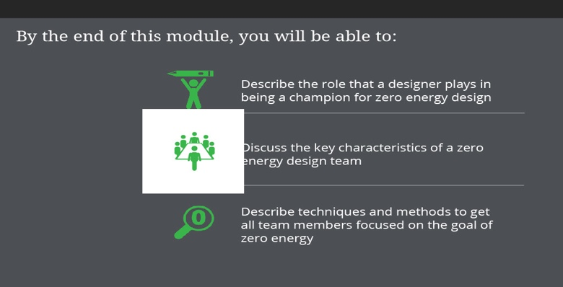
Slide 2-Module Goals
Slide notes: By the end of this module, you will be able to:

Describe the role that a designer plays in being a champion for zero energy design .
Discuss the key characteristics of a zero energy design team
.
Describe techniques and methods to get all team members focused on the goal of zero energy.

Text Captions: Describe techniques and methods to get all team members focused on the goal of zero energy

By the end of this module, you will be able to:
Describe the role that a designer plays in being a champion for zero energy design
Discuss the key characteristics of a zero energy design team


Slide 3-Becoming a Champion
Slide notes: Although everyone on the team should strive to have a zero energy focus, you as the designer are in the unique position to be the champion of this cause.

While most owners have an interest in energy efficiency, many are not at the leading edge of energy efficiency and zero energy design as they don’t routinely design and build buildings. That’s why it’s important that you help the owner establish zero energy and other performance goals for the project as well as a procurement methodology that helps select the best team to meet the goals. This team could be the architectural/engineering (A/E) firm or an expanded team that includes the contractor, which has some advantages in continuity of meeting the goals.

There are enough examples and market pull for zero energy buildings that experienced A/E teams can deliver a zero energy building for the same budget as a conventional one. These teams try to sell the owner on a value-added basis if they are selected. The owner also needs to become a champion, as zero energy is achieved through successful operations and not just design.
Text Captions: Becoming a Champion
Photo by Dennis Schroeder, NREL

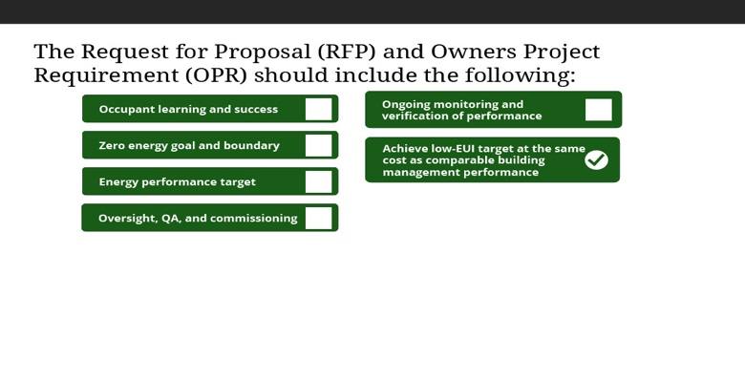
Slide 4-RFP and OPR Includes
Slide notes: In some cases, owners have ideas about energy goals and strategies for achieving actual building performance to meet these goals. Owners in this situation often put these goals into the request for proposals or in the Owners Project Requirement or O P R document. These documents help to identify the best team to achieve these goals. An alternative is that owners know something about energy, but are not aware of the level of efficiency that is achievable today. Architects and Engineering teams need to help the owner think through and refine their goals. The A/E team can help refine the O P R.

Some of the elements that the Request for Proposal and the O P R contain are shown in this slide.

Select each check mark to learn more.
Text Captions: The Request for Proposal (RFP) and Owners Project Requirement (OPR) should include the following:
Occupant learning and success
Occupant learning and success
Occupant learning and success
Occupant learning and success
Zero energy goal and boundary
Zero energy goal and boundary
Zero energy goal and boundary
Zero energy goal and boundary
Energy performance target
Energy performance target
Energy performance target
Energy performance target
Oversight, QA, and commissioning
Oversight, QA, and commissioning
Oversight, QA, and commissioning
Oversight, QA, and commissioning
Ongoing monitoring and
verification of performance
Ongoing monitoring and
verification of performance
Ongoing monitoring and
verification of performance
Ongoing monitoring and
verification of performance
Achieve low-EUI target at the same
cost as comparable building management performance
Achieve low-EUI target at the same
cost as comparable building management performance
Achieve low-EUI target at the same
cost as comparable building management performance
Achieve low-EUI target at the same
cost as comparable building management performance
The expectation that zero energy design and performance will contribute to occupant learning and success.

The zero energy goal, including a description of the energy boundary. Note that any particular zero energy strategies can be included, but design teams may find more cost-efficient
solutions while working through the design process.

The energy performance target is considered essential to achieving zero energy performance. While energy use intensity (EUI) is most common, other energy metrics can also be used. A more aggressive, lower EUI should also be noted as an optional goal.
The nature and extent of oversight, quality assurance, and commissioning expected during design, construction, and close-out, and who will provide it at each stage of the process.

A process for ongoing monitoring and verification of performance after the official close out of construction.
The expectation that the school district, with the exception of the renewable energy sources needed to achieve zero energy, will achieve the low-EUI target without spending any more on the school than it would on a comparable school.

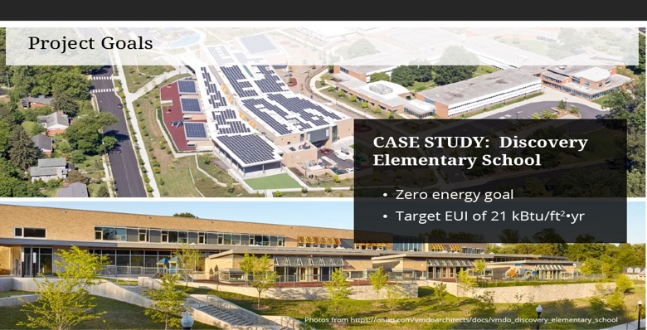
Slide 5-Case Study: Project goals
Slide notes: Arlington Public Schools originally stated LEED Silver certification as the design target for Discovery Elementary, but the A/E team that was selected thought the district’s budget and approach to energy allowed for much better than LEED Silver, so they decided to go for zero energy. Now, after the success of Discovery, APS includes a zero energy goal and a target EUI of 21 in all RFPs for new schools. Current R F Ps from A P S also ask respondents to provide data on previous project EUIs.
Text Captions: Project Goals
CASE STUDY: Discovery Elementary School
Zero energy goal
Target EUI of 21 kBtu/ft2•yr

Photos from https://issuu.com/vmdoarchitects/docs/vmdo_discovery_elementary_school

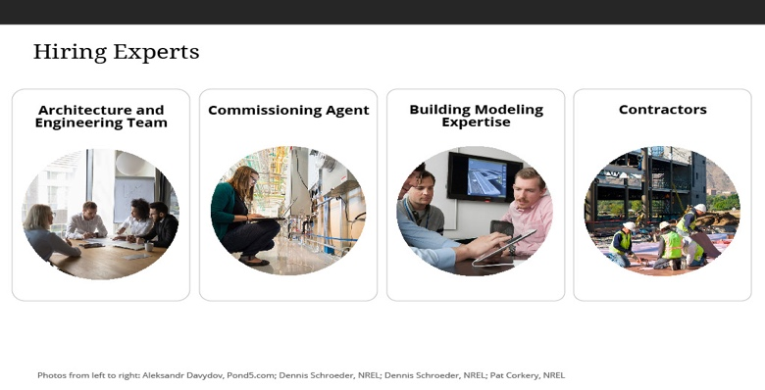
Slide 6-Hiring Experts
Slide notes: Zero energy performance will not be achieved and sustained unless an Architecture and Engineering (A/E) team with the expertise, creativity, and commitment needed to achieve zero energy goals is hired for the project. While having previous zero energy experience helps, it is not cricital to success. What is critical is having a design team that is committed to achieving the energy goal and integrating energy strategies into the architecture of the building as to not increase the construction cost of the project. To help attract an A/E team, communications about the zero energy goal may precede preparation of the R F P for architecture and engineering services to generate interest and excitement about the project.

In addition to the standard A/E team, a successful zero energy team must include a commissioning agent, building modeling expertise, and contractors. We cover these roles in more detail in other modules.
Text Captions: Hiring Experts
Architecture and Engineering Team
Commissioning Agent
Building Modeling Expertise
Contractors
Photos from left to right: Aleksandr Davydov, Pond5.com; Dennis Schroeder, NREL; Dennis Schroeder, NREL; Pat Corkery, NREL

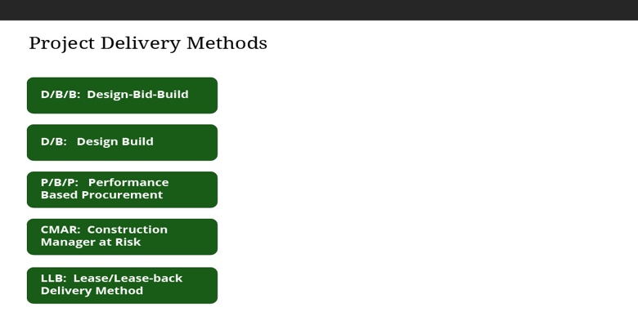
Slide 7-Project Delivery Methods
Slide notes: It is critical to hire a construction contractor or construction management company that understands and is committed to achieving the energy goals for the project. This also applies to their subcontractors and suppliers. Everyone needs to produce quality work for success in meeting the energy goals. As an example, an envelope that doesn’t meet the infiltration requirements but is testing within compliance can single-handedly cause the energy goals to fail. Aligning every person that touches the project from design through construction is difficult and a clear management strategy is needed to make this happen. A variety of project delivery methods are available for construction, each with their own pros and cons regarding the achievement of zero energy performance. For any of these methods to be effective, the contracts must be developed carefully to protect the owner’s interest and maintain the minimum performance criteria, including energy performance. These contracts can be used to align everyone to the energy goals of the project as well as other critical success elements such as cost and budget.

Select each method to read about each one.
Text Captions: Project Delivery Methods
D/B/B: Design-Bid-Build
D/B/B: Design-Bid-Build
D/B/B: Design-Bid-Build
D/B/B: Design-Bid-Build
D/B: Design Build
D/B Design Build
D/B Design Build
D/B Design Build
P/B/P: Performance
Based Procurement
P/B/P Performance
Based Procurement
P/B/P Performance
Based Procurement
P/B/P Performance
Based Procurement
CMAR: Construction Manager at Risk
CMAR Construction Manager at Risk
CMAR: Construction Manager at Risk
CMAR: Construction Manager at Risk
Typically used for comparison purposes, baseline models represent a theoretical benchmark against which the proposed design can be studied. It can be used to calculate percent energy savings from “typical” design.

As zero energy defines an absolute energy goal, baseline models are not necessary unless energy savings is needed for some other reason.

It can also serve as a starting point for analysis, as the code-compliant building is the worst energy performing building that can be legally constructed.

Design models are intended to weigh trade-offs and evaluate strategies and features.

These strategies are tested to determine the impact and progress toward meeting the goal. Ideally, this model is started at conceptual design and informs the form of the building. This model may not represent the final design, as it may need to satisfy rules associated with showing code compliance.

While most modelers will try to satisfy the project needs with only the design models, the standards and codes to which they must adhere may require that they simulate aspects of the building that are not necessarily reflective of the actual project design.

Predictive models need to meet the zero energy design goals, including those for renewable generation.

These models also include passive strategies that are used to eliminate or reduce mechanical cooling requirements, or when the design team plans to use plug load reduction by selecting efficient equipment. The predictive model should match the final set of plans used for construction.

The calibrated model is created to reflect the most accurate set of conditions following construction and during the occupancy of the building.

This should reflect as-installed equipment, as-tested performance information (such as enclosure leakage), and include actual weather and occupancy information. The calibrated model is ultimately used in the measurement and verification process to tune the building and ensure that it is operating properly. When deviations from actual performance exist, they can be compared against the calibrated model looking for issues to correct

Three phases: Designer of Record completes design, then a Contractor is selected through a competitive bidding process and builds the project.

LLB: Lease/Lease-back Delivery Method
LLB Lease/Lease-back Delivery Method
LLB Lease/Lease-back Delivery Method
LLB Lease/Lease-back Delivery Method
Design and construction are completed by the same entity, which increases the opportunity for integration of design with cost-effective construction methods.
Alternative to Design/Build; criteria for the project are performance or goal-based.
Owner negotiates guaranteed maximum price with Contractor, which offers a means for the Contractor to become part of the integrated project delivery team as early as possible.
Engages the builder sooner in the project, reducing the level of public risk while allowing the builder to be chosen based on qualifications rather than price alone.

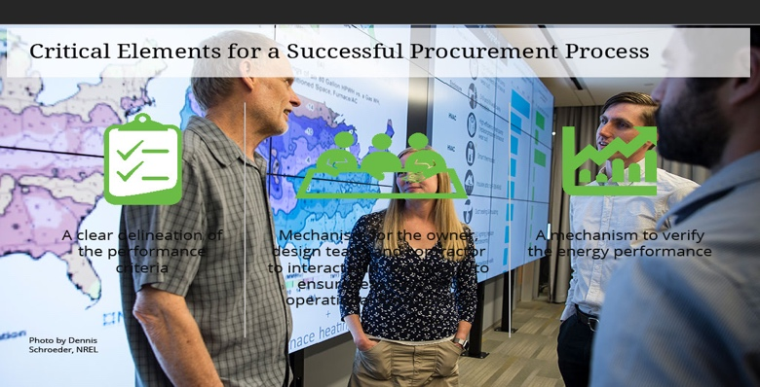
Slide 8-Critical Elements for a Successful Procurement Process
Slide notes: Organizations face constraints which may hinder the pathway towards a zero energy building. Requirement for procurement vary greatly for public building construction. Large organizations may also dictate procurement methodologies. The design team should identify these issues early in the process and brainstorm how constraints outside the project will derail achieving a zero energy building.

Some critical elements:
A clear delineation of the performance criteria, including the E U I target .

A mechanism, including a specific identification of responsibilities, for the owner, design team, and contractor (including subcontractors) to interact and coordinate, to ensure feasibility and operational functionality.

A mechanism to verify the energy performance.

Text Captions: Critical Elements for a Successful Procurement Process
A clear delineation of the performance criteria

Mechanism for the owner, design team, and contractor to interact and coordinate, to ensure feasibility and operational functionality

A mechanism to verify the energy performance

Photo by Dennis Schroeder, NREL

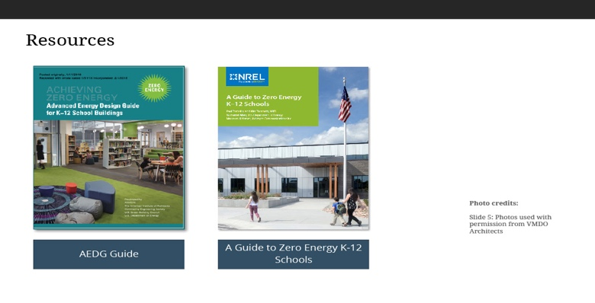
Slide 9-Resources
Slide notes: To learn more about Effective Envelopes, the following resources are available.

Text Captions: Resources
AEDG Guide
AEDG Guide
AEDG Guide
A Guide to Zero Energy K-12 Schools
A Guide to Zero Energy K-12 Schools
A Guide to Zero Energy K-12 Schools
Photo credits:

Slide 5: Photos used with permission from VMDO Architects

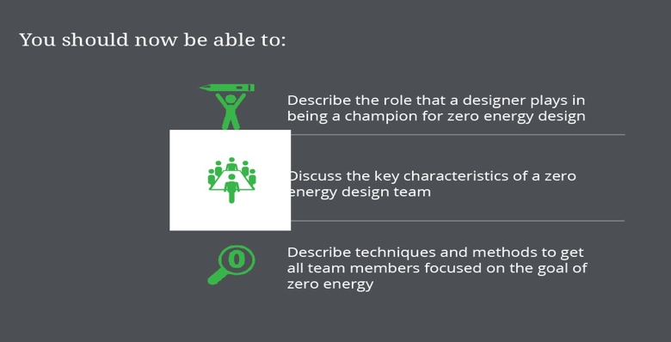
Slide 10-Module Goals Review
Slide notes: You should now be able to:

Describe the role that a designer plays in being a champion for zero energy design .

Discuss the key characteristics of a zero energy design team.

Describe techniques and methods to get all team members focused on the goal of zero energy.

Text Captions: Describe techniques and methods to get all team members focused on the goal of zero energy

You should now be able to:
Describe the role that a designer plays in being a champion for zero energy design
Discuss the key characteristics of a zero energy design team

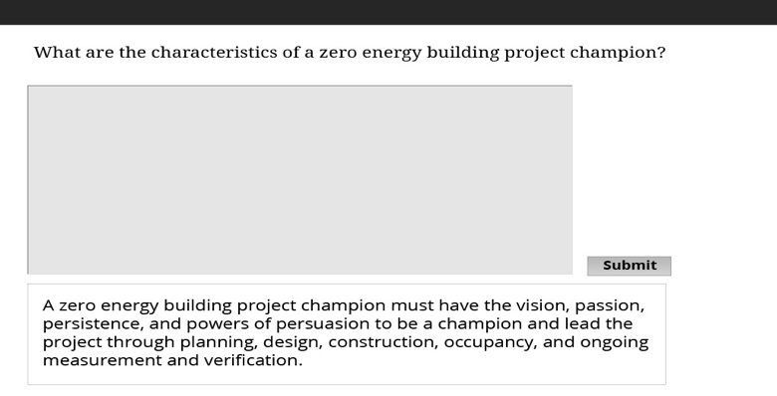
Slide 11-Characteristics of Zero Energy Champion?
Slide notes: To learn more about building the team, the following resources are available.

Text Captions: What are the characteristics of a zero energy building project champion?
A zero energy building project champion must have the vision, passion, persistence, and powers of persuasion to be a champion and lead the project through planning, design, construction, occupancy, and ongoing measurement and verification.

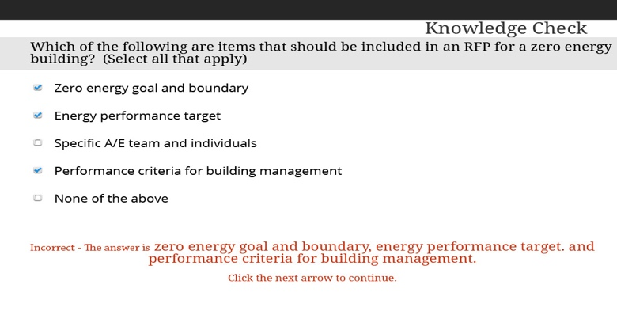
Slide 12-Included in RFP?
Slide notes: Which of the following are items that should be included in an R F P for a zero energy building? (Select all that apply)
Text Captions: Knowledge Check
Which of the following are items that should be included in an RFP for a zero energy building? (Select all that apply)
None of the above Correct - Select the next arrow to continue.
Incorrect - The answer is zero energy goal and boundary, energy performance target. and performance criteria for building management.

Click the next arrow to continue.

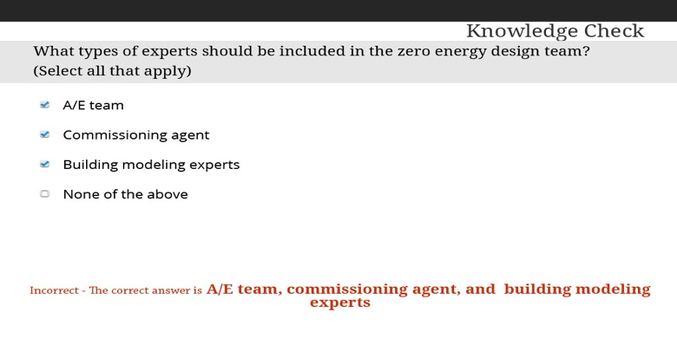
Slide 13-Types of experts?
Slide notes: What types of experts should be included in the zero energy design team? (Select all that apply)
Text Captions: Knowledge Check
What types of experts should be included in the zero energy design team? (Select all that apply)
None of the above Correct - Click the next arrow to continue.
Incorrect - The correct answer is A/E team, commissioning agent, and building modeling experts

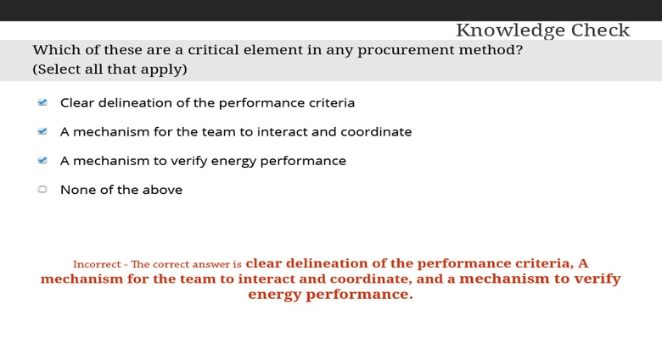
Slide 14-Critical elements?
Slide notes: Which of these are a critical element in any procurement method? (Select all that apply)
Text Captions: Knowledge Check
Which of these are a critical element in any procurement method? (Select all that apply)
None of the above Correct - Click the next arrow to continue.
Incorrect - The correct answer is clear delineation of the performance criteria, A mechanism for the team to interact and coordinate, and a mechanism to verify energy performance.

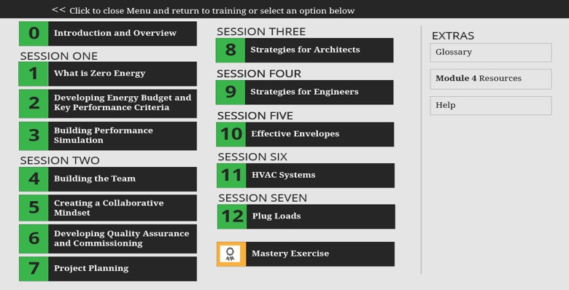
Slide 15-Menu
Text Captions: Glossary
Glossary
Glossary
EXTRAS
Module 4 Resources
Module 4 Resources
Module 4 Resources
<< Click to close Menu and return to training or select an option below
Help
Help
Help
What is Zero Energy
What is Zero Energy
What is Zero Energy
Developing Energy Budget and Key Performance Criteria

Developing Energy Budget and Key Performance Criteria

Developing Energy Budget and Key Performance Criteria
Building Performance Simulation
Building Performance Simulation
Building Performance Simulation
SESSION ONE
SESSION THREE
8
8
8
Strategies for Architects
Strategies for Architects
Strategies for Architects
SESSION FOUR
9
9
9
Strategies for Engineers
Strategies for Engineers
Strategies for Engineers
SESSION FIVE
10
10
10
Effective Envelopes
Effective Envelopes
Effective Envelopes
SESSION SIX
11
11
11
HVAC Systems
HVAC Systems
HVAC Systems
SESSION SEVEN
12
12
12
Plug Loads
Plug Loads
Plug Loads
Mastery Exercise
Mastery Exercise
Mastery Exercise
SESSION TWO
Building the Team
Building the Team
Building the Team
Creating a Collaborative Mindset
Creating a Collaborative Mindset
Creating a Collaborative Mindset
Developing Quality Assurance and Commissioning
Developing Quality Assurance and Commissioning
Developing Quality Assurance and Commissioning
Project Planning
Project Planning
Project Planning
SESSION FOUR
SESSION FIVE
0
0
0
Introduction and Overview
Introduction and Overview
Introduction and Overview
1
1
1
2
2
2
3
3
3
4
4
4
5
5
5
6
6
6
7
7
7

