Technical Analysis using R
Repository URL: [Insert your GitHub or other repository link before submitting]

Overview
This submission implements nine technical indicators as separate base-R scripts. The functions follow the supplied templates and pseudocode where these are consistent; choices for ambiguous instructions are documented below. No third-party technical analysis packages are required.

SMA
sma(data, period)
Computes a simple arithmetic mean for each consecutive window of length period; output has n − period + 1 elements.
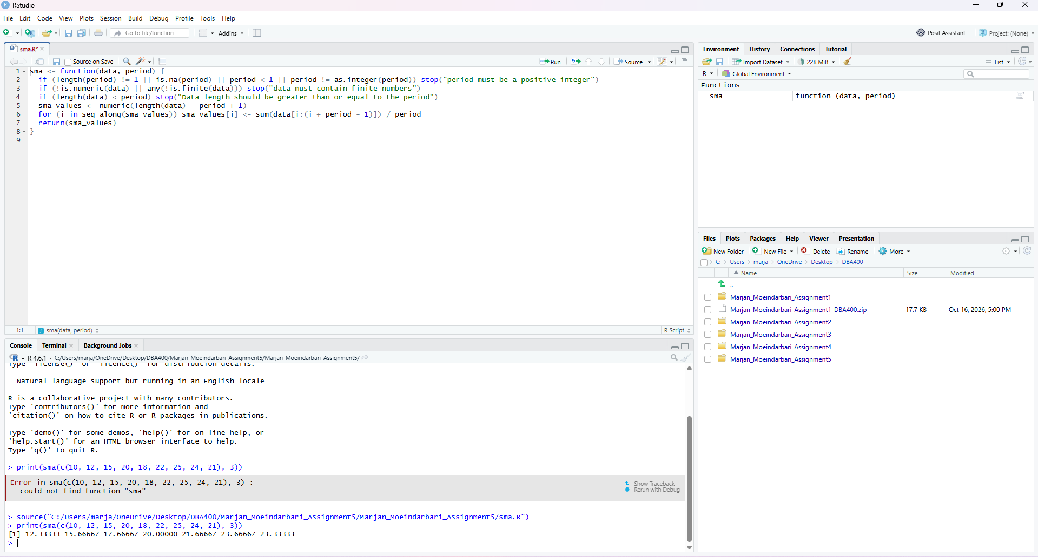

EMA
ema(data, period)
Starts at the first price and recursively updates with the smoothing multiplier 2 / (period + 1).
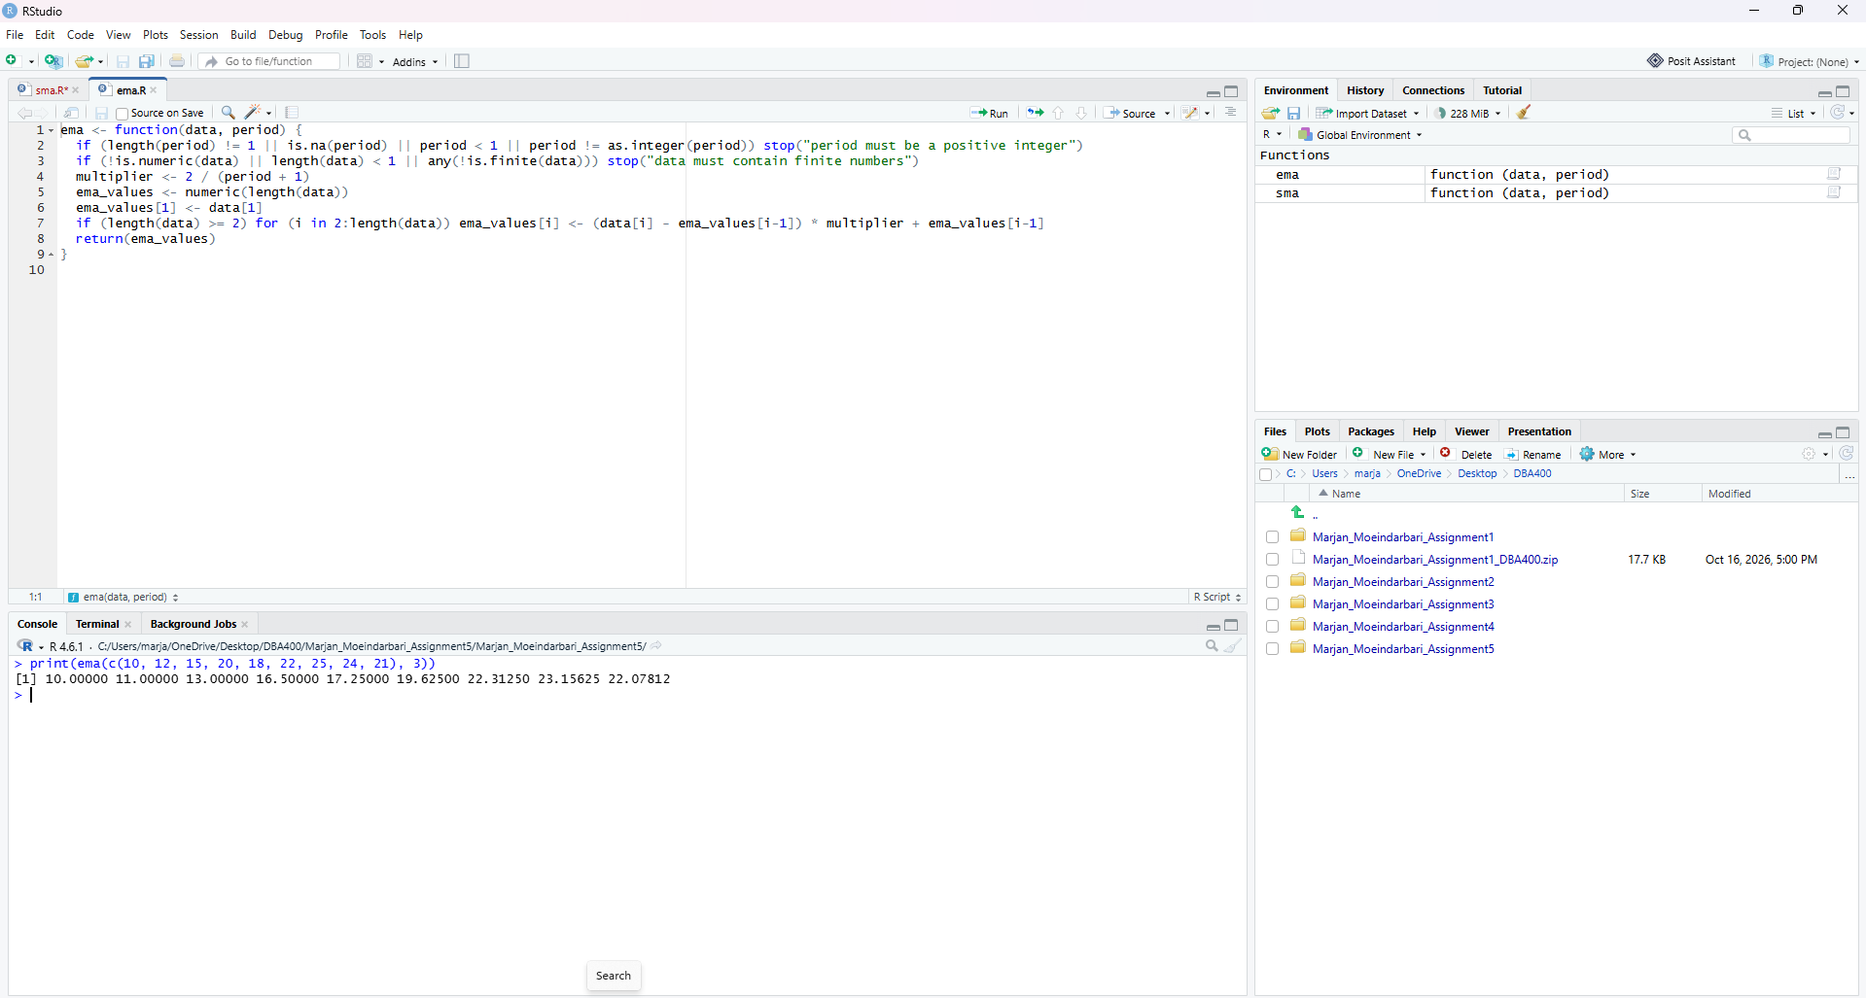

MACD
macd(data, short_period, long_period, signal_period)
Subtracts long EMA from short EMA, then calculates signal EMA and their histogram difference.
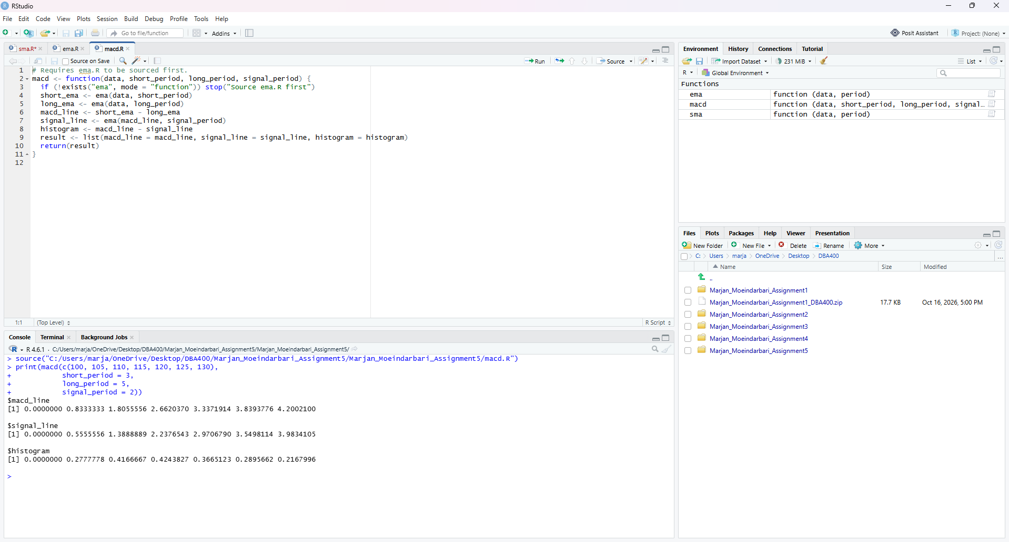

Standard deviation
stdev(data)
Calculates the population standard deviation using the square root of the mean squared deviation (denominator n).
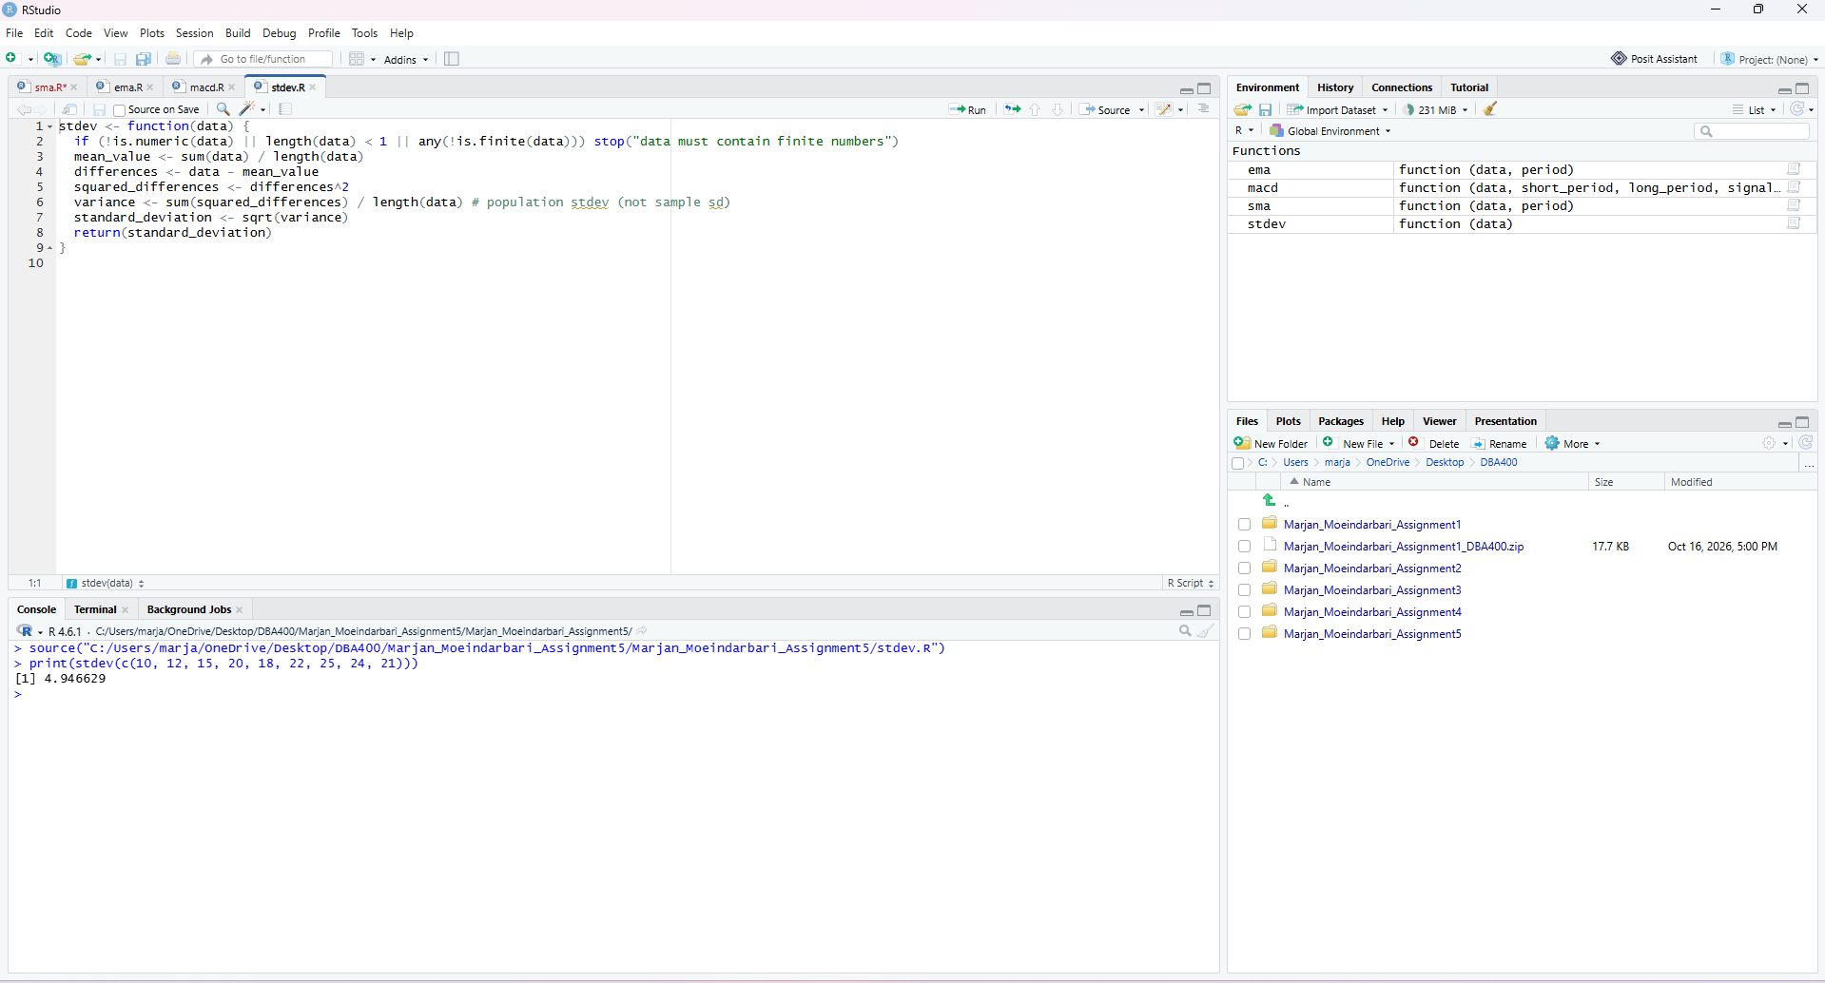

Linear regression
linreg(regressionSource, regressionLength, regressionOffset)
Applies least-squares regression to the selected recent window, returning slope, intercept and predicted values.
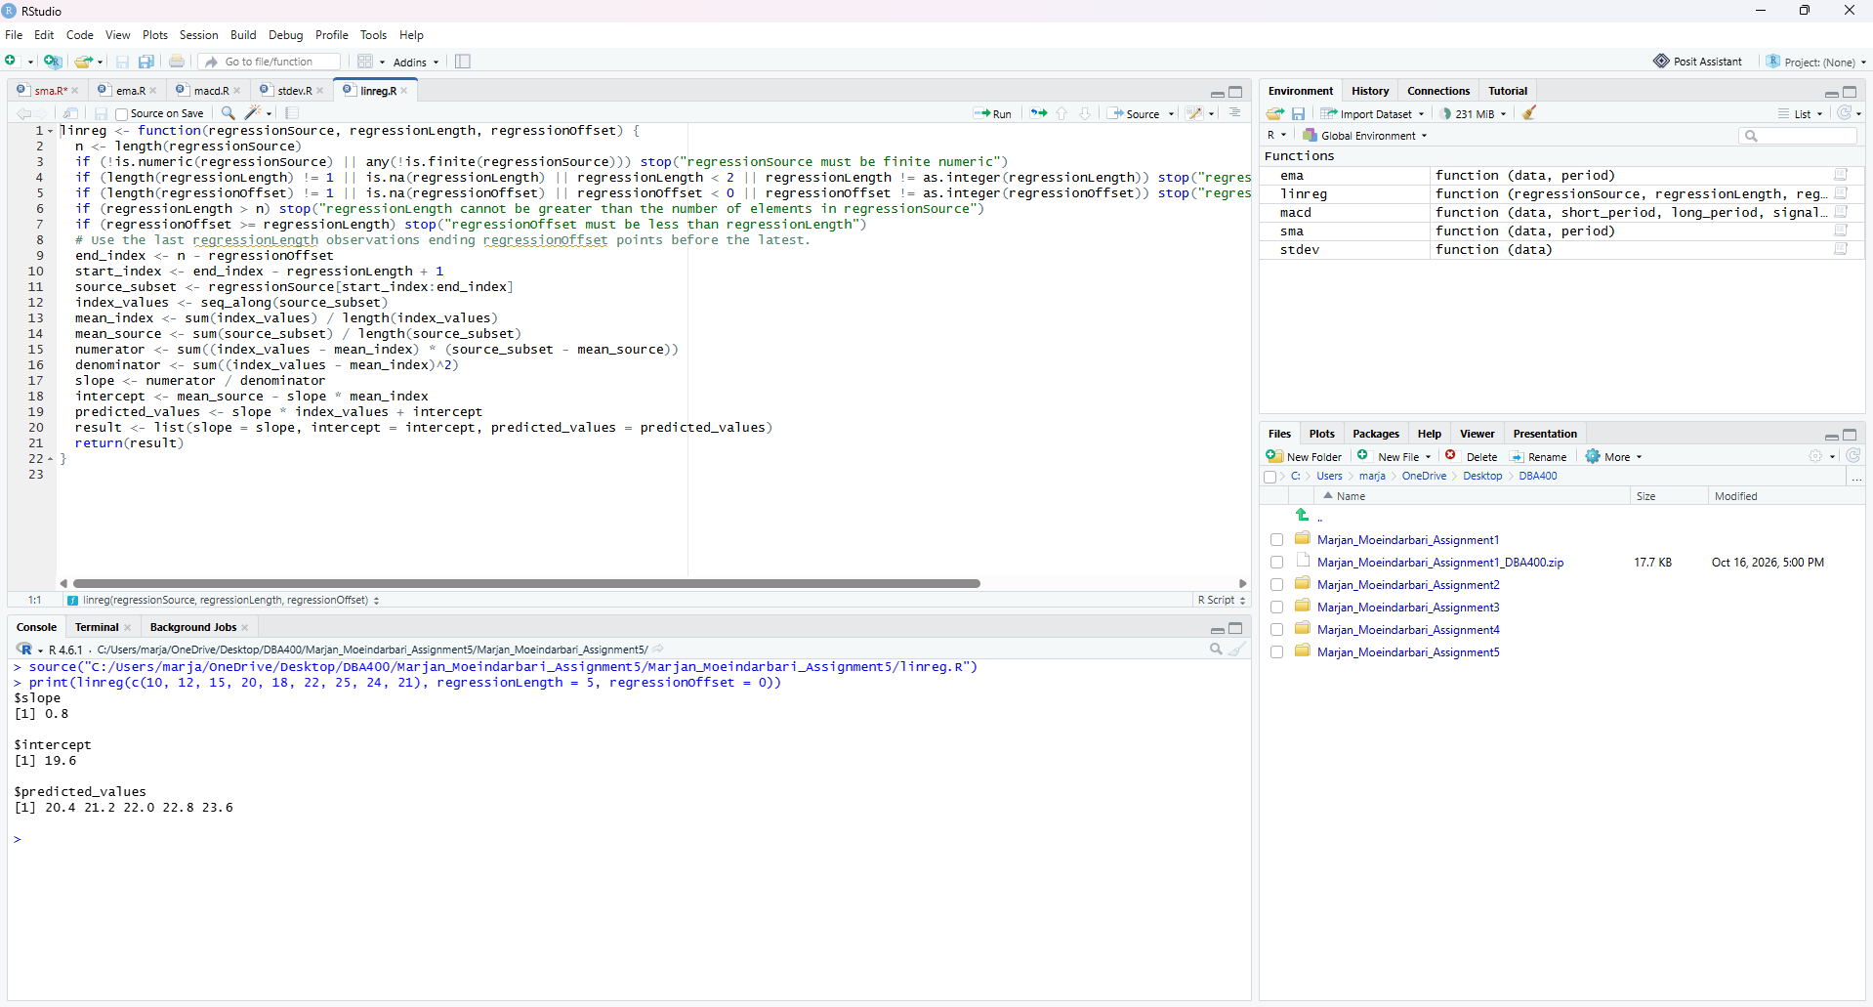

RSI
rsi(data, period)
Measures gains against losses using an initial period average and Wilder smoothing; returns NA for early prices.
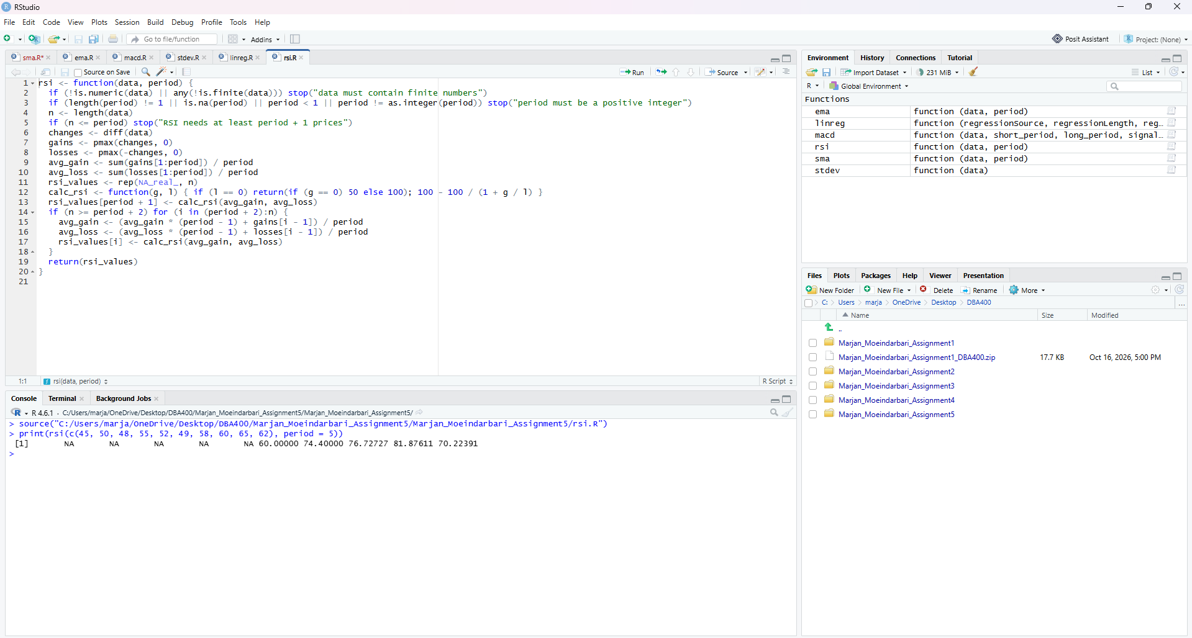

Stochastic RSI
stoch_rsi(data, period, k_period, d_period)
Normalizes available RSI values and smooths the normalized values using SMA to obtain K and D lines.
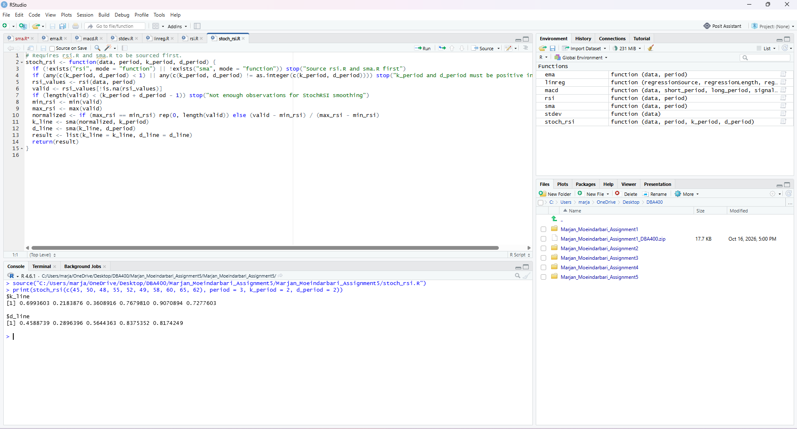

Crossover
crossover(arr1, arr2)
Identifies upward or downward crossings and returns Up, Down or None labels.
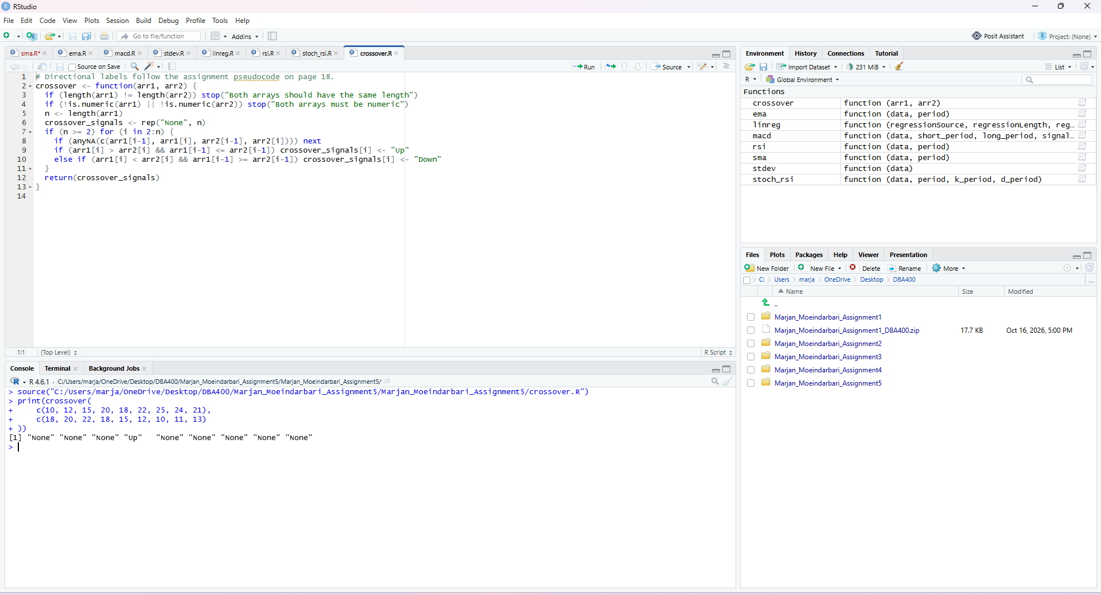

Crossunder
crossunder(arr1, arr2)
Returns a logical TRUE only where the first series crosses from at/above to below the second series.
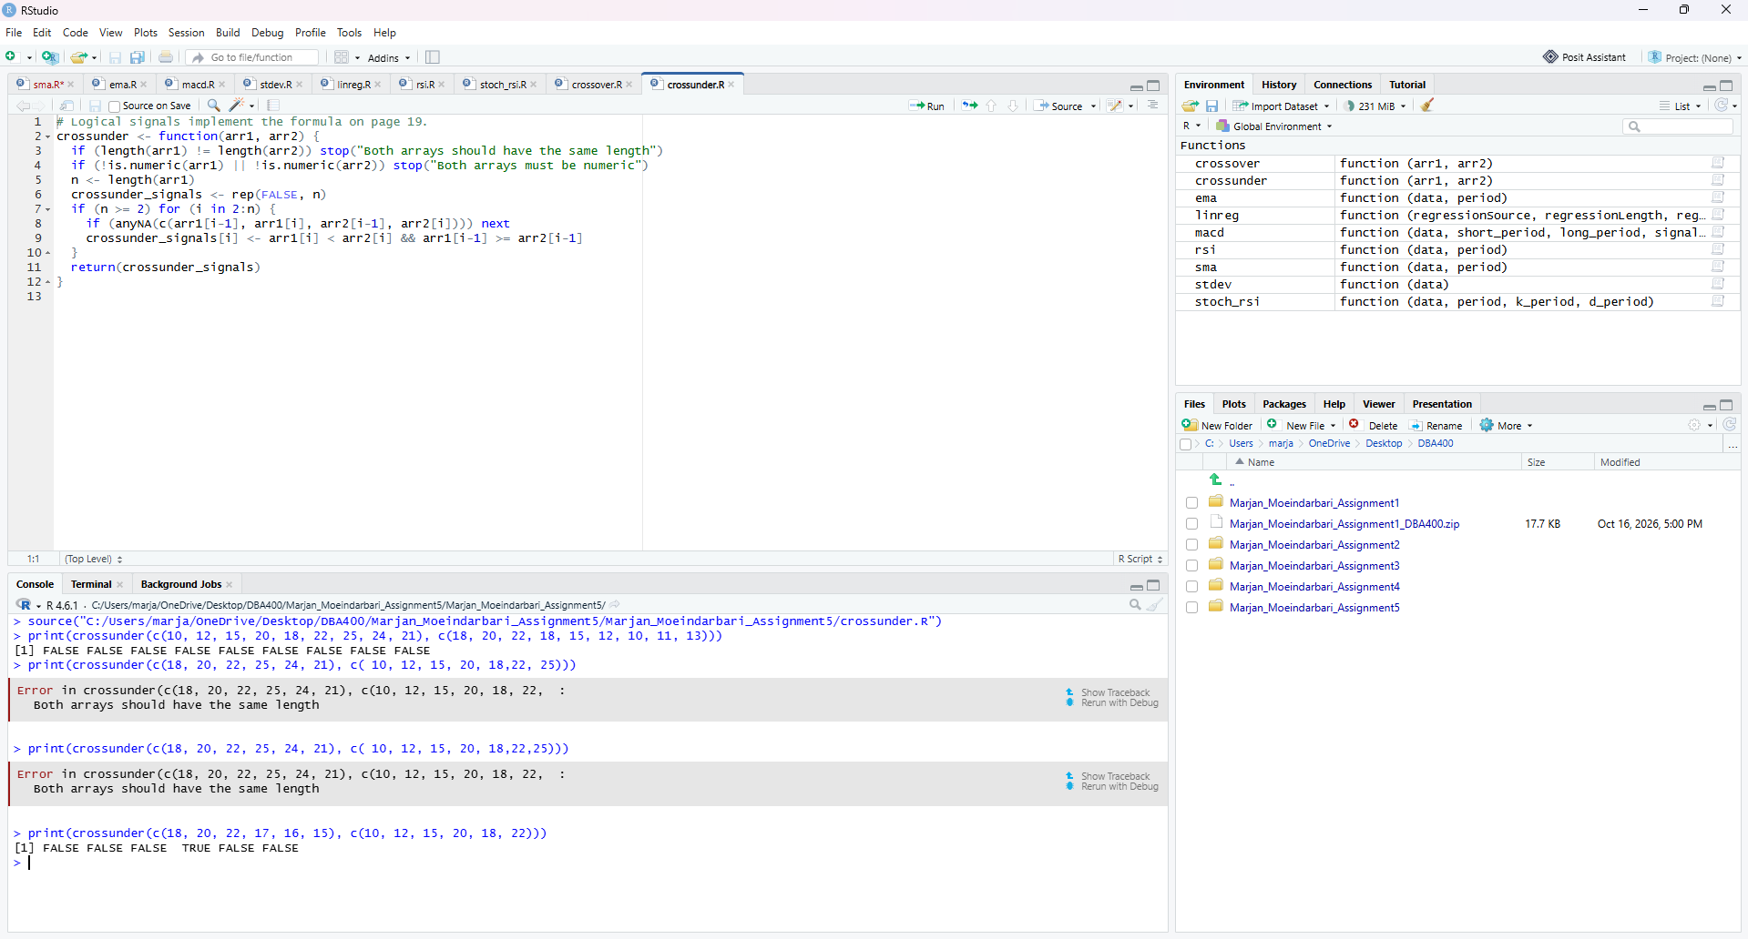

How to run
- Install R and RStudio on your computer.
- Download or clone the Assignment 5 GitHub repository.
- Open RStudio and navigate to the folder containing the R scripts.
- Open each R script and click Source to load the function.
- Load sma.R, ema.R, and rsi.R before running scripts that depend on these functions.
- Execute the functions using the sample data and parameters provided in the assignment.
- View the calculated results in the RStudio Console.
- Compare the outputs with the expected results to verify the functionality of each indicator.
- Run the provided test script, if included, to check the implementations together.
Note: All nine technical indicators were implemented using base R functions without additional technical analysis libraries.

