An apparent H&E imaging biomarker for HER2-low breast cancer reflects scanner batch, tumor grade, and immune context — not HER2: a cautionary analysis, with a cross-platform/cross-model audit of virtual multiplex-immunofluorescence specificity
Draft manuscript — v1 (2026-06-06). Cautionary-methods paper. All numbers are script-reproducible (see Data & Code Availability). Author list, affiliations, and target journal are placeholders pending the author’s decision.
Authors: [M. Pomarole; …; P. A. F. Galante] (placeholder) Affiliation: [Centro de Oncologia Molecular, Hospital Sírio-Libanês, São Paulo, Brazil] (placeholder)

Abstract
Background. HER2-low and HER2-ultralow breast cancer are now therapeutically actionable through trastuzumab-deruxtecan (T-DXd; DESTINY-Breast04 and -06), making the immunohistochemistry (IHC) 0 / 1+ / 2+ ordinal load-bearing — even though the 0-versus-1+ distinction is among the least reproducible calls in pathology. This has motivated deep-learning (DL) models that predict HER2-low status from routine H&E, and H&E→virtual multiplex-immunofluorescence (mIF) models that render interpretable “virtual immune” channels. We stress-test two claims: (1) that an H&E feature signal separating HER2-low from HER2-zero reflects tumor biology, and (2) that H&E→virtual-mIF channels are trustworthy, marker-specific cell-type readouts.
Methods. Using GigaTIME virtual-mIF predictions on a strict high-trust TCGA-BRCA cohort (171 slides; 53 HER2-positive / 57 HER2-low / 61 HER2-zero), we built HER2-low-versus-zero classifiers and benchmarked them against (i) acquisition-confound baselines (slide file size, TCGA source site) under leave-source-site-out validation, and (ii) two generic pathology foundation-model embeddings with no immune interpretation (H-Optimus-0, Virchow2). We sought external validation on the single-scanner BCNB cohort (127 HER2-zero / 654 HER2-low, with grade/ER/PR/Ki67/subtype). We then audited the specificity of the virtual channels directly: a within-slide correlation of each virtual channel against its own-gene spatial RNA, controlling for per-tile cellularity, across 9 breast sections spanning two spatial-transcriptomics platforms (Xenium, Visium) and two histologies (IDC, ILC). We repeated the entire specificity audit with a second, independent H&E→virtual-mIF model (ROSIE), and recomputed GigaTIME’s own virtual-versus-measured-mIF agreement on its released test patches.
Results. GigaTIME virtual immune/myeloid/checkpoint and cytokeratin channels separated HER2-low from HER2-zero (balanced accuracy [BA] 0.71), but the signal is most parsimoniously a confound: raw slide file size alone separated the groups better (BA 0.88) and remained portable under source-site holdout (0.88), whereas GigaTIME collapsed (0.71→0.62); two generic embeddings reproduced both the separation (H-Optimus-0 0.73, Virchow2 0.69; each beating a shuffled-label null at p=0.005) and the same source-site collapse (0.59, 0.55), showing the virtual-immune framing is unnecessary. On the single-scanner external cohort the signal survived but was modest (AUC ≈0.60–0.65), comparable to and partly explained by clinical covariates. Independent literature indicates HER2-low tumors are less often grade 3 and more immune-sparse than HER2-zero — real morphology visible on H&E, but not tumor-cell HER2. The virtual channels themselves were only weakly marker-specific: after cellularity control, only cytokeratin (epithelium) and the aggregate T-cell channels retained channel-specific RNA signal, while the macrophage (CD68), myeloid (CD14/CD16), checkpoint (PD-L1) and proliferation (Ki67) channels did not — and this specificity was tissue-variable across the 9 sections. A second model (ROSIE) showed the same overall ceiling yet disagreed with GigaTIME on which channels were reliable (per-measurement concordance Pearson r=0.12; 44/83 channel-specific calls differed), and GigaTIME’s own measured-mIF agreement did not predict RNA specificity.
Conclusions. An apparently biological H&E imaging biomarker for HER2-low disease is explained by scanner/acquisition batch plus tumor grade and immune context, not HER2 protein; and H&E→virtual-mIF channels behave as a broad tissue-compartment contrast rather than faithful per-marker stains. We recommend that H&E biomarker studies include generic-embedding controls and leave-source-site-out validation, prefer single-scanner external cohorts, and that virtual-mIF channels be validated against an independent modality before being used as quantitative cell-type readouts.

1. Introduction
Antibody–drug conjugates have redrawn the clinical meaning of HER2 status in breast cancer. Trastuzumab-deruxtecan benefits patients whose tumors are HER2-low (IHC 1+, or 2+/ISH-negative; DESTINY-Breast04) and even HER2-ultralow (DESTINY-Breast06), so the ordinal HER2 IHC scale — historically a positive/negative call — is now a therapeutically load-bearing 0 / ultralow / low / positive axis. The reproducibility of that axis, however, is poor precisely at the newly important boundary: concordance for the IHC 0-versus-1+ distinction is modest even among expert pathologists. This combination — high clinical stakes, low analytic reproducibility — has made HER2-low an attractive target for computational pathology, and weakly-supervised DL models predicting HER2-low status directly from H&E have been reported (e.g., Valieris et al., 2024).
In parallel, a class of H&E→virtual-mIF models (e.g., GigaTIME; ROSIE) predicts multiplex-immunofluorescence-like marker maps from H&E, offering biologically legible “virtual” immune, epithelial and checkpoint channels. Such channels are appealing as interpretable intermediates: rather than a black-box HER2 score, they promise to show which microenvironmental features drive a prediction.
Both directions carry a well-known but under-controlled risk. Histology DL models readily learn site- and scanner-specific acquisition signatures rather than biology, and in cohorts like TCGA the clinical labels of interest are often correlated with the contributing institution. And a virtual channel that agrees with its training modality (measured mIF) need not be specific to its nominal marker when tested against an independent modality.
Here we use HER2-low-versus-HER2-zero as a concrete case study to ask, rigorously, whether an apparent H&E biomarker is biology or confound, and whether virtual-mIF channels can be trusted as cell-type readouts. We deliberately adopt a replication-first, falsification-oriented stance: every positive result is benchmarked against an acquisition-confound baseline, a generic (non-interpretable) embedding, an external single-scanner cohort, and — for the virtual channels — an independent molecular modality and a second model.

2. Results

2.1 An apparent H&E signal separates HER2-low from HER2-zero, but not HER2-positive
Applying the published GigaTIME model (no retraining) to a strict high-trust TCGA-BRCA H&E cohort (171 slides: 53 HER2-positive, 57 HER2-low, 61 HER2-zero; female patients; label, file-integrity and slide-readability QC), virtual immune/myeloid/checkpoint and cytokeratin (CK) channels differed between HER2-low and HER2-zero, with HER2-low tumors showing lower virtual CD68, PD-L1, PD-1, CD11c, CD4, CD3 and CK signal than HER2-zero. A slide-level classifier reached BA 0.71 (macro AUC 0.74) for HER2-low versus HER2-zero and beat shuffled-label and nested-feature-selection nulls (empirical p≈0.01–0.03). Crucially, the same features did not classify HER2-positive status (BA ≈0.48; at chance), and bulk ERBB2 RNA — which strongly identifies HER2-positive tumors (AUC 0.905) — only weakly separated low from zero (AUC 0.605). The entire apparent biomarker is therefore a HER2-low-versus-zero morphology contrast, not HER2 detection.

2.2 The separation is explained by acquisition batch, and does not require the virtual-immune framing
HER2-low and HER2-zero slides in TCGA-BRCA are strongly imbalanced for slide file size and source site. Confound baselines outperformed the image model: slide-size covariates alone reached BA 0.888 (AUC 0.921) and remained portable under leave-source-site-out validation (0.882), whereas the GigaTIME classifier dropped from 0.710 to 0.617 when whole source sites were held out (Table 1). Adjusting for tissue composition (HER2-low slides carry a far higher fraction of low-marker tiles, 0.349 vs 0.180; q≈3×10⁻⁴) collapsed most per-channel effects.
We then asked whether the GigaTIME-specific virtual-immune interpretation is even necessary. Two generic pathology foundation-model embeddings with no marker meaning — H-Optimus-0 (1536-d) and Virchow2 (2560-d), each mean-pooled over the same 128 tiles/slide — reproduced the separation (BA 0.726 and 0.693; each beating its shuffled-label null at empirical p=0.005) and collapsed the same way under source-site holdout (to 0.586 and 0.551), while slide-size covariates stayed strong (0.882). Two independent, non-interpretable embeddings recovering the same signal and the same collapse show that the “virtual immune/myeloid/checkpoint” narrative is not required to explain the low-versus-zero axis: it is generic morphology tracking TCGA acquisition structure (Figure 2, Table 1).

2.3 A real but weak, non-HER2 morphology signal underlies the confound
The confound does not mean “nothing is there.” Independent literature indicates HER2-low tumors are less often grade 3 than HER2-zero (less aggressive morphology; Schettini/Tarantino-era series, e.g. Mod. Pathol. 2023) and that HER2-zero tumors may be more immune-infiltrated (higher TIL density; BMC Cancer 2025 — direction to be confirmed in full text). Both grade and immune density are visible on H&E and point in the same direction as the image signal. The honest interpretation is therefore a real morphology signal (grade + immune context) entangled with acquisition batch, but not tumor-cell HER2 protein.
To remove the batch confound by design, we sought a single-scanner external cohort (BCNB; iScan Coreo; 127 HER2-zero / 654 HER2-low, with grade, ER, PR, Ki67 and molecular subtype). The image signal survived but was modest: foundation-model patch classifiers reached BA ≈0.60 / AUC ≈0.64–0.65, statistically above shuffled-label nulls (p=0.005) yet comparable to clinical covariates (BA 0.643 / AUC 0.627), uneven across grade/receptor/subtype strata, and largely attenuated after adjusting for measured covariates and patch QC (residual AUC 0.660→0.592). A weak, covariate-entangled association — not a standalone HER2 classifier.

2.4 The virtual-mIF channels are only weakly marker-specific
If the virtual channels are to serve even as interpretive context, they must track their nominal markers. We tested this directly with a within-slide design immune to cross-patient batch: on tissue with paired H&E and spatial transcriptomics, we tiled the H&E, ran GigaTIME, and for each channel correlated its virtual activation against its own-gene transcript density across tiles, then computed a partial correlation controlling for total per-tile transcript density (cellularity). We ran this across 9 breast sections spanning two platforms and two histologies: two Xenium sections (Janesick et al. 2023), four independent HEST-1k Xenium IDC patients, and three HEST-1k Visium whole-transcriptome sections (two IDC, one ILC).
After cellularity control, channel-specific signal was the exception, not the rule (Figure 4). Aggregating across sections: the T-cell channels (CD3, CD8, CD4) were the most reproducible (CD3 and CD8 positive in 8/9 sections; mean partial r ≈0.16–0.20), followed by CK (epithelium), specific in only 6/9 tumors. In contrast, the macrophage channel CD68 was never channel-specific (0/9; mean −0.06; strongly negative in the Janesick sections), and the myeloid (CD14, CD16), checkpoint (PD-L1) and proliferation (Ki67) channels were likewise non-specific. Own-gene was the single most-correlated gene set for only 1–3 of 8–16 channels per section, and in two tumors (one Xenium patient and the ILC case) essentially no channel was specific. The virtual channels thus reflect a broad epithelial-versus-T-cell-infiltrate contrast that is itself tissue-variable, not faithful per-marker stains.
Consistent with this, we recomputed GigaTIME’s own virtual-versus-measured-mIF Pearson agreement on its released test patches (its exact 8×8-box metric, released model): channels at comparable mIF agreement (~0.5) spanned the full range of RNA specificity — PD-L1 (mIF 0.55) and CD68 (0.52) agreed well with measured mIF yet failed the RNA test (partial r −0.07, −0.33), while CK (0.53) held (+0.31) (Figure 6). Agreement with the training modality does not predict specificity against an independent one.

2.5 The specificity ceiling is a property of the approach, not one model
To test whether this is a GigaTIME idiosyncrasy or a property of H&E→virtual-mIF models generally, we ran a second, independent model — ROSIE (Wu et al., 2025; ConvNeXt, 50 markers) — through the identical RNA-specificity audit on the same 9 sections. ROSIE also showed only weak, tissue-variable specificity, with no consistently-specific channel on breast. Critically, the two models disagreed on which channels were trustworthy: per-measurement concordance of cellularity-controlled partial correlations was only Pearson r=0.12, and the binary “channel-specific” call differed for 44 of 83 channel×sample measurements. Only the T-cell channels (CD8, and CD4 where measured) were reliably shared; GigaTIME additionally recovered CD3/CD11c/CK, whereas ROSIE instead recovered CD14/CD68 (Figure 5). Because two independent models give different per-channel answers on the same tissue, no single model’s virtual channels can be trusted as quantitative cell-type readouts. (Both models are applied out-of-domain to breast — GigaTIME trained on lung, ROSIE on colorectal — a fair, like-for-like cross-organ comparison.)

3. Discussion
Across five independent lines of evidence, an apparently biological H&E imaging biomarker for HER2-low disease dissolves into confound: it is best explained by scanner/acquisition batch (slide size, source site), entangled with genuine but non-HER2 morphology (grade and immune context), and it does not require — and is not improved by — a virtual-immune interpretation. The two generic-embedding controls are the most decisive single result: a foundation-model embedding with no marker semantics reproduces the separation and its source-site collapse, so attributing the signal to “virtual immune biology” is unwarranted.
The specificity audit carries a broader methodological message. Virtual-mIF models are validated, by construction, as virtual-X versus measured-X mIF — but high agreement on that in-modality task does not imply that a channel is specific to its marker when tested against an independent modality. We find the channels behave as a coarse epithelium-versus-lymphocyte contrast; only cytokeratin and aggregate T-cell channels survive a cellularity-controlled, independent-modality test, and even those are tissue-variable. That two independent models disagree on which channels are reliable is the strongest version of the caution: the failure is a property of the H&E→virtual-mIF approach in this out-of-domain setting, not of one network. Virtual channels remain useful as interpretive overlays, but should not be read as quantitative cell-type measurements or used as load-bearing biological evidence.
These findings matter precisely because HER2-low is now actionable. As T-DXd extends to HER2-ultralow, pressure mounts to read the 0/low/ultralow axis off H&E. Our results argue that, at least in the data regimes most readily available (TCGA-style multi-site cohorts; cross-organ virtual-mIF), such readouts are dominated by acquisition and composition artifacts. A trustworthy quantitative HER2 measure for therapy selection will more likely come from a molecular assay than from morphology alone.
Recommendations for H&E-biomarker and virtual-mIF studies. (1) Benchmark every apparent biomarker against acquisition-confound baselines (slide size, source site) and a generic (non-interpretable) foundation-model embedding; if the embedding reproduces the signal, an interpretive narrative is not warranted. (2) Report leave-source-site-out (or leave-scanner-out) performance, not only random cross-validation. (3) Prefer single-scanner external cohorts with measured clinical covariates for validation. (4) Validate virtual-mIF channels against an independent modality (spatial RNA or, ideally, matched protein mIF) with a cellularity control, and report per-channel specificity rather than only global agreement. (5) Where possible, audit ≥2 models — cross-model disagreement is a direct readout of untrustworthiness.

4. Limitations
This is, in part, an internal analysis on TCGA, which cannot prove a signal is biologically meaningless — it shows the virtual-immune framing is not required and that the signal is acquisition-entangled; the external single-scanner cohort addresses this but at modest cohort size for HER2-zero. The literature on HER2-low grade/immune differences is directionally supportive but one immune-direction citation remains to be confirmed in full text. The RNA-specificity audit uses spatial RNA as a proxy for the protein the models predict, imposing a concordance ceiling; we mitigate this with within-RNA row-max tests and a cellularity control (both modality-internal), and the channel-specific (not uniform) pattern of failure cannot be produced by a uniform RNA–protein ceiling — but matched protein mIF would be the gold standard. Both virtual-mIF models are applied out-of-domain to breast; in-domain performance may be higher, though this does not affect the cross-model-disagreement conclusion. Finally, the recomputed GigaTIME mIF agreement uses the released sample test patches, which the authors note differ from (and are lower than) the paper’s full test set; we therefore use it only to demonstrate the agreement-versus-specificity dissociation, not to restate the paper’s reported values.

5. Methods
TCGA-BRCA cohort and HER2 labels. Diagnostic H&E slides, clinical HER2 IHC/ISH supplement fields, and STAR-count RNA were obtained from the GDC. HER2-positive/low/zero/unknown labels were assigned from IHC/ISH fields; analysis was restricted to female patients passing HER2-label-trust, file-integrity and OpenSlide-readability QC, yielding 171 strict high-trust slides (21,888 tile predictions at 128 tiles/slide).
Virtual-mIF prediction. The published GigaTIME model (prov-gigatime/GigaTIME) was applied without retraining to tissue tiles; per-channel activations were aggregated per slide. ROSIE (ericwu09/ROSIE, ConvNeXt-small, 50 markers) was applied identically for the specificity audit, with H&E patches resampled to ROSIE’s native ~0.3775 µm/px field (128-px input).
HER2-low-versus-zero classification and confound baselines. Regularized logistic regression on slide-level features under repeated stratified 5-fold CV (3 repeats) and leave-one-source-site-out validation; PCA fit inside each training fold. Comparators: slide-size covariates, source-site covariates, GigaTIME mean channels, and generic embeddings (H-Optimus-0 1536-d; Virchow2 2560-d), mean-pooled over the same 128 tiles/slide. Sanity: 200 shuffled-label permutations.
External cohort. BCNB (single iScan Coreo scanner; 1,058 patients; 127 HER2-zero / 654 HER2-low with grade/ER/PR/Ki67/subtype). Foundation-model patch embeddings (H-Optimus-0, Virchow2) with deterministic patch sampling; covariate, stratified, and score-driver analyses as above.
Within-slide RNA-specificity audit. On tissue with paired H&E + spatial transcriptomics, H&E was tiled (256 px); each virtual channel’s activation was correlated (within-slide Spearman) against its own-gene transcript density across tiles, with a partial correlation controlling for total per-tile transcript density and spatial block-bootstrap 95% CIs; a channel×gene-set matrix tested whether own-gene is the row maximum. Xenium transcripts were binned via HEST-provided H&E-pixel coordinates (he_x/he_y) or, for the Janesick sections, an inverse alignment affine; Visium spot counts were binned per spot with the analysis restricted to spot-occupied tiles. Cohort: 2 Janesick Xenium + 4 HEST-1k Xenium IDC patients + 3 HEST-1k Visium (2 IDC, 1 ILC). The same statistical core was applied to both models. Cross-model comparison: per-channel verdicts and per-measurement concordance over matched samples.
Recomputed GigaTIME mIF agreement. GigaTIME’s own virtual-versus-measured-mIF Pearson (its 8×8-box activation-count metric) was recomputed on its released 50-patch sample test set with the released model; gzipped-pickle masks were verified non-executing (pickletools) before loading.

6. Data and Code Availability
All analyses are script-reproducible in the project repository. Key scripts: run_gigatime_tcga_brca.py, run_hoptimus_tcga_brca.py, run_virchow2_tcga_brca.py, analyze_hoptimus_embedding_control.py, run_bcnb_patch_embeddings.py + analyze_bcnb_patch_*, validate_gigatime_xenium_rna.py, validate_gigatime_hest_rna.py (--model {gigatime,rosie}), run_rosie_inference.py, aggregate_hest_rna_validation.py, compare_gigatime_rosie.py, recompute_gigatime_mif_pearson.py, make_gigatime_vs_rna_specificity_figure.py. Per-run provenance: docs/RUN_REGISTRY.md. Public data: TCGA-BRCA (GDC); BCNB (bupt-ai-cz.github.io/BCNB); 10x Xenium Human Breast (Janesick et al. 2023); HEST-1k (MahmoodLab/hest). Models: GigaTIME (prov-gigatime/GigaTIME), ROSIE (ericwu09/ROSIE, CC-BY-NC), H-Optimus-0 (bioptimus/H-optimus-0), Virchow2 (paige-ai/Virchow2).

7. Figures and Tables
- Figure 1. Study design: the apparent biomarker and the four falsification tests (confound baselines, generic embeddings, external single-scanner cohort, independent-modality specificity audit + second model). docs/assets/manuscript/figure1_study_design.png
- Figure 2. HER2-low-vs-zero balanced accuracy: GigaTIME vs generic embeddings (H-Optimus-0, Virchow2) vs slide-size/source-site baselines, under repeated CV vs leave-source-site-out. docs/assets/clinical_her2_high_trust_tile128_hoptimus_embedding_control/embedding_control_balanced_accuracy.png
- Figure 3. External single-scanner (BCNB) performance and covariate attenuation across grade/receptor/subtype strata. docs/assets/bcnb_patch_score_covariate_drivers_* / ..._stratified_performance_*
- Figure 4. Cross-sample virtual-channel RNA specificity (cellularity-controlled partial r; 9 sections × 2 platforms). docs/assets/hest_rna_validation_summary/cross_sample_partial_r.png
- Figure 5. Two-model comparison (GigaTIME vs ROSIE) per channel × sample; the models disagree. docs/assets/gigatime_vs_rosie_field_level/gigatime_partial_r.png, ..._rosie_partial_r.png
- Figure 6. GigaTIME measured-mIF agreement (recomputed) vs independent RNA specificity: agreement does not predict specificity. docs/assets/gigatime_vs_rna_specificity/mif_agreement_vs_rna_specificity_scatter.png
- Table 1. HER2-low-vs-zero classifiers under repeated-CV vs leave-source-site-out (GigaTIME 0.710→0.617; H-Optimus-0 0.726→0.586; Virchow2 0.693→0.551; slide-size 0.888→0.882). Source: clinical_her2_high_trust_tile128_hoptimus_embedding_control.md.

8. References (bibliographic details to be verified before submission)
- Valieris R, et al. Weakly-supervised deep learning models enable HER2-low prediction from H&E stained slides. Breast Cancer Research 2024. PMC11331614.
- Valanarasu JMJ, et al. Multimodal AI generates virtual population for tumor microenvironment modeling (GigaTIME). Cell 2025. doi:10.1016/j.cell.2025.11.016.
- Wu E, et al. ROSIE: AI generation of multiplex immunofluorescence staining from histopathology images. Nature Communications 2025. doi:10.1038/s41467-025-62346-0.
- Modi S, et al. Trastuzumab deruxtecan in previously treated HER2-low advanced breast cancer (DESTINY-Breast04). N Engl J Med 2022.
- Bardia A, et al. Trastuzumab deruxtecan in HER2-low and HER2-ultralow advanced breast cancer (DESTINY-Breast06). 2024.
- Janesick A, et al. High resolution mapping of the tumor microenvironment using integrated single-cell, spatial and in situ analysis (10x Xenium Human Breast). 2023.
- Jaume G, et al. HEST-1k: a dataset for spatial transcriptomics and histology image analysis. NeurIPS 2024. arXiv:2406.16192.
- [HER2-low grade] Incidence and clinicopathologic features of HER2-low breast cancer. Mod Pathol 2023. PMID 36967073.
- [HER2 TILs] Clinical characteristics and prognostic impact of HER2-ultralow breast cancer and TILs. BMC Cancer 2025. PMID 41316049. (direction to confirm in full text)
- Filiot A, et al. H-Optimus-0 (Bioptimus); Zimmermann E, et al. Virchow2 (Paige) — pathology foundation models.
- Tarantino P, et al. HER2-low breast cancer: pathological and clinical landscape. J Clin Oncol 2020 (and consensus updates).

Generated as a working draft from the project’s committed results (PROJECT_SUMMARY.md, RUN_REGISTRY.md, the embedding-control / BCNB / HEST / ROSIE / mIF-recompute reports). Intended for author revision; verify all citations and fill author/affiliation/journal before submission.

Table 1 and Figures (rendered)
Table 1. HER2-low vs HER2-zero classification — balanced accuracy under repeated-CV and leave-source-site-out.
Feature set | Repeated-CV BA | Leave-source-site-out BA
Slide-size covariates | 0.888 | 0.882
H-Optimus-0 embedding | 0.726 | 0.586
Virchow2 embedding | 0.693 | 0.551
GigaTIME mean channels | 0.710 | 0.617
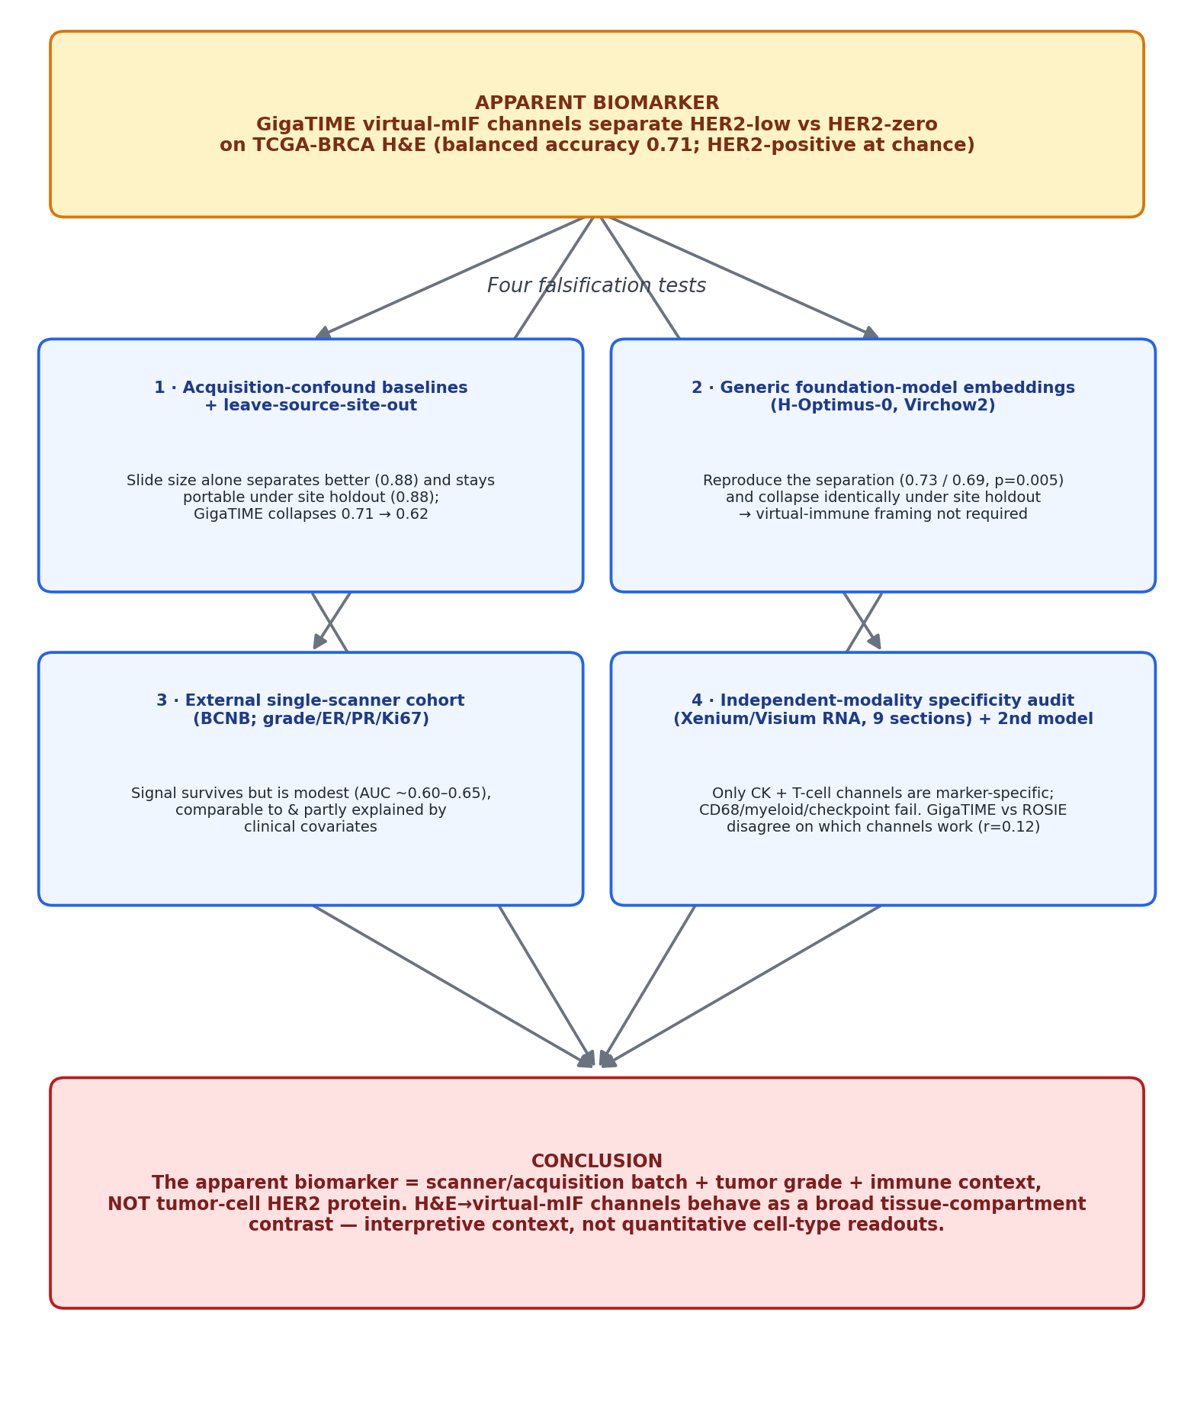
Figure 1. Study design: the apparent biomarker and the four falsification tests.
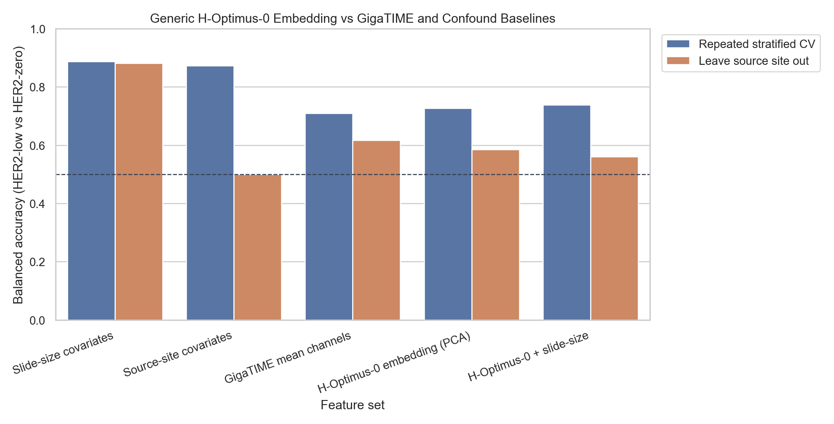
Figure 2. HER2-low-vs-zero balanced accuracy: GigaTIME vs generic embeddings (H-Optimus-0, Virchow2) vs slide-size/source-site baselines, under repeated CV vs leave-source-site-out.
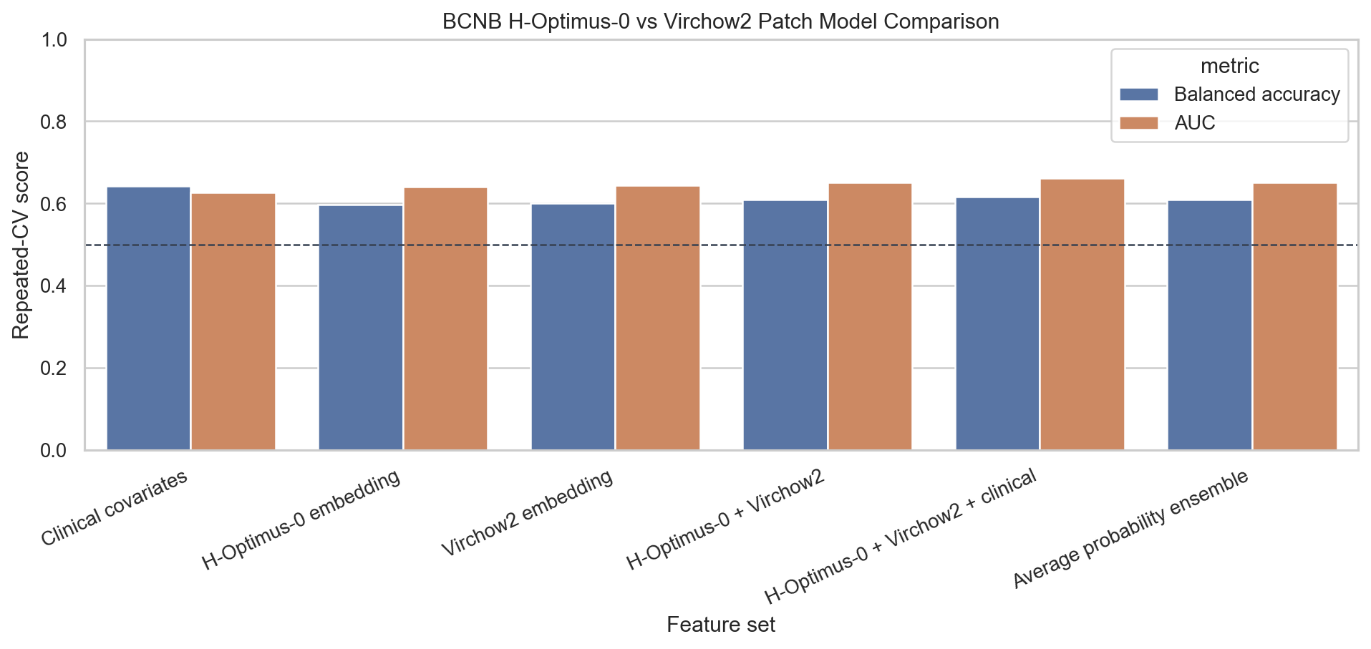
Figure 3. External single-scanner cohort (BCNB): two-model performance and concordance.
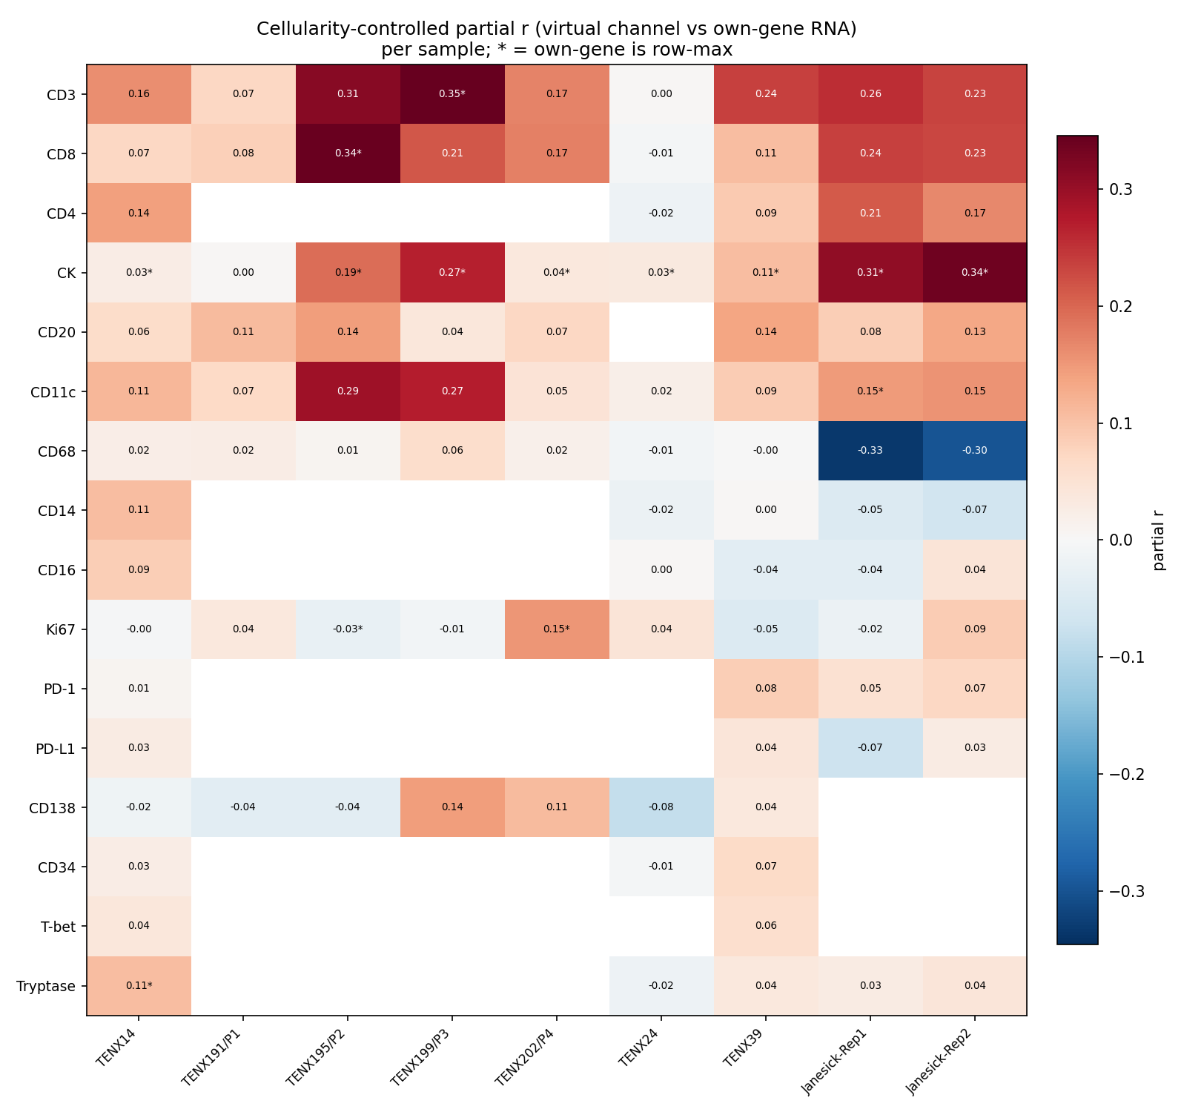
Figure 4. Cross-sample virtual-channel RNA specificity (cellularity-controlled partial r; 9 sections, 2 platforms).
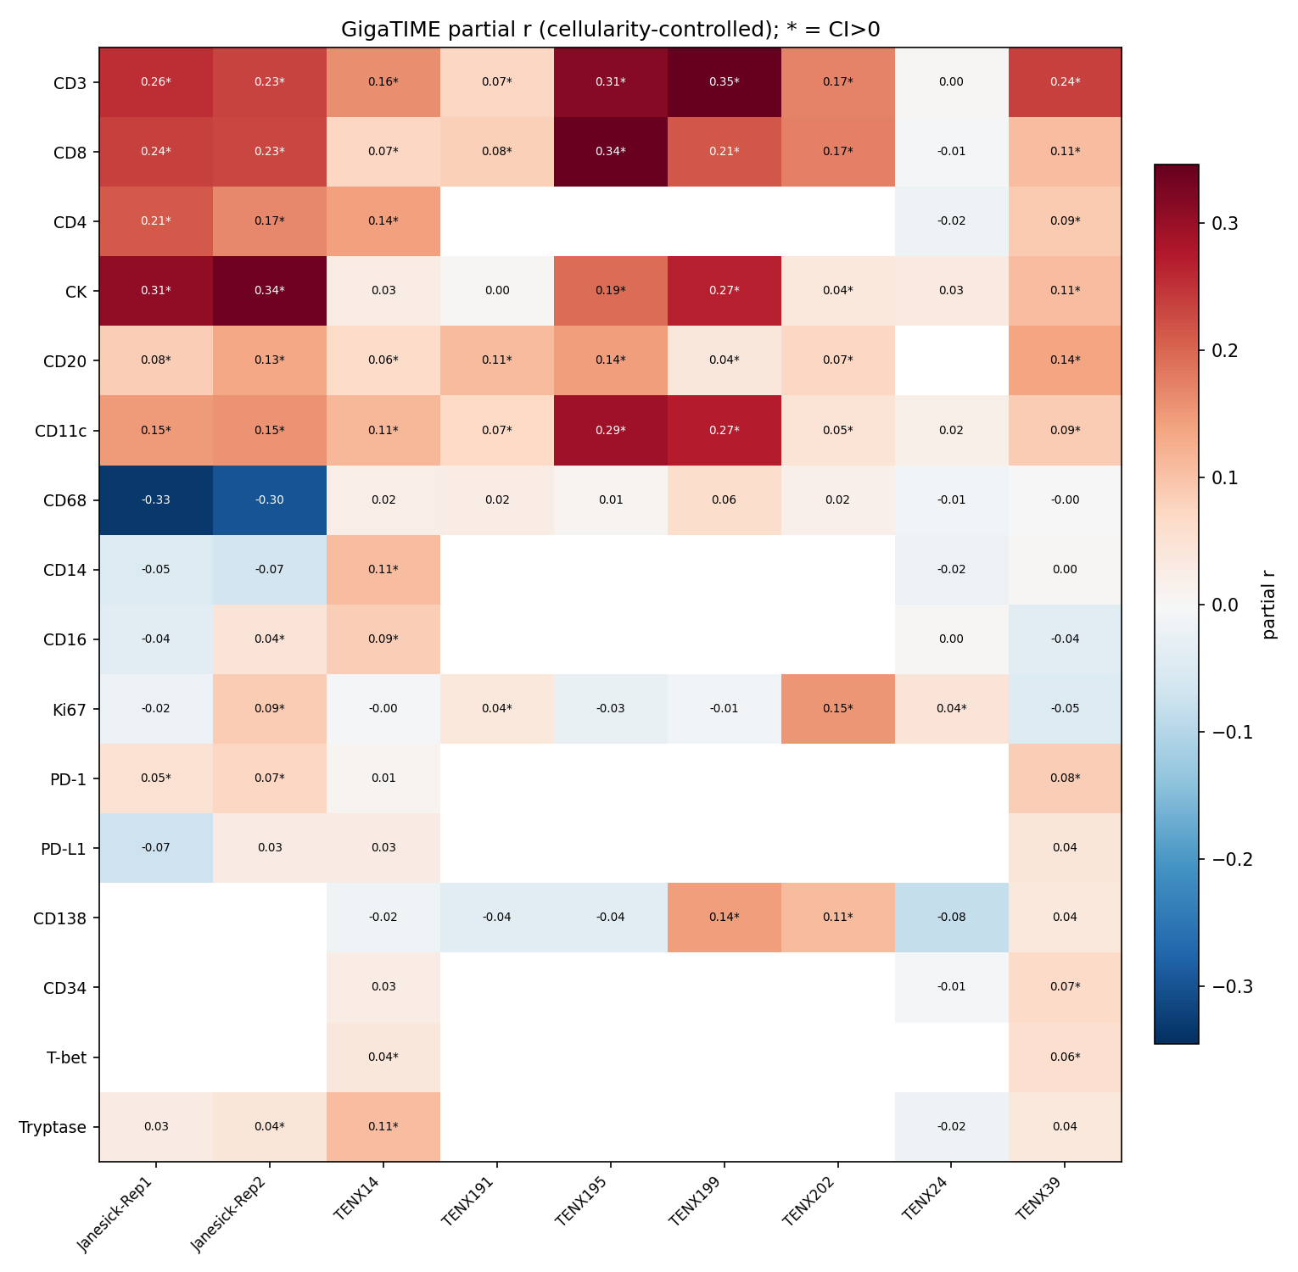
Figure 5a. GigaTIME per-channel RNA specificity across samples.
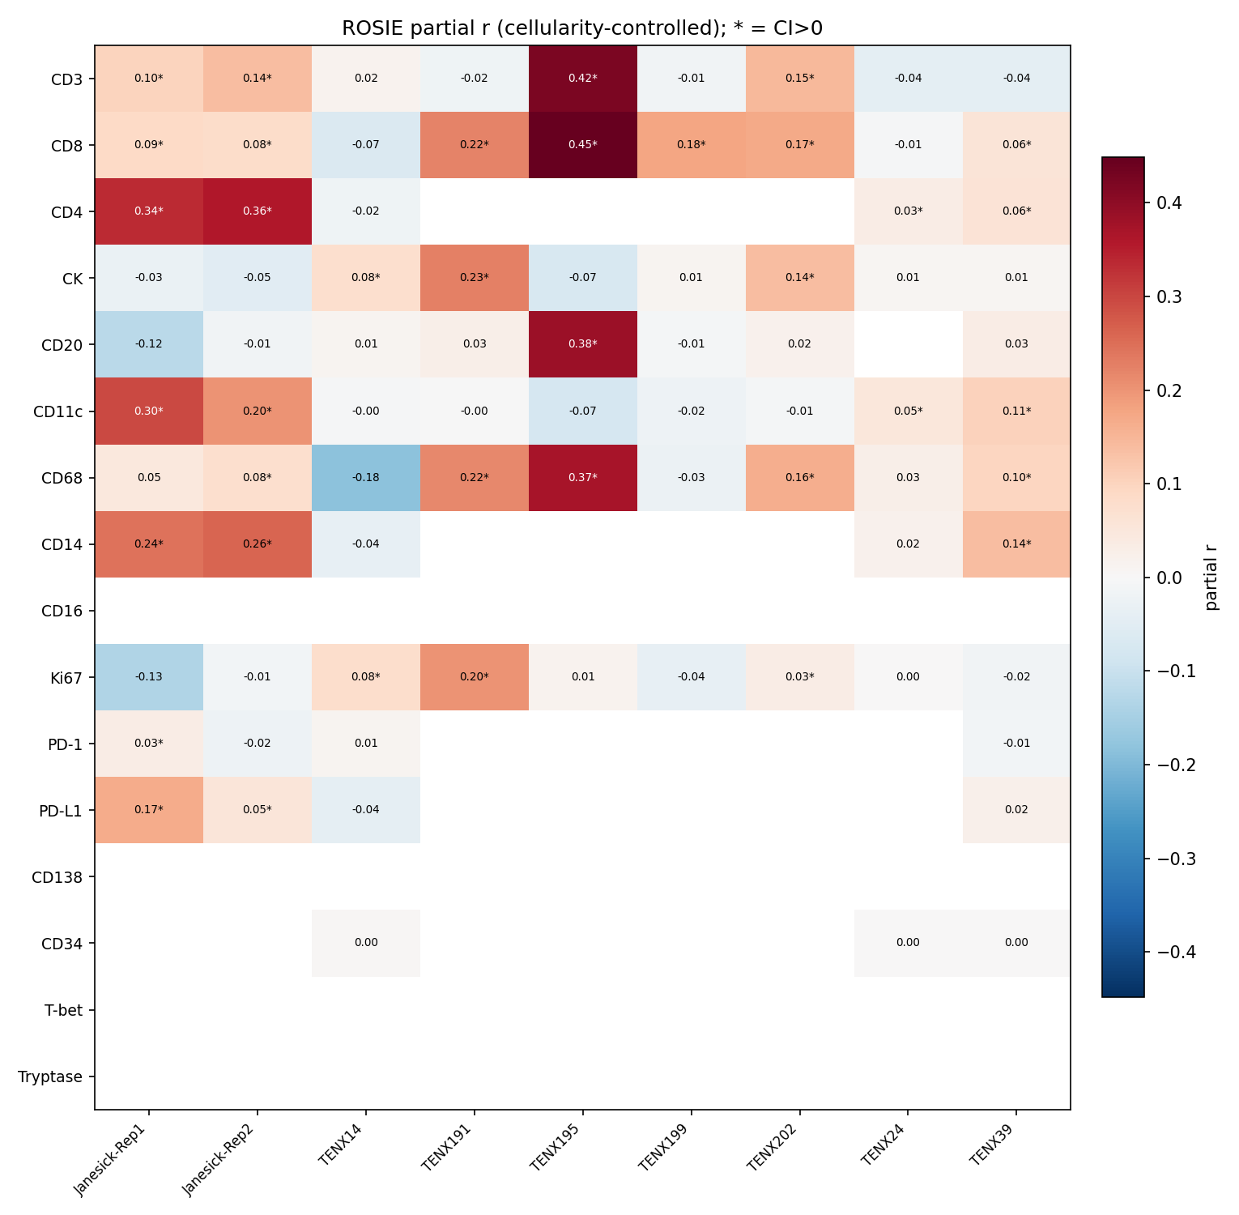
Figure 5b. ROSIE per-channel RNA specificity across samples — the two models disagree (concordance r=0.12).
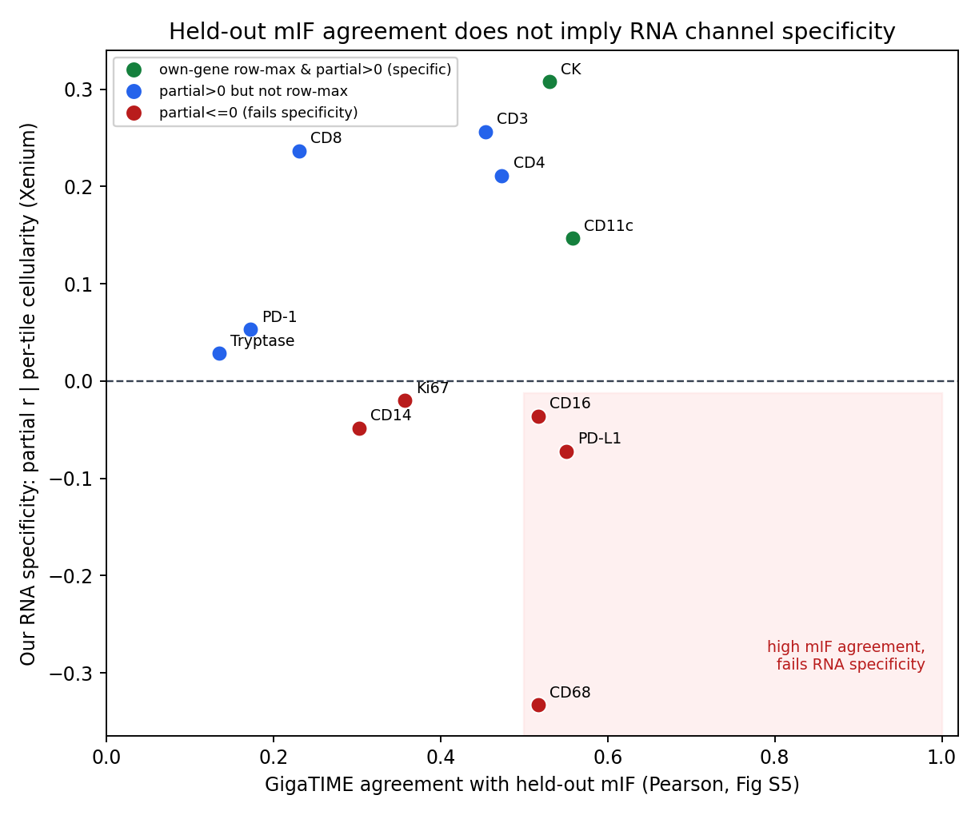
Figure 6. GigaTIME measured-mIF agreement (recomputed) vs independent RNA specificity: agreement does not predict specificity.

