SOW
[[project_name]]

Date: [[submission_date]]

Statement of Work:
Edit Name Here
This Statement of Work (SOW) has an effective date of [[start_date]] and describes the services to be performed by OPSOLUTIONS for [[client _name]].
Client: [[client_name]]
Project Name: [[project_name]]
Service Provider: OPSOLUTIONS
Prepared by: [[prepared_by]]
Noted by: [[noted_by]]

Table of Contents

Table of Contents 2
Introduction 3
Project Background 3
Project Objectives 3
Geographical Scope 4
Project Approach 4
General Specification 5
Development Team 5
Project Features 6
Requirements 7
1. Login 7
2. Forgot Password 7
3. Profile and Logout 8
Version Control 9
Timelines 10
Acceptance 11

Introduction

Project Background

This is the Project Background. Give a brief context. Describe the problem / opportunity. Mention stakeholders involved, initiators / requestors. Mention related / past work if any. This document describes the development and services done by OPSOLUTIONS in the completion of [[project_name]].

Project Objectives

This project aims to:
[[#objectives]]
[[list_index]]. [[detail]]
[[/objectives]]

Geographical Scope
Scope of Work will only cover project support for the following countries:
[[#countries]]
- [[detail]]
[[/countries]]

Project Approach
The team will be using the Scrum Agile approach. Please refer to the figure below. OPSOLUTIONS is using scrum methodology for managing software delivery. Scrum is a methodology used by the organization to break down requirements into manageable chunks by collaborating and communicating both with the people who are doing the work and the people who need the work done.

Scrum Agile Approach diagram:
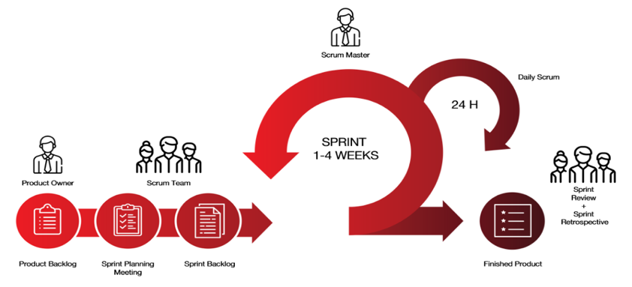
Scrum Project Management Activities:
- Sprint Planning Meeting – This is where the scrum team discusses the work that will be done per sprint. The product backlog is being created containing the level of priorities of each task.
- Daily Scrum or Daily Stand-up – This occurs every day wherein the team gathers to discuss what they have done yesterday, what they are currently working on and what is their next task.
- Sprint Review – At the end of every sprint, the scrum team discusses what they have and have not accomplished during the sprint.
- Sprint Demo – This is where the completed product backlog items are demonstrated with the goal of promoting an information discussion between the Scrum Team and Sprint Review participants.
- Sprint Retrospective – This is where the team gathers and discusses what they have learned, the challenges they have experienced, and the things that they should work on to improve their next sprint.
- Backlog Refinement – This is where the team discusses the list of items and tasks that aim to be covered by the next sprint.

For monitoring tasks, issues, and bugs, OPSOLUTIONS is using Atlassian Jira. It is software used for bug and issue tracking. For this MVP, OPSOLUTIONS will be using JIRA to monitor and track all the development deliverables of the project.

General Specification
[[project_name]] will be available for [[#isPlatformDesktop]]Desktop[[/isPlatformDesktop]] [[#isBothPlatform]] and [[/isBothPlatform]][[#isPlatformMobile]]Mobile phones [[/isPlatformMobile]]. [[specification]]
Here are some of the supported/targeted specifications:

[[#isPlatformDesktop]]
Desktop
Operating System | Browser
Windows 10 + | Google Chrome
macOS | Mozilla Firefox
 | Safari
[[/isPlatformDesktop]]

[[#isPlatformMobile]]
Mobile
Operating System | Layout Supported
Android | Mobile
iOS | Tablet
[[/isPlatformMobile]]

Development Team

- Software Delivery Manager
- Business Technology Consultant
- Technical Lead
- Mobile App Developer
- API Developer
- UI/UX Designer

Project Features

Platforms:
[[#applicationPlatformRequirements]]
- [[name]]
[[/applicationPlatformRequirements]]

[[#applicationPlatformRequirements]]

Platform | Features
[[name]] | [[#features]]  [[feature_index]]. [[feature_name]]  [[/features]]
[[/applicationPlatformRequirements]]

Requirements

[[#applicationPlatformRequirements]]
[[application_platform_index]].[[name]]

[[#features]]
Description | [[description]]
Objective | [[feature_obj]]
[[application_platform_index]].[[feature_index]]. Requirements | [[feature_name]] feature
Acceptance Criteria | [[#acceptance_criteria]]  [[list_index]]. [[detail]]  [[/acceptance_criteria]]

[[/features]]
[[/applicationPlatformRequirements]]

Version Control

Version | Date | Author | Change Status
1.0 | [Date Created] |  | Initial Version

Team Workdays and Costing

Project Team Components | Number of Resources | Working Days Required | Amount
Project Manager | 1
API Developers | 1
Web Developers | 1
Mobile Developer | 1
Technical Lead | 1
Quality Assurance | 1
Business Analyst | 1
UI / UX | 1

Timelines

No. | Improvement / Task | Development Story Points | Testing Story Points
[[#applicationPlatformRequirements]][[#features]][[application_platform_index]].[[feature_index]] | [[feature_name]] feature | [[dev_story_points]] | [[test_story_points]] [[/features]]  [[/applicationPlatformRequirements]]
TOTAL STORY POINTS: |  | [[total_dev_story_points]] | [[total_test_story_points]]

Sprint Events | Dates
Development Dates
Testing Dates
Beta/ UAT Release
Production Release

Acceptance

I accept and approve this Statement of Work for the development of [[project_name]].
Note: This Statement of Work covers only the specified requirements above. Should there be additional requirements required by [[client_name]] which is not part of the Approved Statement of Work, OPSOLUTIONS shall conduct an assessment and evaluation of the effort involved in developing these newly specified requirements and evaluate the impact to the project timeline.

Accepted by:
Name | Designation | Signature | Date

Prepared by:

[[prepared_by]]
OPSOLUTIONS – [[prepared_by_position]]

Noted by:
[[noted_by]]
OPSOLUTIONS – [[noted_by_position]]

