**Web Development 2 – Assignment**

**Name:** Mark Barrett

**StudentID:** C15409432

**List of the PHP pages used in this assignment:**

Throughout my assignment I used classes. The reason for this is because I have prior knowledge to PHP and felt that using classes would make the assignment more efficient and easier to follow and write.

* **register.php :** This is a basic HTML form that allows a user to enter their information and register to use the library system. Once the information is entered, it is checked to make sure it is suitable before it is entered into the database. I.e the username has not been used before, the password confirmation is correct and the mobile number is no longer than 7 digits long.
* **login.php :** This page is a simple HTML form. It allows the user to enter their username and password. The form POST’s the resulting information back to the login.php page. Once it has done so, the PHP user class checks the entered information against the database to make sure that the user entered the correct information. If they have it redirects them to the home page and sets a session variable with the users’ name. Each page that must require a user to login has an authenticate method that is found in the User class. This checks to see if the session variable has been set and if it has then it allows access, else it redirects to the login page.
* **home.php :** This page is the main page of the library system. It displays all books on the right hand side and a navigation bar on the left.
* **search.php :** This page has a HTML form that allows the user to search for books. They can search in every category or in a particular category. When they enter a query to search, it will search for that query both in the author’s column and the book column. The results are then displayed.
* **reserve.php :** This page shows all the books that are available for reservation. Beside each book is a link the user can click to reserve that particular book. Once they click it the reservation will be recorded and the book will be set to taken. They will then be prompted with a confirmation message, saying what book they borrowed and it’s details.
* **view.php :** This page displays all the books that a particular user has borrowed. It lists when they borrowed it and the rest of the books details. It also gives the option to delete the reservation and thus making the book available again.
* **logout.php :** A link to this page is given on every other page as an option to logout. When you click it, it will destroy the current session and redirect the user to the login page.

**Listing of Source Files:**

* classes
  + User.php
  + Books.php
* css
  + style.css
* logout.php
* login.php
* register.php
* footer.php
* header.php
* home.php
* menu.php
* search.php
* reserve.php
* view.php

**Screenshots:**

**login.php**

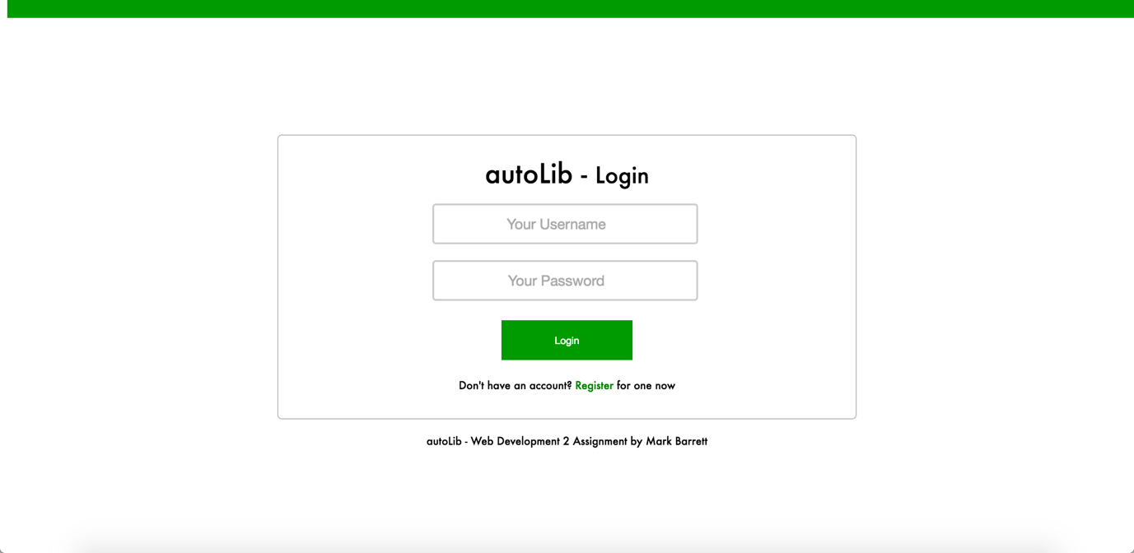

**register.php**

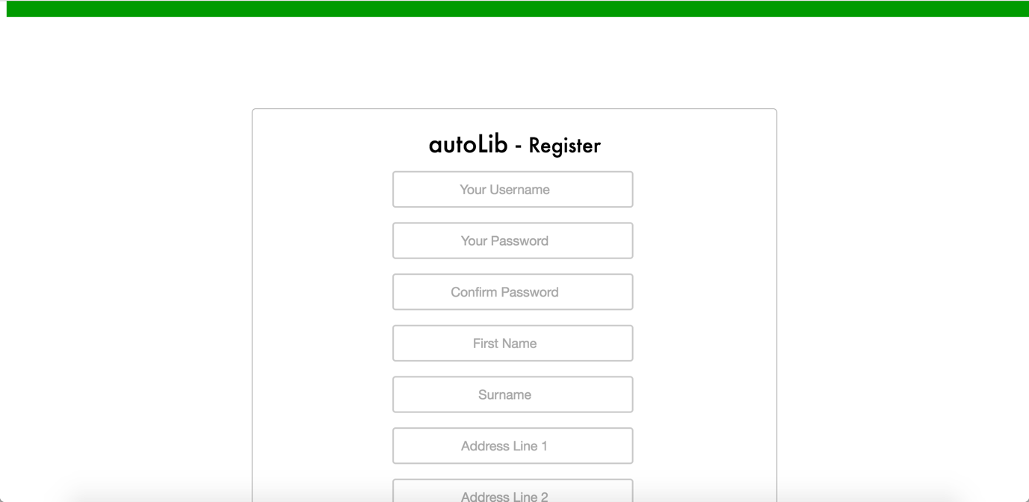

**home.php**

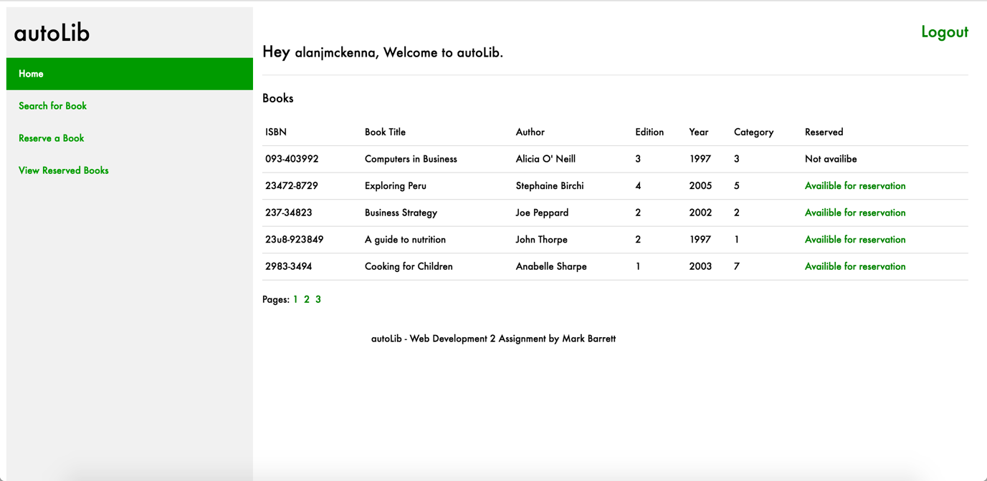

**search.php**

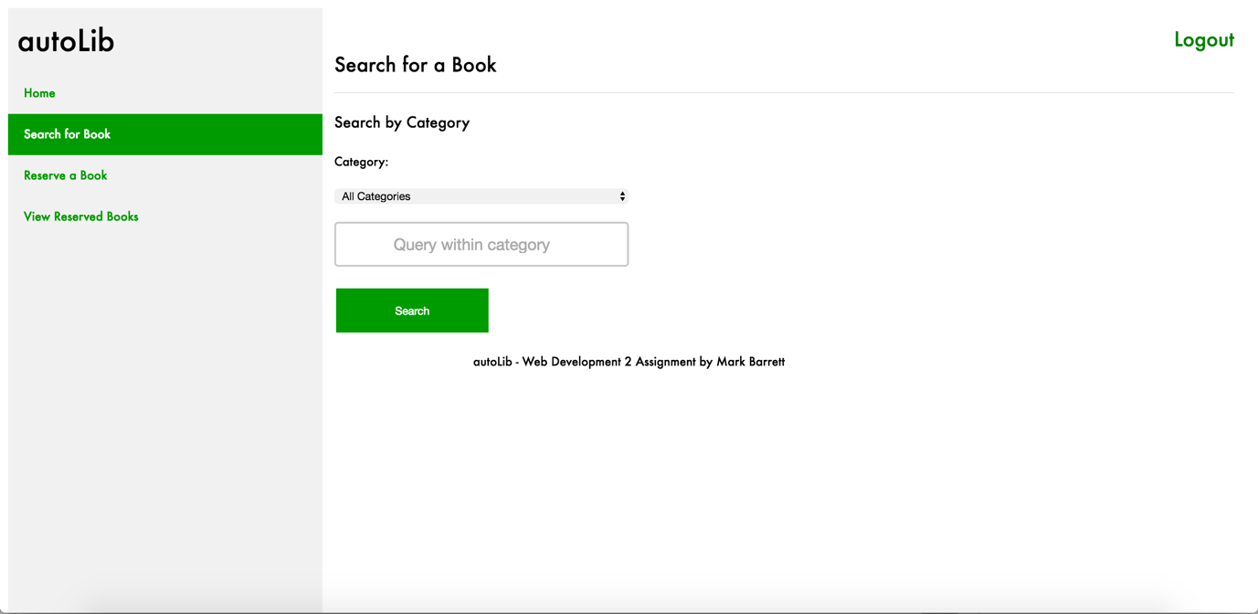

**search.php (When something was searched)**

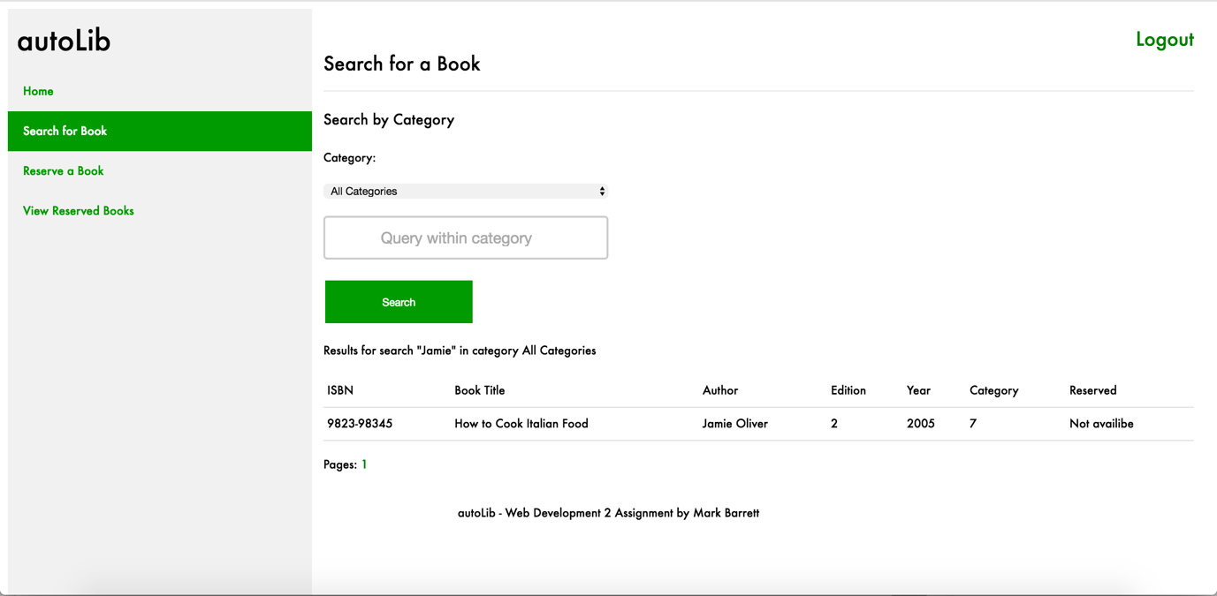

**reserve.php**

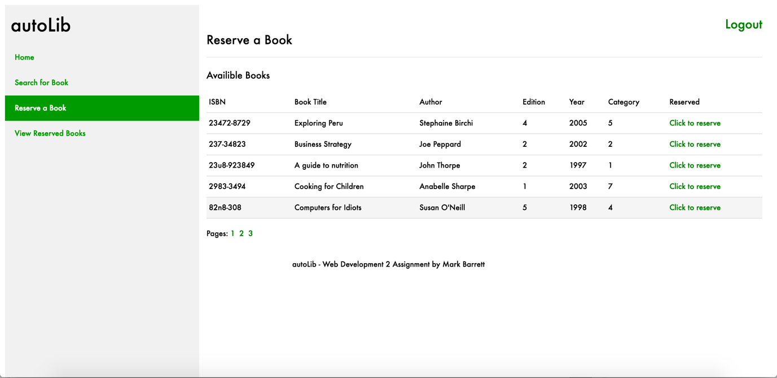

**view.php**

