Hey folks,

Today I decided to take a look at how poorly ESPN predicts our fantasy football games.

In terms of overall wins and losses, ESPN has a 50% accuracy rate. It has predicted seven games correctly, and seven games incorrectly. This is, of course, no better than chance.

Now I would like to compare projected scores to actual scores. We have 14 teams that have played 2 games each, so there are 28 data points. I’ve plotted actual scores as a function of projected scores below:

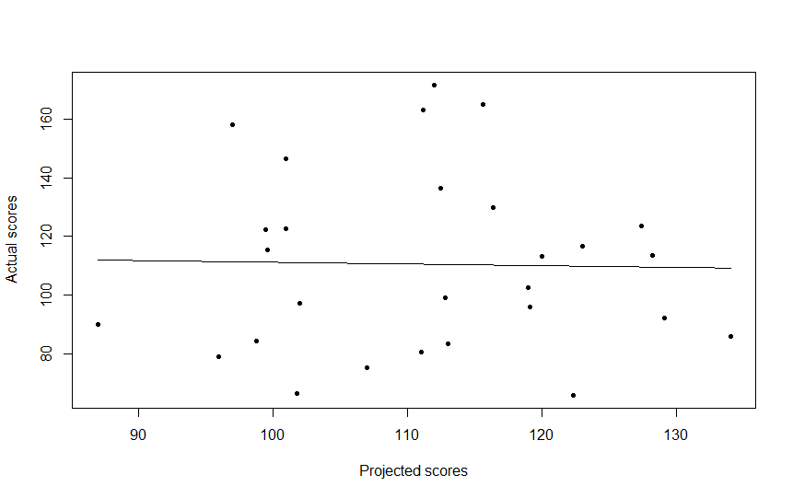

As you can see, projected scores do a very poor job of predicting actual scores. Overall, projected scores predict 0.05% of the variance. It’s garbage, in other words.

I think I’ve figured out why it’s so bad. These projected scores are generated in the worst way possible. Let me explain.

Every fantasy football league has its own particular rules. Yards and touchdowns may be worth different points to different leagues. Let me illustrate how that is handled with an example. This is roughly how ESPN creates Tony Romo’s projected score:

Step one: Predict running yards, passing yards, and touchdown potential separately for Romo. The crucial point here is that everything is predicted separately.

Step two: Multiply each prediction by the relevant number of points. For instance, in our league, we would multiply Romo’s predicted running yards by 0.2 (or whatever).

Step three: Add up everything from step two. This sum is Romo’s predicted fantasy points.

In this way, ESPN can create projected scores for any league, no matter how goofy the scoring rules.

The problem with this approach is that you’re literally introducing error at every possible point. You have to predict everything that could give Romo fantasy points. Each of these predictions has some amount of error. When you add the predictions up, the error is included. So you’re compounding the error by predicting these things separately. It would be much better to just predict fantasy points overall. ESPN would have to do this for each league, since each league has its own rules. But they’ve got all their old data from 2012; they could easily use that to predict fantasy points for leagues with goofy rules. I think that’s more than possible, given that ESPN is a multi-billion dollar corporation.

The worst part of this is, in any league, touchdowns will invariably net you the most points. So you’re giving the touchdown predictions a lot of weight in your projected points. But touchdowns are the hardest thing to predict statistically, since they have much less variability than, say, running yards. So the projected points’ accuracy most heavily relies on touchdowns, which we understand the least.

The final problem is that, so far, I’ve been talking about projected points for PLAYERS. For whole teams, the error is even more compounded, since, again, the projected team score is the sum of a bunch of terms that have error in them.

In short, ESPN’s projected scores are dogshit. They will remain dogshit until a lot of work is done. It’s possible that they could be improved, but with so few fantasy-relevant games in the season, they might always be dogshit.

Of course, I’m only going off two games here. Maybe my estimation of their abilities will improve as the season continues.