
SurvAIve PH
An AI-Powered Offline Mesh Communication and Victim Rescue Coordination System for Disaster-Prone Communities
COMPLETE USER MANUAL
For Victims / Community Users, Field Responders, Response Agencies,
and LGU Administrators
Version 1.0
Documented build: SurvAIve PH v3 (Web Application and Android App)

Document Information and Version History
Table 1. Document information
Item | Details
Document title | SurvAIve PH Complete User Manual
System | SurvAIve PH: An AI-Powered Offline Mesh Communication and Victim Rescue Coordination System for Disaster-Prone Communities
System version documented | SurvAIve PH v3 (web application served by Vite, Supabase online back end, XAMPP PHP/MySQL offline fallback, Capacitor Android app)
Document version | 1.0
Date | October 13, 2026
Intended readers | Community users and victims, field responders, response agency personnel (MDRRMO, Hospital/Ambulance, BFP, PNP, PCG), LGU (municipal) administrators, project evaluators
Basis of content | Inspection of the source code and live testing of the running application. All screenshots were captured from the actual application on October 12–13, 2026 using clearly labelled TEST records.
File location | SurvAIve_PH_Complete_User_Manual.docx (project root); screenshots in the User_Manual_Screenshots folder

Table 2. Version history
Version | Date | Description of changes | Prepared by
1.0 | Oct 13, 2026 | Initial release. Covers all four user roles (Victim / Community User, Field Responder, Response Agency and LGU Administrator), the emergency reporting workflow, offline behaviour, troubleshooting and known limitations. | SurvAIve PH Project Team

NOTE — How to update the table of contents
If page numbers in the table of contents look out of date after editing, right-click the table of contents in Microsoft Word and choose Update Field → Update entire table.

Table of Contents
Document Information and Version History 2
Table of Contents 3
1. Introduction 6
2. Purpose and Scope of the Manual 7
2.1 Purpose 7
2.2 Scope 7
2.3 What this manual does not cover 7
2.4 Conventions used in this manual 7
3. System Overview 8
3.1 User roles 8
3.2 Role access matrix 8
3.3 How the system is connected 9
3.4 About the "AI" features 9
4. System Requirements 10
5. Accessing the Application 11
5.1 Web application 11
5.2 Android application 11
5.3 The landing page 11
6. Login, Logout, and Authentication 13
6.1 Staff Sign-In (Responder, Agency, Admin) 13
6.2 Victim sign-in, registration and guest access 15
6.3 Signing out 16
6.4 How authentication works online and offline 16
7. General Navigation and Interface Overview 17
7.1 Mobile screens (Victim and Field Responder) 17
7.2 Desktop dashboards (Agency and Admin) 17
7.3 New SOS alerts on dashboards 18
7.4 Light and dark appearance 19
8. Victim / Community User Guide 20
8.1 Register a Verified Profile (Sign Up) 20
8.2 Sign In with Your Profile 22
8.3 Continue as Guest 23
8.4 The Home Screen 26
8.5 Submit an SOS Emergency Report 26
8.6 Photo Mode (Simulated Scene Analysis) 28
8.7 After Sending: the Confirmation Screen 29
8.8 Monitor Your Report and Rescue Status 30
8.9 View Your Location and Evacuation Centers 31
8.10 Victim Settings 32
9. Field Responder User Guide 34
9.1 Responder Dashboard 34
9.2 View the Victim Queue 35
9.3 Review Victim Information and Update Rescue Status 36
9.4 Submit Field Notes and Record the Outcome 37
9.5 Field Map 38
9.6 Mesh Relay Node 39
9.7 Responder Settings 40
10. Response Agency User Guide 42
10.1 Shared functions and agency-specific behaviour 42
10.2 Sign In and Select Your Municipality 42
10.3 Agency Command Center and Emergency Alerts 42
10.4 Manage Victim Status 43
10.5 Emergency Reports and AI Situational Analytics 44
10.6 Agency Settings 45
11. LGU Administrator User Guide 47
11.1 Command Center 47
11.2 Monitor Incoming Emergencies (Alerts) 47
11.3 Victim Status (Affected Person Status) 47
11.4 Rescue Updates and Responder Zones 48
11.5 Constituents Registry 49
11.6 Evacuation Centers 51
11.7 Emergency Report, Barangays Comparison and SITREP 52
11.8 AI Situational Analytics 54
11.9 User Management (Admins, Agencies and Responders) 55
11.10 Audit Logs 59
11.11 Admin Settings 60
11.12 Sign Out Securely 61
12. Emergency Reporting and Rescue Workflow 62
13. Victim Status Definitions and Updates 63
13.1 Situation reported by the victim 63
13.2 Rescue status 63
13.3 Priority levels and the AI Priority Score 63
13.4 Constituent status (Constituents registry) 64
14. Offline Mode, Connectivity, and Data Synchronization 65
14.1 How to tell whether you are online or offline 65
14.2 What works without internet 65
14.3 How mesh communication works (Android app) 66
14.4 Synchronization after connectivity returns 67
14.5 If information looks outdated 67
15. Account Settings and Password Management 68
15.1 Change Display Name and Password (or PIN) 68
15.2 Emergency alert settings (Admin and Agency) 69
15.3 Forgotten password or PIN 69
16. Notifications, Reports, Analytics, and Audit Logs 70
17. Security, Privacy, and Responsible System Use 71
17.1 For all users 71
17.2 For staff 71
18. Troubleshooting and Frequently Asked Questions 72
18.1 Troubleshooting guide 72
18.2 Frequently asked questions 73
19. Glossary of Terms 75
20. Support and Contact Information 76
20.1 Reporting a problem 76
21. Appendix 77
Appendix A. Role Permission Summary 77
Appendix B. Known Limitations and Unavailable Features 77
Appendix C. Features That Could Not Be Verified for This Manual 78
Appendix D. Sample (TEST) Data Used in Screenshots 78
Appendix E. Screenshot Index 79

1. Introduction
SurvAIve PH is an emergency reporting and rescue coordination system designed for typhoon-prone and geographically isolated communities in the Philippines. It lets residents send an SOS (an emergency request for help) from a phone, and lets local government units (LGUs), response agencies and field responders see, prioritise and act on those requests.
The system has three main parts:
- A mobile-friendly application for community users (victims). Residents can register a verified profile or send an SOS as a guest, share their GPS location, choose the emergency services they need, and see nearby evacuation centers.
- A field application for responders. Rescue teams see a prioritised queue of SOS reports in their municipality, view victim details and locations on a map, and record rescue progress (En Route, On Scene, Rescued, Cannot Reach).
- Web dashboards for administrators and agencies. LGU administrators and response agencies monitor incoming emergencies, manage records and staff accounts, generate situation reports and review analytics and audit logs.
When there is no internet, the Android version of the app can pass SOS messages from phone to phone over Bluetooth Low Energy (BLE) and Wi-Fi Direct. This is called a mesh network. The app can also fall back to a local server (XAMPP) running on an administrator's computer or hotspot. Chapter 14 explains exactly what works offline and what does not.
IMPORTANT — SurvAIve PH supports, but does not replace, official emergency channels
Sending an SOS does not automatically dispatch a rescue team. Authorized personnel must review the report and act on it.
Mesh relaying depends on nearby phones running the Android app and is not guaranteed to deliver a message.
If you can reach emergency hotlines (for example 911) or your barangay officials by other means, do so as well.

2. Purpose and Scope of the Manual

2.1 Purpose
This manual explains, step by step and with real screenshots, how each type of user operates SurvAIve PH as it is currently built. It is intended for training, system demonstrations, academic evaluation and pilot deployment.

2.2 Scope
- All four user roles implemented in the source code: Victim / Community User (with Guest mode), Field Responder, Response Agency and LGU Administrator.
- Sign-in, navigation, SOS reporting, rescue status updates, dashboards, reports, analytics, staff management, audit logs and settings.
- Offline operation, local server fallback, mesh communication and synchronization, including their limitations.
- Troubleshooting, frequently asked questions, glossary and a list of known limitations.

2.3 What this manual does not cover
- Installing, building or deploying the software (see the separate SurvAIve PH v3 Deployment Guide).
- Database administration and Supabase project configuration.
- Developer-only tools such as the /dev role selector page.

2.4 Conventions used in this manual
Table 3. Conventions
Convention | Meaning
Bold text | A button, menu item, tab or field label exactly as it appears on screen, e.g. Send Emergency SOS.
Orange numbered markers | Numbered circles and boxes on screenshots. Procedure steps refer to them as "marker 1", "marker 2", and so on.
NOTE | Helpful extra information.
IMPORTANT | Information you must read to avoid mistakes or delays.
LIMITATION | A feature that is incomplete, simulated or behaves differently from what its label suggests. These were confirmed by source-code review or testing.
TEST data | All names, phone numbers and reports beginning with "TEST" in the screenshots are sample records created for this manual. Other personal data in screenshots has been blurred.

3. System Overview

3.1 User roles
Table 4. User roles in SurvAIve PH
Role | Who it is for | Main tasks | How they sign in
Victim / Community User | Residents of the municipality | Register a profile, send SOS reports, view evacuation centers, view mesh status | Victim ID + 6-digit PIN, or Continue as Guest
Field Responder | Rescue team members in the field | View victim queue, open rescue details, update rescue status, submit field notes, act as a mesh relay | Staff sign-in: contact number + password
Response Agency | MDRRMO, Hospital/Ambulance, BFP, PNP, PCG personnel | Monitor SOS reports that requested their service, mark victims rescued, generate reports, view analytics | Staff sign-in: contact number + password
LGU Administrator (Admin) | Municipal Administrator | Run the Command Center, manage victims, constituents, evacuation centers, user accounts (admins, agencies and responders), reports and audit logs | Staff sign-in: contact number + password

3.2 Role access matrix
The table below shows which modules each role can open. Access is enforced by role guards in the application: if a user opens a page that is not allowed for their role, they are sent back to the landing page.
Table 5. Role access matrix (verified against the application routes)
Module | Victim | Responder | Agency | Admin
Send SOS report | ✔ | — | — | —
Local map and evacuation centers (mobile) | ✔ | ✔ (Field Map) | — | —
Mesh status / Mesh relay screen | ✔ | ✔ | — | —
Victim queue and Rescue Detail (status updates) | — | ✔ | — | —
Command Center (live map and stats) | — | — | ✔ (own service) | ✔
Victim Status table | — | — | ✔ (own service) | ✔
Rescue Updates | — | — | — | ✔
Constituents registry | — | — | — | ✔
Evacuation Centers management | — | — | — | ✔
Emergency Report | — | — | ✔ | ✔
Barangays Comparison | — | — | — | ✔
SITREP | — | — | — | ✔
AI Situational Analytics | — | — | ✔ | ✔
User Management | — | — | — | ✔ (admins, agencies, responders)
Audit Logs | — | — | — | ✔
Settings, display name and password | ✔ (PIN) | ✔ | ✔ | ✔

3.3 How the system is connected
- Online (normal operation): the apps read and write data in a cloud database (Supabase). Dashboards receive new SOS reports in near real time.
- Offline with a local server: when a phone has no internet, the app sends supported requests (SOS reports, sign-in, evacuation centers, responder data) to a local XAMPP server, for example a laptop connected to a Wi-Fi hotspot. The default address is 192.168.43.1 and can be changed in Settings → Local Server (XAMPP).
- Offline mesh (Android app only): phones running the Android app pass SOS messages to each other using Bluetooth Low Energy and Wi-Fi Direct, for up to 5 hops.

3.4 About the "AI" features
Several screens use the word "AI". To set correct expectations:
- AI Priority Score (0–99) is calculated by fixed rules in the app, based on the victim's situation, number of people, age group, special conditions, verification and how long the report has waited. It is not a trained machine-learning model.
- AI Situational Analytics and the Spam / False Report Indicator are rule-based summaries of the report data.
- Photo Mode ("Analyze Scene with YOLO11") estimates the scene from the photo's colours and brightness on the device. It is a simulation, not a real object-detection model, and the photo itself is not uploaded.
- None of these features make operational decisions automatically. People decide who to rescue and when.

4. System Requirements
Table 6. System requirements
Component | Requirement
Web browser (all roles) | Current version of Google Chrome or Microsoft Edge. Dashboards are designed for a desktop or laptop screen (1280 × 720 or larger). Victim and responder screens are designed for phone-sized screens.
Android phone (mesh features) | Android 7.0 (API 24) or later with Bluetooth Low Energy. Bluetooth, Location and Wi-Fi must be turned on and the app must be given Bluetooth, Location, Nearby Devices and Notification permissions.
Internet connection | Required for normal online operation, live dashboards, maps (OpenStreetMap tiles) and Audit Logs.
GPS / location | Recommended for SOS reports so responders can see where you are. The browser or phone will ask for permission.
Local server (optional, for offline operation) | A computer running XAMPP (Apache + MySQL) with the SurvAIve PH back end, reachable on the local network or hotspot (default 192.168.43.1).
Accounts | Victims register themselves. Staff accounts (admins, agencies and responders) are created by an LGU Admin in User Management. The first LGU Admin account is set up when the system is deployed (see the Deployment Guide).

5. Accessing the Application

5.1 Web application
Open the SurvAIve PH web address provided by your LGU in Chrome or Edge. In the local test installation used for this manual, the address is http://localhost:5173. The application uses addresses with a "#" sign, for example:
Table 7. Main entry addresses
Page | Address (append to the site address)
Landing page (community users) | /#/
Staff sign-in (responder, agency, admin) | /#/staff-login
Victim sign-in with profile | /#/login
Victim registration | /#/signup
Guest SOS | /#/guest

5.2 Android application
The project can produce three Android builds. All of them use the app ID ph.survaive.app, so only one can be installed on a phone at a time.
Table 8. Android builds
Build | Contents | Mesh receive and forward
Combined app (cap:app) | All roles, same screens as the web application | Yes. Received SOS messages are acknowledged, forwarded to the server when online, and shown as alerts and notifications.
Victim app (cap:victim) | Victim screens only | Sends via mesh; the background receive-and-forward service is not started in this build.
Responder app (cap:responder) | Staff sign-in and responder screens only | The background receive-and-forward service is not started in this build.

NOTE
On first launch the Android app asks you to turn on Bluetooth and Wi-Fi and to allow the required permissions. A permanent notification "SurvAIve Mesh Active — Emergency mesh relay is running" shows that the mesh service is running.

5.3 The landing page
Community users start at the landing page. Staff users tap Authorized Personnel Login at the bottom of this page, or open /#/staff-login directly.
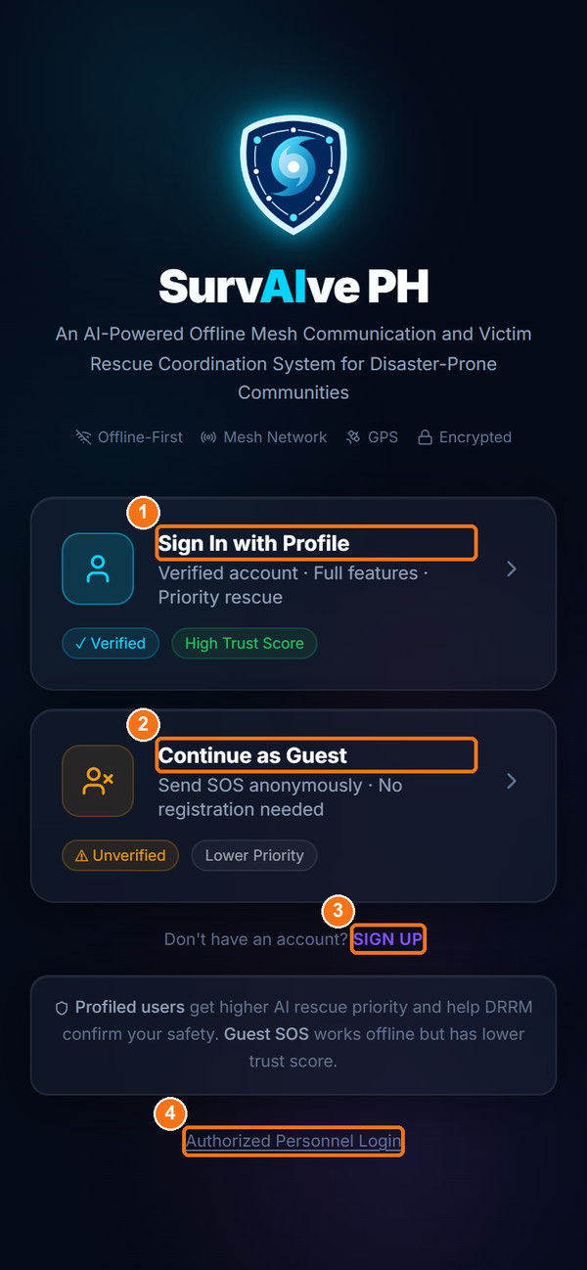
Figure 1. SurvAIve PH landing page
Marker | Control | What it does
1 | Sign In with Profile | Sign in with your Victim ID and PIN (verified user, higher priority).
2 | Continue as Guest | Send an SOS without registering (unverified, lower priority).
3 | SIGN UP | Create a verified community profile.
4 | Authorized Personnel Login | Opens the staff sign-in page for responders, agencies and admins.

6. Login, Logout, and Authentication
SurvAIve PH has two sign-in methods: a Victim ID + PIN for community users, and contact number + password for all staff roles. Community users can also skip sign-in by using Guest mode.

6.1 Staff Sign-In (Responder, Agency, Admin)
Purpose: Sign in to the dashboard for your staff role and choose the jurisdiction whose data you will see.
Who Can Use It: Field Responders, Response Agency personnel and LGU Administrators.
Prerequisites: An active staff account created by an administrator, your registered contact number and password, and an internet connection (or a reachable local server, see 6.4).
Procedure:
- Open the staff sign-in page (/#/staff-login), or tap Authorized Personnel Login on the landing page.
- Under Select Your Role to Continue, tap your role: Field Responder, Response Agency or Admin (Figure 2, left, marker 1 shows Field Responder).
- Under Your Jurisdiction, choose your province in Select Province (Figure 2, right, marker 1) and your municipality in Select Municipality (marker 2). All staff roles must choose both.
- Enter your 11-digit Contact Number in the format 09XXXXXXXXX (marker 3).
- Enter your Password (marker 4). Tap the eye icon to show or hide it.
- Tap Sign In (marker 5). The button shows "Signing in…" while it works.
- Confirm that your dashboard opens: the Responder Dashboard, or the agency or LGU Command Center.
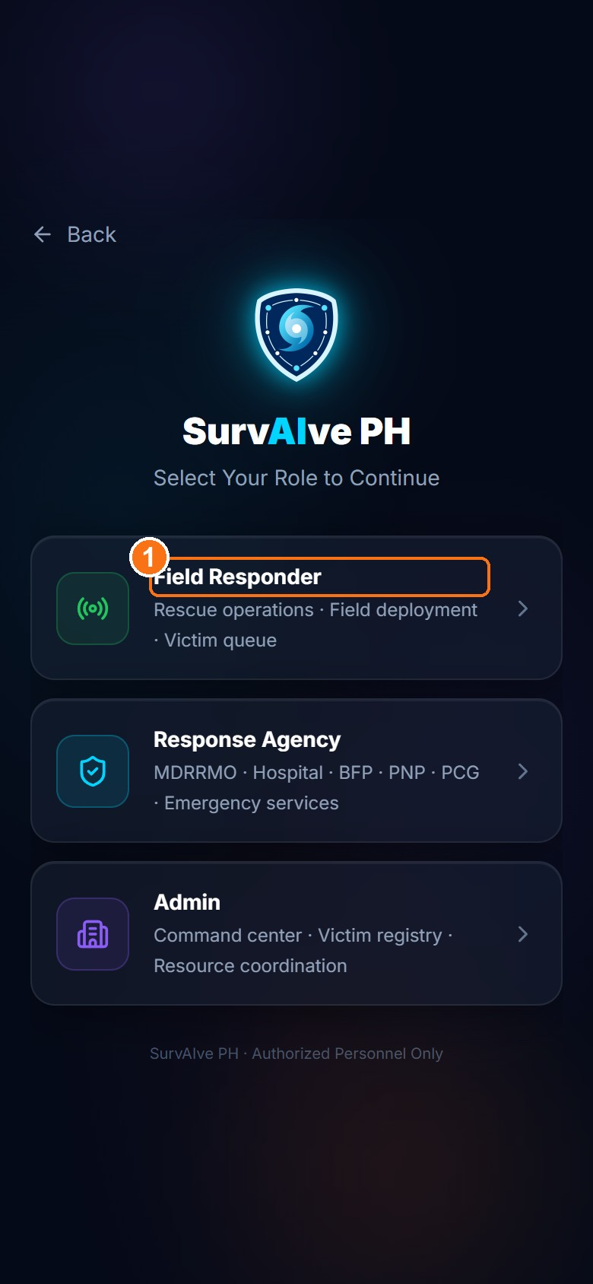  Step 1: choose role | 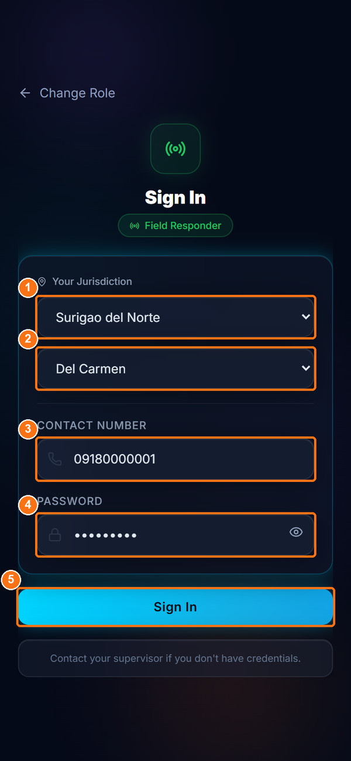  Step 2: jurisdiction and credentials
Figure 2. Staff sign-in: role selection (left) and jurisdiction and credentials (right)
Expected Result: The dashboard for your role opens and shows data for the municipality you selected.
Important Notes:
- The municipality you choose controls which records you see. The app does not check it against the municipality stored on your account, so always choose your own assigned municipality.
- Opening the staff sign-in page signs out any session that is already active on that browser.
- Tap Change Role to go back to the role list. Tap Back on the role list to return to the landing page.
- If you do not have credentials, contact your supervisor or LGU administrator. Admin, agency and responder accounts are all created by an LGU Admin in User Management (Section 11.9).

Sign-in error messages
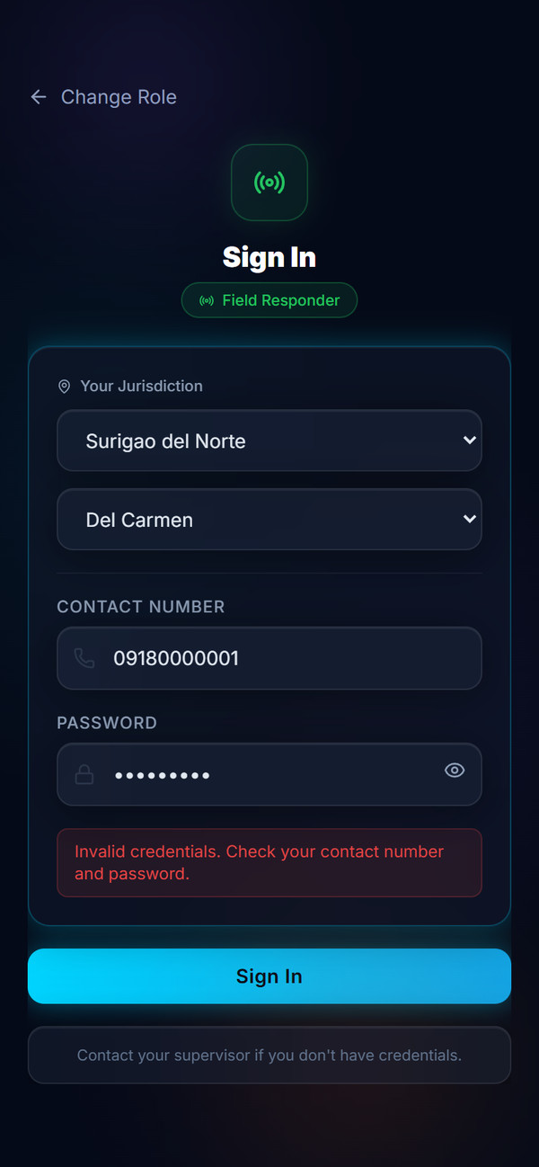
Figure 3. Example of a sign-in error ("Invalid credentials")
Table 9. Staff sign-in messages
Message shown | Meaning
Please fill in all fields | Contact number or password is empty.
Please select your province / Please select your municipality | A required jurisdiction field was not chosen.
Invalid credentials. Check your contact number and password. | The contact number or password is wrong, or the account belongs to a different role than the one you picked.
Account not fully set up. Contact your administrator. | The login account exists but its profile record is incomplete.
Your account has been disabled. Contact your administrator. | A responder account has been set to Inactive.

6.2 Victim sign-in, registration and guest access
Community users can register a verified profile (Section 8.1), sign in with their Victim ID and PIN (Section 8.2) or send an SOS as a guest (Section 8.3). These procedures are described in the Victim / Community User Guide.

6.3 Signing out
Table 10. Sign-out locations
Role | Where to sign out
Victim | Settings tab → scroll to the bottom → Sign Out. Guests see Exit Guest Mode instead.
Field Responder | Settings tab → scroll to the bottom → Sign Out.
Agency, Admin | Sign Out at the bottom of the left sidebar, below Settings.

IMPORTANT — Shared or public computers
Always sign out after using a shared computer. Your session is remembered in the browser until you sign out.

6.4 How authentication works online and offline
- Staff, online: the app checks your contact number and password against the cloud account service (Supabase).
- Staff, offline: the app checks your credentials against the local XAMPP server. This only works after you have signed in online at least once, because a successful online sign-in copies your credentials to the local server.
- Staff, already signed in and offline: opening the staff sign-in page takes you straight back to your dashboard, so that a cached session is not lost during an outage.
- Victims: the Victim ID and PIN are first checked on the phone itself, so a registered victim can sign in without internet on the device they registered with. The offline sign-in remains valid for 30 days.

7. General Navigation and Interface Overview

7.1 Mobile screens (Victim and Field Responder)
Victim and responder screens are designed for phones. A navigation bar at the bottom of the screen gives one-tap access to the main pages. The highlighted icon shows the current page.
Table 11. Mobile navigation bars
Victim bottom bar | Opens | Responder bottom bar | Opens
Home | Home screen with the SOS button and status chips | Home | Responder Dashboard
SOS | Send SOS Report form | Queue | Victim Queue
Map | My Location & Evacuation Centers | Map | Field Map
Mesh | Mesh Network Status | Relay | Mesh Relay Node
Settings | Settings and sign-out | Settings | Responder Settings and sign-out

7.2 Desktop dashboards (Agency and Admin)
Agency and admin pages use a left sidebar. The top of the sidebar shows the role (for example "LGU Admin" or the agency type, such as "MDRRMO"), your name and your jurisdiction. The page title appears in the top bar; a green Live indicator shows that the page receives real-time updates.
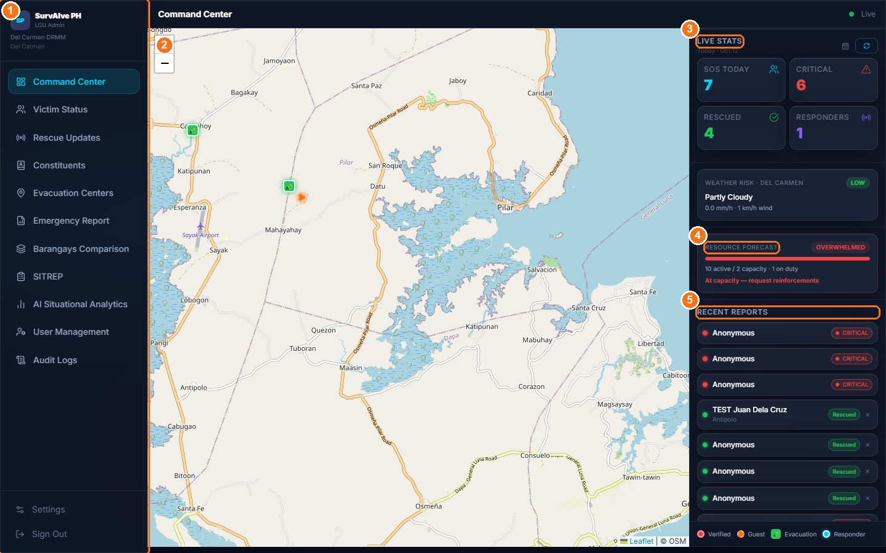
Figure 4. LGU Admin dashboard layout: sidebar (1), map (2), Live Stats (3), Resource Forecast (4) and Recent Reports (5)
Table 12. Sidebar menus by role
Sidebar (LGU Admin) | Sidebar (Response Agency)
Command Center | Command Center
Victim Status | Victim Status
Rescue Updates | Emergency Reports
Constituents | AI Situational Analytics
Evacuation Centers
Emergency Report
Barangays Comparison
SITREP
AI Situational Analytics
User Management
Audit Logs
Settings · Sign Out (bottom) | Settings · Sign Out (bottom)

7.3 New SOS alerts on dashboards
On every Admin and Agency page, a new SOS report triggers an alert card in the top-right corner titled NEW SOS ALERT, a red screen pulse and a repeating alarm sound. A badge in the sidebar shows the number of active alerts.
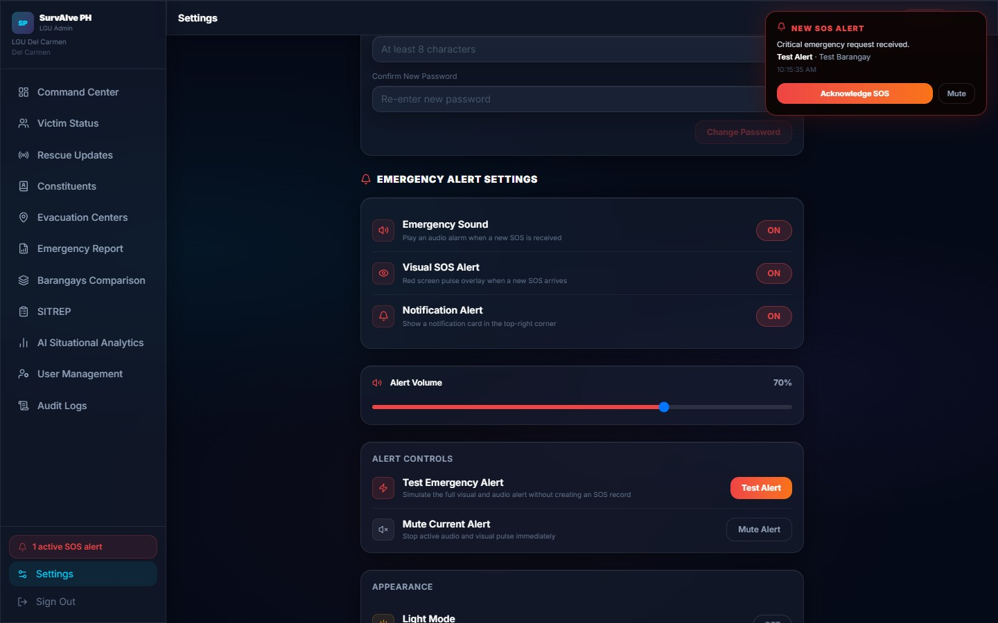
Figure 5. New SOS alert card (shown here using the Test Alert button in Settings)
- Read the alert: it shows the situation and the barangay.
- Click Acknowledge SOS to stop the alarm and close the card, or Mute to silence the sound.
- Open Victim Status or the Command Center to review the report.
NOTE
Alerts arrive through a real-time connection, with an automatic check every 30 seconds. Sound, visual pulse and alert cards can be switched on or off in Settings → Emergency Alert Settings (Section 15.2).

7.4 Light and dark appearance
All roles can switch between the default dark appearance and a brighter one with the Light Mode toggle under Appearance in Settings. This preference is stored only on the current device.

8. Victim / Community User Guide
This chapter is for residents who need to ask for help. You can use SurvAIve PH in two ways:
Table 13. Verified profile compared with Guest mode
 | Verified profile | Guest
Registration | Required once (Victim ID + 6-digit PIN) | Not required
Report label | Verified Report – Trust: HIGH | Guest Report – Trust: LOW
Priority effect | No deduction | 10 points lower AI Priority Score
Profile details | Name, barangay, household and vulnerabilities are attached automatically | Location only
Offline sign-in | Yes, on the registered phone | Not applicable

8.1 Register a Verified Profile (Sign Up)
Purpose: Create a verified community profile so that your SOS reports carry your details and receive higher priority.
Who Can Use It: Any resident.
Prerequisites: A phone with internet for the one-time registration, your mobile number, and your address details.
Procedure:
- On the landing page, tap SIGN UP. The Create Account page opens at Step 1 of 3.
- Under Personal Information, enter your Full Name (marker 1) and Contact Number in the format 09XXXXXXXXX (marker 2).
- Under Location, choose your Province (marker 3), Municipality / City and Barangay (marker 4). Optionally enter your Sitio / Purok.
- Under Household, enter the Number of Household Members and tap all Vulnerabilities that apply: Elderly (60+), Person with Disability (PWD), Infant (0–2 years old), Pregnant or None. Optionally list Known Medical Conditions.
- Under Emergency Contact, enter the contact's name, choose the Relationship and enter their number. Tap Continue.
- On Step 2, tap a 6-digit PIN on the keypad and tap Confirm PIN. Enter the same PIN again and tap Generate Victim ID.
- On Step 3, write down or take a screenshot of Your Victim ID (format VCT-XXXXXXXX). Tap the copy icon to copy it.
- Check the Profile Summary. Tap Edit to change anything, then tap Activate Account.
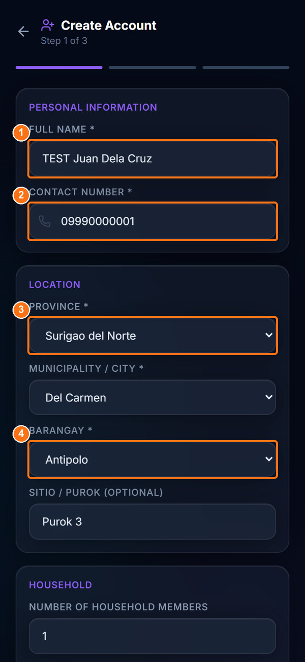  Personal information and location | 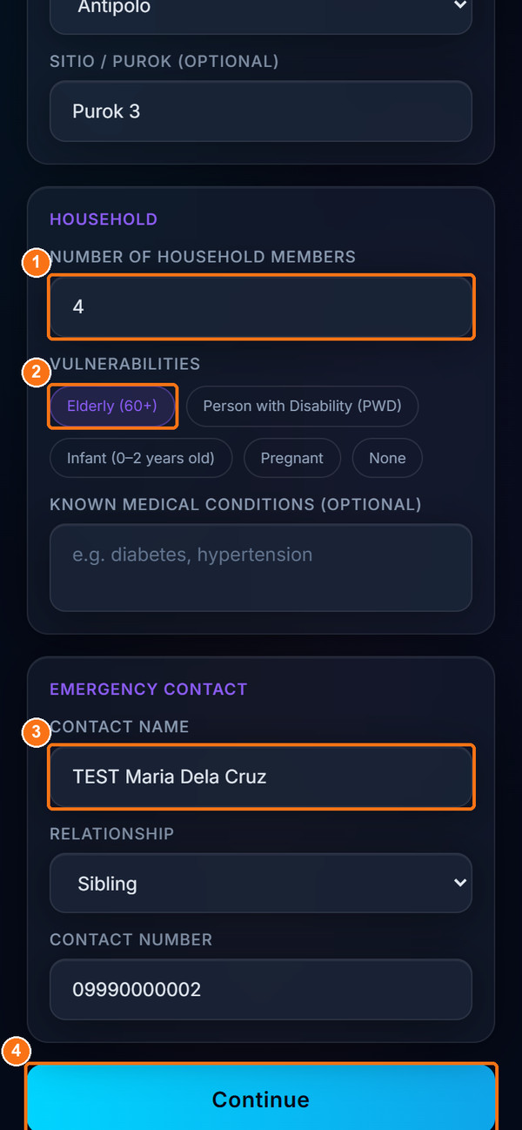  Household and emergency contact
Figure 6. Create Account, Step 1: personal information, location, household and emergency contact
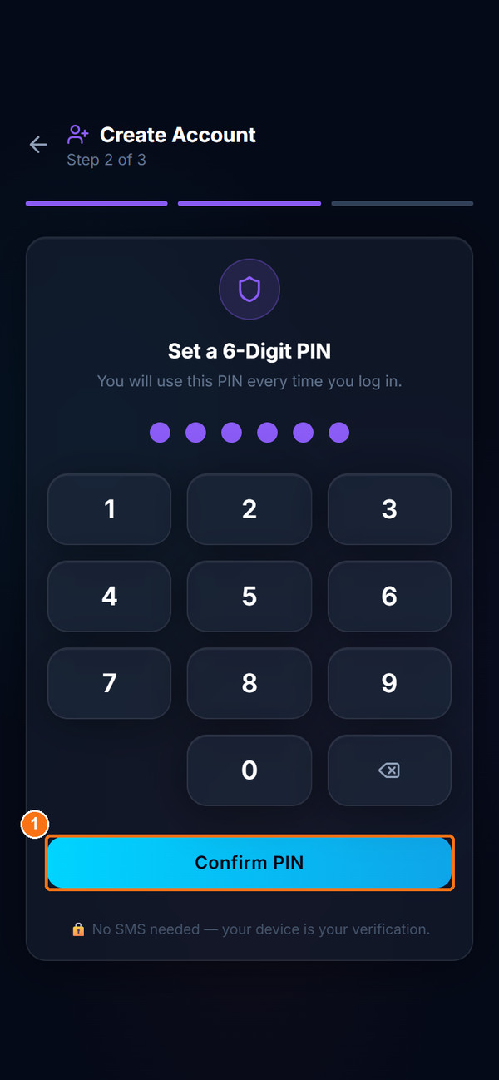  Step 2: set a 6-digit PIN | 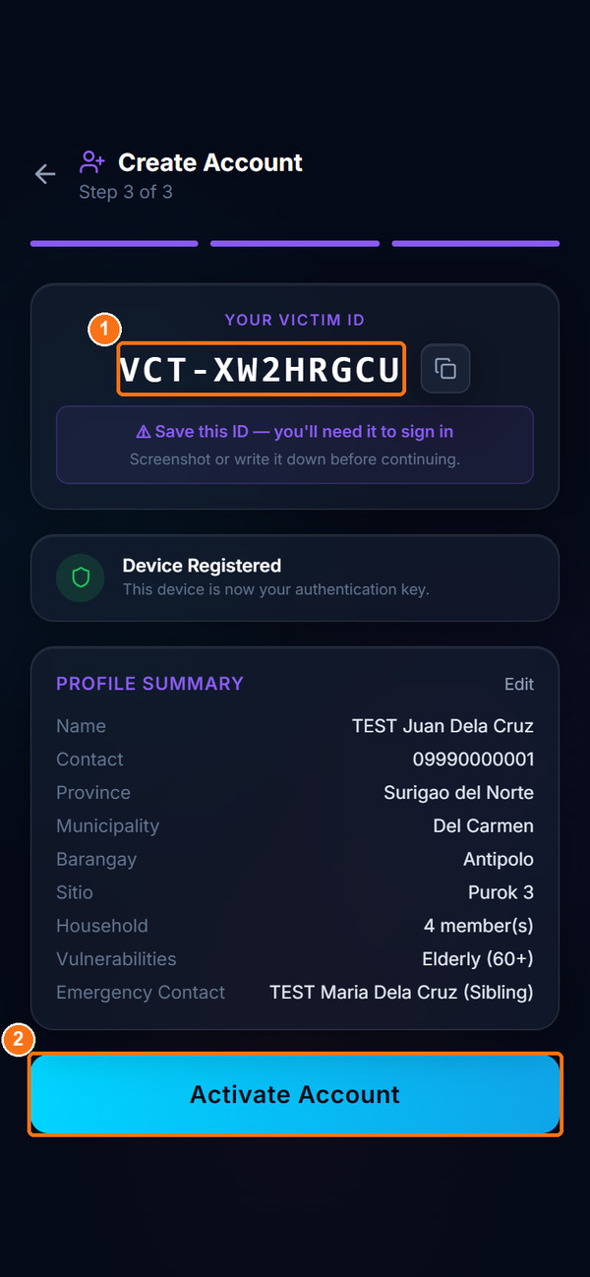  Step 3: Victim ID and Activate Account
Figure 7. Create Account, Steps 2 and 3: set PIN and receive Victim ID
Expected Result: Your account is activated and the Home screen opens with a VERIFIED badge and your name and barangay at the top.
Important Notes:
- Validation messages: "Full name is required.", "Enter a valid Philippine mobile number (09XXXXXXXXX).", "Province, Municipality, and Barangay are required." and "PINs do not match. Please try again."
- No SMS code is sent. Your phone itself becomes your verification ("Device Registered").
- Save your Victim ID. You need it to sign in again.
- Your profile also appears in the LGU's Constituents registry.

8.2 Sign In with Your Profile
Purpose: Return to your verified account.
Who Can Use It: Registered community users.
Prerequisites: Your Victim ID and 6-digit PIN. Sign in on the phone you registered with; the first sign-in on a new phone requires internet.
Procedure:
- On the landing page, tap Sign In with Profile.
- Enter your Victim ID (marker 1). On your registered phone it is filled in automatically and shows "✓ Saved from this device".
- Tap your 6-digit PIN on the keypad (marker 2). The six dots fill in as you type.
- Tap Sign In (marker 3).
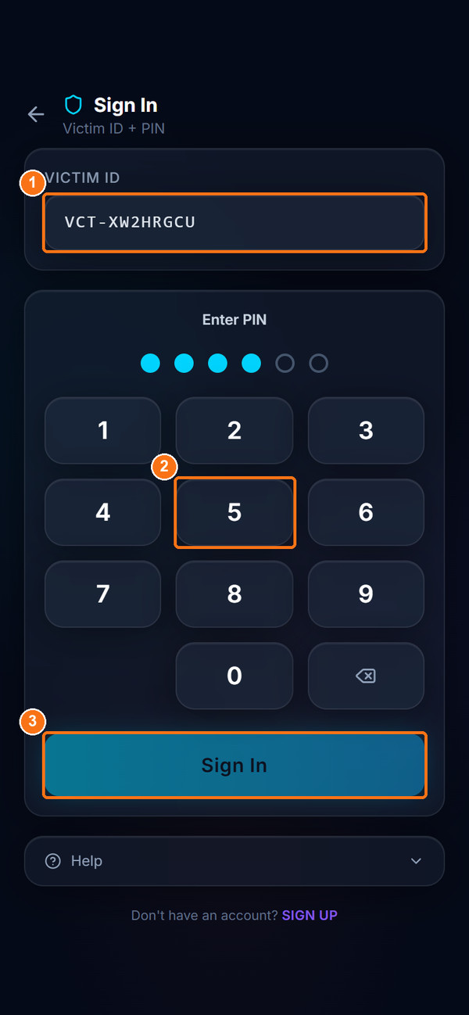  Entering Victim ID and PIN | 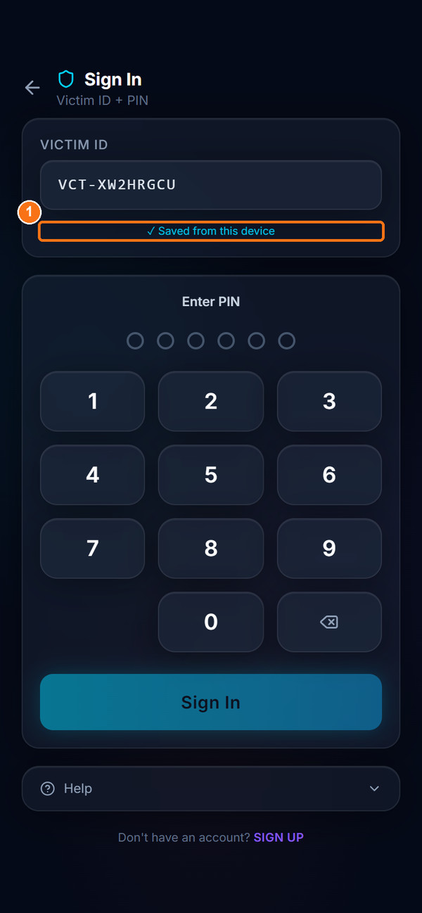  Victim ID saved on the registered device
Figure 8. Victim sign-in with Victim ID and PIN
Expected Result: The Home screen opens with the VERIFIED badge.
Important Notes:
- Error messages include "Enter a valid Victim ID (e.g. VCT-AB3KZ9PQ).", "Enter your 6-digit PIN.", "Wrong PIN or device not recognised.", "Invalid Victim ID or PIN", "Device not recognised. Please log in from your registered device." and "Account is not active. Contact your local DRRM office."
- Tap Help at the bottom of the sign-in page for a short explanation of the Victim ID format and offline sign-in.
LIMITATION — Online sign-in after sending an SOS
After you send an SOS, your registry status changes from Active to "Not Safe" (and later "Safe"). In the current version the online sign-in check requires the Active status, so signing in again from the server may fail with "Account is not active". The offline check on your registered phone still works. If you are blocked, contact your local DRRM office.

8.3 Continue as Guest
Purpose: Send an SOS quickly without creating an account.
Who Can Use It: Anyone, including visitors and people without a profile.
Prerequisites: Location permission is recommended.
Procedure:
- On the landing page, tap Continue as Guest. The Send SOS as Guest page opens.
- Step 1 – Confirm Your Location: wait for "GPS Location Detected" and tap Confirm Location (marker 2). If GPS is not available, tap Set location manually instead (marker 1) and choose Province, Municipality and Barangay.
- Step 2 – Verify you're a real person: read the instruction "Tap the …" (marker 1) and tap the matching picture (marker 2). Tap Confirm. A wrong choice shows "Incorrect. Please try again."
- Step 3 – Disclaimer: read the warning about false reports (RA 10173). Tick I understand and confirm this is a real emergency (marker 1) and tap I Understand – Proceed to SOS (marker 2).
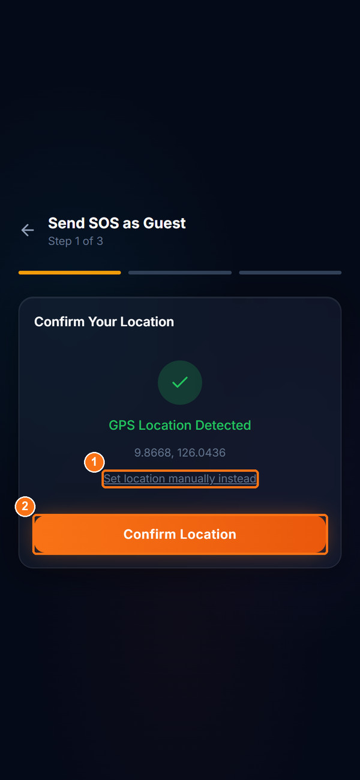  Step 1: location | 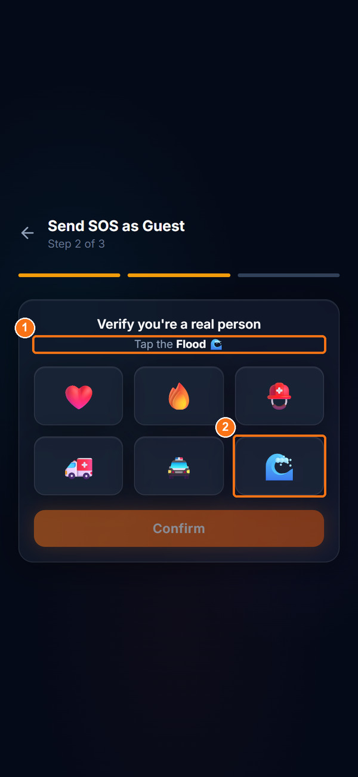  Step 2: tap the requested picture
Figure 9. Guest access, Steps 1 and 2: confirm location and picture check
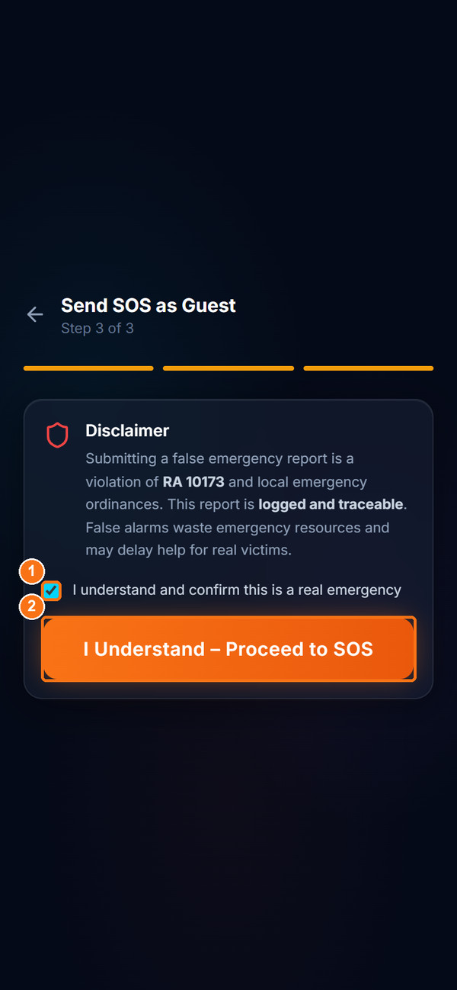  Step 3: disclaimer | 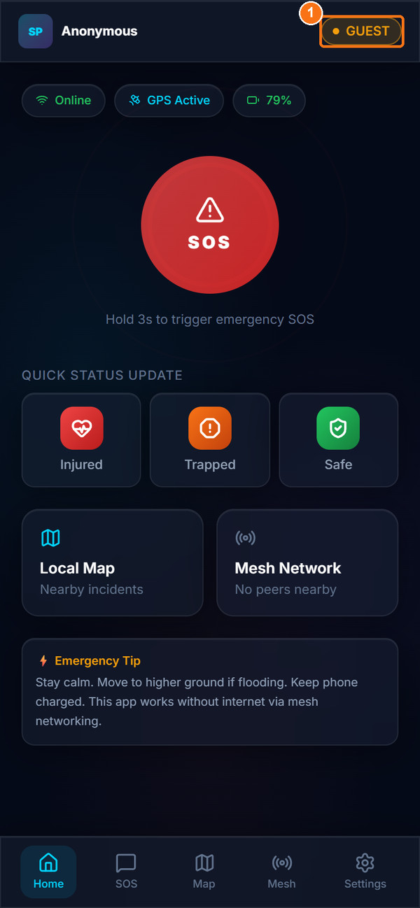  Home screen with GUEST badge
Figure 10. Guest access, Step 3 disclaimer and the Home screen in Guest mode
Expected Result: The Home screen opens with a GUEST badge. You can now send an SOS (Section 8.5).
Important Notes:
- Guest reports are labelled "Guest Report – Trust: LOW" and receive a lower priority score.
- To leave Guest mode, open Settings and tap Exit Guest Mode.

8.4 The Home Screen
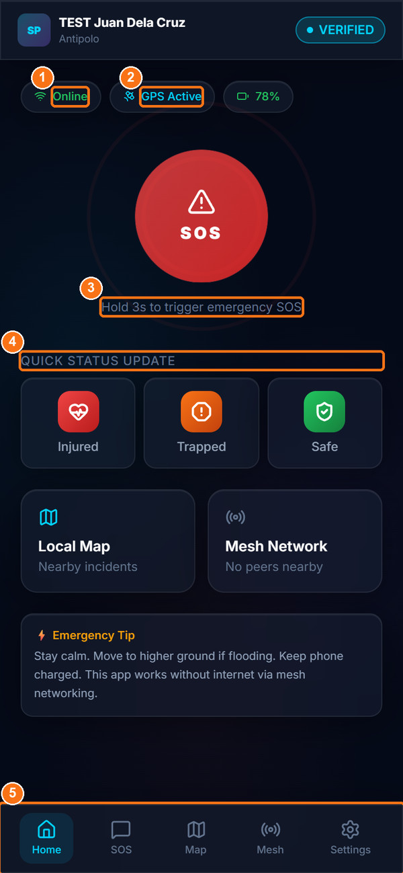
Figure 11. Victim Home screen
Table 14. Home screen items
Marker | Item | Description
1 | Online / Offline chip | Shows whether the phone currently has a network connection.
2 | GPS chip | GPS Active, GPS Denied or GPS Unknown. A battery percentage chip appears when the browser supports it.
3 | SOS button | Press and hold for 3 seconds to open the SOS report form. Holding the button does not send anything by itself.
4 | Quick Status Update | Tap Injured, Trapped or Safe to pre-select your situation on the SOS form.
5 | Bottom navigation | Home, SOS, Map, Mesh and Settings.

The Local Map card opens the evacuation center map and the Mesh Network card shows how many nearby devices were found. The Emergency Tip box gives general safety advice.

8.5 Submit an SOS Emergency Report
Purpose: Ask for help by sending your situation, location and needs to the LGU, response agencies and responders.
Who Can Use It: Verified users and guests.
Prerequisites: Signed in or in Guest mode. GPS permission is strongly recommended.
Procedure:
- Hold the red SOS button on Home for 3 seconds, or tap SOS in the bottom bar. The Send SOS Report page opens.
- Under SOS Report Mode, keep Status Mode (left screenshot of Figure 12, marker 1) to choose your situation yourself. Photo Mode (marker 2) is described in Section 8.6.
- Under Emergency Service, tap every service you need (right screenshot of Figure 12, markers 1–4). You must select at least one: Disaster (MDRRMO), Medical (Hospital/Ambulance), Fire (BFP), Crime / Security (PNP) or Maritime (PCG).
- Under Emergency Status, choose your Current Situation (marker 5): Trapped, Injured, Missing or Safe / Need Supplies.
- Under People & Location, enter the Number of People who need help (Figure 13, left, marker 1). Check that the GPS line shows your coordinates (marker 2).
- Under Victim Age Group, tap Child (under 18), Adult (18–59) or Senior (60+) (marker 3).
- Under Additional Information, type useful details in Notes such as landmarks, injuries or special needs (Figure 13, right, marker 1). You can also tap Speak to dictate if your browser supports it.
- Tap Send Emergency SOS (right screenshot, marker 2).
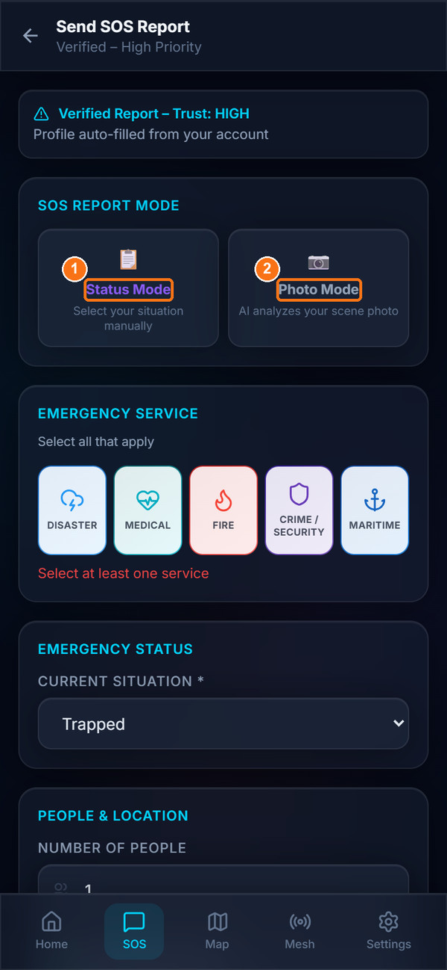  Report mode (Status or Photo) | 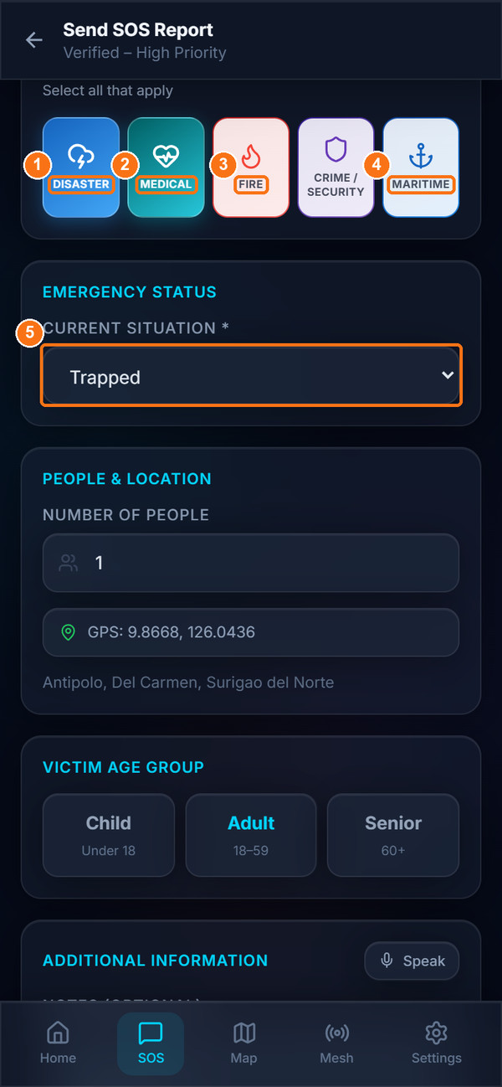  Emergency Service and Current Situation
Figure 12. SOS form: report mode, emergency service and current situation
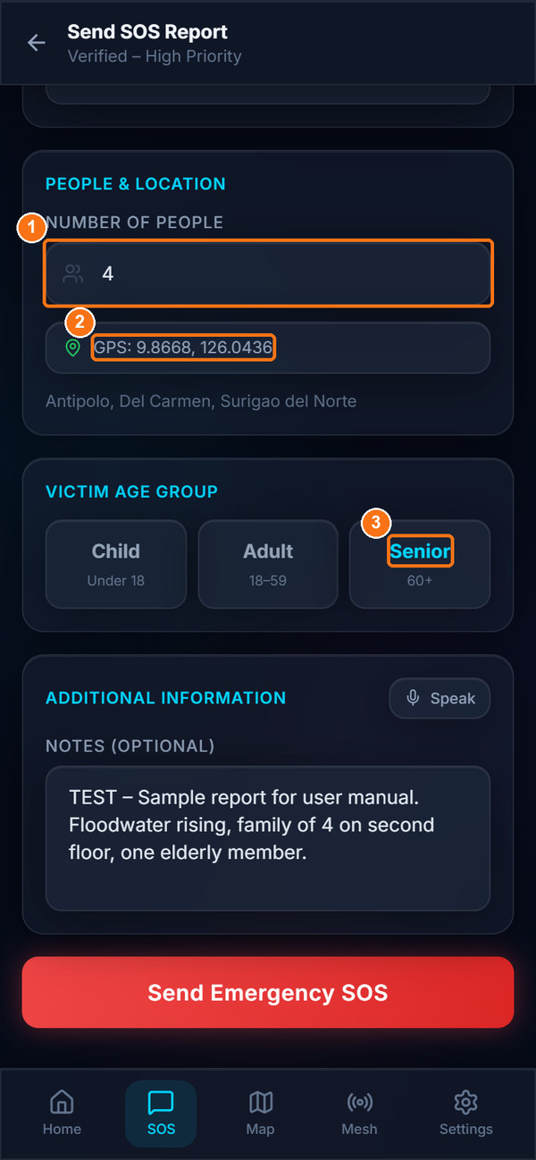  People, GPS and age group | 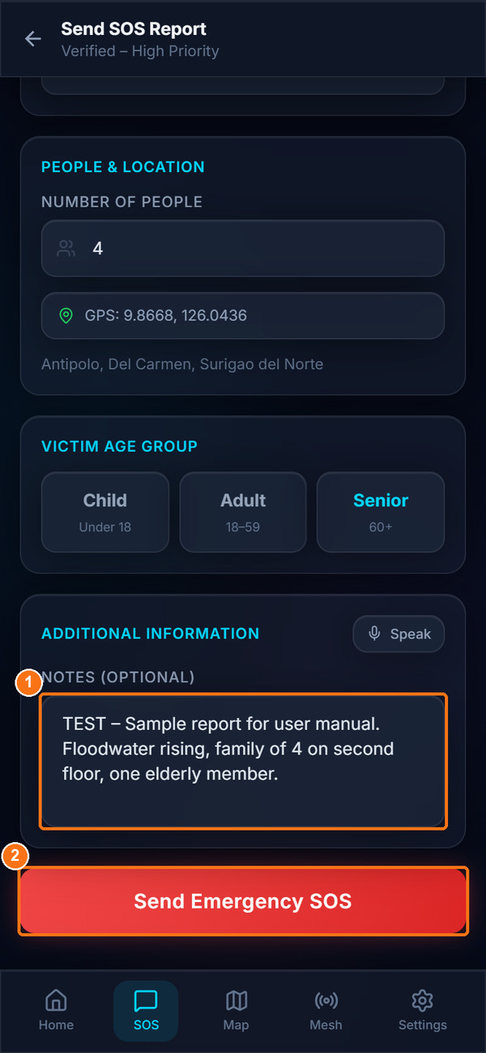  Notes and Send Emergency SOS
Figure 13. SOS form: people, location, age group, notes and the Send button
Expected Result: The confirmation screen "SOS Sent!" appears (Section 8.7).
Important Notes:
- Emergency Service mapping: Disaster → MDRRMO, Medical → Hospital/Ambulance, Fire → BFP, Crime / Security → PNP, Maritime → PCG. Each agency dashboard shows only the reports that selected its service.
- If no service is selected, the form shows "Select at least one service" and will not send.
- Verified users see "Verified Report – Trust: HIGH · Profile auto-filled from your account". Guests see "Guest Report – Trust: LOW".
- GPS is captured once when the form opens. There is no manual map pin; if GPS is unavailable, describe your location in Notes.
- When you speak, certain English and Tagalog words (for example about fire, flood, injury or collapse) automatically adjust the situation, age group and special conditions.

8.6 Photo Mode (Simulated Scene Analysis)
Purpose: Let the app pre-fill the situation and number of people from a photo of the scene.
Who Can Use It: Verified users and guests.
Prerequisites: Camera permission, or a photo in the gallery.
Procedure:
- On the SOS form, tap Photo Mode.
- Tap Tap to open camera and take a photo, or choose Use file from gallery instead.
- Tap Analyze Scene with YOLO11. Results appear as "YOLO11 Classification" and "YOLO11 Detection", and the message "✓ AI pre-filled status, conditions & people count below" appears.
- Check and correct the pre-filled fields, select the Emergency Service, and tap Send Emergency SOS.
Expected Result: The SOS is sent with the analysis results attached. Responders see a "YOLO11 AI Scene Analysis" section and an "📷 AI" tag on the queue card.
Important Notes:
- The send button stays disabled until the photo has been analysed ("Run YOLO11 analysis before submitting, or switch to Status Mode").
LIMITATION — Photo Mode is simulated
The analysis uses simple colour and brightness rules on the phone, not a real YOLO11 object-detection model. The photo itself is not uploaded or shown to responders. Always check the pre-filled values. Photo Mode was not exercised with a real camera for this manual.

8.7 After Sending: the Confirmation Screen
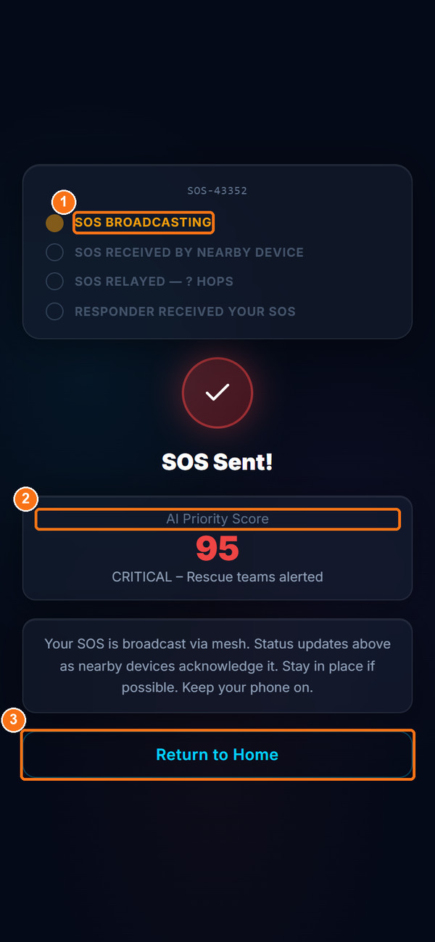  Verified report: score 95, CRITICAL | 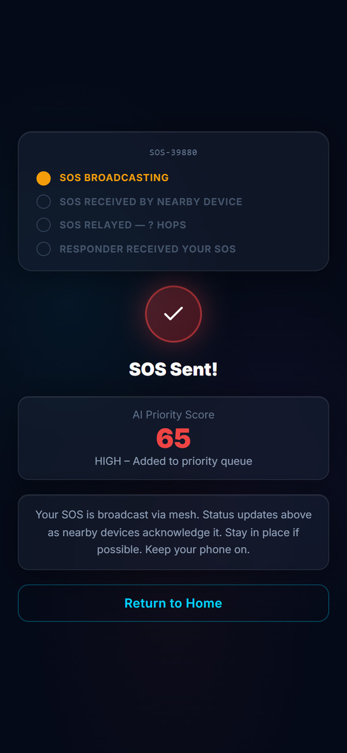  Guest report: score 65, HIGH
Figure 14. SOS confirmation screens for a verified report (left) and a guest report (right)
The confirmation screen shows:
- Your report number (for example SOS-43352) at the top of the panel. This number is for your reference on the device.
- The mesh delivery checklist (marker 1): SOS BROADCASTING → SOS RECEIVED BY NEARBY DEVICE → SOS RELAYED — N HOPS → RESPONDER RECEIVED YOUR SOS. Steps are ticked only when another phone running the Android app acknowledges your message (see Chapter 14).
- AI Priority Score (marker 2) when sent online: CRITICAL (80+) "Rescue teams alerted", HIGH (60+) "Added to priority queue", MODERATE (40+) "In rescue queue", or LOW "Queued for response".
- When sent offline: "Saved offline — will sync when signal returns".
- Return to Home (marker 3).
IMPORTANT — What the confirmation does and does not mean
An AI Priority Score on this screen means the report was saved to the server and will appear on the dashboards.
"Rescue teams alerted" means the report appears as CRITICAL on staff dashboards. It does not mean a team has been dispatched.
Stay in a safe place, keep your phone charged, and keep trying other channels if possible.

8.8 Monitor Your Report and Rescue Status
Purpose: Check what has happened to your SOS.
Who Can Use It: Verified users and guests.
Prerequisites: An SOS has been sent from this phone.
Procedure:
- Tap Mesh in the bottom bar. The Mesh Network Status page opens on the Status tab.
- Check the Active SOS Broadcast panel for the delivery level of your latest SOS.
- Tap the Activity tab to see "Your SOS Broadcast", SOS signals detected nearby and acknowledgements (ACKs) received from other devices.
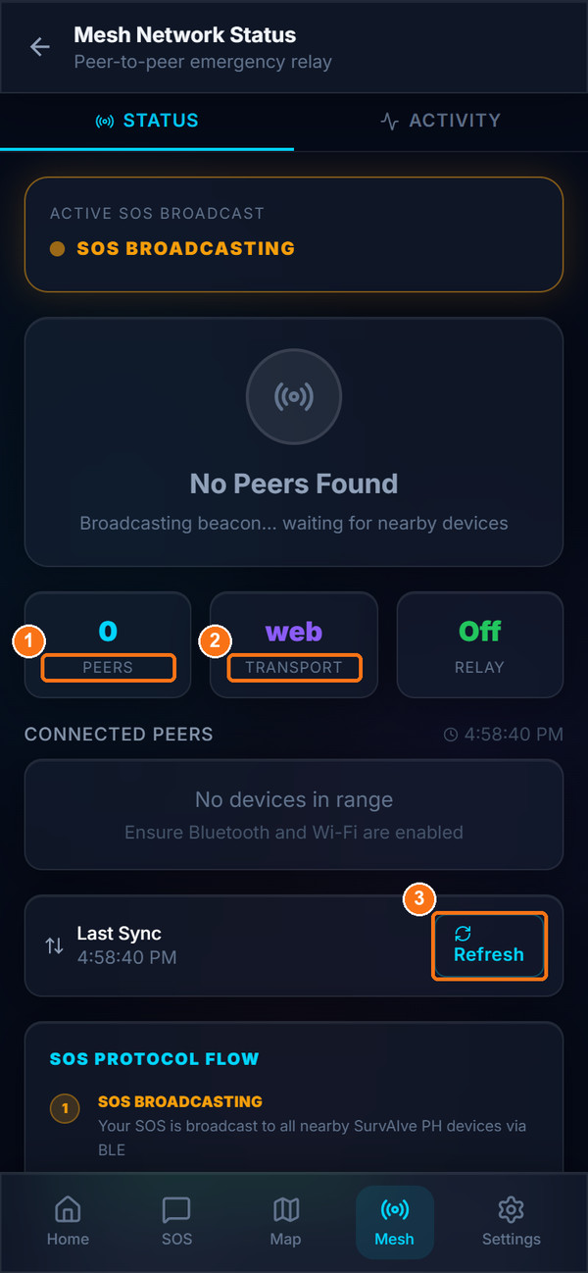  Status tab | 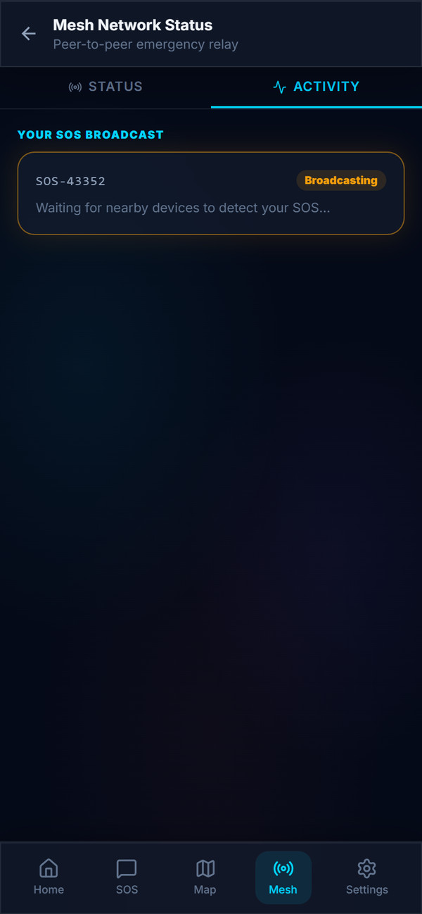  Activity tab
Figure 15. Mesh Network Status: Status tab (left) and Activity tab (right), as shown in a web browser
Expected Result: You can see whether your SOS has been broadcast and whether nearby devices or responders acknowledged it.
LIMITATION — Victims do not see rescue status updates
In the current version, rescue status changes made by responders or administrators (En Route, On Scene, Rescued, Cannot Reach) are not shown to the victim, and victims receive no push notifications.
The "RESPONDER RECEIVED YOUR SOS" step is an automatic acknowledgement from a responder's phone over the mesh. It does not confirm that a team is on its way.
Mesh activity is kept in memory only and is cleared when the app restarts.

8.9 View Your Location and Evacuation Centers
Purpose: Find the nearest evacuation center.
Who Can Use It: Verified users and guests.
Prerequisites: Internet connection to load map tiles; GPS recommended.
Procedure:
- Tap Map in the bottom bar. The My Location & Evacuation Centers page opens.
- Read the banner "Nearest shelter: … — X km away".
- Tap a shelter marker or a card in the Evacuation Centers list for its name, barangay, capacity, contact, distance and status.
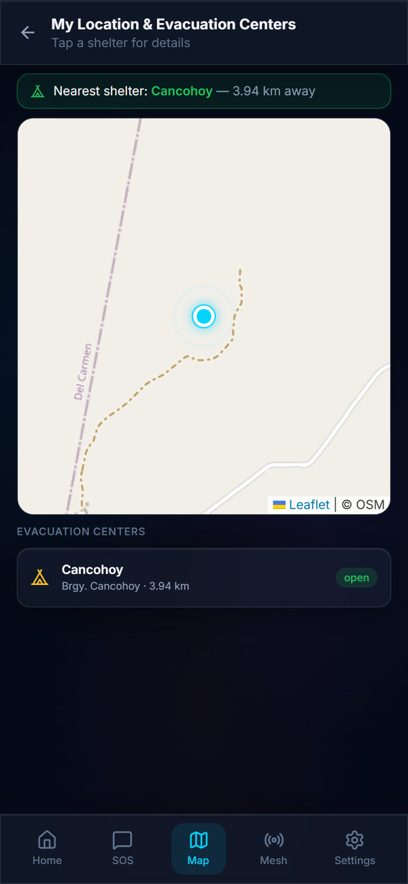
Figure 16. My Location & Evacuation Centers map
Expected Result: Your position ("📍 You are here") and the evacuation centers are shown. Open centers are green, full centers amber and closed centers grey; the nearest one has a gold border.
Important Notes:
- Map tiles need internet and are not stored for offline use.
- The Home card says "Nearby incidents", but the map shows only your position and evacuation centers, not other incidents.

8.10 Victim Settings
Purpose: View your profile, adjust auto-SOS and mesh options, set the local server address and sign out.
Who Can Use It: Verified users and guests.
Prerequisites: None.
Procedure:
- Tap Settings in the bottom bar.
- Review the account card (name, VERIFIED or GUEST badge, contact).
- Use the toggles under Auto-SOS Triggers and Network & Power as needed (see notes).
- Under Local Server (XAMPP), enter the IP address given by your LGU and tap Save (only needed for offline operation).
- Scroll down to Account Settings to change your display name or PIN (Chapter 15), and to Sign Out.
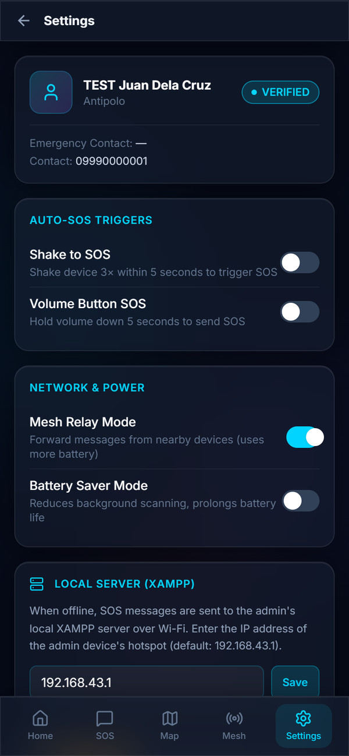  Profile and toggles | 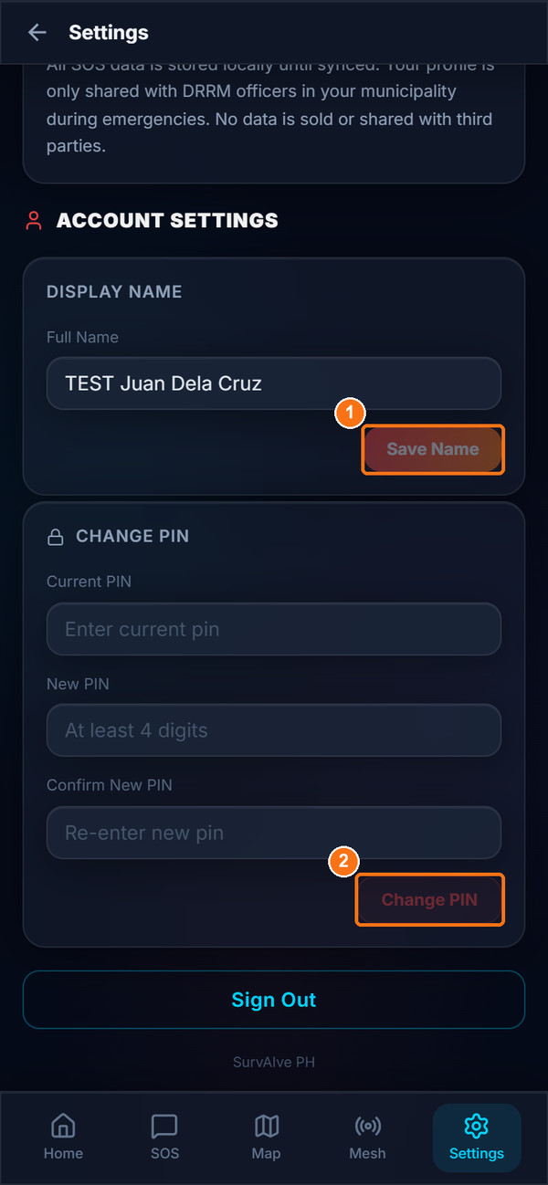  Account Settings (name and PIN)
Figure 17. Victim Settings: profile, toggles, local server and Account Settings
Expected Result: Settings are saved on the device.
Important Notes:
- Mesh Relay Mode (on by default) lets your phone forward other people's SOS messages.
- Battery Saver Mode currently only turns Mesh Relay off; it does not change scanning speed.
LIMITATION — Shake to SOS and Volume Button SOS
These toggles exist, but in the current version the trigger does not reliably open the SOS screen, and volume-key presses usually do not reach the app. Use the SOS button instead.

9. Field Responder User Guide
Field responders use a phone-sized interface. Sign in as described in Section 6.1, choosing Field Responder.

9.1 Responder Dashboard
Purpose: See your duty status, mesh relay status and the number of victims waiting in your municipality.
Who Can Use It: Field Responders.
Prerequisites: Signed in as a Field Responder.
Procedure:
- After sign-in, the Responder Dashboard opens. Your unit name and zone appear under the title, with an ACTIVE or STANDBY badge.
- Check the duty card. Tap Go Standby (marker 1) to stop receiving assignments, or Go On Duty to start again.
- Check the Active Mesh Node card (marker 2) for Peers, Transport and Relay.
- Read the Assigned and Critical tiles. Tap View Queue (marker 3) to open the victim queue, or Open Map to open the Field Map.
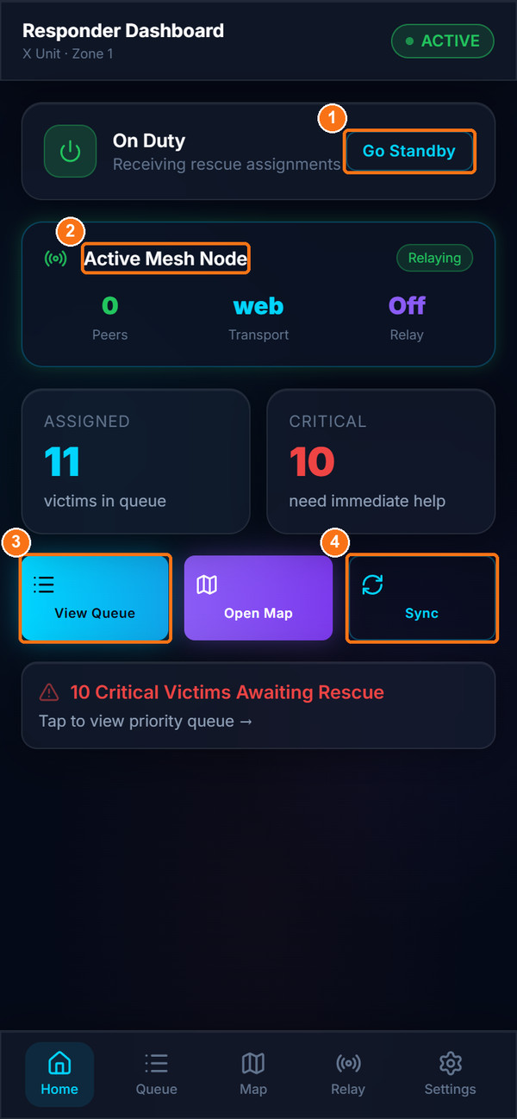
Figure 18. Responder Dashboard
Expected Result: Your duty status is saved and shown to administrators in Rescue Updates.
Important Notes:
- While you are signed in, your phone's GPS position is sent to the server so that administrators can see on-duty responders on the Command Center map.
- The Assigned tile counts all unrescued SOS reports in your municipality, not only reports assigned to you.
- When the combined Android app receives an SOS over the mesh, a red card "CRITICAL SOS — RECEIVED VIA MESH" appears with a VIEW INCIDENT QUEUE button.
LIMITATION — Sync button
The Sync button (marker 4) only shows a short animation. It does not upload or download data. Lists refresh automatically through the live connection.

9.2 View the Victim Queue
Purpose: See all waiting SOS reports in your municipality, sorted by priority.
Who Can Use It: Field Responders.
Prerequisites: Signed in; internet or local server connection.
Procedure:
- Tap Queue in the bottom bar (or View Queue on the dashboard).
- Use the filter chips All, Critical, High or Moderate (marker 1).
- Each card shows the priority, Verified or Guest, name, status, barangay, number of people, time since the report and notes.
- Tap a card (marker 2) to open its Rescue Detail page. Tap the refresh icon at the top right to reload.
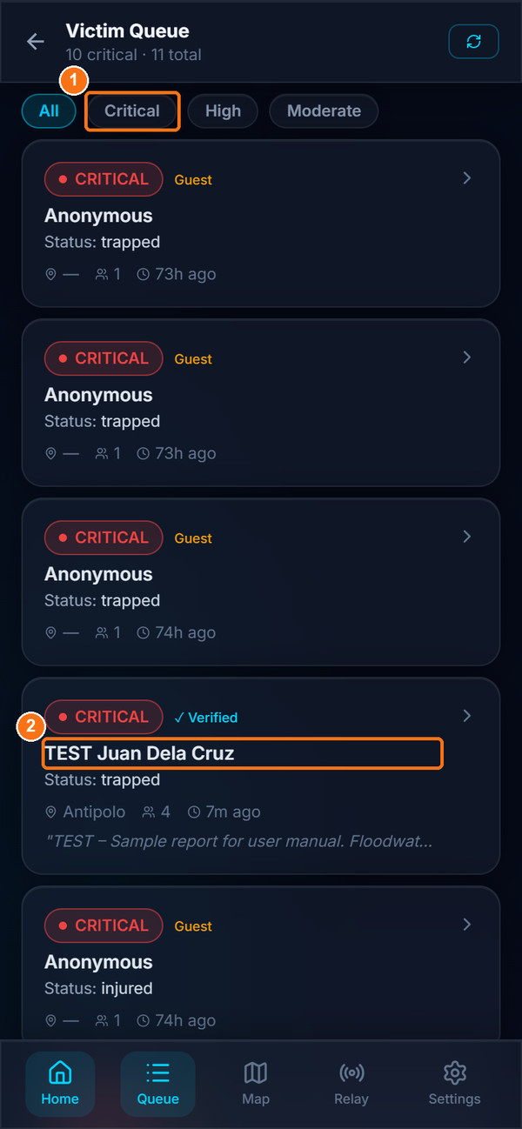
Figure 19. Victim Queue
Expected Result: The Rescue Detail page for the selected victim opens.
Important Notes:
- Rescued victims are removed from the queue.
- There is no "Low" filter chip; low-priority reports appear under All.

9.3 Review Victim Information and Update Rescue Status
Purpose: Review the victim's details and record rescue progress.
Who Can Use It: Field Responders (only responders can set En Route, On Scene and Cannot Reach).
Prerequisites: A report opened from the Victim Queue or Field Map.
Procedure:
- On Rescue Detail, read the priority banner and Victim Information: location and coordinates, number of people, status, contact, vulnerabilities and the victim's notes (Figure 20, left).
- When you leave for the location, tap En Route (right screenshot, marker 1).
- When you arrive, tap On Scene (marker 2). "On scene Ns" appears next to the current status.
- When the victim has been rescued, tap Rescued (marker 3). If you cannot reach the location, tap Cannot Reach (marker 4).
- Check that Current: shows the new status.
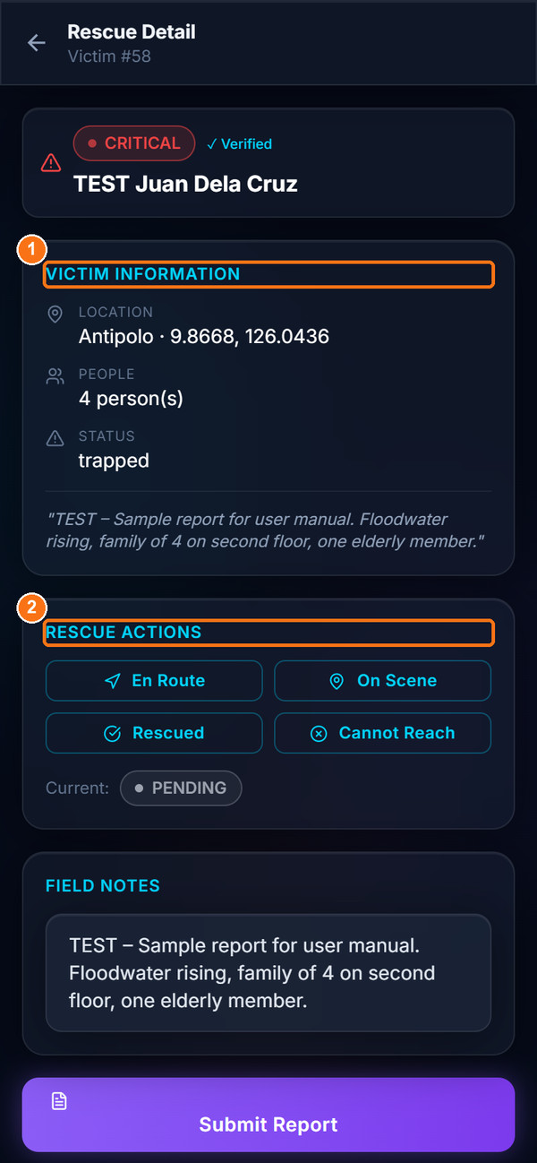  Victim information | 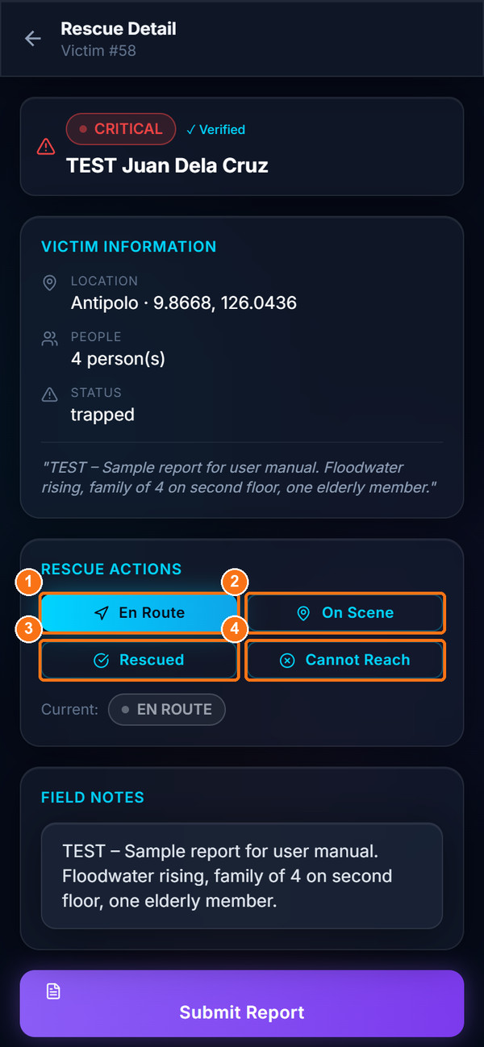  Rescue Actions: En Route selected
Figure 20. Rescue Detail: victim information (left) and Rescue Actions after tapping En Route (right)
Expected Result: The status is saved immediately and appears on the admin Victim Status and Rescue Updates pages, and in the Audit Logs.
Important Notes:
- Status buttons can be tapped in any order. Make sure you tap the correct one.
- If saving fails (for example no connection), no error message is shown. Check that Current shows the new status and, if in doubt, tell your Command Center by radio or phone.
- Tapping Rescued also records your name and the time as the confirmation.

9.4 Submit Field Notes and Record the Outcome
Purpose: Record what happened on scene and link yourself to the rescue.
Who Can Use It: Field Responders.
Prerequisites: Rescue Detail page open.
Procedure:
- Scroll to Field Notes. The box is pre-filled with the victim's notes.
- Replace or extend the text with your field report (marker 2), for example actions taken, equipment used and where the victims were taken.
- Tap Submit Report (marker 3). The button shows "Submitting…" then "Submitted".
- Tap the final status, for example Rescued.
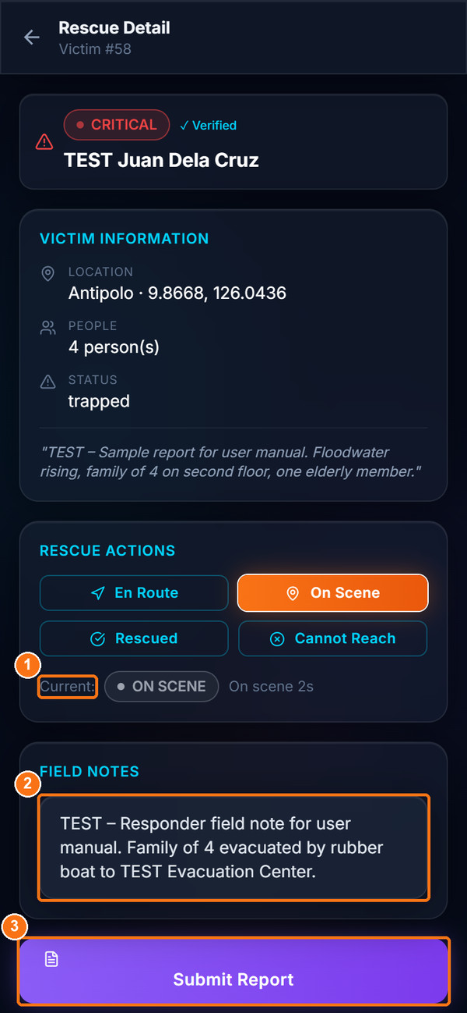  Field Notes and Submit Report | 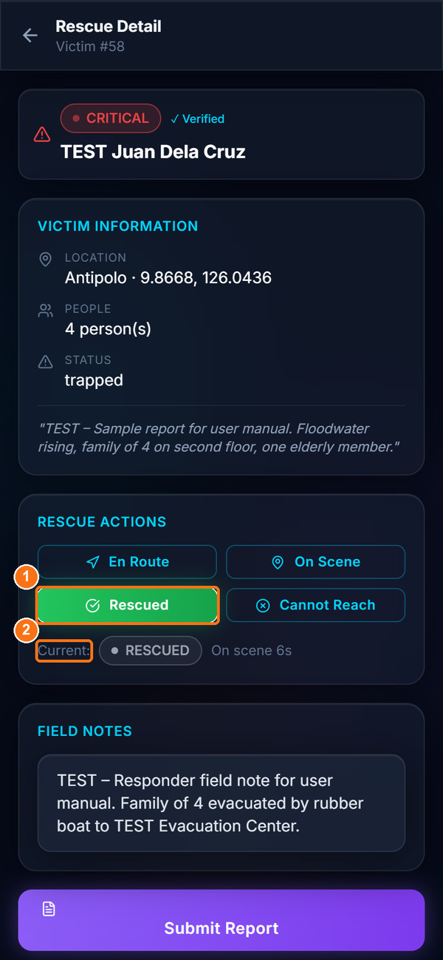  Outcome recorded: Rescued
Figure 21. Field Notes with On Scene status (left) and final Rescued status (right)
Expected Result: The report is saved with your notes, and you are recorded as the assigned responder. Administrators see "Submitted by: <your team>" in Rescue Updates.
Important Notes:
- Submitting replaces the victim's original notes with your field notes. Copy any important victim information into your notes before submitting.
- If submission fails, the message "Submit failed. Please try again." appears.
LIMITATION — No accept button and no incident history
There is no separate "Accept assignment" button. A responder becomes linked to a report only by tapping Submit Report. Rescued reports disappear from the responder's queue and map, and the responder app has no incident history page.

9.5 Field Map
Purpose: See your position, victims, evacuation centers and hotspot clusters on a map.
Who Can Use It: Field Responders.
Prerequisites: Internet for map tiles; GPS.
Procedure:
- Tap Map in the bottom bar.
- Find your position (cyan "You" marker with a 300 m range circle).
- Tap a numbered victim marker (red = critical, orange = high, amber = moderate) and tap View Details → to open Rescue Detail.
- Dashed circles labelled Hotspot Cluster N group nearby reports. The legend at the bottom shows the number of rescued reports.
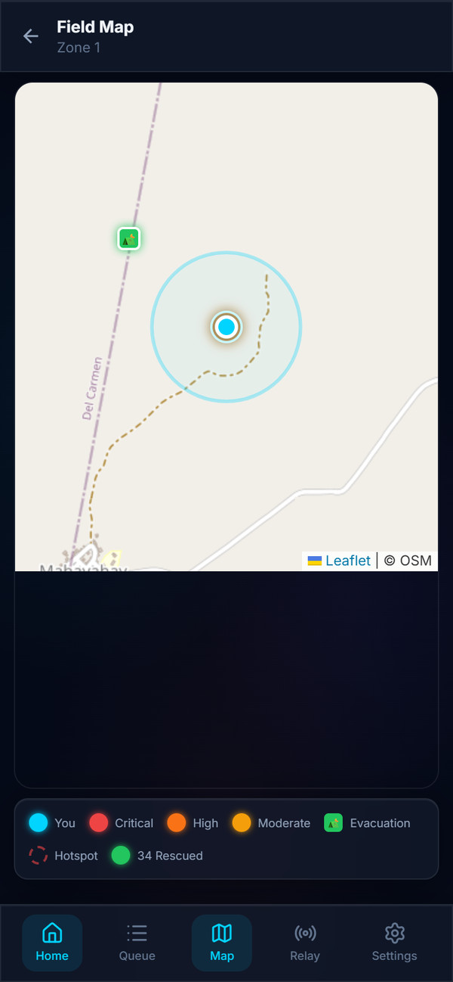
Figure 22. Field Map (no unrescued reports with coordinates were near the test location at capture time)
Expected Result: You can plan your route to the highest-priority victims.

9.6 Mesh Relay Node
Purpose: Use your phone as a relay that forwards SOS messages and sends acknowledgements.
Who Can Use It: Field Responders.
Prerequisites: Combined Android app with Bluetooth, Wi-Fi and Location turned on.
Procedure:
- Tap Relay in the bottom bar.
- Check Active Relay Mode. Tap Disable Relay (marker 1) or Enable Relay to change it.
- Review Peers Nearby, Transport, Relay Active and ACKs Sent, and the lists Received SOS via Mesh and Connected Peers.
- Open the Activity tab and tap VIEW INCIDENT on a received SOS to go to the queue.
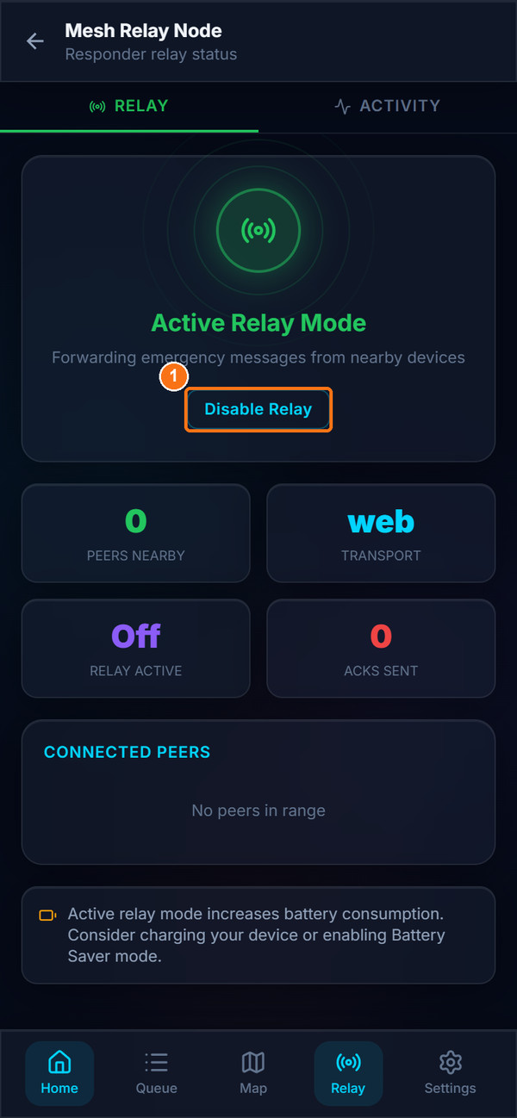
Figure 23. Mesh Relay Node (web browser: 0 peers, transport "web")
Expected Result: When relay is on, your phone forwards SOS messages from nearby victims.
Important Notes:
- In a web browser the mesh is not available: Peers is always 0 and Transport shows "web". Real mesh relaying requires the Android app and could not be demonstrated in these screenshots.
- The relay toggle on this screen always starts as On when the page opens.

9.7 Responder Settings
Purpose: View your profile, change your display name or password, set the local server and sign out.
Who Can Use It: Field Responders.
Prerequisites: None.
Procedure:
- Tap Settings in the bottom bar.
- Use Account Settings at the top to change your display name or password (Chapter 15).
- Review your profile: Contact, Team ID, Unit Name, Assigned Zone, Barangay, Municipality and Province.
- Under Local Server (XAMPP), enter the server IP and tap Save if instructed by your LGU.
- Scroll to the bottom and tap Sign Out when you finish your shift.
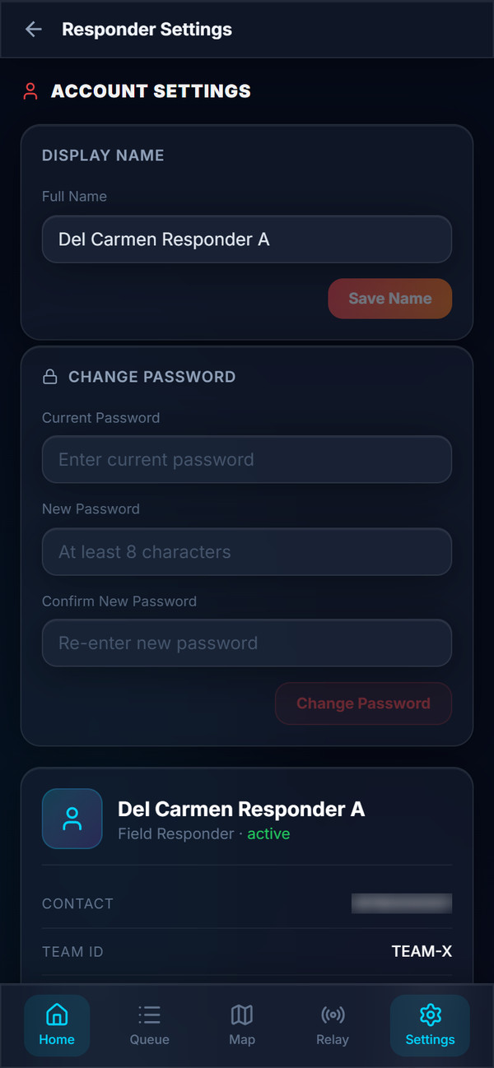  Account Settings and profile | 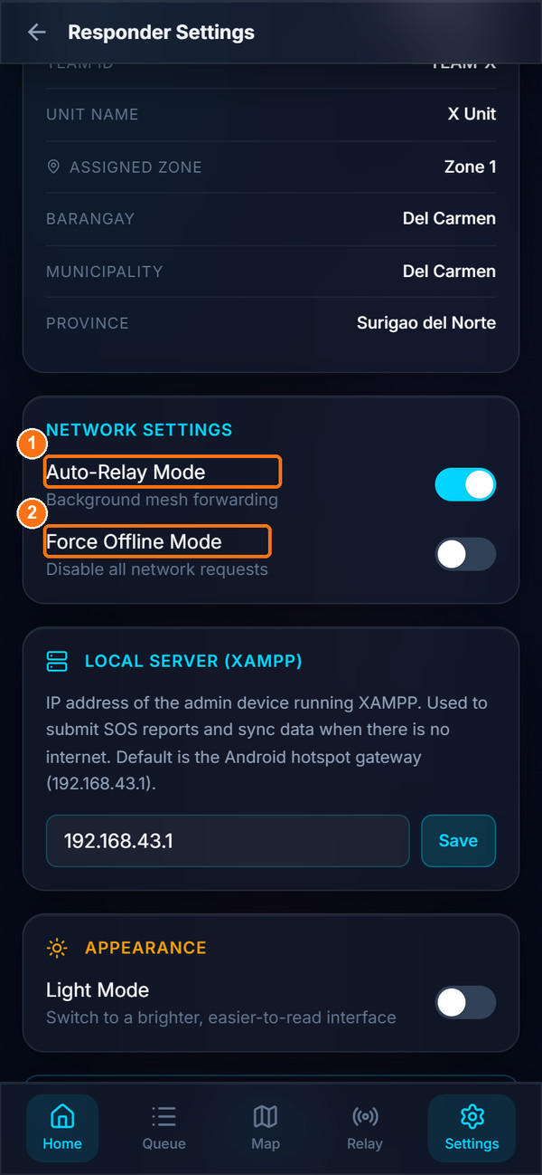  Network Settings
Figure 24. Responder Settings: Account Settings and profile (left), Network Settings and local server (right)
LIMITATION — Auto-Relay Mode and Force Offline Mode
These two toggles (markers 1 and 2) are saved on the phone but currently have no effect on how the app works.

10. Response Agency User Guide
Response agency accounts represent the emergency services that victims can request on the SOS form. Each agency account has one agency type.
Table 15. Agency types and the SOS services they receive
Agency type | Sidebar label | SOS service the agency receives | Typical emergencies
mdrrmo | MDRRMO | Disaster | Flooding, landslides, typhoon damage, trapped residents
hospital | Hospital / Medical | Medical | Injuries, medical emergencies, ambulance requests
bfp | BFP | Fire | Structural and residential fires
pnp | PNP | Crime / Security | Crime, security threats, missing persons
pcg | PCG | Maritime | Sea and coastal emergencies

10.1 Shared functions and agency-specific behaviour
Source-code review confirmed that all five agency types have the same screens and the same permissions. The only differences are:
- Which SOS reports are shown: every list, map, alert and report is automatically filtered to reports that selected the agency's service. A Fire report appears for BFP but not for PCG; a report that selected both Disaster and Medical appears for MDRRMO and Hospital.
- The sidebar label and colour that identify the agency.
Agency screens reuse the LGU Admin screens: Command Center, Victim Status, Emergency Reports, AI Situational Analytics and Settings. The screenshots below were taken with a TEST MDRRMO account in Del Carmen.

10.2 Sign In and Select Your Municipality
Purpose: Access your agency dashboard for your municipality.
Who Can Use It: Response Agency personnel.
Prerequisites: An agency account created by the LGU Admin (Section 11.9).
Procedure:
- Open the staff sign-in page and tap Response Agency.
- Select your Province and Municipality, enter your Contact Number and Password, and tap Sign In (see Section 6.1).
Expected Result: The agency Command Center opens. The sidebar shows your agency label, your account name and the municipality.

10.3 Agency Command Center and Emergency Alerts
Purpose: Monitor your service's SOS reports on a live map with summary statistics.
Who Can Use It: Response Agency personnel.
Prerequisites: Signed in.
Procedure:
- Click Command Center in the sidebar (marker 1).
- Review Live Stats (SOS Today, Critical, Rescued, Responders), the weather risk and the Resource Forecast.
- Review Recent Reports and the map markers. When a new SOS arrives, acknowledge it as described in Section 7.3.
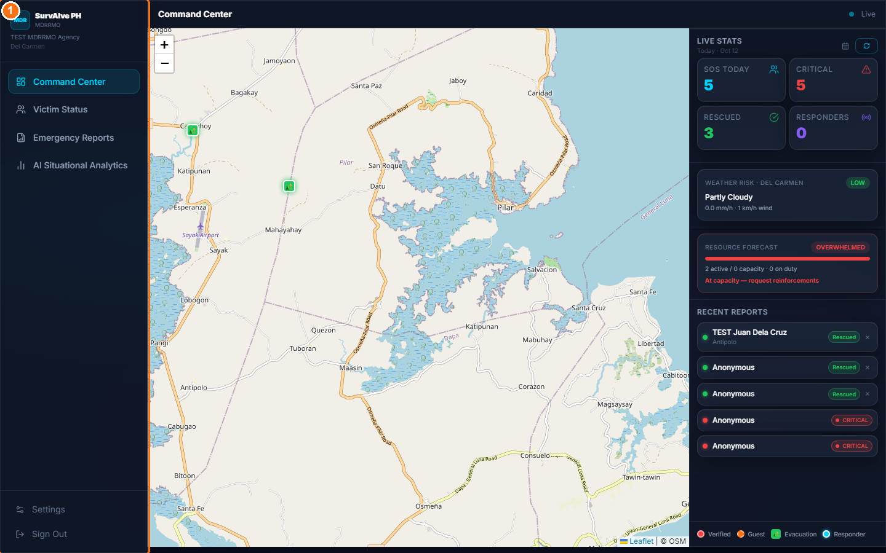
Figure 25. Agency Command Center (TEST MDRRMO account)
Expected Result: You see only reports that requested your service.

10.4 Manage Victim Status
Purpose: Review reports for your service and confirm rescues.
Who Can Use It: Response Agency personnel.
Prerequisites: Signed in.
Procedure:
- Click Victim Status in the sidebar.
- Search, filter by barangay, and use the chips All, Critical, Verified, Guest and Dismissed.
- Use the row actions as described for the LGU Admin in Section 11.3 (Mark Rescued, Flag Suspicious, Dismiss).
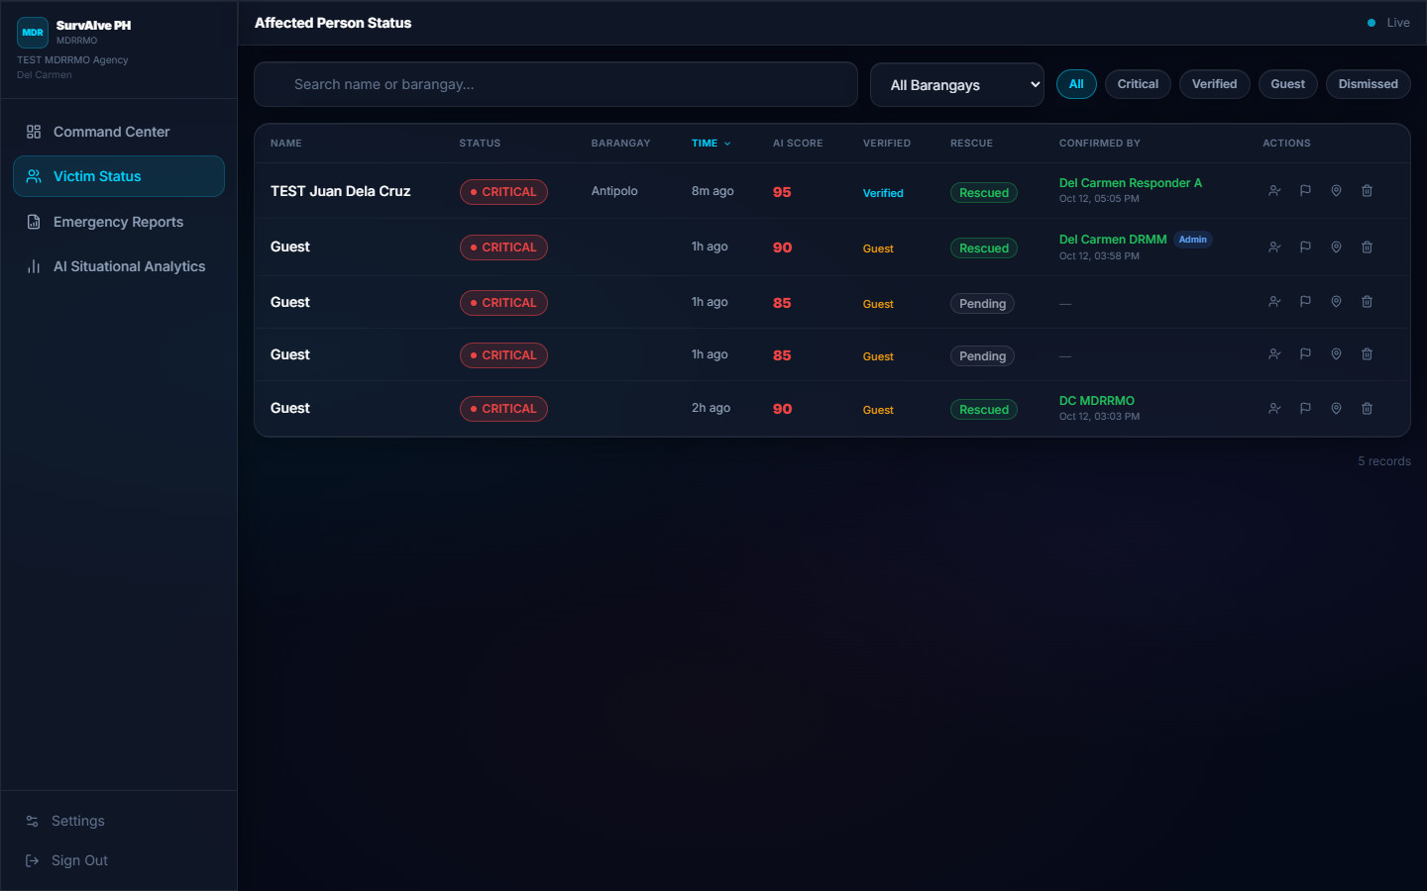
Figure 26. Agency Victim Status table filtered to MDRRMO reports
Expected Result: Rescues confirmed by the agency show the agency name in the Confirmed By column and in the Audit Logs.
LIMITATION — Do not use "View on Map" from an agency account
In the current version, the View on Map action in the agency Victim Status table opens an admin-only page, which sends the agency user back to the landing page (effectively signing out). Use the agency Command Center map instead.

10.5 Emergency Reports and AI Situational Analytics
Purpose: Produce printable summaries and review analytics for your service.
Who Can Use It: Response Agency personnel.
Prerequisites: Signed in.
Procedure:
- Click Emergency Reports, choose Today, Last 7 Days, Last 30 Days or Custom, click Generate Report, then Print / Export (same procedure as Section 11.7).
- Click AI Situational Analytics to view status and priority distributions, reports over time and the spam indicator (see Section 11.8).
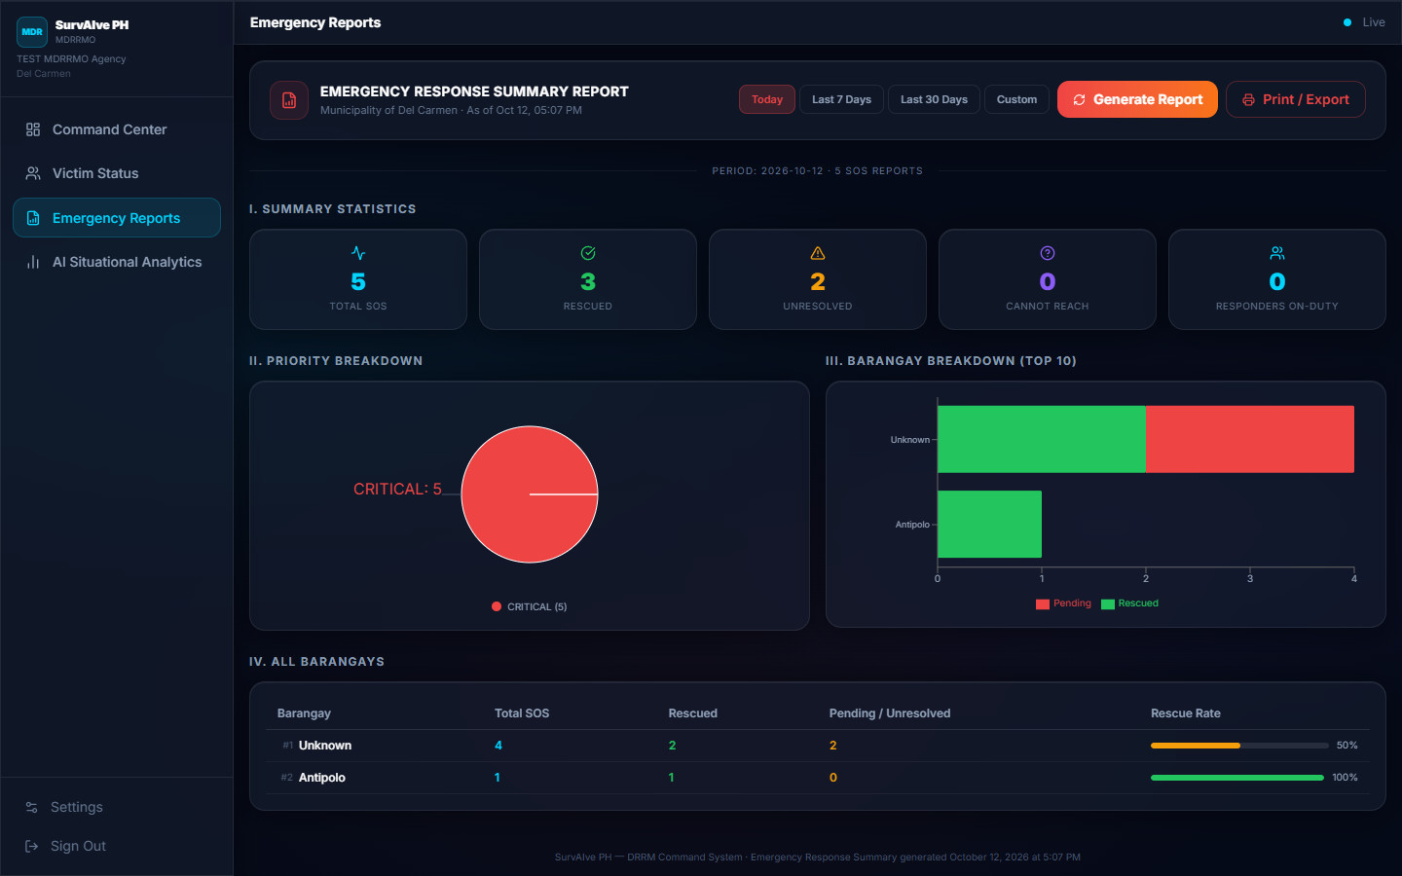
Figure 27. Agency Emergency Response Summary Report
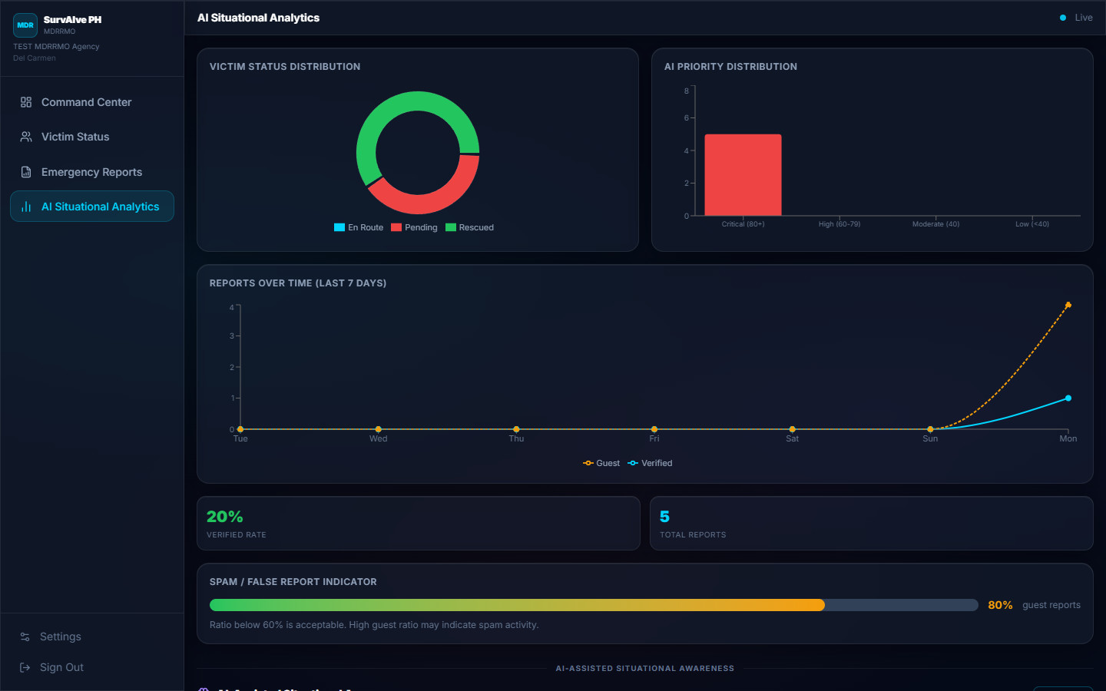
Figure 28. Agency AI Situational Analytics

10.6 Agency Settings
Purpose: Change your display name or password, alert preferences and appearance.
Who Can Use It: Response Agency personnel.
Prerequisites: Signed in.
Procedure:
- Click Settings at the bottom of the sidebar.
- Use Account Settings (Chapter 15) and Emergency Alert Settings (Section 15.2).
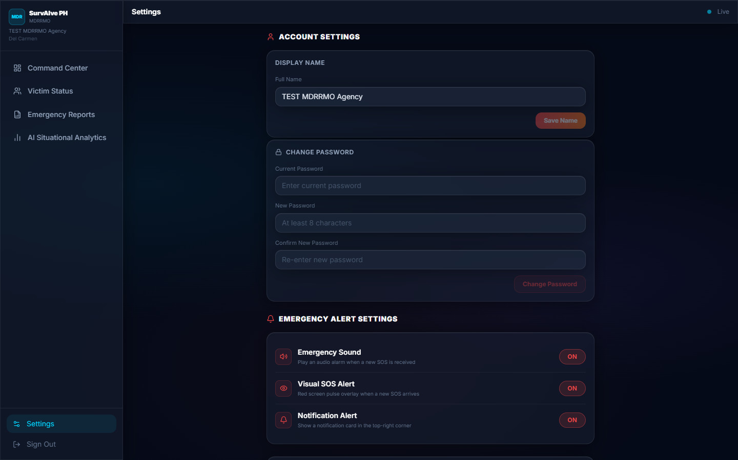
Figure 29. Agency Settings

11. LGU Administrator User Guide
The LGU Administrator (Admin) runs the municipal emergency operations dashboard. Sign in as described in Section 6.1 and choose Admin and your municipality.

11.1 Command Center
Purpose: Monitor incoming emergencies on a live map with key statistics.
Who Can Use It: LGU Administrators (Agencies have a filtered version).
Prerequisites: Signed in as Admin.
Procedure:
- Click Command Center in the sidebar (marker 1 in Figure 4). It opens automatically after sign-in.
- On the map (marker 2), review SOS markers by priority, highlight circles around CRITICAL and HIGH reports, evacuation centers and on-duty responders. The legend at the bottom explains the colours (Verified, Guest, Evacuation, Responder).
- Read Live Stats (marker 3): SOS Today, Critical, Rescued and Responders. Click the refresh button to update. The calendar icon shows the daily report history saved in this browser.
- Read the weather risk card and the Resource Forecast (marker 4), for example "OVERWHELMED – At capacity — request reinforcements" or "Capacity sufficient".
- Review Recent Reports (marker 5). The × button removes a resolved report from this list.
Expected Result: You have an up-to-date picture of the situation in your municipality.
Important Notes:
- When the dashboard loses its connection, an offline banner with a Retry button appears.
- Weather information is included in the priority calculation shown on the dashboard.

11.2 Monitor Incoming Emergencies (Alerts)
Purpose: Be alerted immediately when a new SOS arrives.
Who Can Use It: LGU Administrators and Agencies.
Prerequisites: Signed in with the dashboard open; sound allowed by the browser.
Procedure:
- Keep any admin page open. When a new SOS arrives, the NEW SOS ALERT card appears with an alarm sound (Figure 5).
- Click Acknowledge SOS or Mute.
- Open Victim Status to review the report.
Expected Result: The alarm stops and the alert is cleared.

11.3 Victim Status (Affected Person Status)
Purpose: View, search and manage all SOS reports in your municipality.
Who Can Use It: LGU Administrators (and Agencies for their service).
Prerequisites: Signed in.
Procedure:
- Click Victim Status in the sidebar. The page title is Affected Person Status.
- Type in the search box (marker 1) to find a name or barangay, and choose a barangay in All Barangays (marker 2).
- Use the filter chips All, Critical (marker 3), Verified, Guest and Dismissed. Click the Status, Barangay, Time or AI Score column headers to sort.
- Use the row actions: Mark Rescued (marker 4), Flag Suspicious (marker 5), View on Map (opens the Command Center focused on the report) and Dismiss (marker 6).
- In the Dismissed filter, use Remove from view and confirm with Yes, Remove to hide a row.
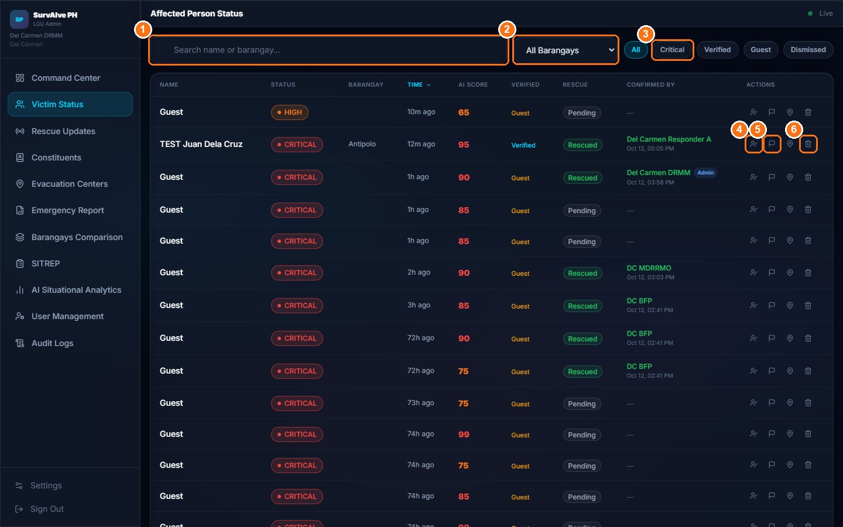
Figure 30. Victim Status table with row actions
Expected Result: Mark Rescued sets the rescue status to Rescued and records your name and role in Confirmed By. Dismiss moves the report to the Dismissed filter.
Important Notes:
- Columns: Name, Status (priority), Barangay, Time, AI Score, Verified, Rescue, Confirmed By, Actions.
- Admins and agencies can only set Rescued (and Dismiss). The intermediate statuses En Route, On Scene and Cannot Reach are set by field responders.
LIMITATION — Flag Suspicious and Remove from view are not saved
Flag Suspicious lowers the displayed score by 20 only on your screen, and Remove from view only hides the row on your screen. Neither change is saved to the database or seen by other users.

11.4 Rescue Updates and Responder Zones
Purpose: Follow rescue progress reported by field teams and assign teams to zones.
Who Can Use It: LGU Administrators.
Prerequisites: Signed in.
Procedure:
- Click Rescue Updates in the sidebar.
- In Rescue Status Feed, choose the period: Today (marker 1), Last 7 Days, Last 30 Days or Custom.
- Filter by status: All, En Route (marker 2), On Scene, Rescued or Cannot Reach. Each item shows the status, notes and "Submitted by: <team>".
- In Rescue Teams, click a team to show Assign to zone: (marker 3) and click Zone 1, Zone 2 or Zone 3.
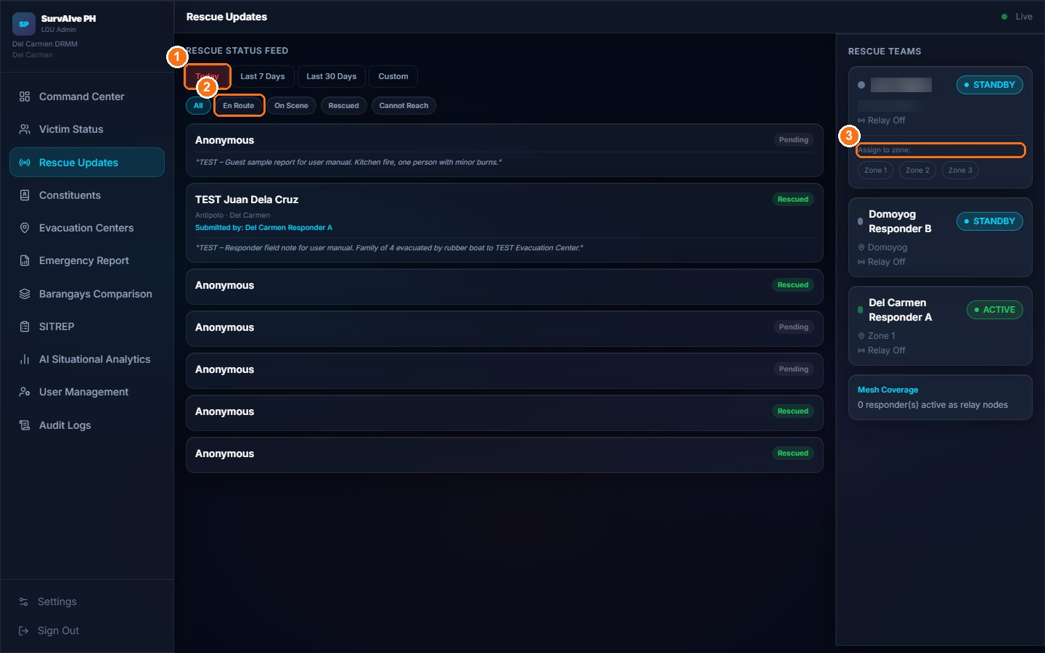
Figure 31. Rescue Updates feed and Rescue Teams panel (team names blurred)
Expected Result: The team's assigned zone is updated. Each team card shows STANDBY or ACTIVE (on duty).
LIMITATION — Responder assignment
Administrators cannot assign a responder to a specific SOS report. Assignment is limited to the three fixed zones (Zone 1–3). A responder becomes linked to a specific report only when they tap Submit Report on that report.

11.5 Constituents Registry
Purpose: Maintain the list of registered residents and their safety status.
Who Can Use It: LGU Administrators.
Prerequisites: Signed in.
Procedure:
- Click Constituents in the sidebar. Summary counts show Registered, Not Safe, Safe and Status Unknown.
- Search by name or barangay and filter with All Barangays and All Status.
- To add a resident without a smartphone, click Manual Entry (marker 1). Enter Full Name, Contact Number, Barangay and Household Count and click Save Entry.
- To edit, click the pencil icon in Actions, change the Status (Not Safe, Safe, Unknown) or the Account Login Access (Enabled/Disabled), and click Update. Click the trash icon to delete.
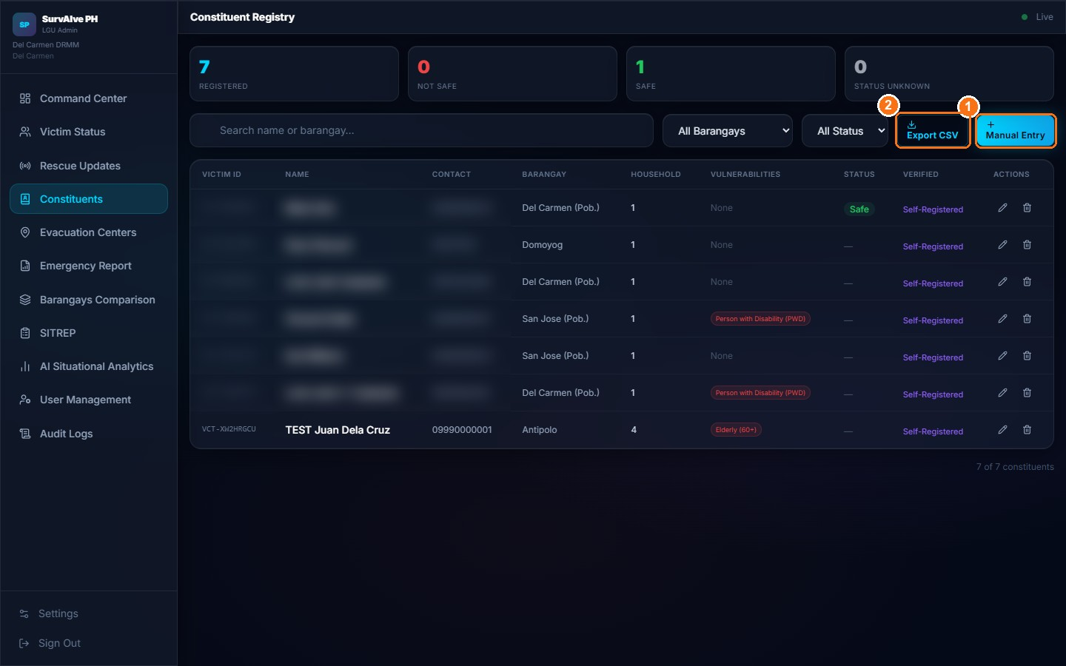
Figure 32. Constituent Registry (personal data of real records blurred)
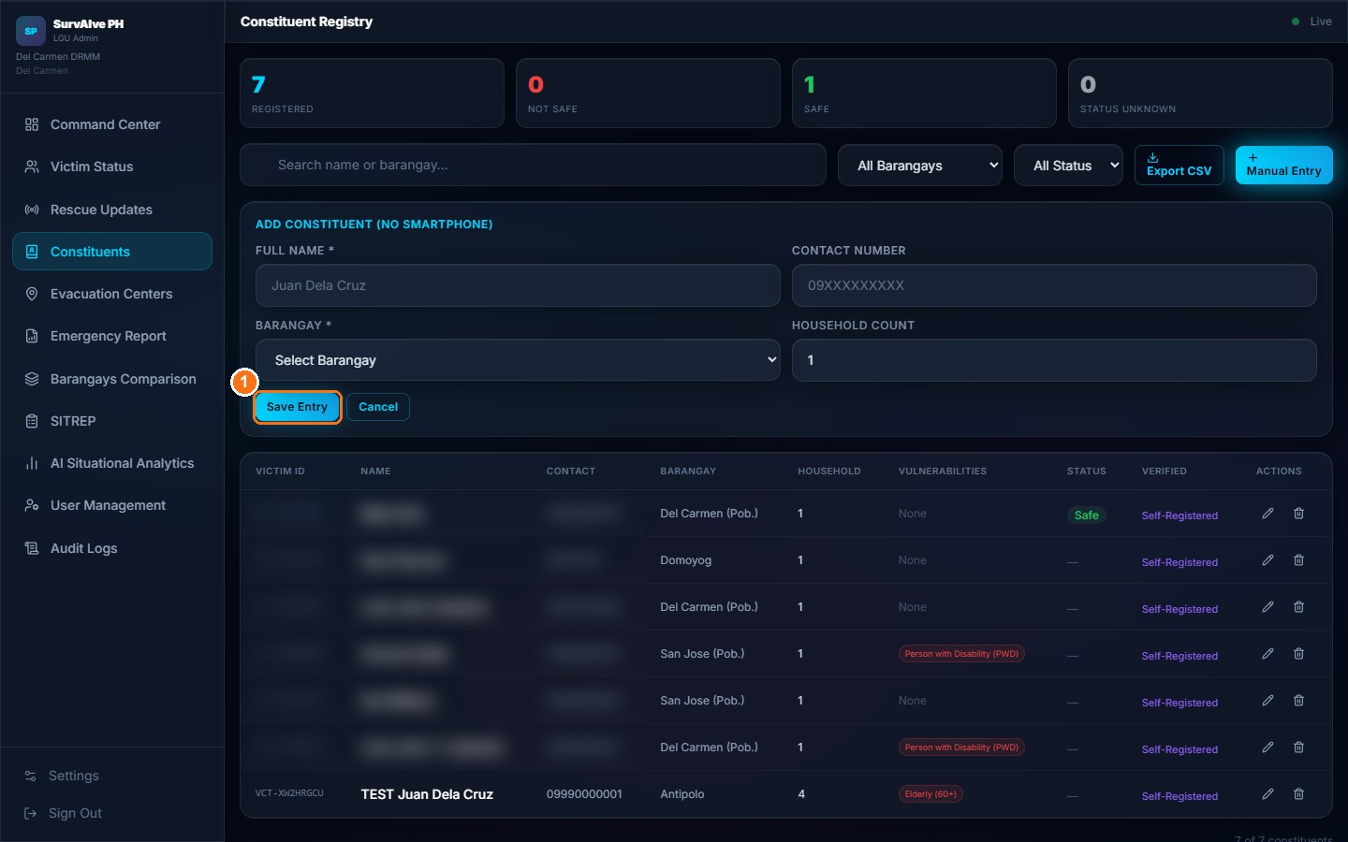
Figure 33. Add Constituent (No Smartphone) form
Expected Result: The registry is updated. Statuses also change automatically: a resident becomes "Not Safe" when they send an SOS and "Safe" when the SOS is marked Rescued.
Important Notes:
- A manually added constituent receives a Victim ID but no PIN, so they cannot sign in to the app.
LIMITATION — Export CSV
The Export CSV button (marker 2) currently only shows a message and does not download a file.

11.6 Evacuation Centers
Purpose: Publish evacuation center locations and status, which victims and responders see on their maps.
Who Can Use It: LGU Administrators.
Prerequisites: Signed in; the center's coordinates (latitude and longitude).
Procedure:
- Click Evacuation Centers in the sidebar. Counts show Total, Open, Full and Closed.
- Click Add Center (marker 1 in Figure 35).
- In New Evacuation Center, enter the Name (marker 1 in Figure 34), choose the Barangay, and enter Address and Capacity (marker 2).
- Enter Latitude (marker 3) and Longitude. Both are required.
- Optionally enter a Contact Number, choose the Status (Open, Full or Closed) (marker 4), and click Save (marker 5).
- To update a center later, click its pencil icon, change the status (for example to Full) and click Save.
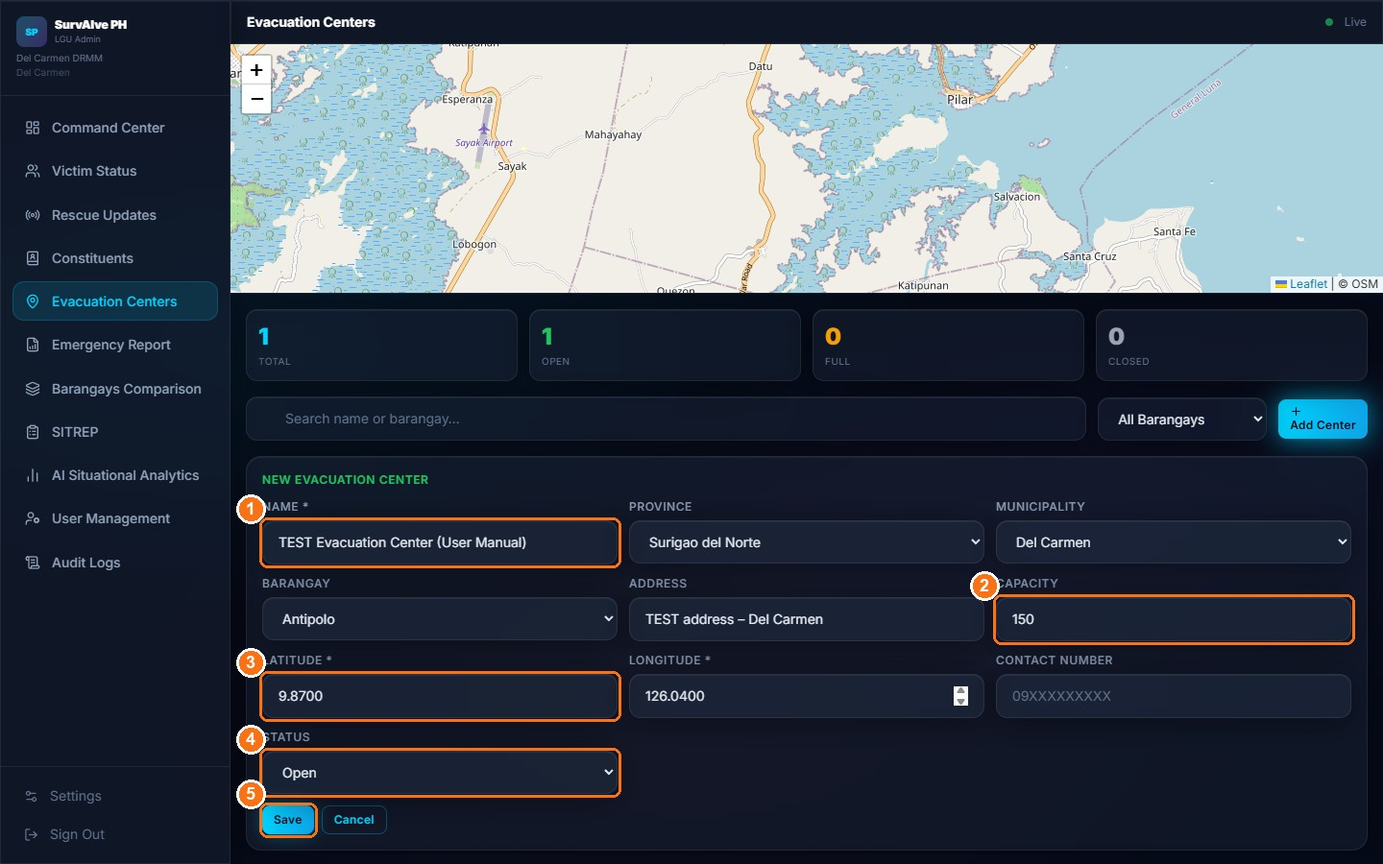
Figure 34. New Evacuation Center form
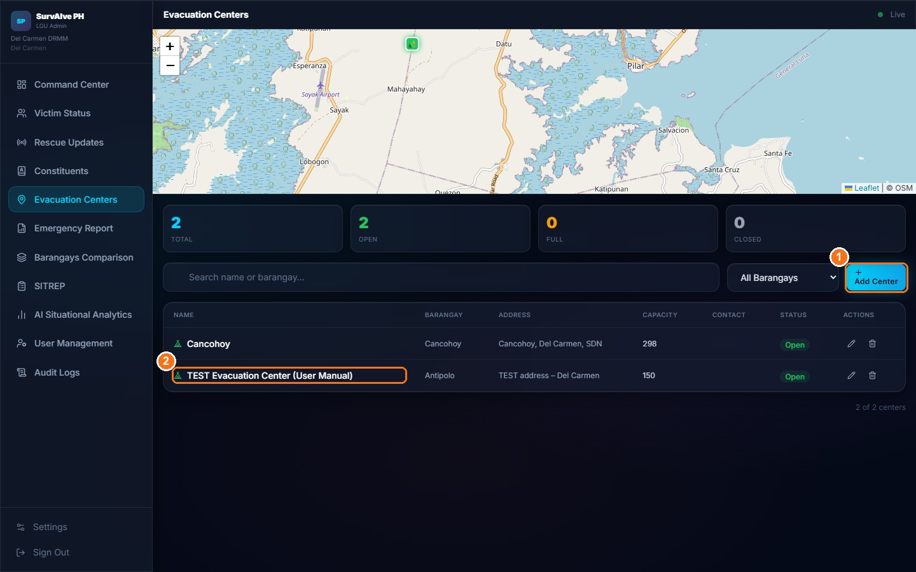
Figure 35. Evacuation Centers list with the new TEST center
Expected Result: The center appears in the list and on the victim and responder maps.

11.7 Emergency Report, Barangays Comparison and SITREP
Purpose: Generate printable municipal reports.
Who Can Use It: LGU Administrators (Agencies have Emergency Reports).
Prerequisites: Signed in.
Procedure:
- Click Emergency Report, Barangays Comparison or SITREP in the sidebar.
- Choose the period: Today (marker 1), Last 7 Days, Last 30 Days or Custom (date range).
- Click Generate Report (marker 2).
- Review the sections and click Print / Export (marker 3) to print or save the report as PDF from the browser's print dialog.
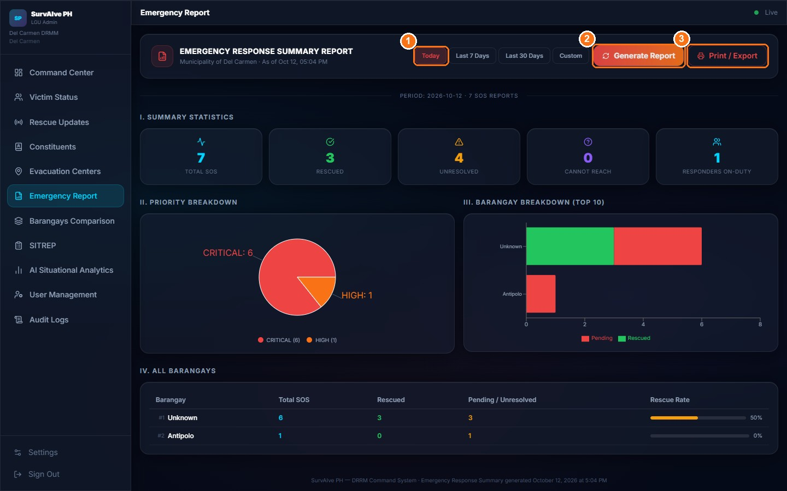
Figure 36. Emergency Response Summary Report
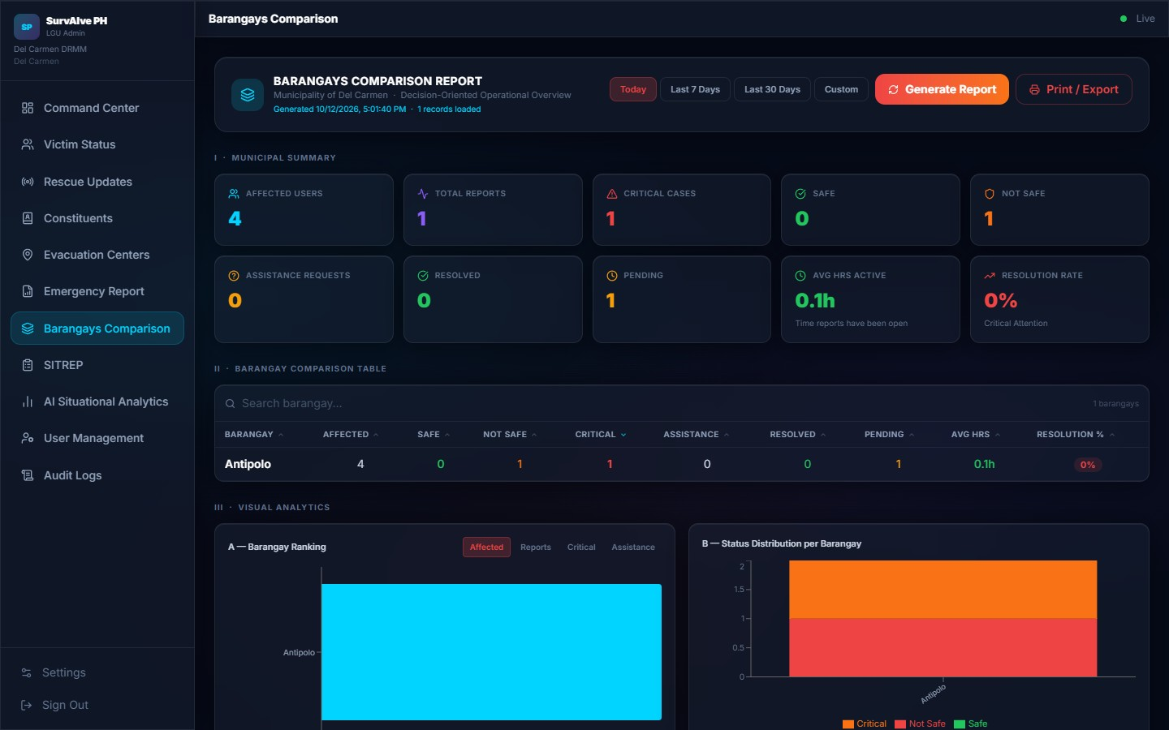
Figure 37. Barangays Comparison Report
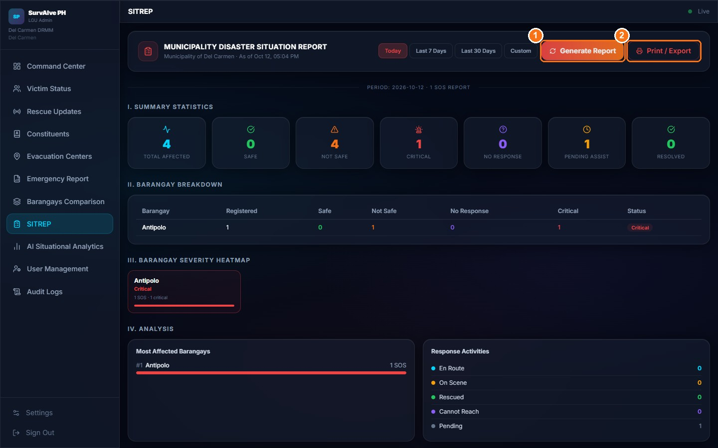
Figure 38. Municipality Disaster Situation Report (SITREP)
Expected Result: A printable report for the selected period.
Important Notes:
- Emergency Report sections: I. Summary Statistics, II. Priority Breakdown, III. Barangay Breakdown (Top 10), IV. All Barangays.
- Barangays Comparison: Municipal Summary, a sortable comparison table (Affected, Safe, Not Safe, Critical, Assistance, Resolved, Pending, Avg Hrs, Resolution Rate) and Visual Analytics charts.
- SITREP sections: I. Summary Statistics, II. Barangay Breakdown, III. Barangay Severity Heatmap, IV. Analysis, V. Trends Over Time.

11.8 AI Situational Analytics
Purpose: Review summary charts and rule-based insights about the current situation.
Who Can Use It: LGU Administrators and Agencies.
Prerequisites: Signed in.
Procedure:
- Click AI Situational Analytics in the sidebar.
- Review Victim Status Distribution, AI Priority Distribution and Reports Over Time (Last 7 Days).
- Review the verified rate, total reports and the Spam / False Report Indicator (a high share of guest reports may indicate false reports).
- Scroll down to AI-Assisted Situational Awareness zones and AI Insights. Click Refresh to recalculate.
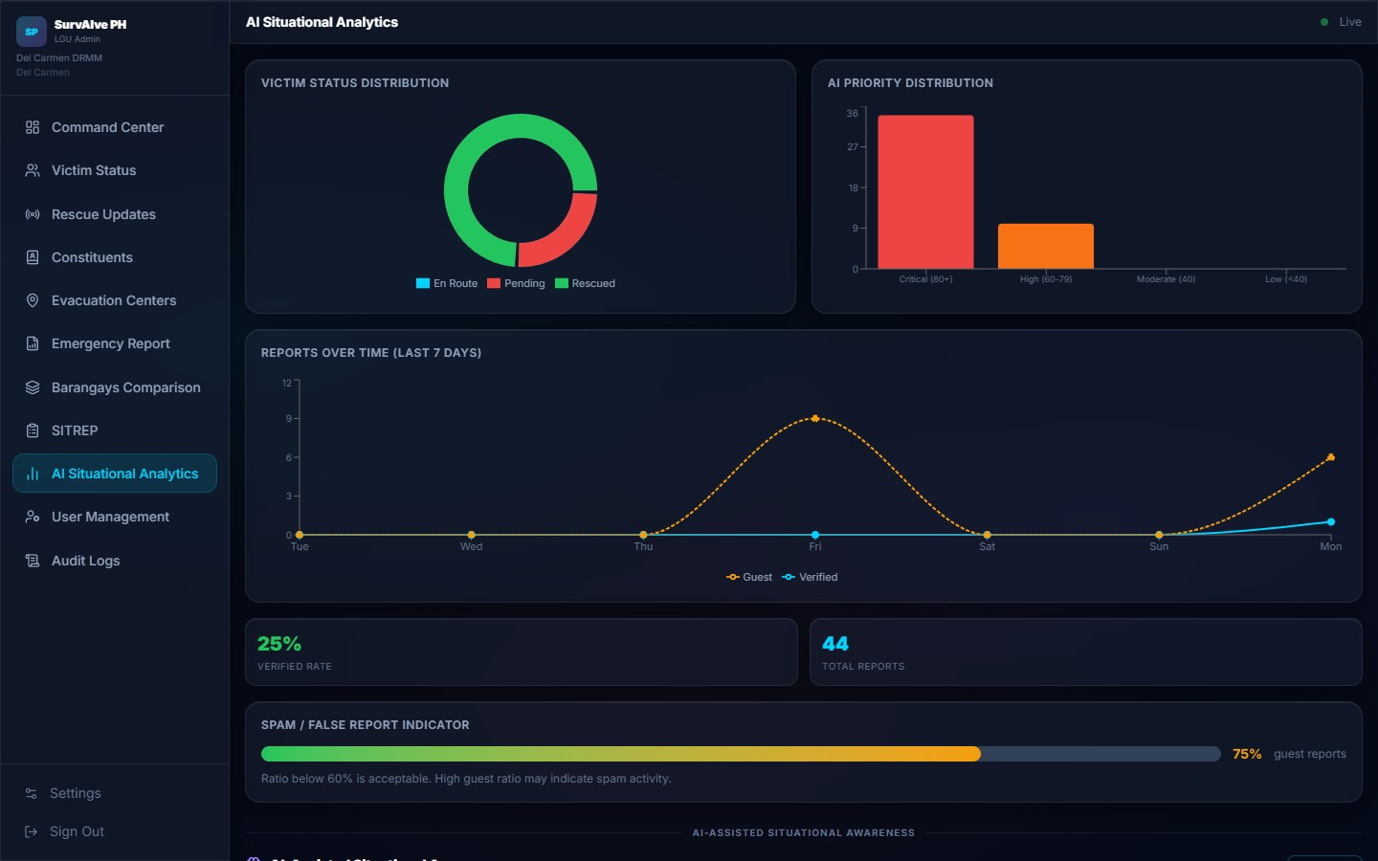
Figure 39. AI Situational Analytics
Expected Result: Charts and insights based on the current reports.
Important Notes:
- These analytics use fixed rules, not a trained AI model. Use them to support, not replace, human judgement.

11.9 User Management (Admins, Agencies and Responders)
Purpose: Create and manage the administrator, response agency and field responder accounts that can sign in to SurvAIve PH.
Who Can Use It: LGU Administrators.
Prerequisites: Signed in as Admin; the new user's name, contact number and an initial password.
Procedure:
- Click User Management in the sidebar. Choose the Admin tab (marker 1), the Agencies tab (marker 2) or the Responders tab (marker 3) (Figure 40). The cards above the list show the Total, Active and Inactive accounts on the selected tab.
- To find an account, type a name or contact number in the search box. To create one, click Add Admin, Add Agency or Add Responder (Figure 40, marker 4).
- For an admin, enter Full Name (marker 1 in Figure 41) and Contact Number (marker 2), and optionally a Gmail address. Province is fixed to your own; choose the Municipality the new admin will manage (marker 3). Enter a Password (marker 4).
- For an agency, enter Full Name (marker 1 in Figure 43), Contact Number (marker 2), choose the Agency Type (marker 3: MDRRMO, Hospital / Medical, BFP, PNP or PCG) and enter a Password (marker 4). Province and Municipality are fixed to your own.
- For a responder (Responders tab, Figure 42), also enter Gmail, Barangay, Team ID, Unit Name, Assigned Zone and Assigned Barangay.
- Click Save (marker 5 in Figure 41 or Figure 43). The new account appears in the list (Figure 44, marker 3).
- To edit an account, click its pencil icon, change the details or set Status to Inactive, and click Save. To delete an account, click its trash icon and confirm.
- Give the new user their contact number and password through a secure channel.
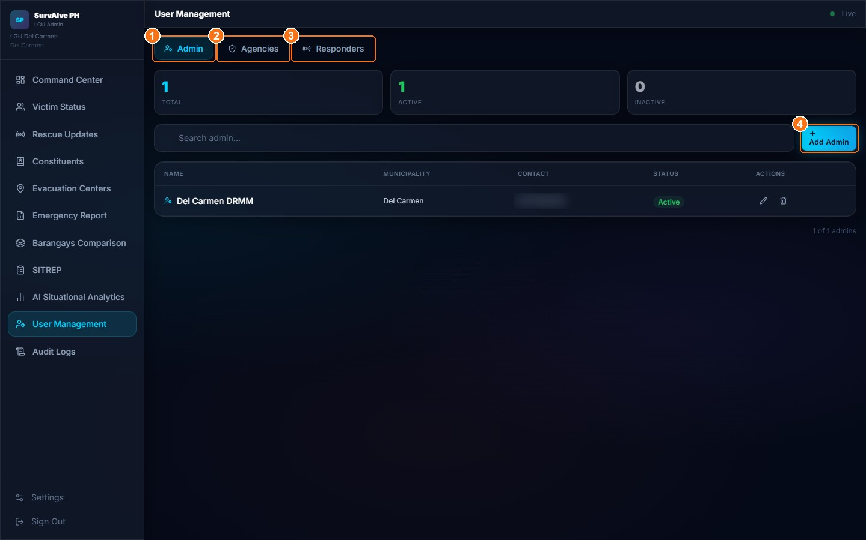
Figure 40. User Management: Admin tab (contact number blurred)
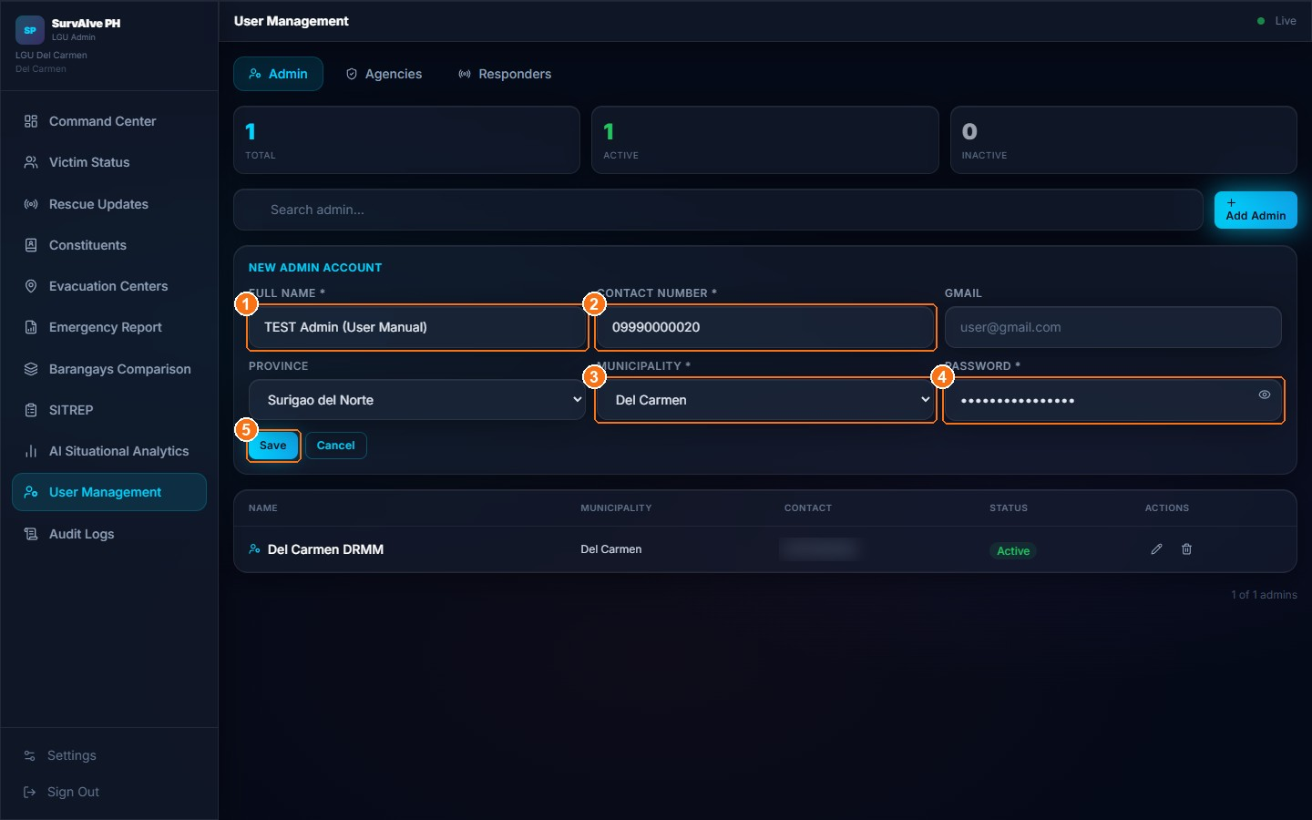
Figure 41. User Management: New Admin Account form
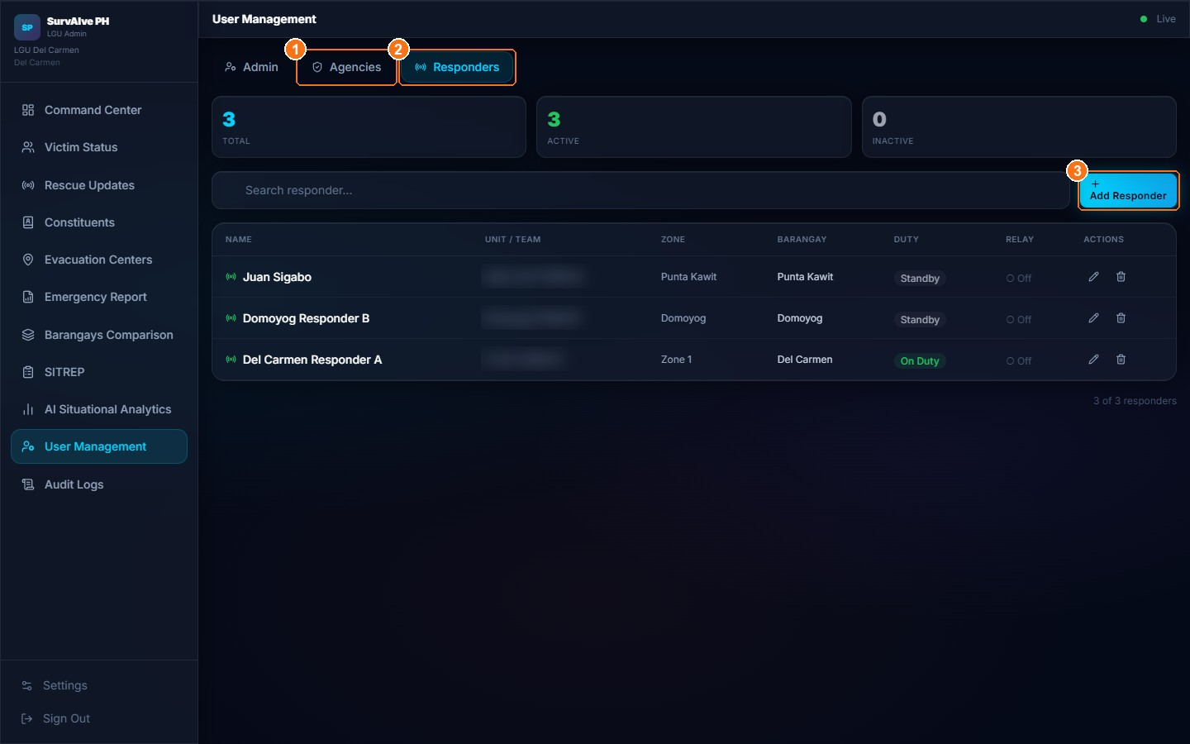
Figure 42. User Management: Responders tab (unit names blurred)
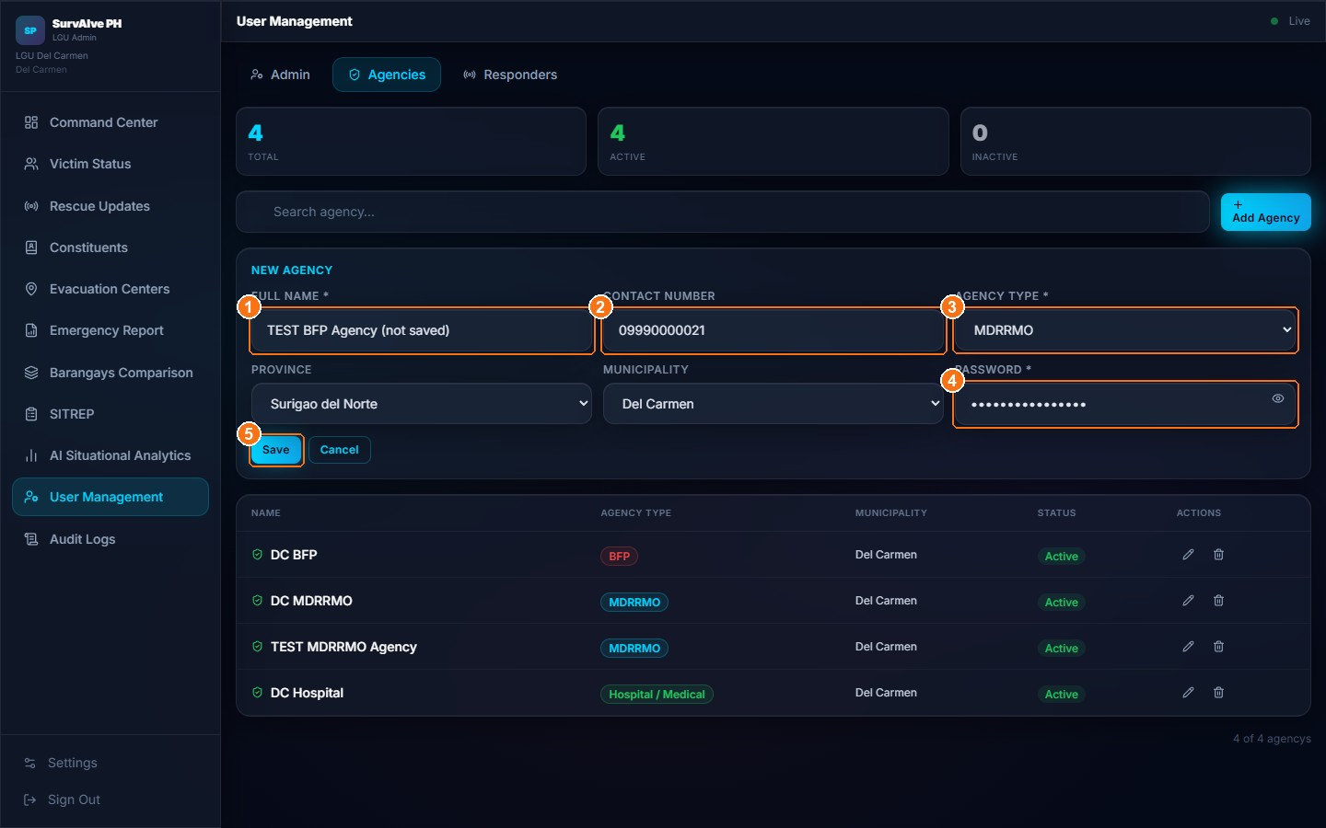
Figure 43. User Management: New Agency form
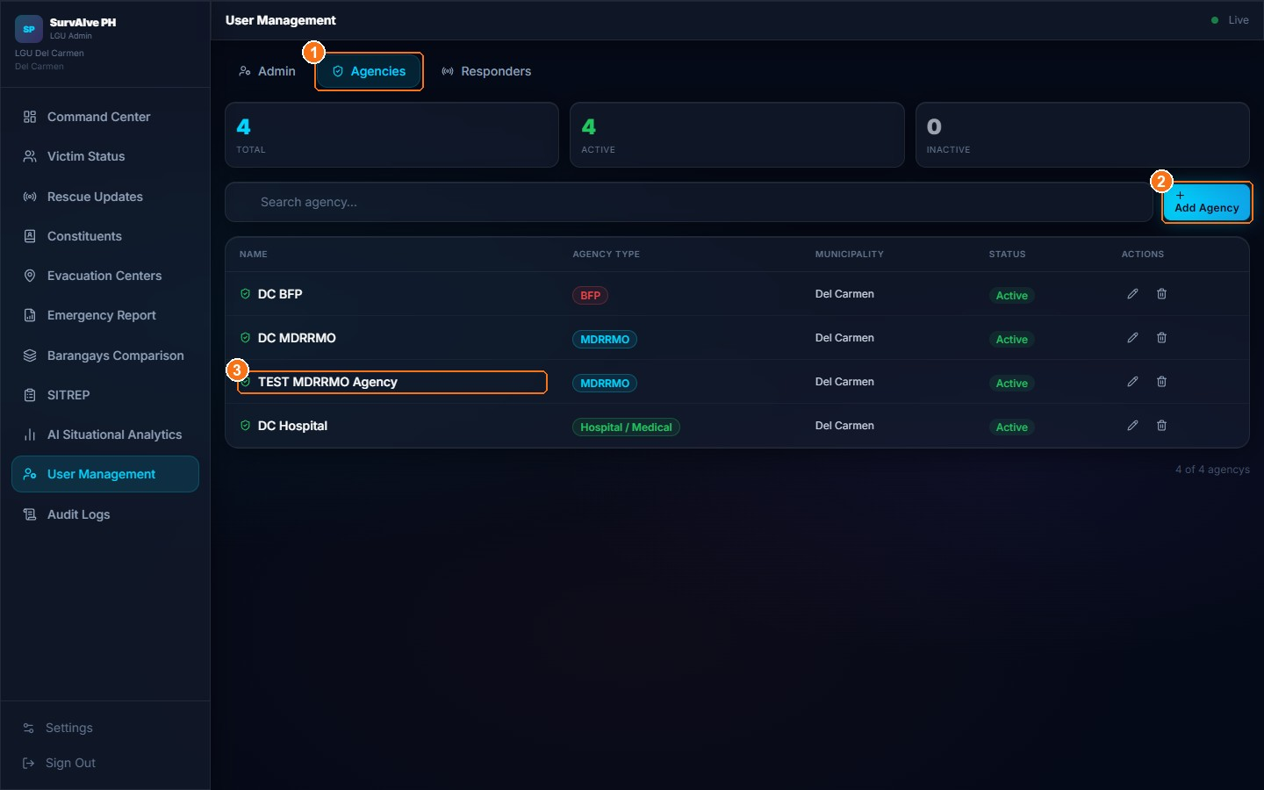
Figure 44. User Management: Agencies tab with the TEST MDRRMO agency
Expected Result: Agency and responder accounts are created and can sign in immediately with the selected role. For admin accounts, see the limitation below.
Important Notes:
- The Admin tab lists every admin account in your province. The Agencies and Responders tabs list accounts in your municipality.
- Validation messages: "Name is required", "Contact number is required" and "Municipality is required" (admins), "Password is required", and "Contact number 09XXXXXXXXX already has an account."
- Inactive responders cannot sign in ("Your account has been disabled. Contact your administrator.").
LIMITATION — Adding, editing or deleting admin accounts
In the current version, clicking Save for a new admin shows the error new row violates row-level security policy for table "admins". The online database does not yet allow the Admin role to change admin records, so editing or deleting an admin does not work either. (Observed during testing on October 13, 2026.)
Although the error is shown, the new admin's sign-in account is still created and can sign in, but the admin does not appear in the Admin tab. Report every failed attempt to the project team so that the sign-in account can be removed.

LIMITATION — Passwords, deactivation and deletion
When editing an existing account, the field New Password (blank = no change) is shown, but the new password is not saved. Ask the user to change their own password in Settings (Chapter 15).
Setting Status to Inactive blocks sign-in only for responders. Inactive admin and agency accounts can still sign in online.
Deleting an account removes it from the list but does not delete its sign-in account, so the person can still sign in online. To remove access completely, contact the SurvAIve PH project team.

11.10 Audit Logs
Purpose: Review who did what and when.
Who Can Use It: LGU Administrators.
Prerequisites: Signed in and online (Audit Logs are not available offline).
Procedure:
- Click Audit Logs in the sidebar.
- Search by user or action (marker 1), filter by role (marker 2), and choose Today (marker 3), Last 7 Days, Last 30 Days or Custom. Click Refresh to reload.
- Read the columns: Date & Time, User, Role / Agency, Action Performed, Affected Record and Details (for example "Pending → Rescued, By: …").
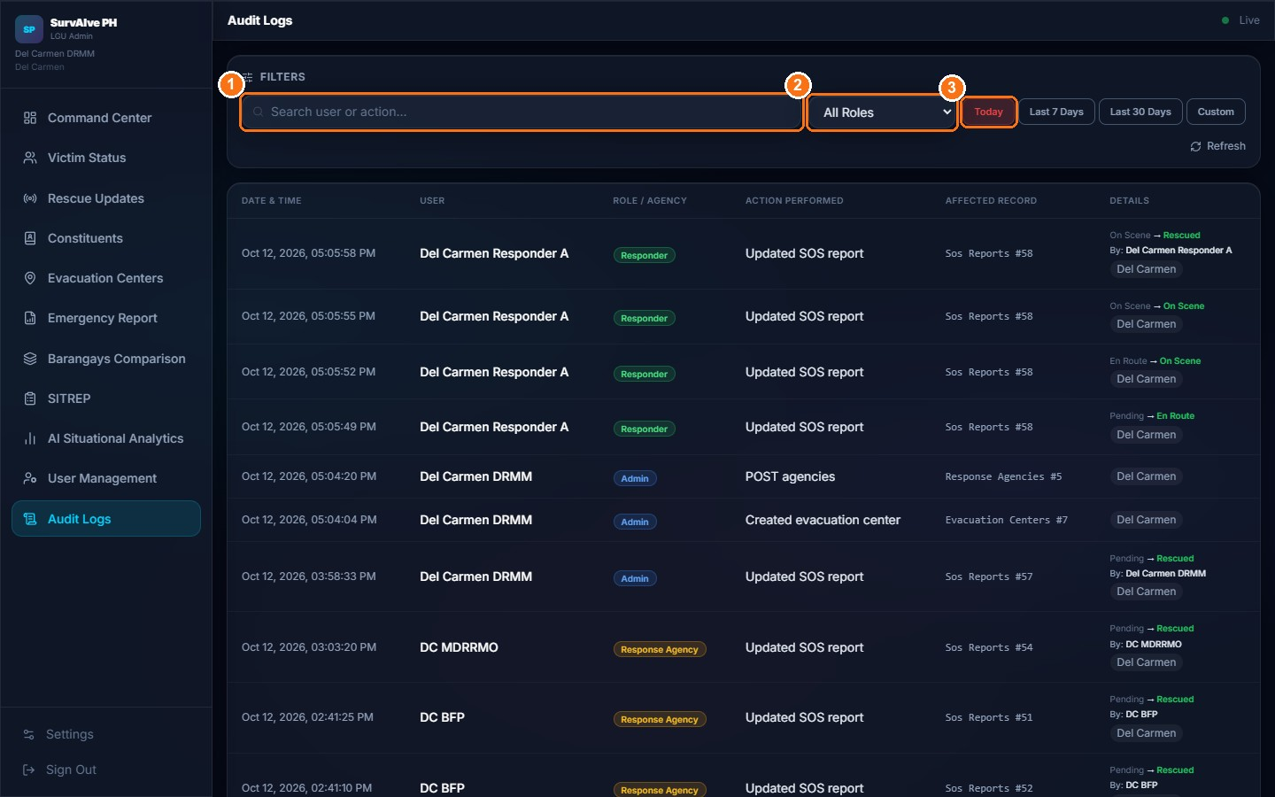
Figure 45. Audit Logs showing the TEST rescue updates and records created for this manual
Expected Result: The latest 200 activity records for your municipality are listed.
Important Notes:
- Offline, the page shows "Audit Logs are only available when online."
- Recorded actions observed during testing include "Updated SOS report", "Created evacuation center" and agency creation.

11.11 Admin Settings
Purpose: Manage your account and alert preferences.
Who Can Use It: LGU Administrators.
Prerequisites: Signed in.
Procedure:
- Click Settings at the bottom of the sidebar.
- Use Account Settings to change your display name (Save Name, marker 1) or password (Change Password, marker 2). See Chapter 15.
- Scroll to Emergency Alert Settings to set alerts (Section 15.2).
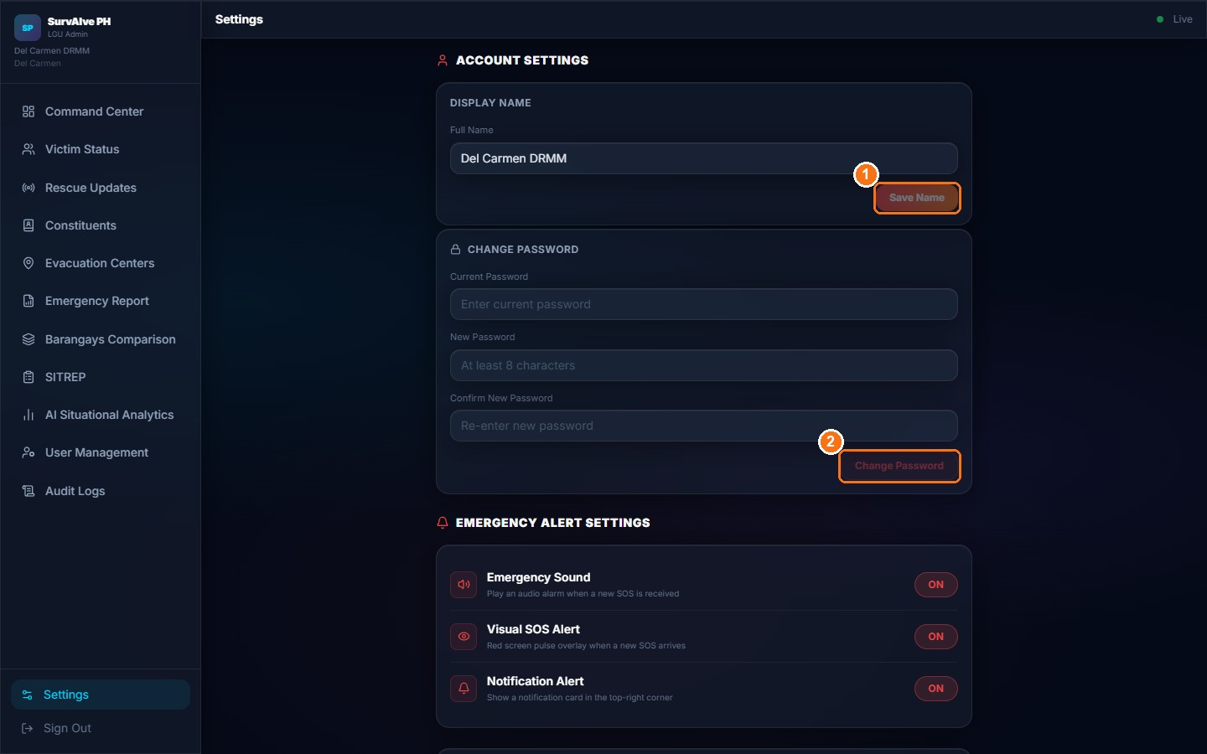
Figure 46. Admin Settings: Account Settings
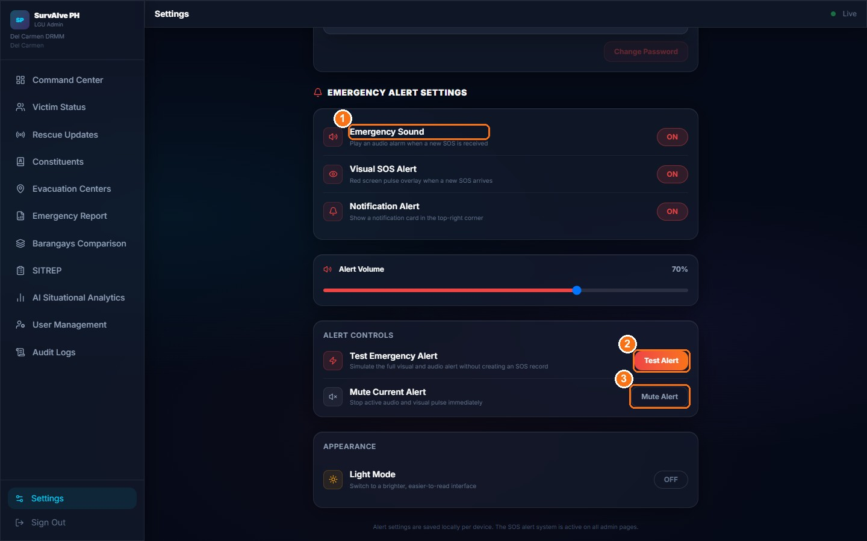
Figure 47. Admin Settings: Emergency Alert Settings, Alert Controls and Appearance

11.12 Sign Out Securely
- Click Sign Out at the bottom of the sidebar.
- Confirm that the landing page appears.
- Close the browser if the computer is shared.

12. Emergency Reporting and Rescue Workflow
The table below shows the complete emergency response process as implemented, and which steps happen automatically and which need a person to act.
Table 16. End-to-end emergency workflow
Step | What happens | Who / where | Automatic or manual
1 | The victim sends an SOS with the service(s), situation, number of people, age group, notes and GPS location. | Victim app – Send SOS Report | Manual (victim)
2 | The report is saved with rescue status Pending and an AI Priority Score. When offline, it is stored on the phone and broadcast over the mesh. | System | Automatic
3 | The report appears on the Command Center, Victim Status and responder queue. Dashboards show a NEW SOS ALERT with sound. Agencies see it only if their service was selected. | Admin, Agency, Responder screens | Automatic (display only, no dispatch)
4 | Staff review and acknowledge the alert and decide on the response. Teams can be assigned to Zone 1–3; there is no per-report assignment. | LGU Admin / Agency | Manual
5 | A responder opens the report from the queue or map and reviews the victim information and location. | Responder – Rescue Detail | Manual
6 | The responder updates the status: En Route → On Scene → Rescued or Cannot Reach, and submits field notes (which links the responder to the report). | Responder – Rescue Detail | Manual
7 | The outcome is recorded. Rescued stores who confirmed it and when. Admins and agencies can also click Mark Rescued. The constituent status changes to "Safe". | Responder / Admin / Agency; database | Manual, with automatic status sync
8 | Rescued reports leave the responder queue. Reports can be dismissed by staff. There is no separate "Closed" status. | System / Admin | Automatic / Manual
9 | Administrators review rescue progress in Rescue Updates, generate Emergency Reports and SITREPs, and check the Audit Logs. | LGU Admin | Manual

IMPORTANT — Key facts about the workflow
An SOS does not automatically dispatch emergency services.
AI scores and analytics do not make operational decisions.
The victim is not notified when the rescue status changes.
Mesh communication does not guarantee delivery.

13. Victim Status Definitions and Updates

13.1 Situation reported by the victim
Table 17. Victim-reported situation
Value | Label on SOS form | Meaning
trapped | Trapped | Cannot leave the location without help (default).
injured | Injured | Someone is hurt and needs medical attention.
missing | Missing | Reporting a missing person.
safe | Safe / Need Supplies | Safe but needs supplies such as food, water or medicine.

13.2 Rescue status
Table 18. Rescue status values
Status | Meaning | Set by
Pending | Received, no rescue action recorded yet. | System (automatic, when the SOS is saved)
En Route | A responder is travelling to the victim. | Field Responder
On Scene | A responder has arrived. | Field Responder
Rescued | The victim has been rescued or helped. | Field Responder; Admin and Agency (Mark Rescued)
Cannot Reach | The responder could not reach the location. | Field Responder
Dismissed | Removed from the active list by staff (e.g. duplicate or false report). | Admin / Agency (Dismiss)

13.3 Priority levels and the AI Priority Score
Table 19. Priority levels
Priority | Score | Confirmation message to victim
CRITICAL | 80 – 99 | Rescue teams alerted
HIGH | 60 – 79 | Added to priority queue
MODERATE | 40 – 59 | In rescue queue
LOW | below 40 | Queued for response

The score starts at 50 and is adjusted by fixed rules, capped at 99:
Table 20. AI Priority Score rules
Factor | Points
Situation | Trapped +30, Injured +20, Missing +15
Number of people | 10 or more +25, 5 or more +15, 2 or more +5
Age group | Senior +20, Child +15
Special conditions (from voice or photo) | Medical emergency +20, Fire +15, Structural collapse +10, Flooding +10
Verification | Guest (unverified) −10
Waiting time (on staff lists) | +5 after 30 min, +10 after 1 h, +15 after 2 h, +20 after 4 h

13.4 Constituent status (Constituents registry)
Table 21. Constituent status values
Status | Shown as | When it changes
active | — | Default after registration.
sos_sent | Not Safe | Automatically, when the constituent sends an SOS.
rescued | Safe | Automatically, when their SOS is marked Rescued; or manually by the Admin.
unknown | Status Unknown | Set manually by the Admin.

14. Offline Mode, Connectivity, and Data Synchronization
SurvAIve PH is designed for situations where cellular and internet service fail. It is important to understand the difference between four things:
Table 22. Offline concepts
Concept | What it means | Does it mean help is coming?
Offline interface | The app screens open and you can fill in the SOS form without internet. | No
Local storage | An SOS sent while offline is saved on your phone. | No – it has not reached anyone yet
Mesh relay | Your SOS is passed from phone to phone (Android app only) and may reach a responder's phone or a phone with internet. | Not by itself – only if it reaches staff
Server delivery | The SOS is saved in the database (online) or on the local XAMPP server, and appears on staff dashboards. | It is visible to staff, who must then act

14.1 How to tell whether you are online or offline
- Victim Home screen: the Online / Offline chip.
- SOS form: the banner "📡 Offline Mode – SOS will be stored locally and broadcast via mesh".
- SOS confirmation: an AI Priority Score means the report reached a server; "Saved offline — will sync when signal returns" means it is only stored on the phone.
- Dashboards: a green Live indicator at the top right; an offline banner with Retry on the Command Center.
- Mesh screens: Peers, Transport (BLE, Wi-Fi Direct or "web") and Relay; Last Sync shows when the statistics were last read.
NOTE — Connected is not always online
"Online" means the phone is connected to a network. On an LGU hotspot without internet, the chip may still show Online, and requests then go to the local XAMPP server if it is set up.

14.2 What works without internet
Table 23. Offline availability
Function | Without internet | Notes
Victim sign-in on the registered phone | Yes | Checked on the phone, valid for 30 days.
Fill in and send the SOS form | Yes | Stored on the phone and broadcast over the mesh (Android).
SOS delivery to the local server | Yes, if the XAMPP server is reachable | Set the address in Settings → Local Server (XAMPP).
Staff sign-in | Yes, via the local server | Only after one successful online sign-in.
Victim queue, Rescue Detail status updates | Yes, via the local server | Uses local MySQL data.
Evacuation centers list | Yes, via the local server | Map tiles do not load offline.
Maps (OpenStreetMap tiles) | No | Tiles are not cached.
Audit Logs | No | "Audit Logs are only available when online."
Analytics, User Management, reports | No (cloud only) | Require the online database.
Display name / password change | Only via the local server | Online, changes go to the cloud account (victim PIN: local server only). See Chapter 15.

14.3 How mesh communication works (Android app)
- When you send an SOS, the app broadcasts a small message containing your status, number of people, location and barangay.
- Nearby phones running SurvAIve PH receive it over Bluetooth Low Energy (or Wi-Fi Direct) and forward it again, up to 5 hops.
- A phone that receives the SOS sends back an acknowledgement (ACK). Your confirmation screen and Mesh page tick: Received by nearby device (level 2), Relayed — N hops (level 3), or Responder received your SOS (level 4, when the acknowledging phone belongs to a responder).
- In the combined Android app, a phone that receives an SOS and has internet uploads it to the server automatically and shows a "SOS Received via Mesh" notification.
LIMITATION — Mesh limitations (confirmed in source code)
Mesh works only in the Android app. In a web browser, Peers is always 0 and Transport shows "web"; the screenshots in this manual therefore show the web state.
Only the combined Android app receives, acknowledges and uploads mesh messages. The separate victim and responder builds do not start this service.
The phone retries unsent mesh messages for as long as the app is running (up to 20 messages); they are lost if the app is closed.
The very short Bluetooth beacon used for passive reception only carries Trapped, Injured and general SOS statuses and a shortened barangay name.
Mesh delivery is not guaranteed. It depends on how many phones nearby run the app with Bluetooth on.

14.4 Synchronization after connectivity returns
LIMITATION — Stored SOS reports are not re-sent automatically
The app is designed to re-send SOS reports saved offline when the connection returns. In the current version this automatic re-sending does not work (a defect in the offline queue), and there are no "pending", "synced" or "failed" indicators.
What to do: when you get a signal again, open the SOS form and send your SOS again. Check that the confirmation screen shows an AI Priority Score.

14.5 If information looks outdated
- Dashboards: click the refresh button on Live Stats, or reload the page (F5). Check the Live indicator.
- Responder queue: tap the refresh icon at the top of the Victim Queue.
- Mesh page: tap Refresh (this only re-reads mesh statistics; it does not sync reports).
- If data is still stale, check your connection and contact your administrator.

15. Account Settings and Password Management

15.1 Change Display Name and Password (or PIN)
Purpose: Update the name shown on your account and change your password (staff) or PIN (victims).
Who Can Use It: All signed-in users (not guests).
Prerequisites: Your current password or PIN. Staff need an internet connection, or the local XAMPP server when offline. Victims need the local XAMPP server to change their PIN (see the limitation below).
Procedure:
- Open Settings (bottom bar on mobile, bottom of the sidebar on dashboards). The Account Settings panel is at the top (victims: scroll down).
- To change your name, edit Full Name under Display Name and click Save Name (marker 1). The button is disabled until you change the name. A confirmation appears below the name (marker 2).
- To change your password, enter the Current Password, the New Password (at least 8 characters) and Confirm New Password, then click Change Password. Victims see Change PIN (minimum 4 characters).
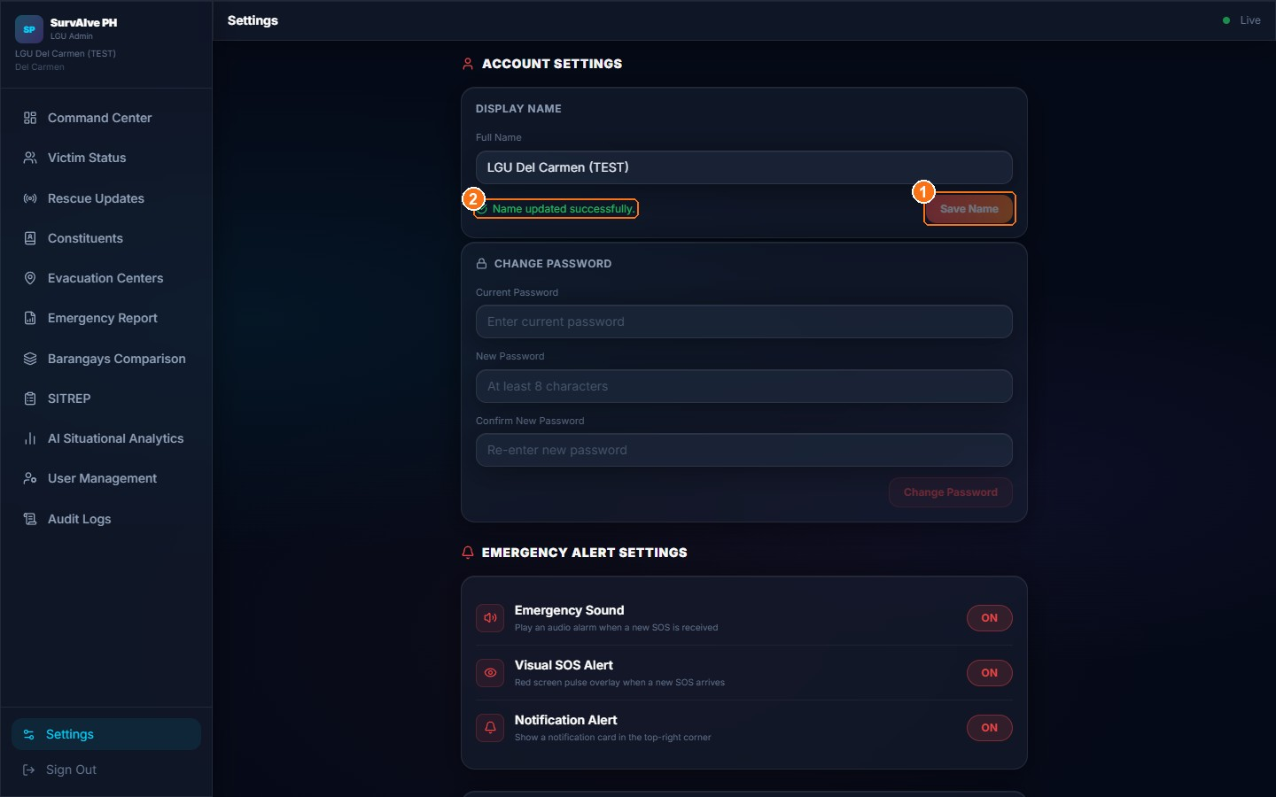
Figure 48. Account Settings after a successful display name change (TEST name, restored afterwards)
Expected Result: When successful: "Name updated successfully.", "Password changed successfully." or "PIN changed successfully." Validation messages include "Passwords do not match.", "PINs do not match.", "Password must be at least 8 characters." and "PIN must be at least 4 characters."
LIMITATION — Where name, password and PIN changes are saved
Online, a display name change is saved to your cloud account (and copied to the local XAMPP server when it can be reached).
A staff password change is saved to your cloud account when you are online and the local XAMPP server cannot be reached, which is the normal case on mobile data or home internet. The new password works at your next online sign-in (verified on October 13, 2026).
When the local XAMPP server can be reached (for example on the LGU network), the change is sent to that server first. If you signed in online, the server may reject it with "Invalid or expired token"; if you signed in offline, the new password applies only to offline sign-in. If a change does not take effect, ask your administrator.
Victims: PIN changes are sent only to the local XAMPP server, and the new PIN is not applied to the offline sign-in stored on the phone.

15.2 Emergency alert settings (Admin and Agency)
Table 24. Emergency alert settings
Setting | What it does
Emergency Sound | Plays an alarm when a new SOS is received.
Visual SOS Alert | Red screen pulse when a new SOS arrives.
Notification Alert | Shows the NEW SOS ALERT card in the top-right corner.
Alert Volume | Slider for the alarm volume.
Test Alert | Simulates the visual and audio alert without creating an SOS record.
Mute Alert | Stops the current alarm and visual pulse immediately.
Light Mode | Switches to the brighter appearance.

These preferences are stored in the current browser only.

15.3 Forgotten password or PIN
- Staff: there is no self-service "Forgot password" link. Contact your administrator.
- Victims: there is no PIN reset. Contact your local DRRM office. They can check your record in the Constituents registry.

16. Notifications, Reports, Analytics, and Audit Logs
Table 25. Notifications and reporting features
Feature | Available to | Where described
NEW SOS ALERT card with alarm sound and screen pulse | Admin, Agency | Sections 7.3 and 15.2
"CRITICAL SOS — RECEIVED VIA MESH" card | Responder (combined Android app) | Section 9.1
Android notification "SOS Received via Mesh" | Any user of the combined Android app | Section 14.3
Victim notifications of rescue progress | Not implemented | Section 8.8
Emergency Report | Admin, Agency | Section 11.7
Barangays Comparison, SITREP (municipal) | Admin | Section 11.7
AI Situational Analytics | Admin, Agency | Section 11.8
Audit Logs | Admin (online only) | Section 11.10

NOTE — Push notifications
The push-notification library is installed in the Android project but is not used by the current version. Staff should keep the dashboard open to receive SOS alerts.

17. Security, Privacy, and Responsible System Use

17.1 For all users
- Use SurvAIve PH only for real emergencies. False reports waste resources and may delay help for real victims. Guest reports are logged and traceable.
- Personal data is handled under the Data Privacy Act of 2012 (Republic Act 10173).
- Do not share your password, PIN or Victim ID with others.
- Sign out on shared devices.

17.2 For staff
- Access victim information only for emergency response purposes.
- Always select your own jurisdiction at sign-in.
- Give new users their initial passwords through a secure channel. When staff leave, set responder accounts to Inactive and ask the project team to remove the sign-in accounts of admins and agencies (Section 11.9).
- Do not print or export reports containing personal data unless needed, and store printed copies securely.
- Review the Audit Logs regularly.
- Treat AI scores and analytics as decision support only.
IMPORTANT — Device and browser storage
Sign-in sessions and offline victim credentials are stored on the device. Protect phones and computers with a screen lock.

18. Troubleshooting and Frequently Asked Questions

18.1 Troubleshooting guide
Table 26. Troubleshooting guide
Problem or error | Possible cause | Recommended solution | When to contact the administrator
Unable to sign in (staff) | Wrong role card chosen; no internet and never signed in online; account inactive | Choose the correct role; check the connection; sign in online once before relying on offline sign-in | If the problem continues after checking role and connection
"Invalid credentials. Check your contact number and password." | Wrong contact number or password, or the account belongs to another role | Re-enter the 11-digit number (09XXXXXXXXX) and password; use the eye icon to check it | If you are sure the credentials are correct
"Your account has been disabled." | The responder account was set to Inactive | None for the user | Immediately – ask the LGU Admin to reactivate
"Account not fully set up." | Login exists without a complete profile record | None for the user | Immediately
Victim: "Invalid Victim ID or PIN" / "Wrong PIN or device not recognised." | Wrong PIN, mistyped Victim ID, or a different phone | Check the ID format VCT-XXXXXXXX; use the registered phone; sign in online once on a new phone | If you forgot your PIN or ID
Victim: "Account is not active." | Registry status changed after sending an SOS (known limitation) | Use the registered phone (offline check), or continue as guest in an emergency | Contact the local DRRM office
Access denied / sent back to the landing page | Opening a page not allowed for your role; agency "View on Map" defect; session expired | Sign in again with the correct role; avoid View on Map from agency accounts | If it happens on normal pages
A menu or module is missing | Different roles have different menus (Section 7.2) | Check that you signed in with the correct role | If your role should have access
SOS cannot be sent (nothing happens) | No Emergency Service selected; Photo Mode without analysis | Select at least one service; analyse the photo or switch to Status Mode | Not needed
"SOS saved offline. (Error: …)" | Server could not be reached | Move to a place with signal and send the SOS again; use other channels | If online sending keeps failing
Location shows "Getting GPS location…" or GPS Denied | Location permission denied, GPS off, indoors | Allow location in browser/phone settings, turn on GPS, move near a window; describe your location in Notes | Not needed
Map is blank or grey | No internet for map tiles | Reconnect; use the evacuation center list below the map | Not needed
Internet connection problems | Network outage | Use the local server address in Settings; use the Android mesh; retry later | To confirm the local server address
Offline SOS never appears on dashboards | Automatic re-send of the offline queue does not work in this version | Re-send the SOS once online | Report the incident to the LGU by other means
Dashboard information looks stale | Real-time connection dropped | Click refresh or reload the page; check the Live indicator | If it stays stale after reloading
Database or server error / "Failed to fetch" | Cloud service unavailable, or the local XAMPP server is off or unreachable | Retry; check the local server address; reload | If it continues, so the server can be checked
Unable to update victim status (responder) | No connection; the update failed silently | Check that Current shows the new status; retry; report by radio | If updates repeatedly do not appear on dashboards
Password or PIN change fails ("Failed to fetch", "Invalid or expired token") | Victim PIN changes need the local XAMPP server; a reachable local server may reject a session that was started online | Staff: retry on a normal internet connection (away from the LGU network). Victims: connect to the LGU network with the local server | If the change still fails, or for password resets
User Management: new password not applied | Edit form does not save passwords (known limitation) | Have the user change it in Settings, or contact the project team | —
Add Admin shows "new row violates row-level security policy" | The online database does not allow the Admin role to write admin records (known limitation) | None for the user; the admin was not added | Immediately, so that the sign-in account created by the failed attempt can be removed
Mesh shows 0 peers | Web browser (no mesh); Bluetooth/Wi-Fi off; no nearby devices; permissions denied | Use the Android app; turn on Bluetooth, Wi-Fi and Location; allow permissions | If peers never appear with several phones nearby

18.2 Frequently asked questions
Q: Does sending an SOS automatically send a rescue team?
A: No. It alerts staff dashboards and adds you to the queue. Staff and responders decide and act.
Q: Will I be told when a responder is coming?
A: Not in the current version. The app shows mesh acknowledgements only. Stay where you are, keep your phone on, and use other channels if you can.
Q: Can I use SurvAIve PH without internet?
A: Partly. You can fill in and store an SOS and broadcast it over the mesh with the Android app. It reaches staff only if it gets to the server (directly, through the local server, or through another phone with internet).
Q: Why does my guest report have lower priority?
A: Guest reports are unverified, so 10 points are deducted from the AI Priority Score. Register a profile for full priority.
Q: What is my Victim ID?
A: A code like VCT-AB3KZ9PQ shown once when you register. You need it with your PIN to sign in.
Q: Can I choose more than one emergency service?
A: Yes. Each selected agency will see your report.
Q: Why can't an agency user see all reports?
A: Agencies only see reports that requested their service.
Q: Who creates staff accounts?
A: An LGU Admin creates admin, agency and responder accounts in User Management (Section 11.9).
Q: Is the "AI" a real artificial intelligence model?
A: The priority score and analytics are rule-based, and Photo Mode is a simulation. They support but do not replace human judgement.

19. Glossary of Terms
Table 27. Glossary
Term | Definition
ACK (acknowledgement) | A short reply from another phone confirming that it received an SOS over the mesh.
AI Priority Score | A 0–99 score calculated by fixed rules to rank SOS reports (Section 13.3).
BFP | Bureau of Fire Protection.
BLE (Bluetooth Low Energy) | A low-power Bluetooth technology used by the Android app to exchange mesh messages.
Command Center | The main live dashboard for LGU Admins and Agencies.
Constituent | A registered resident in the municipality's registry.
Guest | A user who sends an SOS without registering. Reports are unverified.
Hop | One step of an SOS message passing from one phone to the next. The mesh allows up to 5 hops.
Jurisdiction / scope | The province and municipality chosen at staff sign-in, which filters what data you see.
LGU | Local Government Unit (the municipality or city).
MDRRMO | Municipal Disaster Risk Reduction and Management Office.
Mesh network | Phones passing messages directly to each other without internet or cellular service.
PCG | Philippine Coast Guard.
PIN | A 6-digit number used by victims to sign in.
PNP | Philippine National Police.
RA 10173 | Republic Act 10173, the Data Privacy Act of 2012.
Rescue status | Pending, En Route, On Scene, Rescued or Cannot Reach (Section 13.2).
SITREP | Situation Report: a structured summary of the emergency situation for a period.
SOS | An emergency request for help sent through the app.
Supabase | The cloud database and sign-in service used when online.
Victim ID | A unique code (VCT-XXXXXXXX) given to a registered community user.
Wi-Fi Direct | A way for phones to connect to each other over Wi-Fi without a router; a backup mesh transport.
XAMPP (local server) | A local web and database server used as an offline fallback on the LGU network or hotspot.
YOLO11 | The name shown for Photo Mode scene analysis. In this version it is a simulation (Section 8.6).

20. Support and Contact Information
For help with SurvAIve PH, contact the following in order. Fill in the local details before distributing this manual.
Table 28. Support contacts
Who | For | Contact details
Your LGU DRRM Office / LGU Administrator | Staff and admin accounts, password resets, victim account issues, local server address | Office: ____________________  Phone: ____________________  Email: ____________________
SurvAIve PH Project Team | System errors, defects listed in Appendix B, technical support | Name: ____________________  Email: ____________________

IMPORTANT — In a life-threatening emergency
Always also try the national emergency hotline (911), your barangay officials and local radio channels.

20.1 Reporting a problem
When reporting a problem, include: your role, the page name, what you did, the exact message shown, the date and time, and whether you were online or offline. A screenshot helps.

21. Appendix

Appendix A. Role Permission Summary
Table 29. Role permissions summary
Action | Victim | Responder | Agency | Admin
Send SOS | ✔ | — | — | —
Set En Route / On Scene / Cannot Reach | — | ✔ | — | —
Set Rescued | — | ✔ | ✔ | ✔
Dismiss report | — | — | ✔ | ✔
Change own duty status | — | ✔ | — | —
Assign team to zone | — | — | — | ✔
Manage constituents | — | — | — | ✔
Manage evacuation centers | — | — | — | ✔
Create agency / responder accounts | — | — | — | ✔
Create admin accounts | — | — | — | ✔ (see Section 11.9 limitation)
Generate reports | — | — | ✔ | ✔
View Audit Logs | — | — | — | ✔

Appendix B. Known Limitations and Unavailable Features
The following were confirmed by source-code review and/or testing on October 12 and 13, 2026. They are listed so that users and evaluators have accurate expectations.
Table 30. Known limitations
# | Area | Limitation
1 | Victim feedback | Victims do not see rescue status updates and receive no notifications. Mesh "Responder received" is an automatic acknowledgement.
2 | Offline sync | SOS reports saved offline are not re-sent automatically; there are no pending/synced/failed indicators.
3 | Mesh | Works only in the Android app, and receive/forward/notify only in the combined build. Web browsers show 0 peers.
4 | AI features | Photo Mode ("YOLO11") is simulated and the photo is not uploaded. Priority scores and analytics are rule-based.
5 | Assignment | No per-report responder assignment and no Accept button; only Zone 1–3 team assignment. Responder lists show all municipal reports. No responder incident history.
6 | Account settings | Online display name and staff password changes work. Victim PIN changes still go only to the local XAMPP server, and a reachable local server may reject staff changes. User Management edit does not save new passwords.
7 | Admin accounts | Add Admin fails with a row-level security error but still creates a sign-in account. Editing and deleting admins does not work.
8 | Agency navigation | "View on Map" in agency Victim Status sends the user to the landing page.
9 | No-effect controls | Responder Sync button, Auto-Relay Mode and Force Offline Mode toggles, Battery Saver (only disables relay), Flag Suspicious and Remove from view (not saved), Constituents Export CSV (message only), Shake/Volume auto-SOS (unreliable).
10 | Pages not in navigation | Situational Awareness and Emergency Ops Reports exist in the code but cannot be opened from the menus. They are not available in this version.
11 | Victim sign-in | Online sign-in may be refused ("Account is not active") after the victim has sent an SOS.
12 | Jurisdiction | The municipality chosen at staff sign-in is not checked against the account's assigned municipality.
13 | Responder status saves | Failed status updates are not reported to the responder. Submitting field notes overwrites the victim's original notes.
14 | Push notifications | Not implemented; only the mesh local notification exists in the combined Android app.
15 | Developer page | The /dev role selector is a developer tool and should be disabled in production. Its "Victim (Profiled)" button does not work.
16 | Account removal | Inactive status blocks sign-in only for responders. Deleting any staff account leaves its sign-in account able to sign in online.

Appendix C. Features That Could Not Be Verified for This Manual
- Real BLE / Wi-Fi Direct mesh relaying between Android phones, the "SOS Received via Mesh" notification and the "SurvAIve Mesh Active" notification. Screenshots were captured in a web browser, where the mesh is not available.
- Offline operation through the local XAMPP server, including offline staff sign-in. The local server was not running during capture.
- Password and PIN changes through the local XAMPP server, including victim PIN changes. (Online display name and staff password changes were verified on October 13, 2026.)
- Photo Mode with a real camera, and voice input (Speak).
- Shake to SOS and Volume Button SOS on a physical device.
- Printed output of Print / Export (the browser print dialog was not captured).

Appendix D. Sample (TEST) Data Used in Screenshots
The following clearly labelled sample records were created in the live system for this manual. Administrators may delete them after review.
Table 31. TEST records
Record type | Identifier / name | Where to find it
Victim profile (constituent) | TEST Juan Dela Cruz, Victim ID VCT-XW2HRGCU, Antipolo, Del Carmen | Admin → Constituents
SOS report (verified) | TEST Juan Dela Cruz, Disaster + Medical, Trapped, 4 people (record #58). Status set to Rescued by a field responder. | Admin → Victim Status / Rescue Updates
SOS report (guest) | Anonymous guest, Fire, Injured, 2 people, notes beginning "TEST – Guest sample report" | Admin → Victim Status (Guest)
Response agency account | TEST MDRRMO Agency (MDRRMO), Del Carmen | Admin → User Management → Agencies
Evacuation center | TEST Evacuation Center (User Manual), capacity 150 | Admin → Evacuation Centers
Admin sign-in account (from the failed Add Admin test) | TEST Admin (User Manual), contact 09990000020. Not listed in User Management because the admin record was rejected (Section 11.9). | Supabase Authentication and the profiles table. Remove it from the Supabase dashboard.

Appendix E. Screenshot Index
All screenshots are embedded in this document. Copies of the annotated screenshots are in the User_Manual_Screenshots folder next to this document. Personal data belonging to real records has been blurred.
Table 32. Screenshot index
Figure | Title | Screenshot file(s)
Figure 1 | SurvAIve PH landing page | v_landing.png
Figure 2 | Staff sign-in: role selection (left) and jurisdiction and credentials (right) | staff_login_roles.png, staff_login_form.png
Figure 3 | Example of a sign-in error ("Invalid credentials") | staff_login_error.png
Figure 4 | LGU Admin dashboard layout: sidebar (1), map (2), Live Stats (3), Resource Forecast (4) and Recent Reports (5) | a_command_center.png
Figure 5 | New SOS alert card (shown here using the Test Alert button in Settings) | a_test_alert.png
Figure 6 | Create Account, Step 1: personal information, location, household and emergency contact | v_signup_1.png, v_signup_1b.png
Figure 7 | Create Account, Steps 2 and 3: set PIN and receive Victim ID | v_signup_2.png, v_signup_3.png
Figure 8 | Victim sign-in with Victim ID and PIN | v_profile_login.png, v_profile_login_saved.png
Figure 9 | Guest access, Steps 1 and 2: confirm location and picture check | v_guest_1.png, v_guest_2.png
Figure 10 | Guest access, Step 3 disclaimer and the Home screen in Guest mode | v_guest_3.png, v_guest_home.png
Figure 11 | Victim Home screen | v_home.png
Figure 12 | SOS form: report mode, emergency service and current situation | v_sos_top.png, v_sos_service.png
Figure 13 | SOS form: people, location, age group, notes and the Send button | v_sos_details.png, v_sos_notes.png
Figure 14 | SOS confirmation screens for a verified report (left) and a guest report (right) | v_sos_sent.png, v_guest_sos_sent.png
Figure 15 | Mesh Network Status: Status tab (left) and Activity tab (right), as shown in a web browser | v_mesh_status.png, v_mesh_activity.png
Figure 16 | My Location & Evacuation Centers map | v_map.png
Figure 17 | Victim Settings: profile, toggles, local server and Account Settings | v_settings.png, v_settings_account.png
Figure 18 | Responder Dashboard | r_home.png
Figure 19 | Victim Queue | r_queue.png
Figure 20 | Rescue Detail: victim information (left) and Rescue Actions after tapping En Route (right) | r_detail.png, r_detail_enroute.png
Figure 21 | Field Notes with On Scene status (left) and final Rescued status (right) | r_detail_notes.png, r_detail_rescued.png
Figure 22 | Field Map (no unrescued reports with coordinates were near the test location at capture time) | r_map.png
Figure 23 | Mesh Relay Node (web browser: 0 peers, transport "web") | r_relay.png
Figure 24 | Responder Settings: Account Settings and profile (left), Network Settings and local server (right) | r_settings.png, r_settings_network.png
Figure 25 | Agency Command Center (TEST MDRRMO account) | g_command_center.png
Figure 26 | Agency Victim Status table filtered to MDRRMO reports | g_victim_status.png
Figure 27 | Agency Emergency Response Summary Report | g_reports.png
Figure 28 | Agency AI Situational Analytics | g_analytics.png
Figure 29 | Agency Settings | g_settings.png
Figure 30 | Victim Status table with row actions | a_victim_status.png
Figure 31 | Rescue Updates feed and Rescue Teams panel (team names blurred) | a_rescue_updates.png
Figure 32 | Constituent Registry (personal data of real records blurred) | a_constituents.png
Figure 33 | Add Constituent (No Smartphone) form | a_constituents_add.png
Figure 34 | New Evacuation Center form | a_evac_form.png
Figure 35 | Evacuation Centers list with the new TEST center | a_evac.png
Figure 36 | Emergency Response Summary Report | a_emergency_report.png
Figure 37 | Barangays Comparison Report | a_brgy_compare.png
Figure 38 | Municipality Disaster Situation Report (SITREP) | a_sitrep.png
Figure 39 | AI Situational Analytics | a_analytics.png
Figure 40 | User Management: Admin tab (contact number blurred) | a_staff_admins_tab.png
Figure 41 | User Management: New Admin Account form | a_staff_add_admin.png
Figure 42 | User Management: Responders tab (unit names blurred) | a_staff_responders.png
Figure 43 | User Management: New Agency form | a_staff_add_agency.png
Figure 44 | User Management: Agencies tab with the TEST MDRRMO agency | a_staff.png
Figure 45 | Audit Logs showing the TEST rescue updates and records created for this manual | a_audit.png
Figure 46 | Admin Settings: Account Settings | a_settings.png
Figure 47 | Admin Settings: Emergency Alert Settings, Alert Controls and Appearance | a_settings_alerts.png
Figure 48 | Account Settings after a successful display name change (TEST name, restored afterwards) | a_settings_result.png

