**Welcome To the Experiment!**

In this experiment, you can earn money. **For a successful experiment, you must not communicate with other participants or make yourself noticeable to them in any way.** Please read the following instructions carefully. Should you have any questions, please signal us. Thank you for your participation. We hope you enjoy the experiment, and wish you good luck!

After reading please click

**Today’s session**

Today’s session is divided into three parts: (1) a virtual lottery game, (2) a biosecurity game, and (3) a questionnaire. We will begin with the virtual lottery game.

After reading please click to proceed to the instructions for the virtual lottery game.

**Part 1: Virtual Lottery Game**

**Instructions**

Imagine you are taking part in a virtual lottery game where you have a choice between playing for the money amounts in Prize A or Prize B.

The PLAY PANELS contain the odds of each Prize, for each game. Please close the instructions momentarily by clicking on the blue instructions icon to the right of the screen and you will be able to see the first of three PLAY PANELS. Once you have inspected the PLAY PANEL, click on the instructions icon again to return back to these instructions.

In each PLAY PANEL, the default choice is Prize A for each game. If you find the odds in Prize B more appealing at any given game, you can switch to Prize B. However, once you’ve switched to Prize B, you cannot go back to Prize A for the rest of the PLAY PANEL.

**How the game works**

Thirty-five balls (numbered 1-35) will be put into a virtual bingo cage and one ball will be randomly picked. This numbered ball will correspond to the GAME NUMBER in one of your PLAY PANELS and determines which out of the 35 games will be played.

All balls are then removed from the bingo cage and ten balls (numbered 1-10) are put back in. The next ball that is picked determines how much money you win (or lose).

For example, if GAME NUMBER 7 was randomly selected out of the 35 games, and you chose Prize A for that game, you will win:

* $40 if the ball number is between 1 and 3, or
* $10 if the ball number is between 4 and 10.

If you chose Prize B, you will win:

* $150 if the ball number is 1, or
* $5 if the ball number is between 2 and 10.

When instructed to do so, please click to proceed

**Part 2: Biosecurity Game**

**Overview of the game**

Please read through these instructions carefully. If you have any questions please raise your hand and one of the administrators will come to you.

You are about to take part in an experiment about collective decision-making related to risky choices. This experiment gives you an opportunity to earn money. How much you earn depends partly on your decisions, partly on the decisions of others, and partly on chance.

In this experiment, you own an apple orchard and you have three neighbours who also grow apples. Each season, your orchard will generate revenue. You will receive this revenue in the seasons where there is ***no outbreak*** of pests. When an ***outbreak*** of pests occurs, the pests spread quickly and infect all neighbouring orchards, resulting in the loss of that season’s apples. You will generate no revenue in a season where an ***outbreak*** of pests occurs.

You must decide whether to ***protect*** or ***not protect*** against an ***outbreak*** of pests (at the start of) each season. There is a cost associated with choosing to ***protect***. You do not have to pay this cost if you choose to ***not protect***.

The probability of an ***outbreak*** of pests occurring is quite variable and partially dependent on whether your neighbours protect their orchards. Sometimes, if everyone chooses to ***not protect*** there will be ***no outbreak*** of pests. On other occasions, the majority may choose to ***protect***, and an ***outbreak*** of pests will still occur.

After reading please click

**Your anonymity**

All decisions you make in the game are anonymous. To ensure this, a pseudonym is assigned to you by the computer, visible at the bottom left of the screen. These pseudonyms correspond to names of moons in our solar system (Leda, Triton, Portia, or Sinope).

**Game structure**

The game is divided into two blocks of 15 rounds (30 rounds in total), where each round corresponds to a season. Each round is divided into two stages: a contribution stage and a feedback stage.

C:\Users\00078816\Desktop\Picture2.emf

**Figure 1.** Illustration of the contribution stage of the biosecurity game.

A screenshot of the contribution stage is provided in Figure 1. In this stage, you will be presented with three sources of information about each player for the current playing round: the value of their orchard, their cost of protecting it, and their cost of production.

After reading please click

The value of each player’s orchard represents the amount of revenue it will generate if there is no outbreak of pests. The cost of protection represents each player’s cost of protecting their orchard from an outbreak of pests. The cost of production represents each player’s cost of producing his or her apples. For simplicity, in today’s game, the value of each player’s orchard ($25), their cost of protection ($10), and their cost of production ($5) are identical and do not vary across rounds.

In the contribution stage, you must decide whether you will protect your orchard from an outbreak of pests or not. If you select “Yes” then you will be required to pay the cost of protection of $10, whereas if you select “No” then you will not be required to pay this cost.

Note that whilst you can choose on each round whether or not to protect your orchard, you will always be required to pay the $5 cost of production. This will be automatically deducted from any revenue you earn on each round.

Your revenue on each round is determined as follows:

* If you choose to ***protect*** and there is ***no outbreak***, the income you receive is **$10** (value of orchard - cost of protection - cost of production = 25 – 10 – 5 = 10).
* If you choose to ***not protect***and there is ***no outbreak***, the income you receive is **$20** (value of orchard - cost of production = 25 – 5 = 20).
* If you choose to ***protect*** and there is an ***outbreak***, the **loss** you receive is **-$15** (0 - cost of protection - cost of production = 0 – 10 – 5 = -15).
* If you choose to ***not protect***and there is an ***outbreak***, the income you receive is -**$5** (0 – cost of production = 0 – 5 = -5).

After reading please click

After all players have simultaneously made their decision whether or not to protect their orchards in the contribution stage, the computer will proceed to the feedback stage. A screen shot of this stage is provided in Figure 2.

C:\Users\00078816\Desktop\Picture1.emf

**Figure 2.** Illustration of the feedback stage of the biosecurity game.

In the feedback stage, you will receive information about the decisions made by each player in the contribution stage. In the example shown in Figure 2, it can be seen that on Round 2 three players decided to incur the cost of protecting their orchards (Leda, Portia, and Sinope) and one player decided not to incur that cost (Triton). You will also receive information about whether an outbreak of pests occurred, your payout for the round, and the balance of your account so far. In the example, an outbreak did not occur and the player (Triton) earned revenue of $20, taking the balance of her account to $40, meaning that she must also have earned revenue of $20 on Round 1.

After reading please click

**Communication Stage**

At the beginning of **rounds 1, 6,** and **11** in the low- and high-risk blocks, you will be able to communicate with your co-players via a “chat room” before you enter the biosecurity contribution stage. A screenshot of this chat room is provided in Figure 3.

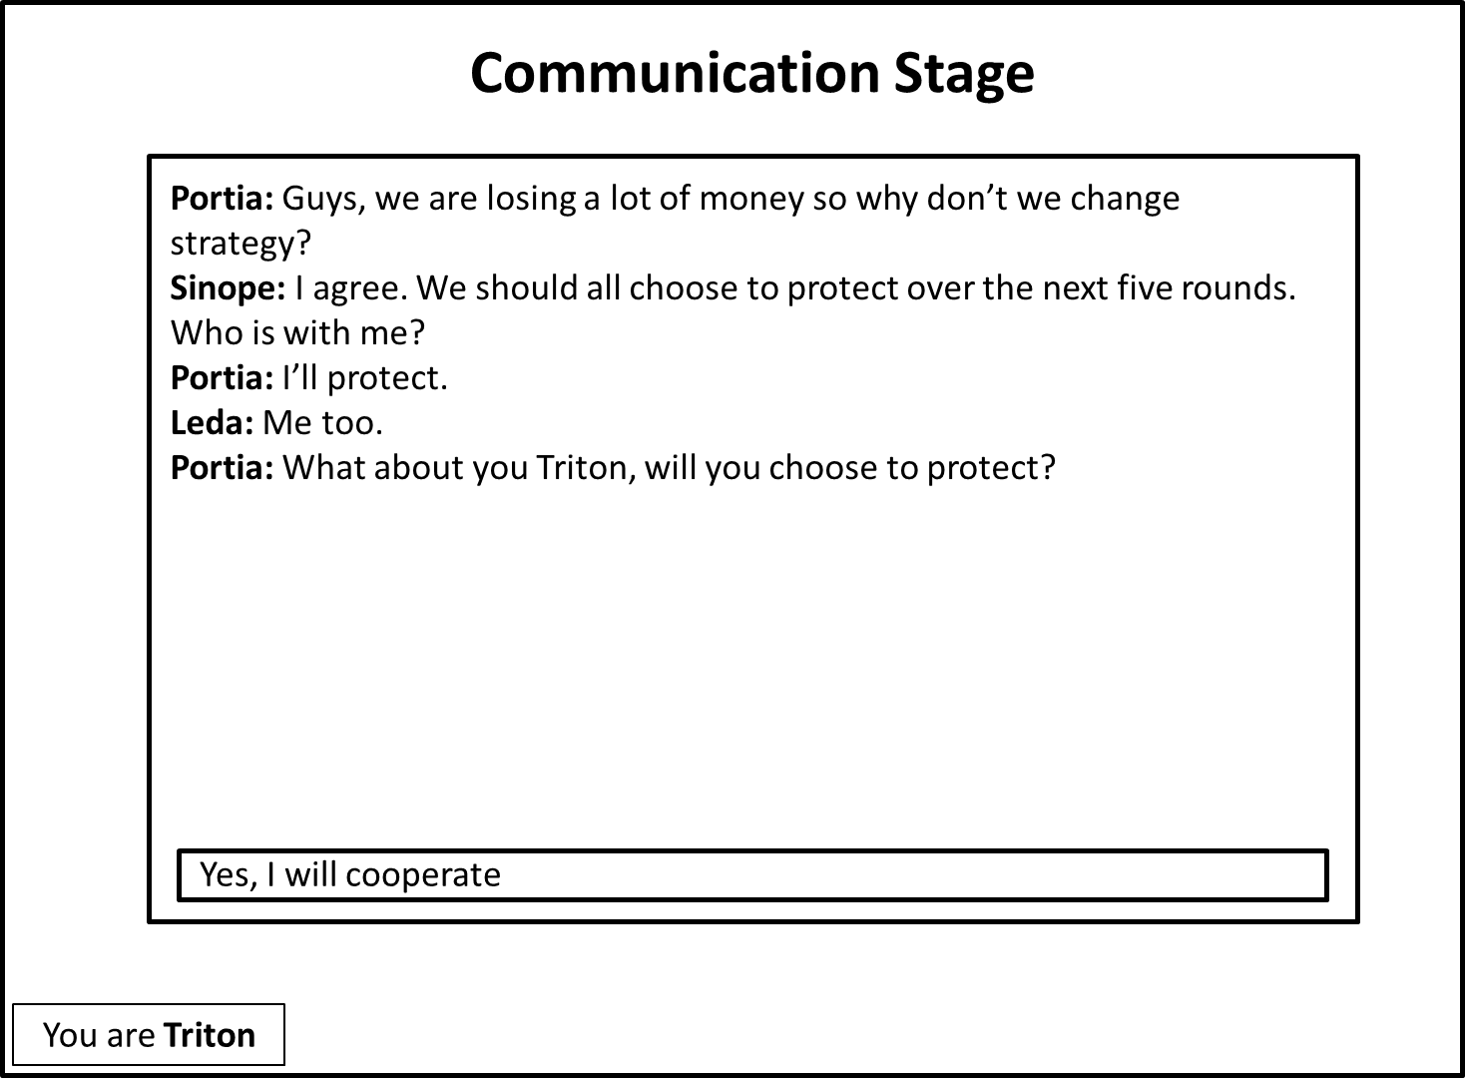

**Figure 3.** Illustration of the communication stage of the biosecurity game.

The chat room contains a text entry field at the bottom (in the example in Figure 3, this is the field in which the player Triton has typed—but not yet submitted—the message “Yes, I will cooperate”). You can type a message in this field and when you press the enter key on the keyboard it will be displayed in the public window under your assigned pseudonym for the other players to see. In the chat room, you can discuss anything, but please abide by the following rules:

* Refrain from using obscene language and do not threaten other players
* Do not offer side payments. An example of a side payment would be if Portia said: “Triton, if you choose to protect over the next five rounds, I’ll give you $5 of my experimental earnings”
* Keep your real identity private at all times

After reading please click

Remember that you will only be able to communicate with your co-players through the chat room at the beginning of **rounds 1, 6,** and **11**. On each of these rounds, you will have **exactly 2 minutes** to communicate with one another in the chat room.

After reading please click

**Probability of an outbreak of pests**

As noted earlier, you will complete two blocks of 15 rounds of the biosecurity game. In one block, the probability of an outbreak of pests will be low (**low-risk condition**), whereas in the other block the probability of an outbreak of pests will be high (**high-risk condition**).

**Low-risk condition.** The table below gives the probability of an ***outbreak*** on each round in the low-risk condition, as a function of the number of players choosing to protect, or not protect, their orchards.

|  |  |  |
| --- | --- | --- |
| Number of players choosing to: | | Probability of an ***outbreak %*** |
| ***protect*** | ***not protect*** |
| 0 | 4 | 34% |
| 1 | 3 | 27% |
| 2 | 2 | 19% |
| 3 | 1 | 10% |
| 4 | 0 | 0% |

**High-risk condition.** The table below gives the probability of an ***outbreak*** on each round in the high-risk condition, as a function of the number of players choosing to protect, or not protect, their orchards.

|  |  |  |
| --- | --- | --- |
| Number of players choosing to: | | Probability of an ***outbreak %*** |
| ***protect*** | ***not protect*** |
| 0 | 4 | 59% |
| 1 | 3 | 49% |
| 2 | 2 | 36% |
| 3 | 1 | 20% |
| 4 | 0 | 0% |

After reading please click

**Your payout**

At the end of the experiment, you will be paid any revenue generated during the biosecurity game, subject to a conversion rate. The conversion rate is your revenue earned × 0.1. For example, if your revenue earned was $300 then you would be paid 300 × 0.1 = $30.

After reading please click

**Player Strategies**

You can choose to play using a number of different strategies.

For example, one strategy would be for each player to choose to protect on every round in both the low- and high-risk blocks. Using this strategy, each player would earn a **total of $30:** $15 in the low-risk block and $15 in the high-risk block.

Another strategy would be for all players to choose to not protect on each round. Using this strategy, each player’s earnings would depend upon the number of pest outbreaks that occurred. However, on average, using this strategy each player would earn **less than** if each player chose toprotect.

Of course, there are many other strategies you could use aside from these two examples.

After reading please click

**Control questions**

If you have finished reading the instructions and do not have any questions, please answer the control questions on the sheet in front of you, and signal us when you have finished. We will then come to you and check your answers.