RUMWaiter Mk2 - Developer Guide v1.1

# Git Cheat Sheet

## 🟢 Simple Workflow (main branch)

git status # See what’s changed  
git add . # Stage all changes  
git commit -m "Message" # Commit with message  
git push origin main # Push to GitHub  
git pull origin main # Pull from GitHub

## 🔵 Branching Workflow (safer experiments)

git checkout -b feature/avr8js # Create & switch branch  
git add .  
git commit -m "Initial avr8js integration"  
git push -u origin feature/avr8js  
  
# After first push:  
git push

## 🔄 Keeping branch up to date

git checkout main  
git pull origin main # Update main  
git checkout feature/avr8js  
git merge main # Merge main into feature

## ✅ Merging feature branch back to main

git checkout main  
git pull origin main  
git merge feature/avr8js  
git push origin main

## 🟠 Handy Extras

git log --oneline --graph --decorate # Pretty history view  
git diff # Show changes  
git reset --soft HEAD~1 # Undo last commit (keep changes staged)

# Branching Workflow Diagram

Diagram of branching and merging workflow:

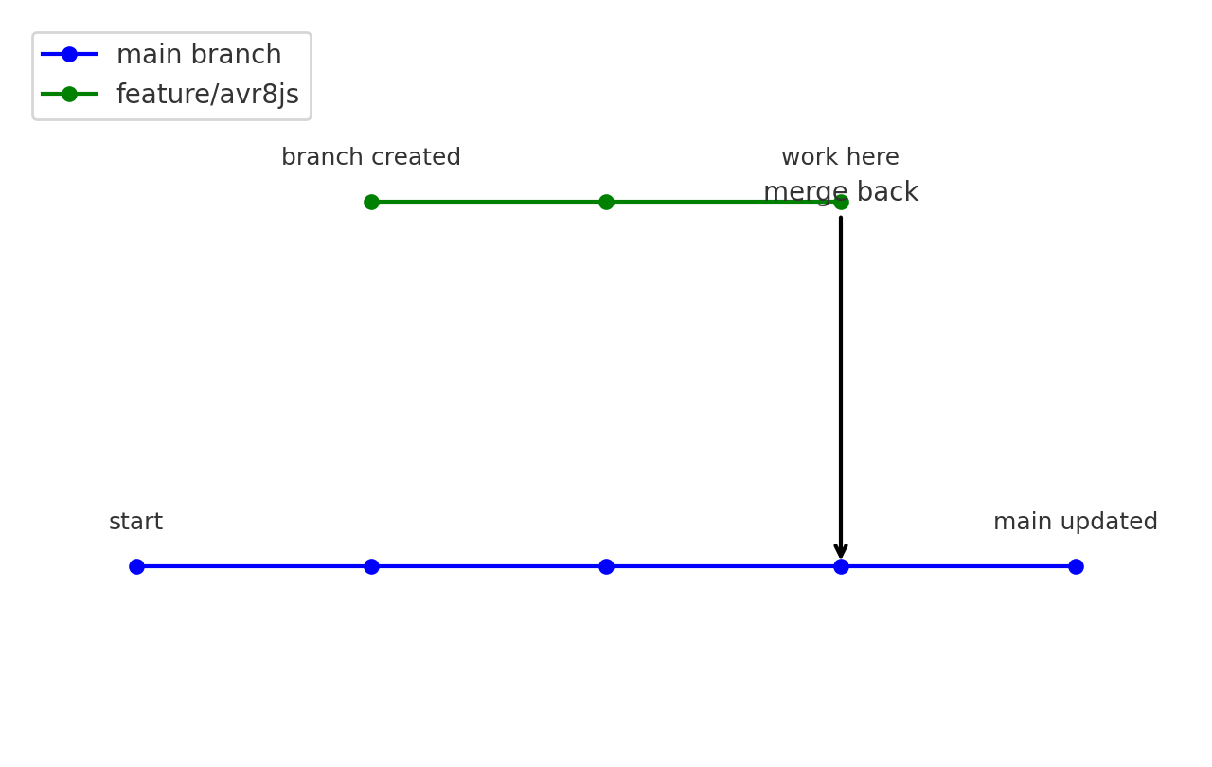

# PNPM Install / Build / Run Guide

## 📦 Setup

pnpm install # Install all dependencies  
pnpm -v # Check pnpm version (should match spec)

## 🏗️ Build

pnpm build # Build all packages in the monorepo  
pnpm --filter sim-ui dev # Start the UI dev server (Vite)  
pnpm --filter emu test # Run emulator unit tests

## ▶️ Run

pnpm start # Start default app (if defined)  
pnpm --filter sim-ui dev # Run UI simulator in dev mode  
pnpm --filter physics test # Run physics test suite

## 🛠️ Tips

pnpm workspace list # Show packages in the monorepo  
pnpm --filter <pkg> <cmd> # Run cmd only in <pkg>  
pnpm build --parallel # Build all packages in parallel

# Arduino CLI - Compile / Upload / HEX

## 📦 Setup

arduino-cli version # Check version  
arduino-cli board list # Detect connected boards  
arduino-cli core install arduino:avr # Install AVR core (Uno/Mega)

## 🏗️ Compile

arduino-cli compile --fqbn arduino:avr:uno firmware/blink  
arduino-cli compile --fqbn arduino:avr:mega firmware/rumwaiter

## ⬆️ Upload to Board

arduino-cli upload -p COM3 --fqbn arduino:avr:uno firmware/blink  
arduino-cli upload -p COM4 --fqbn arduino:avr:mega firmware/rumwaiter

## 💾 Export HEX (for emulator)

arduino-cli compile --fqbn arduino:avr:uno firmware/rumwaiter --output-dir ./build  
Result: ./build/rumwaiter.ino.hex

## 🛠️ Tips

Use `--clean` with compile to force rebuild  
Use `arduino-cli config init` to create a global config file  
HEX files in ./build are what avr8js will load

# Emulator (avr8js) Workflow

## 📦 Setup

pnpm --filter emu add avr8js # Install avr8js in emulator package  
Ensure firmware HEX files are exported via Arduino CLI

## ▶️ Run Emulator

pnpm --filter emu dev # Start emulator dev mode  
Load firmware HEX into avr8js instance  
Tie Arduino pins -> physics & sensor adapters

## 🔄 Development Loop

1. Edit Arduino sketch in firmware/  
2. Compile & export HEX with arduino-cli  
3. Reload HEX in emulator (no code changes needed in sim)  
4. Observe motor physics, sensors, OLED UI in sim

## 🛠️ Tips

Use fixed 1 ms step mode for deterministic runs  
Use real-time mode for interactive UI testing  
Log outputs to CSV/JSON for regression tests