

Install macOS Catalina on your University-Managed Mac Device

This document provides instructions for completing the macOS Catalina authorization process on your University-managed Mac. To receive the option to install macOS Catalina, you must complete this process.

**Warning:** Apple removed support for 32-bit applications in macOS Catalina. Any applications you use that have not been updated from 32-bit to 64-bit will no longer work on macOS Catalina. Computing and Technology Services (CTS) has developed a tool to help identify 32-bit applications installed on your Mac device before upgrading to macOS Catalina.

After completing the macOS Catalina authorization process, you will have the option to install macOS Catalina at  
your convenience through the Mac App Store. MacOS Catalina will not be automatically installed on your   
Mac, and you are not required to install it after authorization is complete.

## In this document

Authorize your Mac for macOS Catalina

FAQ

# Authorize your Mac for macOS Catalina

1. Open **Finder.**
2. Select the **Applications tab** on the left side of the Finder window.
3. Locate the **Self Service** application and double-click to open it.



1. Select **Operating Systems** on the left side of the Self Service window.

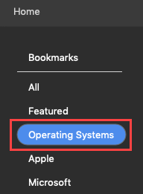

1. Select **macOS Catalina.**
2. Review the warning presented. To proceed with updating to macOS Catalina, click **Authorize Upgrade.** If you do not want to proceed, click **Close.**

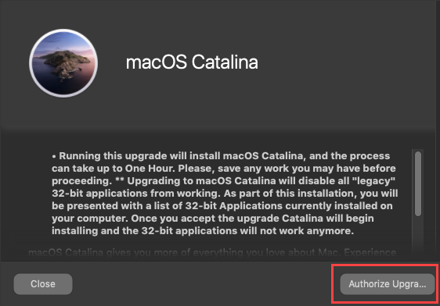

1. Click **View your 32-bit Apps** for a list of 32-bit applications installed on your device that will be affected by upgrading to macOS Catalina.

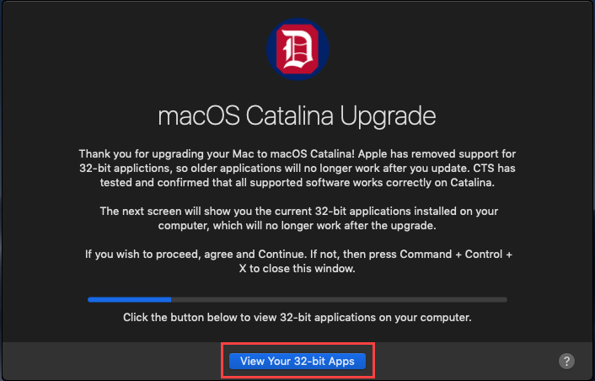

1. Review the list of 32-bit applications installed on your device that will no longer work after upgrading to macOS Catalina.
   * If you wish to continue with the upgrade, select **I Agree** and then click **Continue.** The macOS Catalina authorization process begins.
   * If you wish to cancel the upgrade, click **Cancel** and then press **Command + Ctrl + X** to close the Authorization tool.
2. Once the macOS Catalina authorization process completes, the Mac App Store will open. Click **Get** to install macOS Catalina.

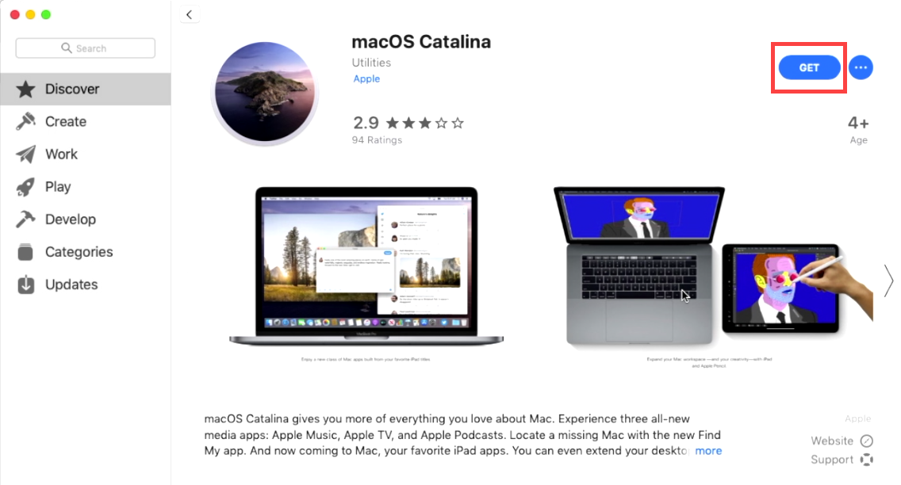

**Note:** You are not required to install macOS Catalina after the authorization process completes, and it will not be automatically installed on your Mac.

# FAQ

## What should I do if 32-bit applications are installed on my Mac?

If you use 32-bit applications, CTS recommends contacting the application provider to see if they offer a 64-bit version of the application before upgrading to macOS Catalina.

## Do I need to install macOS Catalina as soon as I finish the authorization process?

No. Completing the macOS Catalina authorization process gives you the ability to install macOS Catalina at your convenience. If you want to install it at a later date, open the Mac App Store and search for macOS Catalina.

## If I wait to install macOS Catalina, do I need to complete the authorization process again?

No. You only need to complete the macOS Catalina process once on your University-managed Mac.

## I have multiple University-managed Mac devices. Do I need to complete the macOS Catalina authorization process on each one?

Yes. Each University-managed Mac is required to complete the macOS Catalina authorization process before macOS Catalina is made available in the Mac App Store.