HOW TO IMPORT EXCEL TO MYSQL WORKBENCH:
Note: Make sure your Excel File is saved as .csv
- Create Database in Mysql
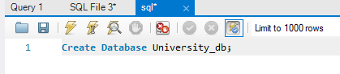
- Go to created database and right Click Tables
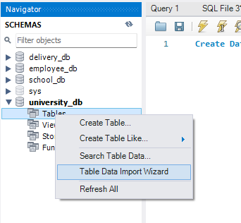
- Click Browse and find you excel file and click next
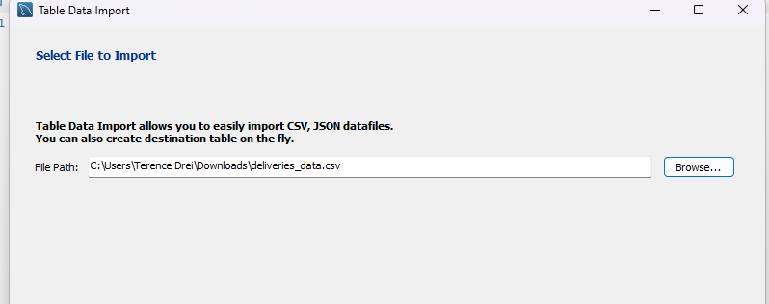

- Click Next Again
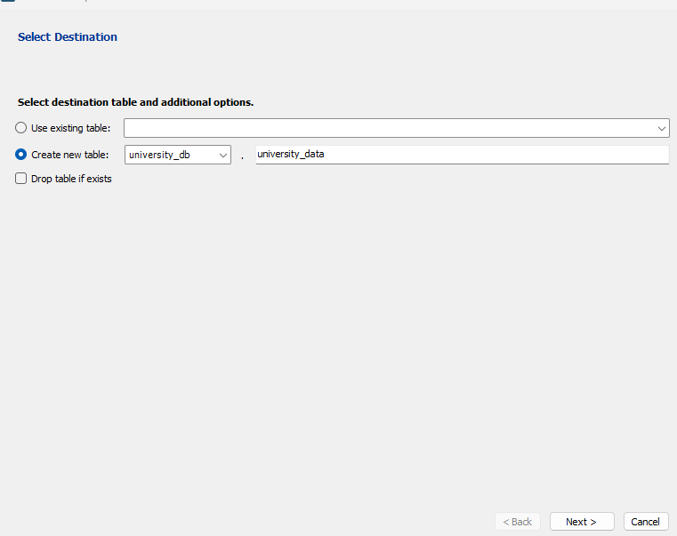
- Click Next
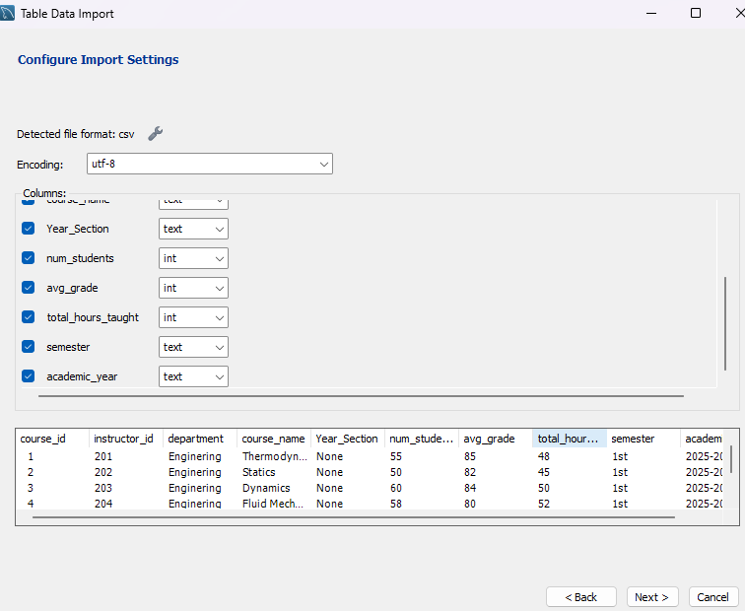
- Click Next
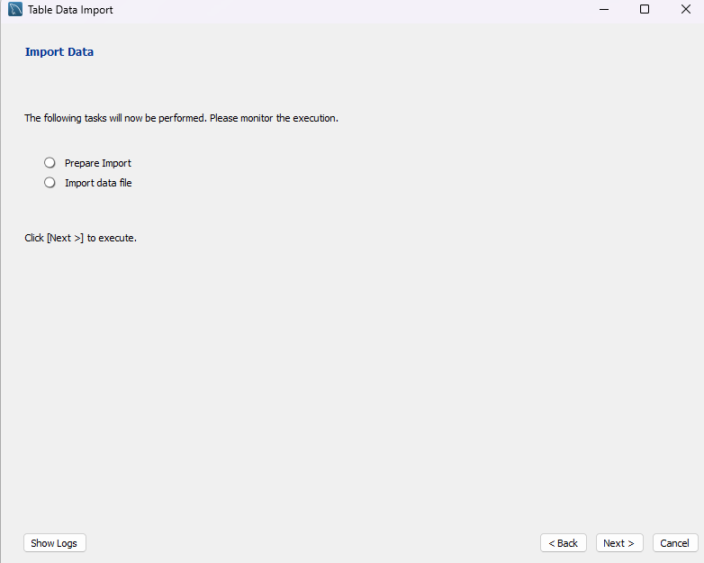
- Click Next again and finish
