Linux Basics — DevOps Assignment

1. Creating and Renaming Files/Directories
Commands used:
mkdir test_dir
touch example.txt
mv example.txt test_dir/
cd test_dir/
mv example.txt renamed_example.txt
ls
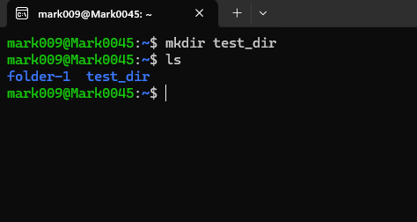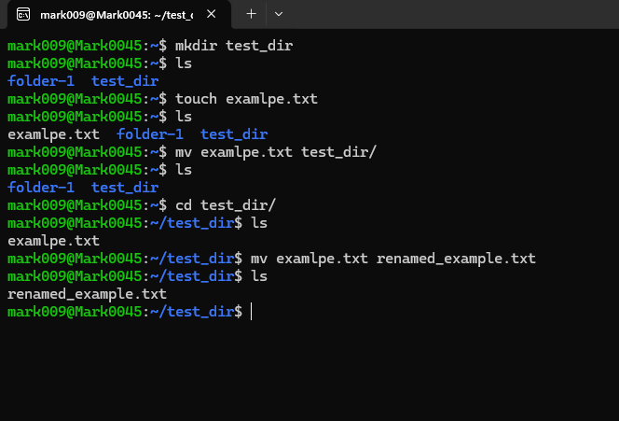

2. Viewing File Contents
cat /etc/passwd
head -n 5 /etc/passwd
tail -n 5 /etc/passwd
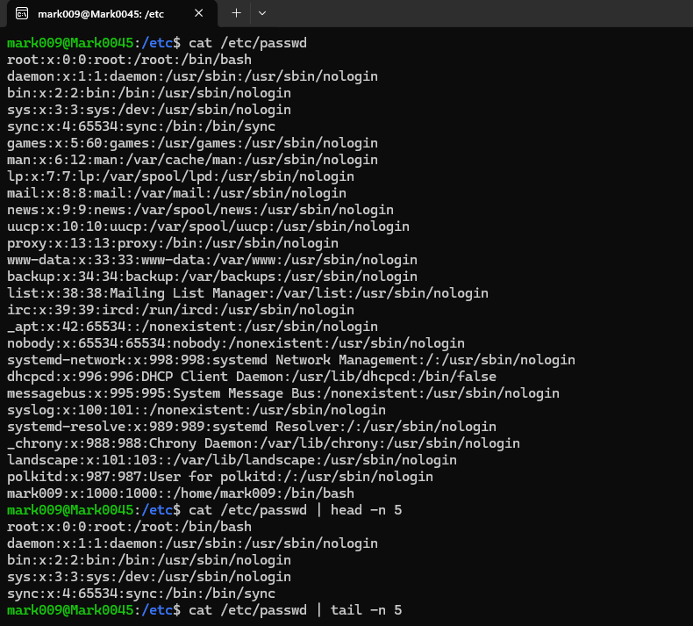
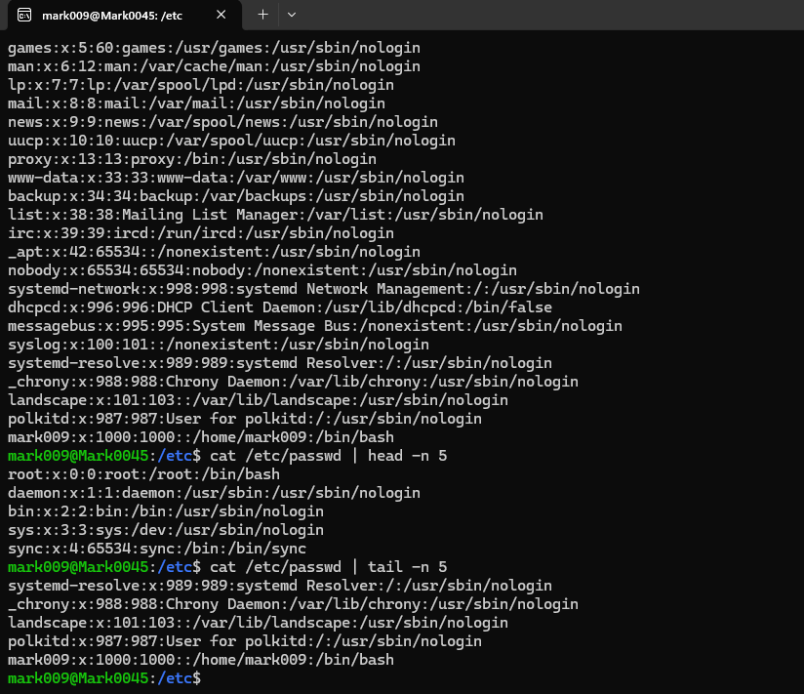

3. Searching for Patterns with grep
grep "root" /etc/passwd
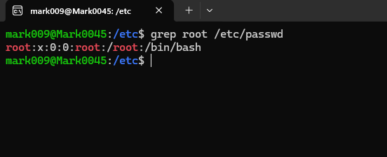

4. Zipping and Unzipping
zip -r test_dir.zip test_dir
unzip test_dir.zip -d unzipped_dir
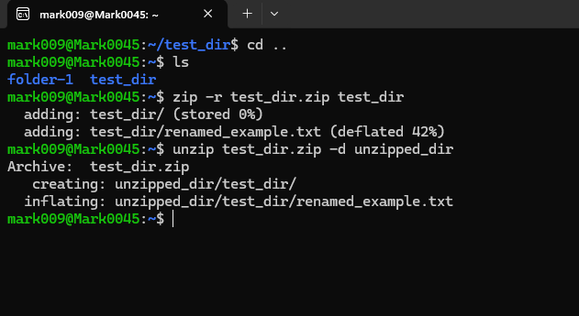

5. Downloading a File with wget
The assignment requires downloading a file from a URL using wget. The supplied terminal evidence shows a successful download from a GitHub Gist URL.
wget https://gist.github.com/Talha-Altair/b8a27d2b45add1dd7658fd34fa1968db
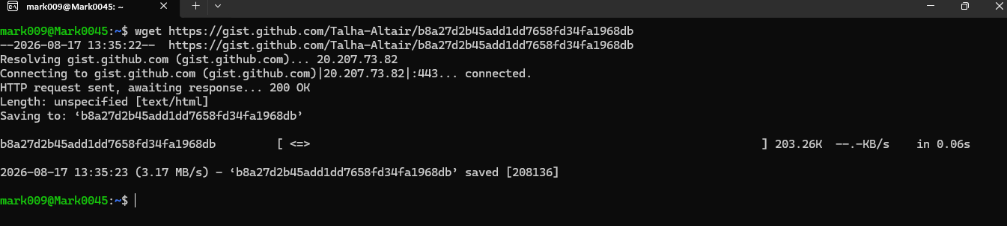

6. Changing File Permissions
touch secure.txt
chmod 444 secure.txt
ls -l
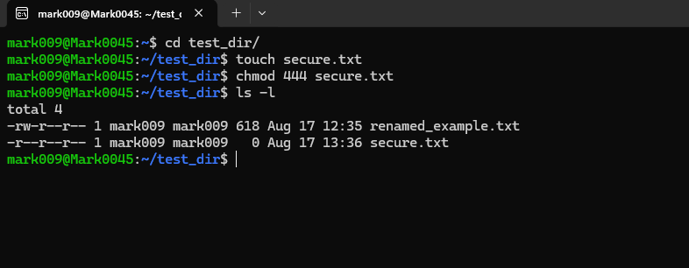

7. Environment Variable
export MY_VAR="Hello, Linux!"
echo "$MY_VAR"

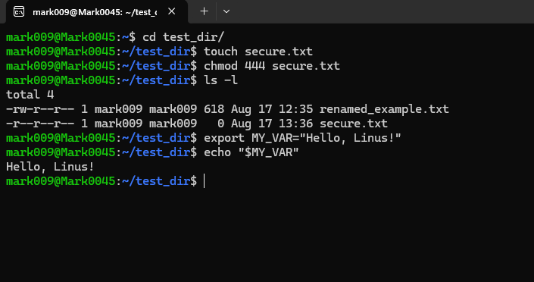

GitHub Repository
GitHub repository link: https://github.com/mark45-code/linux_basics_jayesh

