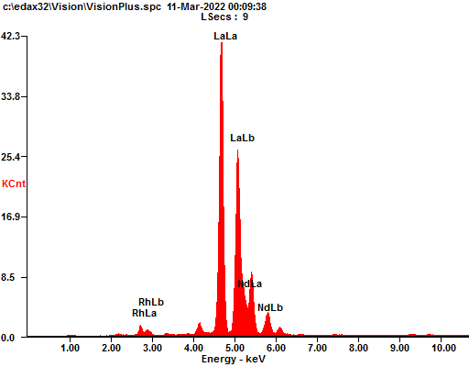

|  |  |  |
| --- | --- | --- |
| ***Element*** | ***Wt%*** | ***At%*** |
| ***RhL*** | 0.00 | 0.00 |
| ***LaL*** | 91.75 | 92.03 |
| ***NdL*** | 8.25 | 7.97 |

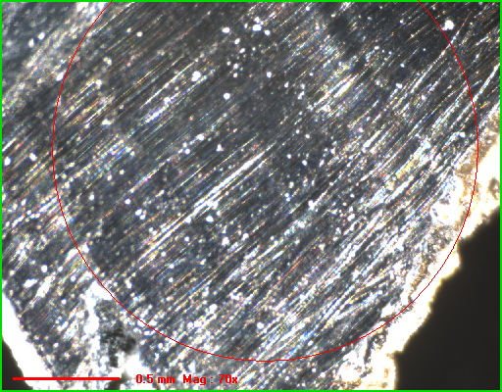

***Spectrum Filename : c:\edax32\Vision\VisionPlus.spc 11-Mar-2022 12:09 AM kV:20 uA: 300 2000 um-Spot TC: 12.8uSecs***

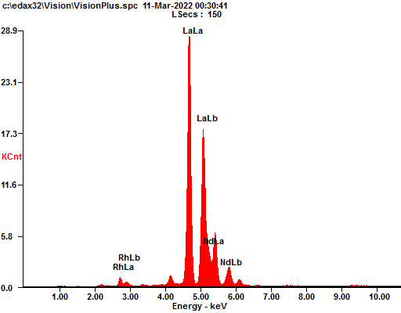

|  |  |  |
| --- | --- | --- |
| ***Element*** | ***Wt%*** | ***At%*** |
| ***RhL*** | 0.00 | 0.00 |
| ***LaL*** | 91.90 | 92.17 |
| ***NdL*** | 8.10 | 7.83 |

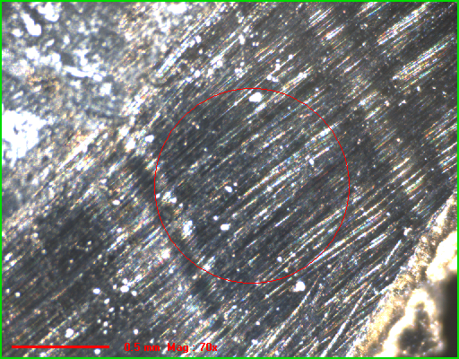

***Spectrum Filename : c:\edax32\Vision\VisionPlus.spc 11-Mar-2022 12:15 AM kV:20 uA: 800 1000 um-Spot TC: 12.8uSecs***

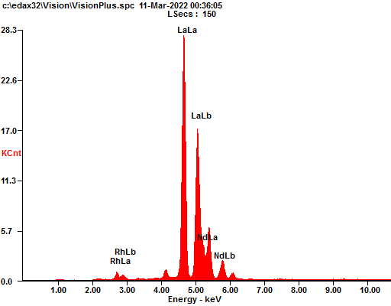

|  |  |  |
| --- | --- | --- |
| ***Element*** | ***Wt%*** | ***At%*** |
| ***RhL*** | 0.00 | 0.00 |
| ***LaL*** | 91.94 | 92.22 |
| ***NdL*** | 8.06 | 7.78 |

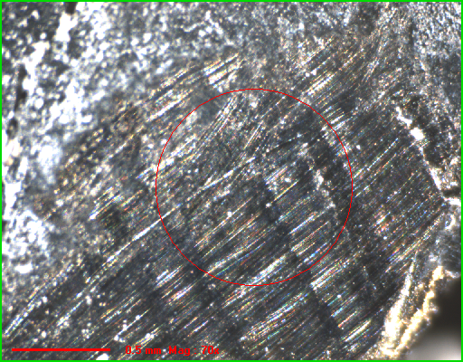

***Spectrum Filename : c:\edax32\Vision\VisionPlus.spc 11-Mar-2022 12:32 AM kV:20 uA: 800 1000 um-Spot TC: 12.8uSecs***

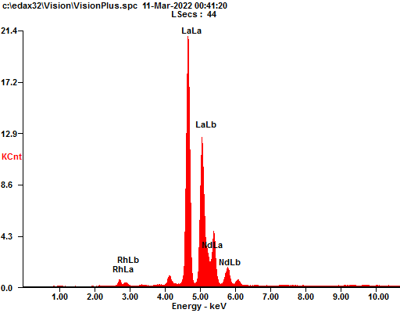

|  |  |  |
| --- | --- | --- |
| ***Element*** | ***Wt%*** | ***At%*** |
| ***RhL*** | 0.00 | 0.00 |
| ***LaL*** | 92.07 | 92.34 |
| ***NdL*** | 7.93 | 7.66 |

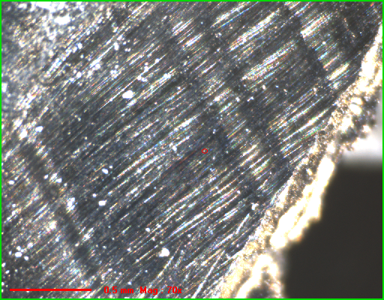

***Spectrum Filename : c:\edax32\Vision\VisionPlus.spc 11-Mar-2022 12:41 AM kV:20 uA: 100 30 um-Spot TC: 12.8uSecs***

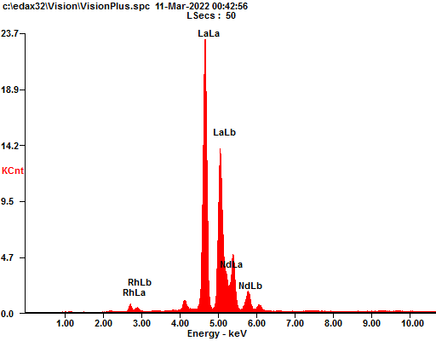

|  |  |  |
| --- | --- | --- |
| ***Element*** | ***Wt%*** | ***At%*** |
| ***RhL*** | 0.00 | 0.00 |
| ***LaL*** | 92.11 | 92.37 |
| ***NdL*** | 7.89 | 7.63 |

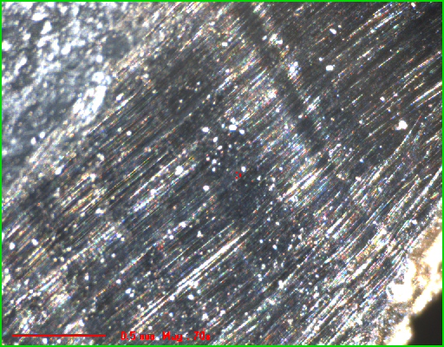

***Spectrum Filename : c:\edax32\Vision\VisionPlus.spc 11-Mar-2022 12:42 AM kV:20 uA: 100 30 um-Spot TC: 12.8uSecs***

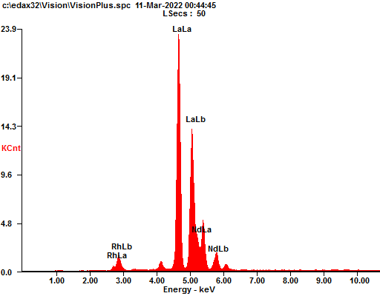

|  |  |  |
| --- | --- | --- |
| ***Element*** | ***Wt%*** | ***At%*** |
| ***RhL*** | 0.00 | 0.00 |
| ***LaL*** | 91.72 | 92.00 |
| ***NdL*** | 8.28 | 8.00 |

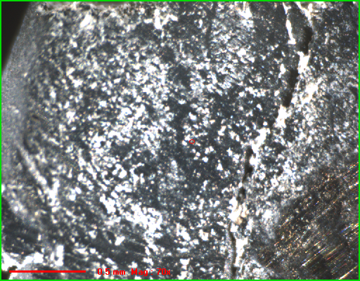

***Spectrum Filename : c:\edax32\Vision\VisionPlus.spc 11-Mar-2022 12:44 AM kV:20 uA: 100 30 um-Spot TC: 12.8uSecs***

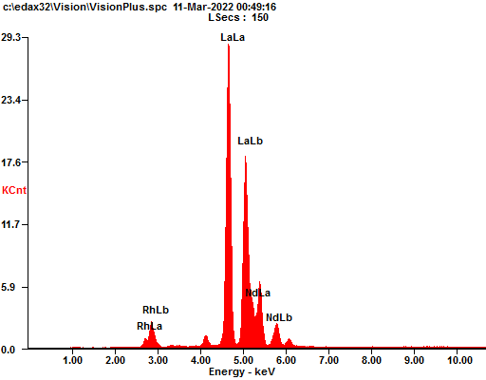

|  |  |  |
| --- | --- | --- |
| ***Element*** | ***Wt%*** | ***At%*** |
| ***RhL*** | 0.00 | 0.00 |
| ***LaL*** | 91.64 | 91.92 |
| ***NdL*** | 8.36 | 8.08 |

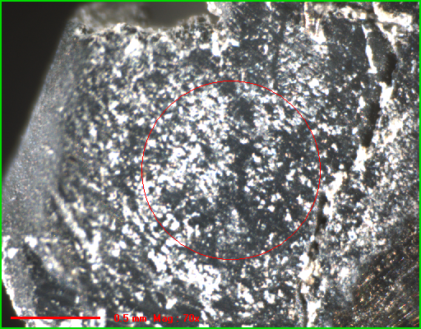

***Spectrum Filename : c:\edax32\Vision\VisionPlus.spc 11-Mar-2022 12:46 AM kV:20 uA: 900 1000 um-Spot TC: 12.8uSecs***

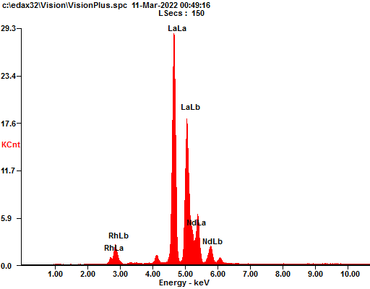

|  |  |  |
| --- | --- | --- |
| ***Element*** | ***Wt%*** | ***At%*** |
| ***RhL*** | 0.00 | 0.00 |
| ***LaL*** | 91.64 | 91.92 |
| ***NdL*** | 8.36 | 8.08 |

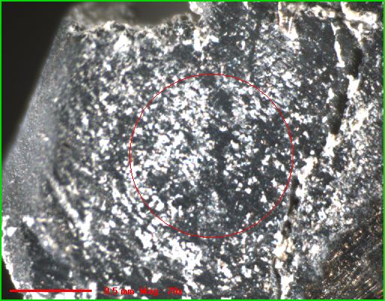

***Spectrum Filename : c:\edax32\Vision\VisionPlus.spc 11-Mar-2022 12:46 AM kV:20 uA: 900 1000 um-Spot TC: 12.8uSecs***