|  |  |  |
| --- | --- | --- |
| ***Element*** | ***Wt%*** | ***At%*** |
| ***RhL*** | 0.00 | 0.00 |
| ***LaL*** | 91.75 | 92.03 |
| ***NdL*** | 8.25 | 7.97 |

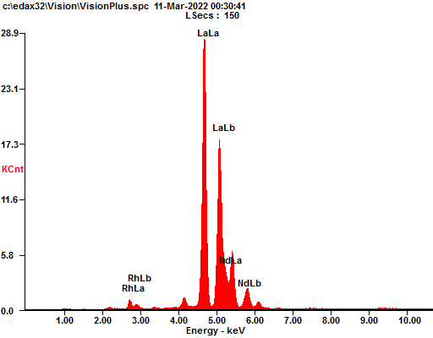

***Spectrum Filename : c:\edax32\Vision\VisionPlus.spc 11-Mar-2022 12:09 AM kV:20 uA: 300 2000 um-Spot TC: 12.8uSecs***

