|  |  |  |
| --- | --- | --- |
| ***Element*** | ***Wt%*** | ***At%*** |
| ***LaL*** | 93.35 | 93.58 |
| ***NdL*** | 6.65 | 6.42 |

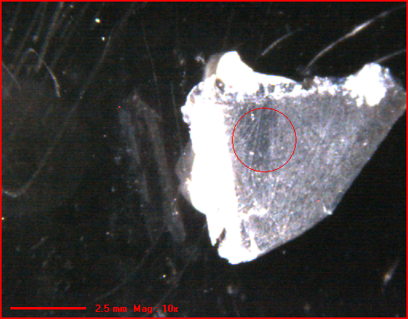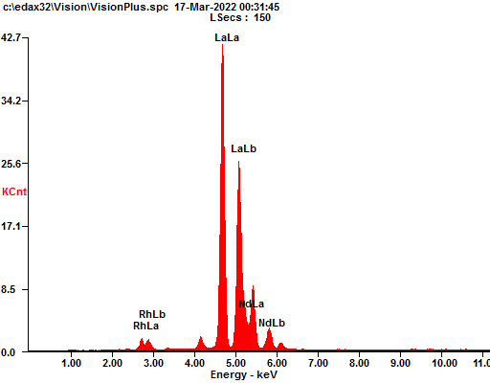

***Spectrum Filename : c:\edax32\Vision\VisionPlus.spc 16-Mar-2022 11:58 PM kV:20 uA: 300 2000 um-Spot TC: 12.8uSecs***