電通二乙微處理器實驗 實驗結報

實驗名稱 | Lab04
組別 | 29 | 組員 | 謝宇庭

- 實驗目的
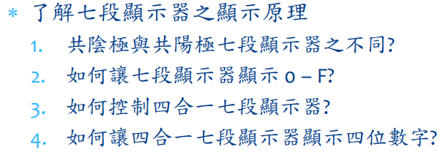

- 實驗步驟
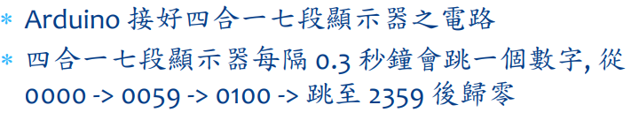
- 程式碼
#include "SevSeg.h"
SevSeg sevseg; //Instantiate a seven segment controller object
byte Hour=0;
byte Min=0;
void setup() {
byte numDigits = 4;
byte digitPins[] = {2, 3, 4, 5};
byte segmentPins[] = { 8, 9, 10, 11, 12, 13,14};
bool resistorsOnSegments = false; // 'false' means resistors are on digit pins
byte hardwareConfig = COMMON_CATHODE; // See README.md for options
bool updateWithDelays = false; // Default. Recommended
bool leadingZeros = false; // Use 'true' if you'd like to keep the leading zeros

sevseg.begin(hardwareConfig, numDigits, digitPins, segmentPins, resistorsOnSegments, updateWithDelays, leadingZeros);
sevseg.setBrightness(90);
}

void loop() {
static unsigned long timer = millis();
// static int deciSeconds = 0;

if (millis() - timer >= 100) {
timer += 100;

sevseg.setNumber(Hour * 100 + Min, 3);
Min = Min + 1;
if (Min == 60)
{
Min = 0;
if (Hour == 23)
Hour=0;
else
Hour++;
}
}
sevseg.refreshDisplay(); // Must run repeatedly

}
- 實驗結果及分析
能夠正常計時
- 心得討論
覺得蠻困難
- 修正電路圖
- 修正程式碼

