電通二乙微處理器實驗 實驗結報

實驗名稱 | Lab06-LCD顯示器
組別 | 29 | 組員 | 謝宇庭

- 實驗目的
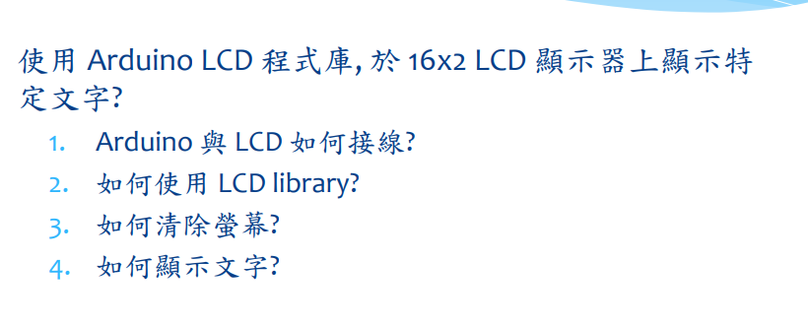

- 實驗步驟
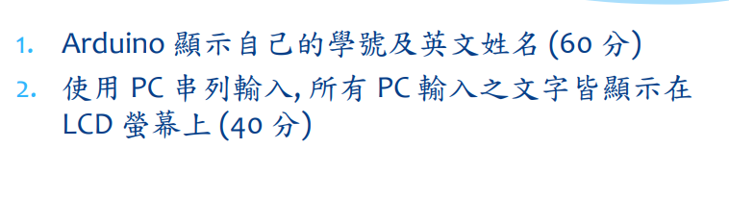
- 程式碼
#include <LiquidCrystal.h> // include the library code
LiquidCrystal lcd(12, 11, 5, 4, 3, 2); // initialize interface pins
void setup() {
lcd.begin(16, 2); // set up the LCD's number of columns and rows:
lcd.print("05050750 MARK"); // Print a message to the LCD.
}
void loop() {
// set the cursor to column 0, line 1
// (note: line 1 is the second row, since counting begins with 0):
lcd.setCursor(0, 1);
lcd.print(millis()/1000); // print the number of seconds since reset:
}
- 實驗結果及分析
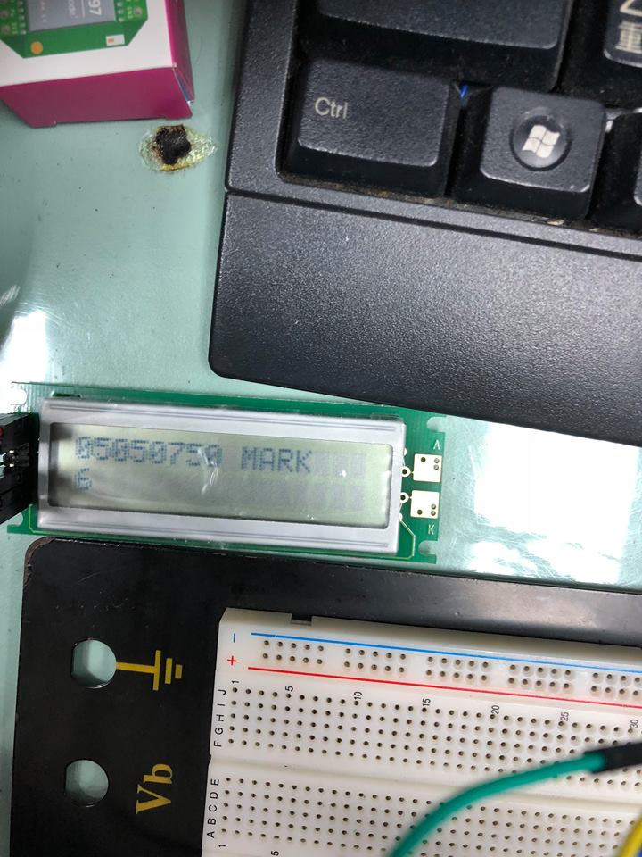

- 心得討論
杜邦線都會接觸不良，真的太難用了

