This is the public Master GIT repository and should be configured as the upstream destination for remote push. Before the remote push can be done, a remote repository for your project needs to be created and initialized. For more information about git, see <http://git-scm.com/>

The directory/sub-directory structure and the remote git repository for the remote push must first be created under H:\GIT-Repository Create the sub-directory structure (in this example *test_CGI.WS.PayPilot*) then run git init as shown below.

H:  
cd \GIT-Repository  
mkdir test_CGI.WS.PayPilot  
cd *test_CGI.WS.PayPilot*  
git init --bare *test_CGI.WS.PayPilot.git*

In Eclipse (Java EE 4.3.2), in the “Git Repositories” tab, select the project that the remote is to be configured for. Right click on “Remotes” and select “Create Remote” to get the following:

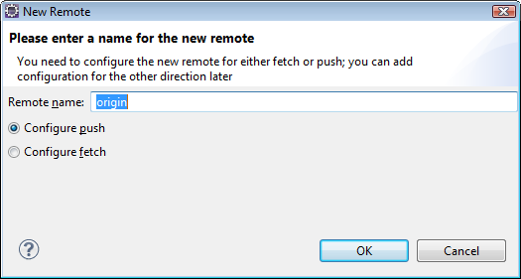

Keep the name “origin” and click “OK” to get the following.

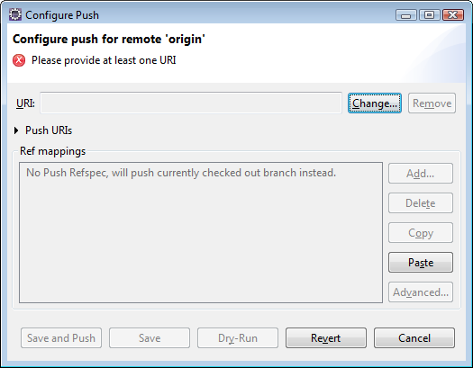

Click “Change” to get the following:

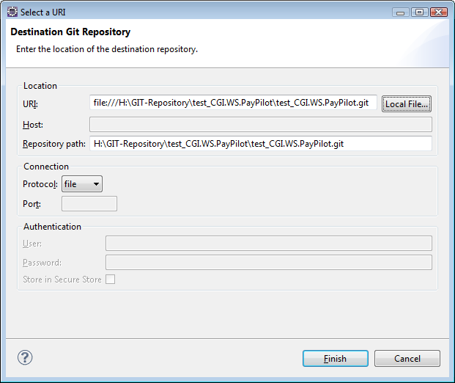

Click “Local File” and browse to the *test_CGI.WS.PayPilot.git* that was created above and click “Finish”. This returns you to:

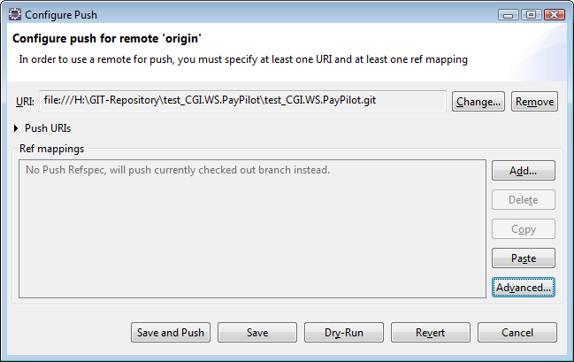

Click “Advanced”

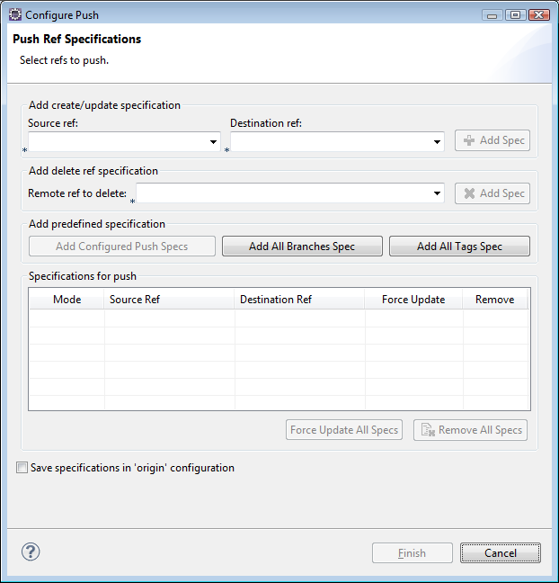

Click on “Add All Branches Spec”, “Add All Tags Spec” and “Save specification in ‘origin’ configuration”, then click “Finish” to get this.

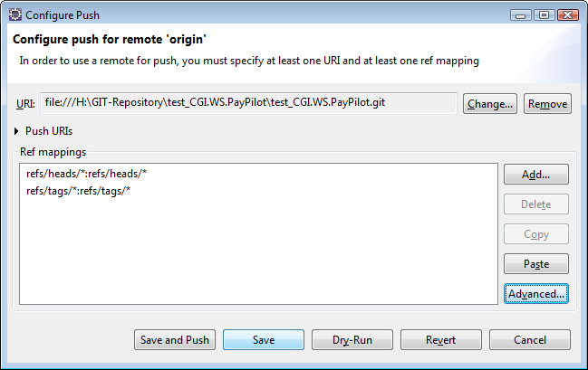

Click “Save”.

In Eclipse, to push your local repository to the master repository, right click on your project and select “Team / Remote / Push” from the menu.

To clone from the master repository, navigate to the folder where you want to create the clone and enter:

git clone H:\GIT-Repository\WebServices-ProtoType\WebServices.git

This will create a new folder named WebServices which contains the cloned git repository plus a folder named WebServices containing the WebServices project structure.

**C:\gitCloneTest>** git clone h:\GIT-Repository\WebServices‑ProtoType\WebServices.git

Cloning into 'WebServices'...

done.

**C:\gitCloneTest>** dir /a WebServices

Volume in drive C is OS

Volume Serial Number is 127F-3637

Directory of C:\gitCloneTest\WebServices

2014-04-17 10:50 <DIR> .git

2014-04-17 10:50 <DIR> WebServices