

**Java Web Service – getCheckID**

The purpose of this web service is to return from the check [Chk] table the Check ID [ID] when given the original ID [OrigID].

**Usage:**

This service can be run in two modes. The mode that is used is determined by the format of the url that is entered into the web browser.

Operationally the URL will be entered in this form (with the parameter OrigID=8224):

<http://localhost:8080/getCheckID/getOrigChkID?OrigID=8224>

and the service will return an xml packet that looks similar to this:

<?xml version="1.0" encoding="UTF-8"?>

<getOrigChkID>

<num_records>1</num_records>

<data_record>

<OrigID>8224</OrigID>

<ID>138185</ID>

</data_record>

</getOrigChkID>

The second mode is useful for testing. If the URL is entered in this form without a parameter:

<http://localhost:8080/getCheckID/getOrigChkID.html>

a web page is presented where you can enter the OrigID

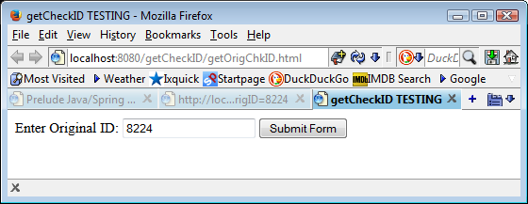

and submit the form to the web service which returns:

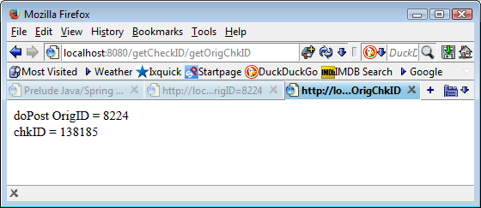

**Design Overview:**

The web service is written in Java using the Spring framework and runs under the Apache Tomcat web server. Spring was used because from within a small xml configuration you can specify the database connection string and then Spring will manage most of the database overhead such as the database connection, creating the result set, navigating through the result set and handling exceptions that may thrown when an error occurs.