Homework 1

1. The Iowa data set iowa.csv is a toy example that summarises the yield of wheat (bushels per acre) for the state of Iowa between 1930-1962. In addition to yield, year, rainfall and temperature were recorded as the main predictors of yield.
   1. First, we need to load the data set into R using the command read.csv(). Use the help function to learn what arguments this function takes. Once you have the necessary input, load the data set into R and make it a data frame called iowa.df.
   2. How many rows and columns does iowa.df have?
   3. What are the names of the columns of iowa.df?
   4. What is the value of row 5, column 7 of iowa.df?
   5. Display the second row of iowa.df in its entirety.

iowa.df = read.csv("data/Iowa.csv",header = T)  
rcol = dim(iowa.df)  
rcol[1]

## [1] 33

rcol[2]

## [1] 10

colnames(iowa.df)

## [1] "Year" "Rain0" "Temp1" "Rain1" "Temp2" "Rain2" "Temp3" "Rain3" "Temp4"  
## [10] "Yield"

iowa.df[5,7]

## [1] 79.7

iowa.df[2,]

## Year Rain0 Temp1 Rain1 Temp2 Rain2 Temp3 Rain3 Temp4 Yield  
## 2 1931 14.76 57.5 3.83 75 2.72 77.2 3.3 72.6 32.9

1. Syntax and class-typing.
   1. For each of the following commands, either explain why they should be errors, or explain the non-erroneous result.

vector1 <- c("5", "12", "7", "32")  
typeof(vector1)

## [1] "character"

max(vector1)

## [1] "7"

sort(vector1)

## [1] "12" "32" "5" "7"

#sum(vector1)

**解答：**

1. non-erroneous.vector is a sequence of values, all of the same type,vector1 is characters.
2. non-erroneous.max(vector1) 是求“5”,“7”,“12”,“32”字符对应的编码的最大值（不一定是ascii）
3. non-erroneous.sort(vector1) 是对字符对应的编码进行排序，结果和max(vector1)一致
4. Error.sum(vector1) vector1为字符型向量，无法进行sum运算

b. For the next series of commands, either explain their results, or why they should produce errors.

vector2 <- c("5",7,12)  
typeof(vector2)

## [1] "character"

#vector2[2] + vector2[3]  
  
dataframe3 <- data.frame(z1="5",z2=7,z3=12)  
dataframe3[1,2] + dataframe3[1,3]

## [1] 19

typeof(dataframe3[1,2])

## [1] "double"

list4 <- list(z1="6", z2=42, z3="49", z4=126)  
list4[[2]]+list4[[4]]

## [1] 168

#list4[2]+list4[4]  
typeof(list4[2])

## [1] "list"

**解答：**

1. Error.vector2[2] + vector2[3].vector2 = c(“5”,7,12).vector is a sequence of values, all of the same type,vector1 is characters.
2. non-erroneous. Dataframes are hybrids of matrices and lists, for classic tabular data. dataframe3[1,2] and dataframe3[1,3] are double.
3. list4[2]+list4[4]中list4[2]和list4[4]都是list.
4. Working with functions and operators.
   1. The colon operator will create a sequence of integers in order. It is a special case of the function seq() which you saw earlier in this assignment. Using the help command ?seq to learn about the function, design an expression that will give you the sequence of numbers from 1 to 10000 in increments of 372. Design another that will give you a sequence between 1 and 10000 that is exactly 50 numbers in length.
   2. The function rep() repeats a vector some number of times. Explain the difference between `rep(1:3, times=3) and rep(1:3, each=3).

###a.(1)the sequence of numbers from 1 to 10000 in increments of 372  
seq(1,10000,by = 372)

## [1] 1 373 745 1117 1489 1861 2233 2605 2977 3349 3721 4093 4465 4837 5209  
## [16] 5581 5953 6325 6697 7069 7441 7813 8185 8557 8929 9301 9673

#(2)a sequence between 1 and 10000 that is exactly 50 numbers in length  
seq(1,10000,length.out = 50)

## [1] 1.0000 205.0612 409.1224 613.1837 817.2449 1021.3061  
## [7] 1225.3673 1429.4286 1633.4898 1837.5510 2041.6122 2245.6735  
## [13] 2449.7347 2653.7959 2857.8571 3061.9184 3265.9796 3470.0408  
## [19] 3674.1020 3878.1633 4082.2245 4286.2857 4490.3469 4694.4082  
## [25] 4898.4694 5102.5306 5306.5918 5510.6531 5714.7143 5918.7755  
## [31] 6122.8367 6326.8980 6530.9592 6735.0204 6939.0816 7143.1429  
## [37] 7347.2041 7551.2653 7755.3265 7959.3878 8163.4490 8367.5102  
## [43] 8571.5714 8775.6327 8979.6939 9183.7551 9387.8163 9591.8776  
## [49] 9795.9388 10000.0000

#b.(1)rep(1:3,times = 3)是将1，2，3整体重复三次  
rep(1:3,times = 3)

## [1] 1 2 3 1 2 3 1 2 3

#(2)rep(1:3,each = 3)是将1重复三数，然后2重复三次，3重复3次  
rep(1:3,each = 3)

## [1] 1 1 1 2 2 2 3 3 3

MB.Ch1.2. The orings data frame gives data on the damage that had occurred in US space shuttle launches prior to the disastrous Challenger launch of 28 January 1986. The observations in rows 1, 2, 4, 11, 13, and 18 were included in the pre-launch charts used in deciding whether to proceed with the launch, while remaining rows were omitted.

Create a new data frame by extracting these rows from orings, and plot total incidents against temperature for this new data frame. Obtain a similar plot for the full data set.

data(orings,package = "DAAG")  
rows = c(1,2,3,11,13,18)  
launchrows = orings[rows,]  
plot(Total~Temperature,type = "p",data = launchrows)

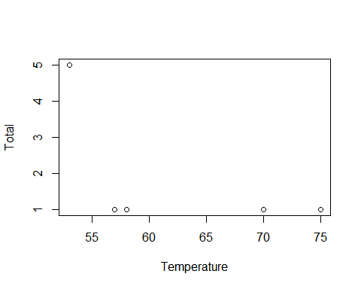

plot(Total~Temperature,type = "p",data = orings)

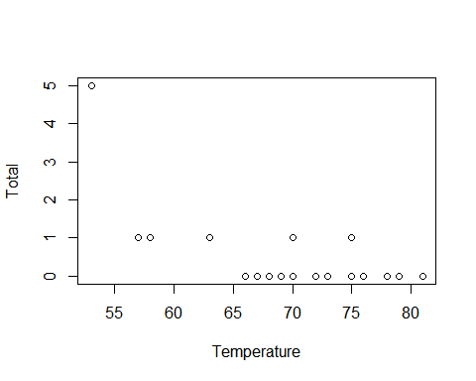 MB.Ch1.4. For the data frame ais (DAAG package)

1. Use the function str() to get information on each of the columns. Determine whether any of the columns hold missing values.

data("ais",package = "DAAG")  
str(ais)

## 'data.frame': 202 obs. of 13 variables:  
## $ rcc : num 3.96 4.41 4.14 4.11 4.45 4.1 4.31 4.42 4.3 4.51 ...  
## $ wcc : num 7.5 8.3 5 5.3 6.8 4.4 5.3 5.7 8.9 4.4 ...  
## $ hc : num 37.5 38.2 36.4 37.3 41.5 37.4 39.6 39.9 41.1 41.6 ...  
## $ hg : num 12.3 12.7 11.6 12.6 14 12.5 12.8 13.2 13.5 12.7 ...  
## $ ferr : num 60 68 21 69 29 42 73 44 41 44 ...  
## $ bmi : num 20.6 20.7 21.9 21.9 19 ...  
## $ ssf : num 109.1 102.8 104.6 126.4 80.3 ...  
## $ pcBfat: num 19.8 21.3 19.9 23.7 17.6 ...  
## $ lbm : num 63.3 58.5 55.4 57.2 53.2 ...  
## $ ht : num 196 190 178 185 185 ...  
## $ wt : num 78.9 74.4 69.1 74.9 64.6 63.7 75.2 62.3 66.5 62.9 ...  
## $ sex : Factor w/ 2 levels "f","m": 1 1 1 1 1 1 1 1 1 1 ...  
## $ sport : Factor w/ 10 levels "B_Ball","Field",..: 1 1 1 1 1 1 1 1 1 1 ...

#没有缺失值  
sum(!complete.cases(ais))

## [1] 0

1. Make a table that shows the numbers of males and females for each different sport. In which sports is there a large imbalance (e.g., by a factor of more than 2:1) in the numbers of the two sexes?

sporttable = table(ais$sport,ais$sex)  
table(ais$sport,ais$sex)

##   
## f m  
## B_Ball 13 12  
## Field 7 12  
## Gym 4 0  
## Netball 23 0  
## Row 22 15  
## Swim 9 13  
## T_400m 11 18  
## T_Sprnt 4 11  
## Tennis 7 4  
## W_Polo 0 17

imb = (sporttable[,1]>2*sporttable[,2]|sporttable[,2]>2*sporttable[,1])  
sports = sort(unique(ais$sport))  
sports[imb]

## [1] Gym Netball T_Sprnt W_Polo   
## Levels: B_Ball Field Gym Netball Row Swim T_400m T_Sprnt Tennis W_Polo

MB.Ch1.6.Create a data frame called Manitoba.lakes that contains the lake’s elevation (in meters above sea level) and area (in square kilometers) as listed below. Assign the names of the lakes using the row.names() function. elevation area Winnipeg 217 24387 Winnipegosis 254 5374 Manitoba 248 4624 SouthernIndian 254 2247 Cedar 253 1353 Island 227 1223 Gods 178 1151 Cross 207 755 Playgreen 217 657

Manitoba.lakes

## elevation area  
## Winnipeg 217 24387  
## Winnipegosis 254 5374  
## Manitoba 248 4624  
## SouthernIndian 254 2247  
## Cedar 253 1353  
## Island 227 1223  
## Gods 178 1151  
## Cross 207 755  
## Playgreen 217 657

row.names(Manitoba.lakes)

## [1] "Winnipeg" "Winnipegosis" "Manitoba" "SouthernIndian"  
## [5] "Cedar" "Island" "Gods" "Cross"   
## [9] "Playgreen"

1. Use the following code to plot log2(area) versus elevation, adding labeling information (there is an extreme value of area that makes a logarithmic scale pretty much essential):

attach(Manitoba.lakes)  
plot(log2(area) ~ elevation, pch=16, xlim=c(170,280))  
# NB: Doubling the area increases log2(area) by 1.0  
text(log2(area) ~ elevation, labels=row.names(Manitoba.lakes), pos=4)  
text(log2(area) ~ elevation, labels=area, pos=2)   
title("Manitoba’s Largest Lakes")

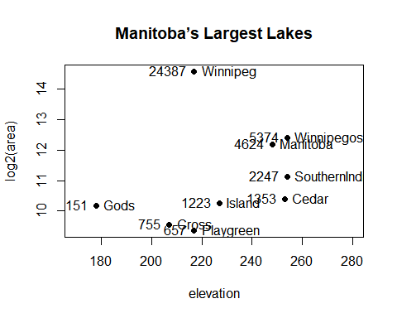 Devise captions that explain the labeling on the points and on the y-axis. It will be necessary to explain how distances on the scale relate to changes in area.

1. Repeat the plot and associated labeling, now plotting area versus elevation, but specifying log=“y” in order to obtain a logarithmic y-scale.

plot(area ~ elevation, pch=16, xlim=c(170,280), ylog=T)  
text(area ~ elevation, labels=row.names(Manitoba.lakes), pos=4, ylog=T)  
text(area ~ elevation, labels=area, pos=2, ylog=T)   
title("Manitoba’s Largest Lakes")

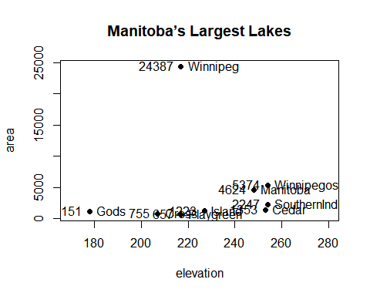 MB.Ch1.7. Look up the help page for the R function dotchart(). Use this function to display the areas of the Manitoba lakes (a) on a linear scale, and (b) on a logarithmic scale. Add, in each case, suitable labeling information.

#a on a linear scale  
dotchart(area,labels = area,xlab = "area[meters]")  
title("area of Manitoba lakes")

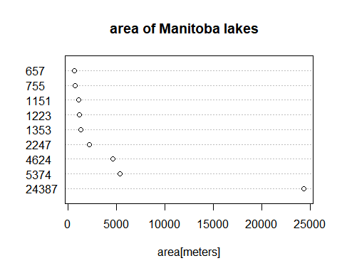

#b on a logarithmic scale  
dotchart(log(area),labels = area,xlab = "log(area)")  
title("log(area) of Manitoba lakes")

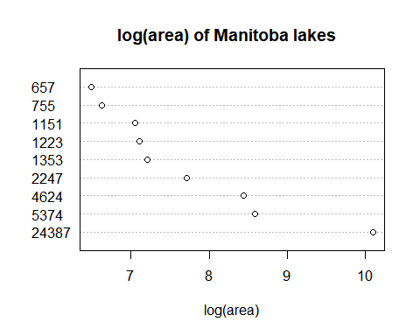

MB.Ch1.8. Using the sum() function, obtain a lower bound for the area of Manitoba covered by water.

sum(Manitoba.lakes[,2])

## [1] 41771