Development of a centralized software package for ‘SIC lab’ IIT Indore

Software Requirements Specification

Date: January 31, 2014

DocSIC v1.0 beta

Rahul Pandya cse1200122

Vishwas Jain cse1200139

Aman Doshi cse1200102

Radhakishan cse1200125

(Project Developers)

Prepared for:

Dr. Shaikh M. Mobin

In charge, Sophisticated Instrumentation Centre, IIT Indore.

Email: xray[at]iiti.ac.in <http://www.iiti.ac.in/SIC/>

Revision History

|  |  |  |  |
| --- | --- | --- | --- |
| **Date** | **Description** | **Author** | **Comments** |
| Jan 19 ’14 | Version 1.0.beta | VARP Inc. | Project started with beta version |
| Jan 25 ‘14 | Version 1.0.beta | VARP Inc. | SRS documents submitted |

**Document Approval**

The following Software Requirements Specification has been accepted and approved by the following:

|  |  |  |  |
| --- | --- | --- | --- |
| **Name** | **Title** | **Date** | **Signature** |
| Dr. Mobin Sheikh | SIC lab Head |  |  |
| Dr. Abhishek Shrivastava | CS HOD |  |  |

Table of Contents

1. Introduction 3

1.1 Purpose 3

1.2 Scope 3

1.3 Glossary 3

1.4 References 4

1.5 Overview of Document 4

2. General Description 5

2.1 Product perspective 5

2.2 Product functions 5

2.3 User characteristics 6

2.4 Constraints 6

2.5 Assumptions and dependencies 6

3. Specific Requirements 7

3.1 External interface Requirements 7

3.1.1 User Interfaces 7

3.1.2 Hardware interfaces 7

3.1.3 Software interfaces 7

3.1.4 Communications interfaces 7

3.2 Functional requirements 8

3.2.1 Functional requirement-1 8

3.2.2 Functional requirement-2 8

3.2.3 Functional requirement-3 8

3.2.4 Functional requirement-4 8

3.2.5 Functional requirement-5 9

3.2.6 Functional requirement-6 9

3.2.7 Functional requirement-7 9

3.2.8 Functional requirement-8 9

3.2.9 Functional requirement-9 9

3.2.10 Functional requirement-10 9

3.2.11 Functional requirement-11 10

3.2.12 Functional requirement-12 10

3.3 Software system attributes 10

3.3.1 Special User requirements 10

3.3.2 Availability 10

3.3.3 Portability 10

3.3.4 Maintainability 10

3.3.5 Security 11

4. Release Plan 12

5. Analysis Model 13

5.1 Data Flow Diagram 13

5.2 State Transition Diagram (Experimenter) 13

5.3 State Transition Diagram (Admin) 14

5.4 UML Diagram: 14

6. Change Management Process: 16

# 1. Introduction

### 1.1 Purpose

The purpose of this document is to present a detailed description of the "centralized software for the SIC lab, IIT INDORE". It will explain the purpose and features of the software, the interfaces, what the software will do (and if need arise) what the software won't do, the constraints under which it must operate and how the software will react to external stimuli. This document is intended for the client and the developers of the software and will be presented before the faculty for approval.

### 1.2 Scope

This software is "web based monitoring of SIC lab” developed for our faculty "Dr. Mobin Shaikh" at the SIC Lab, IIT INDORE. This software is being developed to ease the functioning of the lab and maintain the records of sample testing and store and review for future reference, which would otherwise have to be performed manually. The software will minimise the trouble of maintaining the records of lots of work being done and who does what (details about Users, when they login etc.) at the same time keeping it easy it use and understand.

More specifically, this software is developed to allow the faculty to know about the activities in the lab at any point of time and over the "Internet " and review the information later at his convenience and also get an overview of the progress and total work being done in a month or a year, manually which would be inconvenient and papery. This software will facilitate the storage of the records on a server and allow view to the admin only. Sample specification forms are used by the person working the sample (initially done on paper) will now be done through online form filling and save the trouble of maintaining the paper records. The software also contains a relational database containing a list of Users and different types of X-ray machines and their specifications and who can access them etc.

### 1.3 Glossary

1. Experimenter/user: A user present in the lab who tests the sample and submits the results.
2. Administrator: He who has complete authority over the entire data stored and view each one’s work and approves various functionalities such as reset password etc.
3. DESC: Description of the topic being discussed.
4. RAT: Rationals about the functionality (explanation in simple words).
5. TITLE: The title of the requirement section.
6. UML: User case diagram.

### 1.4 References

IEEE. IEEE Std. 830-1998 IEEE Recommended Practice for Software Requirements Specifications. IEEE Computer Society, 1998.

### 1.5 Overview of Document

The next chapter, the General Description, of this document gives an overview of the working of the software. It describes the requirements and is used to establish a reference for the technical requirements specification in the next chapter.

The third chapter, Requirements Specification, of this document is written primarily for the developers and describes the technical terms the details of the working of the software.

Both sections of the document describe the same software product in its entirety, but are intended for different readers and thus use different language.

# 2. General Description

This section will give an overview of the whole web portal. The portal will be explained in its context to show how the website interacts with other systems in the SIC lab over the internet, for storing the SIC related information, accessible to administrator from any remote location. It also introduce the basic functionality of the portal. It will also describe who all will use the portal and what functionality is available for each user. At last, the constraints and assumptions for the portal will be presented.

### 2.1 Product perspective

This system will consist of a web portal. The web portal will be used for managing the information about the experiments, the experimenter and the results generated in a particular experiment. The information, which will be accepted as a form (duly filled by the experimenter), will be feed onto a localised server. This confidential information will be available only to the person bearing the administrator-login-credentials for accessing the database. The web portal will provide the following functionality with the form:

* Entering the experiment details (SIC code, Sample details etc.).
* Entering the experimenter details. (User code, Name etc.)
* Attaching photos, graphs etc. (generated as a result or inference of the experiment).

Since this is a data-centric product it will need somewhere to store the data. For that, a database will be used. The web portal will communicate with the database. The web portal will provide the following functionality with the data:

* Add data: Only to the experimenter. • Confirm data : Only to the experimenter • Delete data: Only to the Administrator.
* Modify data: Only to the Administrator.

All of the database communication will go over the Internet. To avoid problems with overloading the operating system the application is only allowed to use 120 megabytes of memory while running the application (same as that of internet browser). The maximum amount of hard drive space is also 10240 megabytes.

### 2.2 Product functions

The product will function at two levels:

* **Experimenter level:** The product will work as an input interface for the experimenter. The experimenter can only view the machine documentation. The experimeter can't access other person's result or experiment proceedings. Apart from that the experimenter will enter his work details, which will be accepted as a form and after submission, it won't be available to anyone.
* **Administrator level:** The product will work as both input and output interface for the administrator. The administrator can view the information about each machine with proper time stamp of the work carried out on it or about each experimenter with the proper time stamp of the work carried out by that person. Apart from that, the administrator will have an access to modify and delete a record.

Both the level persons will be given a credential to access the website content.

### 2.3 User characteristics

There are two types of users that will interact with the system:

* **Experimenter:**  The experimenter will feed his personal details like User Code, Name etc. and the experiment details like SIC Code, sample information etc. into a form, before conducting the experiment. After the experiment is over, the user need to feed in the experiment results, graph, images etc. in order to get the form filled completely.
* **Administrator:** The administrator will operate the portal with a high-security password. All the information about the experimenter, experiment and scientific instruments will be available to the administrator with a proper time stamp. All the results, graph, images etc. associated with experiment will be accessible by the administrator. As the database is not localised onto a single system, the administrator will have the functionality of accessing the database from any remote location.

### 2.4 Constraints

The web portal is constrained by the availability of the internet. Since there may be a time that during the experiment internet goes off, in that case the information will be stored onto a local machine and as soon as the connection is restored, the information will be moved to the database. Since the portal fetches data from the database over the Internet, it is crucial that there is an Internet connection for the portal to function. The web portal will be constrained by the capacity of the database. Since the database is shared, it may be forced to queue incoming requests and therefor increase the time it takes to fetch data.

### 2.5 Assumptions and dependencies

If the local machine does not have enough hardware and software resources available for the web browser, for example the Ethernet and wireless drivers are not installed or the Ethernet or wireless adapter not installed on the motherboard, product does not work as intended or even at all. Another assumption is that each user will be having his own credentials for accessing the website and for form filling.

# **3. Specific Requirements**

This section contains all of the functional and quality requirements of the system. It gives a detailed description of the system and all of its features.

### 3.1 External interface Requirements

This section provides a detailed description of all inputs into and outputs from the system. It also gives a description of the hardware, software and communication interfaces and provides basic prototypes of the user interface.

#### 3.1.1 User Interfaces

Just after entering the URL in the address bar of the browser, a login window will prompt the user to enter the login credentials. This URL will be a purchased domain name from a hosting site. This page will also have a “forgot password” just beneath the ‘login’ button.

If the user credentials in login prompt are correct, the user will then jump to ‘main activity’ page.

If the users inputs in the login prompt doesn’t match with the database details, he/she will then be shown a pop-up with ‘Invalid credentials’ error message and upon closing that pop-up, he/she will get back to login window.

If the user forgot his/her login credentials, then he/she will request the Admin to reset the password by clicking on the ‘Forgot password’ link. Upon clicking this link, a new activity will open and that will ask the user to enter his valid mail-ID and his specific SR code and hit ‘Proceed’ button.

If that mail-ID exists in the server database of the lab and matches with the SR code of the same user, then his request to reset the password will be forwarded to the admin, and a pop-up will appear saying “Request successfully Forwarded”, otherwise request will be declined and the same pop-up will thumb down your request.

After a successful login attempt, a new window with main functionality of the software will open.

#### 3.1.2 Hardware interfaces

Since the web portal doesn’t have any designated hardware, it does not have any direct hardware interfaces. The hardware connection to the database server is managed by the underlying operating system on the web server.

#### 3.1.3 Software interfaces

This web portal will interact with the web browser to forward its requests to the web server. It will then access the database of the user details maintained at the other end.

#### 3.1.4 Communications interfaces

The communication between the different parts of the system is important since they depend on each other. However, in what way the communication is achieved is not important for the system and is therefore handled by the underlying operating systems for the web portal.

### 3.2 Functional requirements

This section includes the requirements that specify all the fundamental actions of the software system.

#### 3.2.1 Functional requirement-1

**ID: FR1**

**TITLE: Login/Logout**

**DESC:** A registered user should be able to login to the web portal on the page of purchased domain name itself. In the format of login page, there will be only two columns to be filled, one asking the username on the top and a password field after that.

A username for a user will be his/her roll no. of IIT-I with his/her discipline as the prefix (ex. cse, ee, me). The username and the password will be allowed to be stored as the cookies to the web browsers so that a user should not bothered every time he/she logs in to the pc.

After the work is done and the sample tests are submitted, user should able to logout of his/her account with a single click.

**RAT:** In order for a user to login to the ‘home page.

#### 3.2.2 Functional requirement-2

**ID: FR2**

**TITLE:** Retrieve password

**DESC:** Given that a user has registered, then the user should be able to retrieve his/her password by clicking on the ‘forgot password’ link on the homepage itself.

Upon clicking this link, a new activity will open and that will ask the user to enter his valid mail-ID and his specific SR code and hit ‘Proceed’ button.

If that mail-ID exists in the server database of the lab and matches with the SR code of the same user, then his request to reset the password will be forwarded to the admin, and a pop-up will appear saying “Request successfully Forwarded”, otherwise request will be declined and the same pop-up will thumb down your request.

**RAT:** In order for a user to retrieve his/her password.

#### 3.2.3 Functional requirement-3

**ID: FR3**

**TITLE: Signup**

**DESC:** If a new student joins the SIC lab, then in order to add him/her to the user list, he/she will have to send his/her details to the faculty member and get an approval from them.

For this functionality, a link has been added at the home page only as ‘signup’. At signup page, new students have to fill up their basis details to create a new account. **RAT:** In order to add a new student to the user database.

#### 3.2.4 Functional requirement-4

**ID: FR4**

**TITLE: Home Page**

**DESC:** This is the main page where the user will be directed after the login activity. Here user can add a new sample details, change the password, access to the documentation of the machines and see his/her profile. **RAT:** In order to access other main features of the portal.

#### 3.2.5 Functional requirement-5

**ID: FR5**

**TITLE: New Sample**

**DESC:** At the homepage only, the logged in user will have the link to create new sample details. **RAT:** In order to make a new sample entry.

#### 3.2.6 Functional requirement-6

**ID: FR6**

**TITLE: Submit sample test results**

**DESC:** User will have to fill up this form with valid entries. This sample result will then be stored in the database and will be notified to the administration.

**RAT:** In order to submit the test results to the faculty members.

#### 3.2.7 Functional requirement-7

**ID: FR7**

**TITLE: Attachment**

**DESC:** If any sample observation also has the graph plottings, then a link of ‘attachment’ will attach the graph with test result.

**RAT:** In order to attach a graph or some other test observations with the result.

#### 3.2.8 Functional requirement-8

**ID: FR8**

**TITLE: Notification**

**DESC: When admin is logged in:** Whenever a new sample is submitted by the students, a red light in the notification section pops-up with a little details about submission. These notifications will also have a time stamp at the bottom.

**When experimenter is logged in:** If the results submitted by the experimenter are considered by the admin as inappropriate, then he/she will be asked to redo the experiment.

**RAT:** In order to see the fresh test results submitted and reviews of that result submitted.

#### 3.2.9 Functional requirement-9

**ID: FR9**

**TITLE: Test logs**

**DESC:** When the admin will click on a notification, he will be directed to another page showing the test results submitted by the experimenter but with the test logs at the top. This will test log will contain details about the experiment like duration of the experiment etc.

**RAT:** In order to show other related information about the experiment.

#### 3.2.10 Functional requirement-10

**ID: FR10**

**TITLE: Change password**

**DESC:** If a user wishes to change his/her password, then he/she can do it merely by clicking on the change password tab on the home page and then just reset it by entering old password, SR code and the new password.

**RAT:** In order to change the password of user’s account.

#### 3.2.11 Functional requirement-11

**ID: FR11**

**TITLE: Modification in test results**

**DESC:** If the admin is not satisfied with the sample test outcomes, then he can recommend the experimenter to redo the experiment. This option will be available when admin will open the details about the result submitted. He/ She can also delete this data from the database as now it is just a piece of trash. **RAT:** In order to modify the test results submitted.

#### 3.2.12 Functional requirement-12

**ID: FR12**

**TITLE: History**

**DESC:** Both experimenter and the admin will have the privilege to view the history. In case of admin, he/she can view past submissions of any person working the lab.

In case of experimenter, he/she can only view his/her own submission history. This will help him/her to consider the mistake and any hint from the past observations. **RAT:** In order to review the past submissions.

## 3.3 Software system attributes

#### 3.3.1 Special User requirements

**ID: FR13**

**TITLE: Backup**

**DESC:** Admin will have the privilege to keep the backups of all of the test results in a separate local drive. The experimenter will have the privileges to take the backup of their submissions in local storage.

**RAT:** In order to make sure the test results are always accessible without internet connection also.

#### 3.3.2 Availability

**ID: QR1**

**TITLE: Internet Connection**

**DESC:** The application should be connected to the Internet.

**RAT:** In order for the application to communicate with the database.

#### 3.3.3 Portability

**ID: QR2**

**TITLE: Software portability**

**DESC:** This web portal should be portable with most common web browser such as Chrome, Mozilla, internet explorer and torch.

**RAT:** The adaptable browsers for the application to run on.

#### 3.3.4 Maintainability

**ID: QR3**

**TITLE: Software extendibility**

**DESC:** The functions and features in web portal should be easy to extend with new versions.

Coding of the software should be done in such a way that it favors implementation of new features. **RAT:** In order for future functions to be implemented easily to the software.

#### 3.3.5 Security

**ID: QR4**

**TITLE: Database storage**

**DESC:** The database will not be stored on the local drive to prevent any theft expect if the administrator specifically ask for the backup of the test results in the local drive. All the test reports will be stored at web server with decent encryption.

**RAT:** In order to prevent theft of local data.

**ID: QR6**

**TITLE:** **Password security**

**DESC:** A one-way encryption security feature such as 'digests' will be adopted for the passwords. In this way, even the administrator will not be able to see the passwords of other users because of hash code which do not decrypt the passwords.

**ID: QR5**

**TITLE: Database security and encryption**

**DESC:** Encryption functionality alone is not sufficient for protecting confidential data.

Managing access controls and the privileges that enable users to encrypt or decrypt data are of equal importance.

Security mechanism will also support partial encryption to keep the performance at the top. **RAT:** In order to give comprehensive database security features.

**ID: QR7**

**TITLE: Admin Account Security**

**DESC:** An admin and IP address should not be able to log-in to the web portal for a certain time period after three times of failed log-in attempts.

The locking period should be half an hour, and during that period the log-in function is disabled.

**RAT:** In order to block the access to complete database of the test results in case of doubtful login as admin.

# 4. Release Plan

The requirements were divided into three releases based on the prioritization and their dependencies. The three different releases were assembled so that each would work as a fully functional application.

In the first release the requirements that build up the foundation of the application were included, together with the most highly prioritized requirements and their dependencies.

The second release also includes important requirements. However, these requirements are not vital for a functional application. They are more suited to act as additional features that can contribute to making the software product more attractive.

The third release includes the requirements that can be afforded to discard if the project gets delayed or overruns the budget.

# 5. Analysis Model

### 5.1 Data Flow Diagram

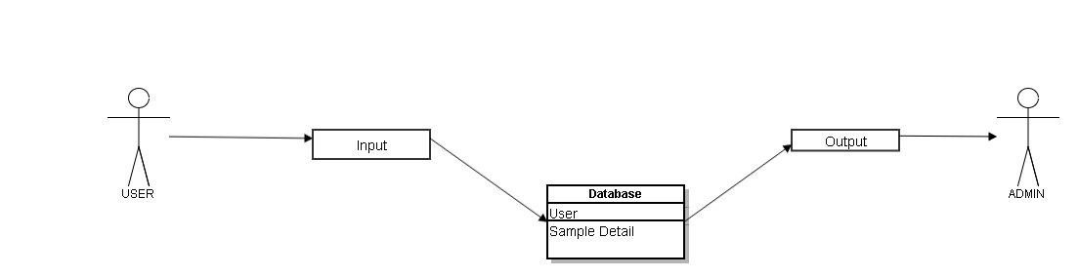

### 5.2 State Transition Diagram (Experimenter)

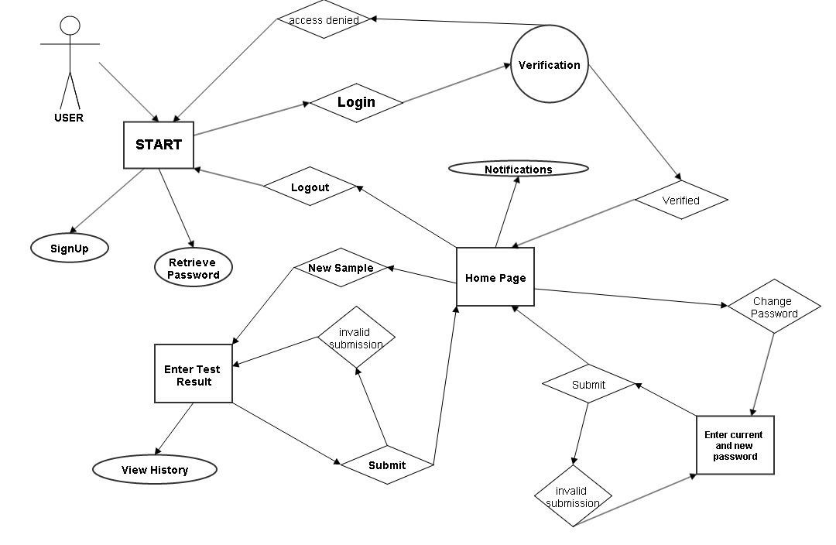

**Verification:**Corresponds to the page where you can enter your username and password.

**User Added:** Database is updated to process data of new user.

**User Removed**: Details of user has been removed from database.

**All Records with Time Stamps:** Admin can search and view by time.

### 5.3 State Transition Diagram (Admin)

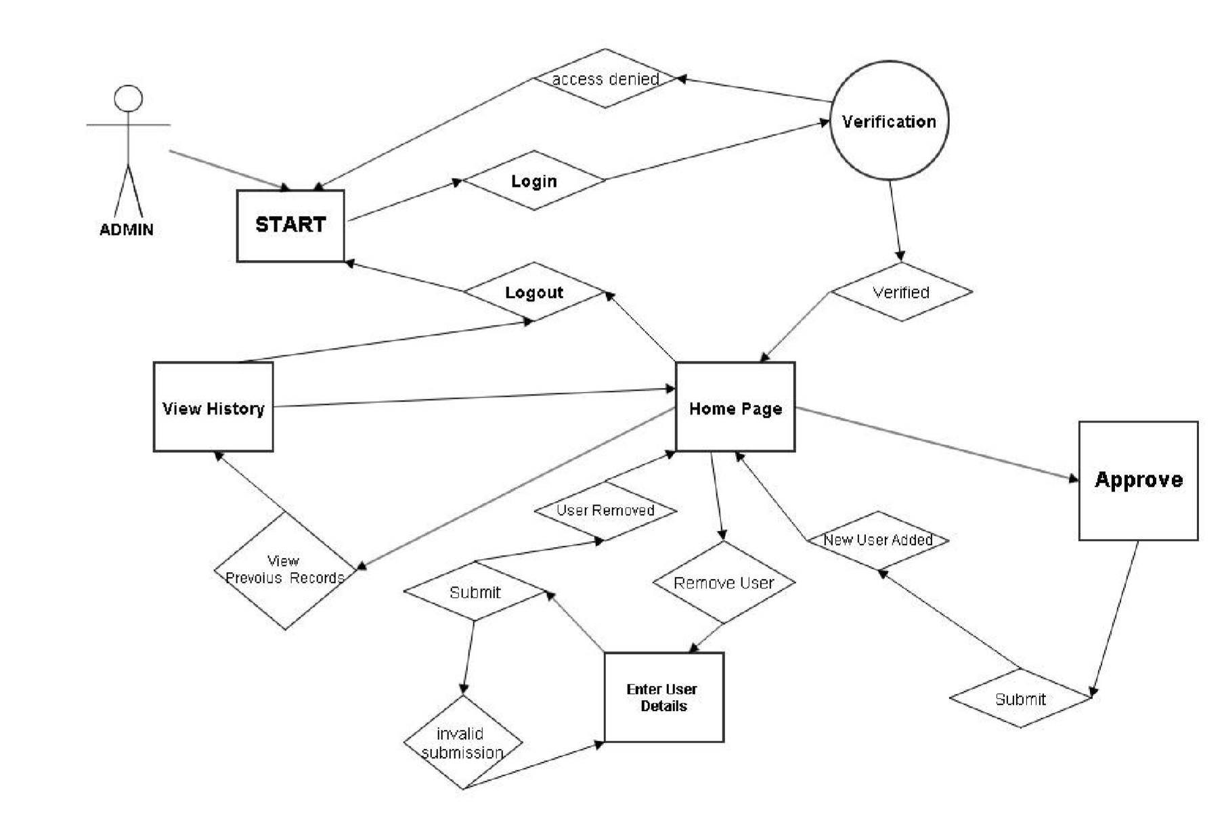

***Verification:*** Is the process of verification of password. If password is incorrect user will be directed to START page.

***User Added*:** Database is updated to process data of new user.

***User Removed***: Details of user has been removed from database.

***All Records with Time Stamps:*** Admin can search and view previous records with time details of that experiment.

### 5.4 UML Diagram:

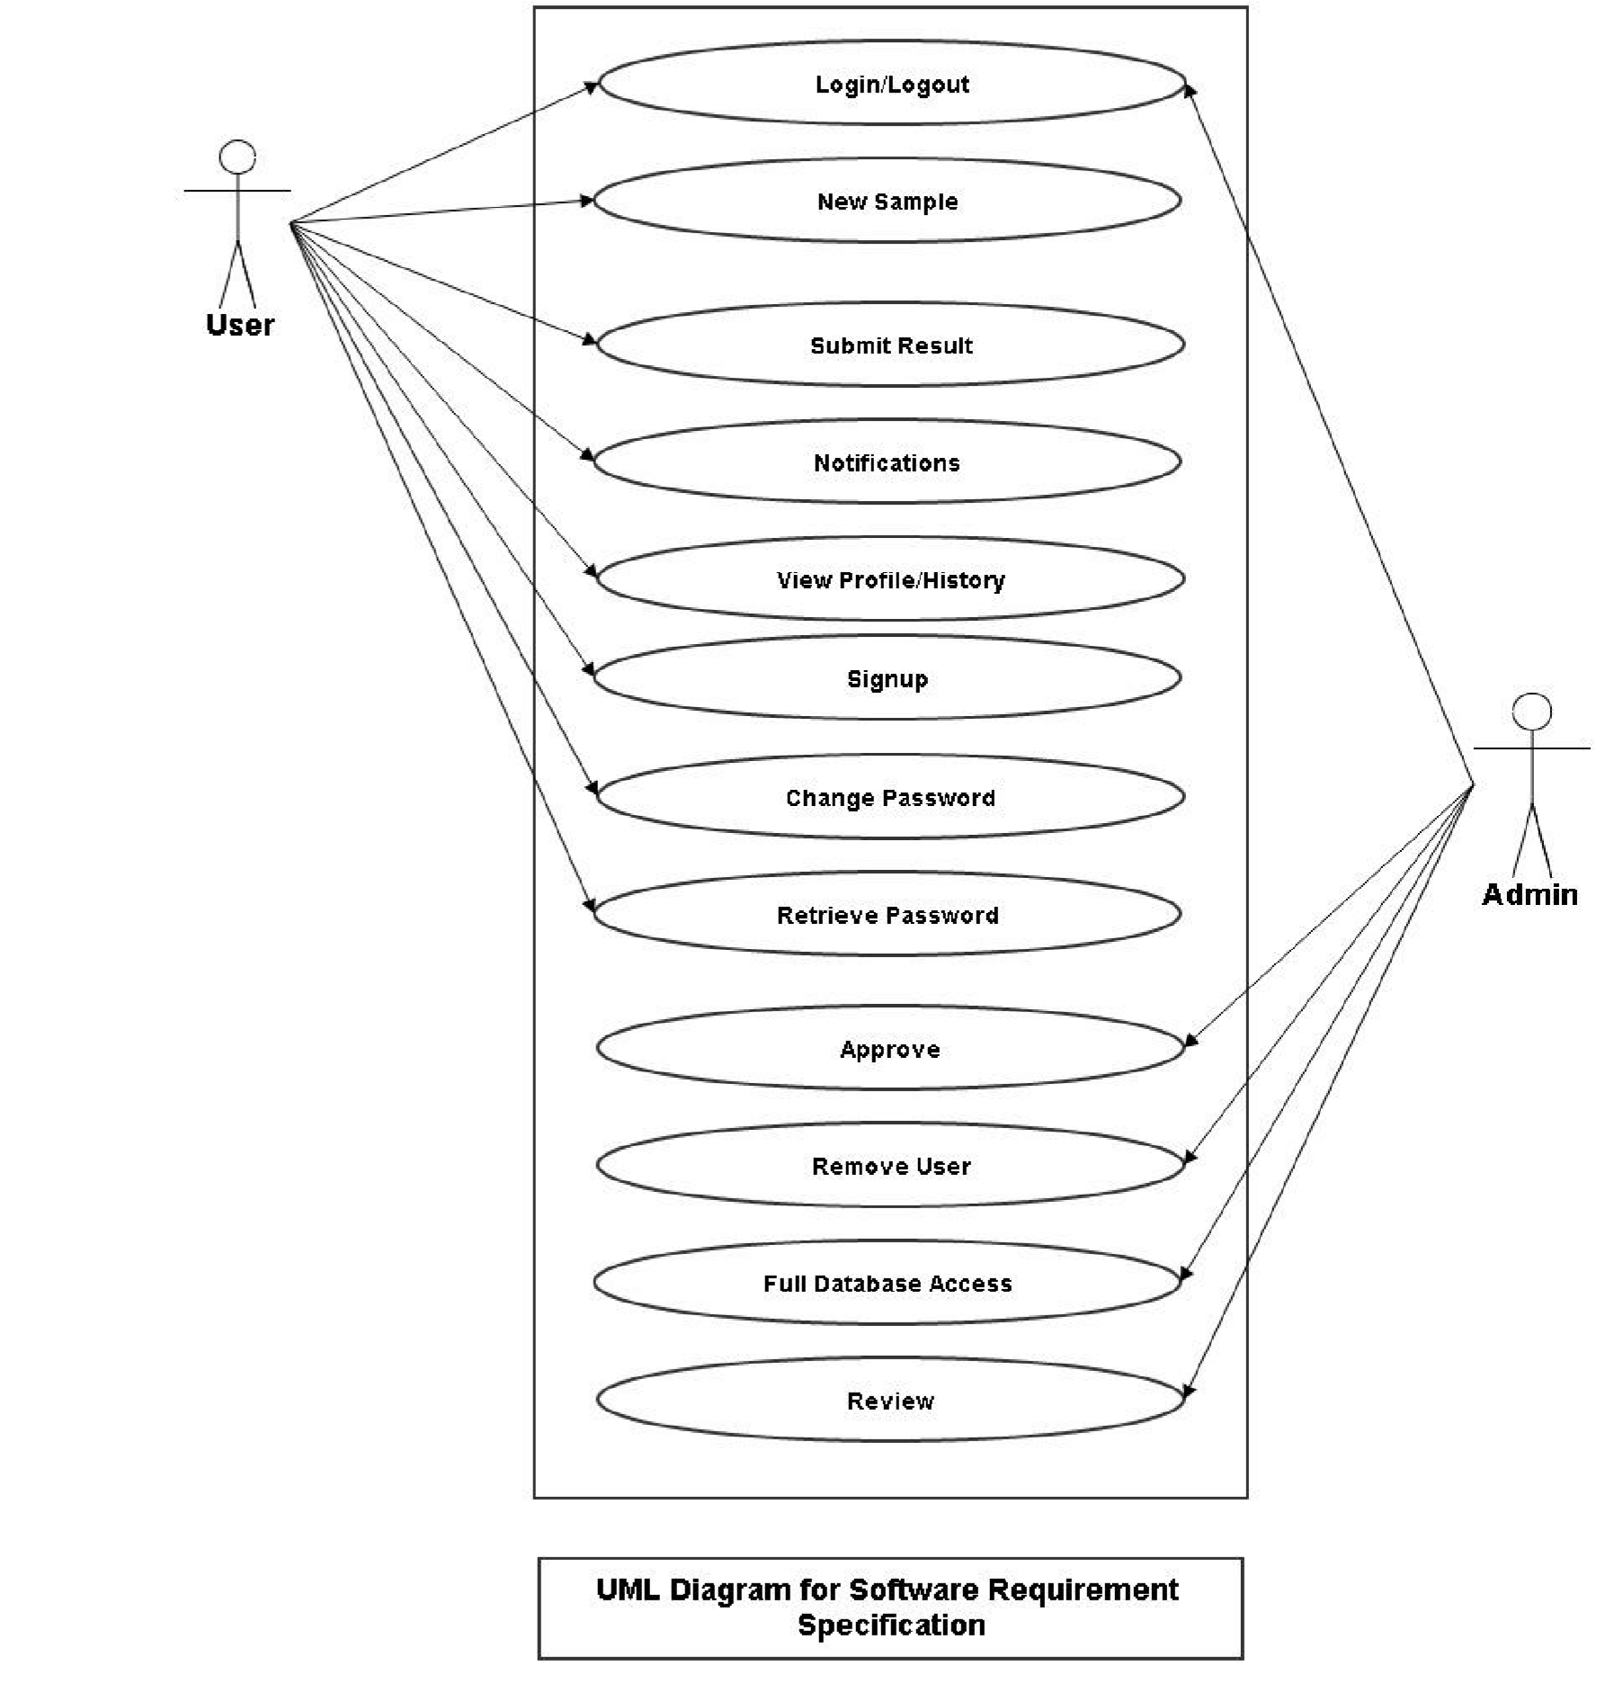

***User Login***: By clicking this link user will be asked to enter his/her username and password.

***New Sample***: By clicking this link new window will pop up and ask for sample details.

***Submit Result***: By clicking this link details of the sample will be saved in database and admin can view those using View Previous Records.

***User Logout***: To end ongoing sessions

***Admin Login***: To authenticate Admin’s credentials

***Add New User***: Using this link Admin can add new user.

***Remove User***: Admin can remove a user.

***View Previous Records***: Admin can search and view all Sample Results with time stamps.

# 6. Change Management Process:

As a team, we will update and evaluate our SRS document every week as we make changes in our design and requirements. We will add new detailed information which will include: references, charts and graphs, and more specifications and requirements modification that we find along the way in the designing and implementation of the product.