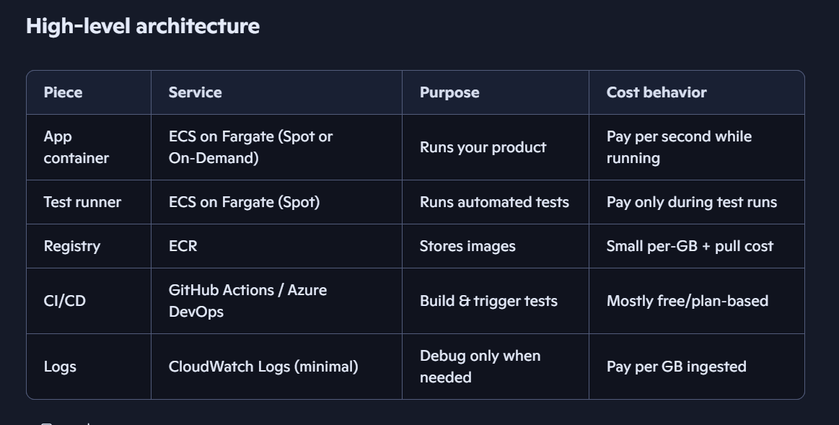
1. Core design principles
- No always-on servers: everything is container + Fargate task.
- No load balancer, no NAT Gateway in the learning phase.
- Single AZ, single public subnet to avoid cross-AZ and NAT costs.
- Short-lived tasks: app and tests run only when you need them.
- Spot where safe: tests on Spot, app on Spot or On-Demand depending on tolerance.
2. Network layout (minimal-cost VPC)
- VPC with:
  - 1 public subnet in a single AZ (e.g., us-east-1a).
- Internet Gateway attached to the VPC.
- Route table for the public subnet:
  - Default route 0.0.0.0/0 → Internet Gateway.
- No NAT Gateway, no private subnets for now.
All ECS tasks run in the public subnet with public IPs (fine for learning and early testing).
3. ECS + Fargate setup
3.1. ECS cluster
- Create an ECS cluster with:
  - Fargate and Fargate Spot capacity providers enabled.
  - No EC2 instances.
3.2. Task definitions
Create two task definitions:
- App task definition (your product)
  - Container: your app image from ECR.
  - CPU/memory: start small (e.g., 0.25 vCPU / 0.5–1 GB).
  - Networking: awsvpc, assign public IP.
  - Logging: CloudWatch Logs, but keep log level low.
- Test runner task definition
  - Container: test runner image (e.g., same codebase with a test entrypoint).
  - CPU/memory: just enough to run tests.
  - Networking: same as app.
  - Logging: CloudWatch Logs, but only keep logs you actually need.
4. How you run things
4.1. Running the app (for manual testing)
- From the AWS console or CLI:
  - Run Task → choose App task definition.
  - Use Fargate Spot if you’re okay with occasional interruptions.
- The task starts, gets a public IP.
- You hit it directly (e.g., via Postman or browser) for manual testing.
- When you’re done, stop the task.
- You pay only for the runtime.
4.2. Running automated tests
- CI (e.g., GitHub Actions) pipeline steps:
  - Build Docker image.
  - Push to ECR.
  - Trigger ECS RunTask for the Test runner task definition (Fargate Spot).
  - Wait for task completion and read exit code:
    - 0 → tests passed.
    - Non-zero → tests failed.
- Tests run entirely inside AWS, close to your app’s environment.
- You pay only for the minutes the test task is running.
5. CI/CD flow (concrete)
Assume GitHub Actions:
- On push / PR:
  - Job 1: Build & push image
    - Build app image.
    - Tag with commit SHA.
    - Push to ECR.
  - Job 2: Run tests in Fargate
    - Call aws ecs run-task with:
      - Cluster name.
      - Test runner task definition.
      - Override container image tag (the one just built).
      - Capacity provider: Fargate Spot.
    - Poll task status until it stops.
    - Fetch exit code and fail the job if non-zero.
You can later add a deploy job that runs the app task definition with the same image tag.
6. Cost-control habits
- Use the smallest task sizes that still run reliably.
- Stop tasks when not in use (no long-running idle containers).
- Use Spot for tests and non-critical app runs.
- Turn down logging:
  - Avoid debug logs by default.
  - Consider short retention (e.g., 1–3 days) for CloudWatch log groups.
- Stay in one region (e.g., us-east-1).
- Avoid ALBs, NAT Gateways, and multi-AZ until you truly need them.
7. Suggested first steps for you
- Create ECR repo for your app.
- Create VPC + 1 public subnet (or use the default VPC for learning).
- Create ECS cluster with Fargate + Fargate Spot.
- Create app and test task definitions.
- Manually run:
  - App task → hit it from your machine.
  - Test task → watch it in ECS console and CloudWatch Logs.
- Wire up GitHub Actions to:
  - Build & push image.
  - Trigger ECS RunTask for tests.

