ALPAS
Time & Attendance System

Administrator Manual
System configuration, departments, audit logs, and reference

Version 1.0 · July 2026

ALPAS Time & Attendance System
As an Administrator, you have full access to the entire system — including all Employee, Department Head, and HR features — plus exclusive tools for managing departments, viewing audit logs, and overseeing the whole organization.
Also see: The Employee, Department Head, and HR Manuals for features shared with those roles.

1. Admin Dashboard
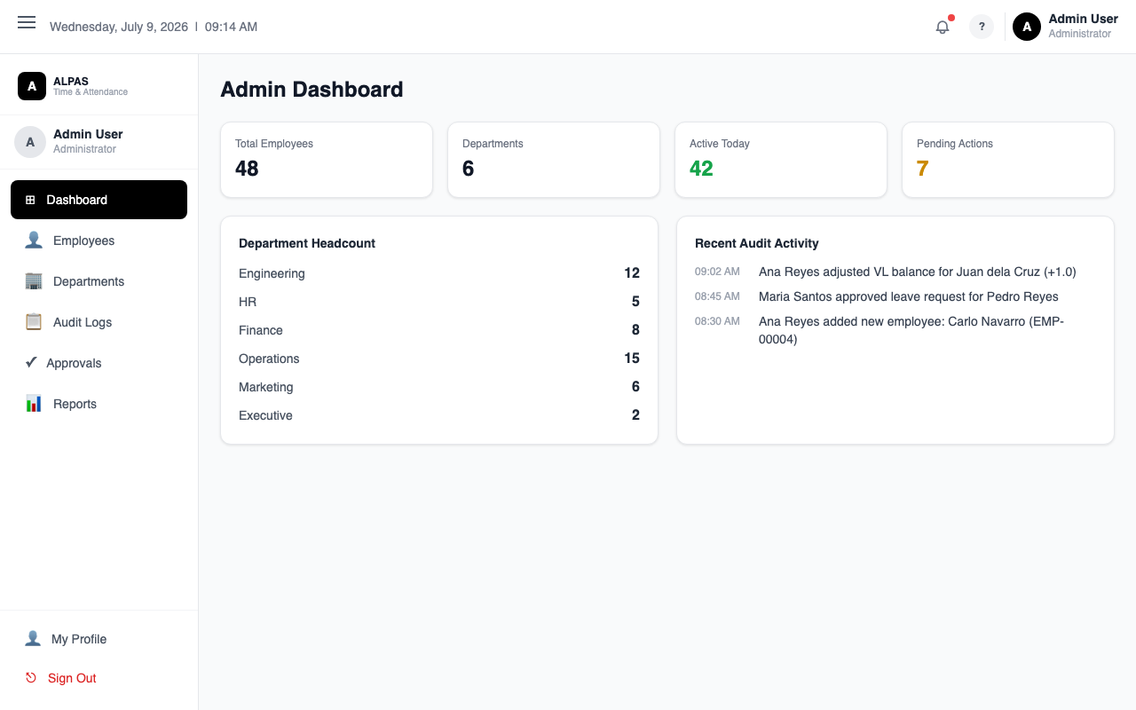
Admin Dashboard — system-wide headcount, department breakdown, and recent audit activity
Navigation: Sidebar → Admin Dashboard
Section | What It Shows
Total Users | Active users out of all registered
Departments | Number of active departments
Present Today | Employees clocked in
Absent Today | Employees with no clock-in (red)
Pending Total | Combined count of pending leaves, OT, corrections, and conversions
Recent Audit Logs | Last 6 system actions with actor and timestamp

Click View all under the audit log preview to open the full Audit Logs page.
[Insert Screenshot: Admin Dashboard]

2. Employee Management
Navigation: Sidebar → Employees (Admin section)
Identical to the HR Employees page. As Admin, you can:
- Add, edit, archive, restore, and delete employees
- Reset passwords
- Import and export employee lists
- Upload and manage employee documents
- Assign any role, including HR and Admin
See the HR Manual, Section 2 for full step-by-step instructions.
Admin-only: Only Administrators can assign the Admin role to another user.
[Insert Screenshot: Admin Employees Page]

3. Department Management
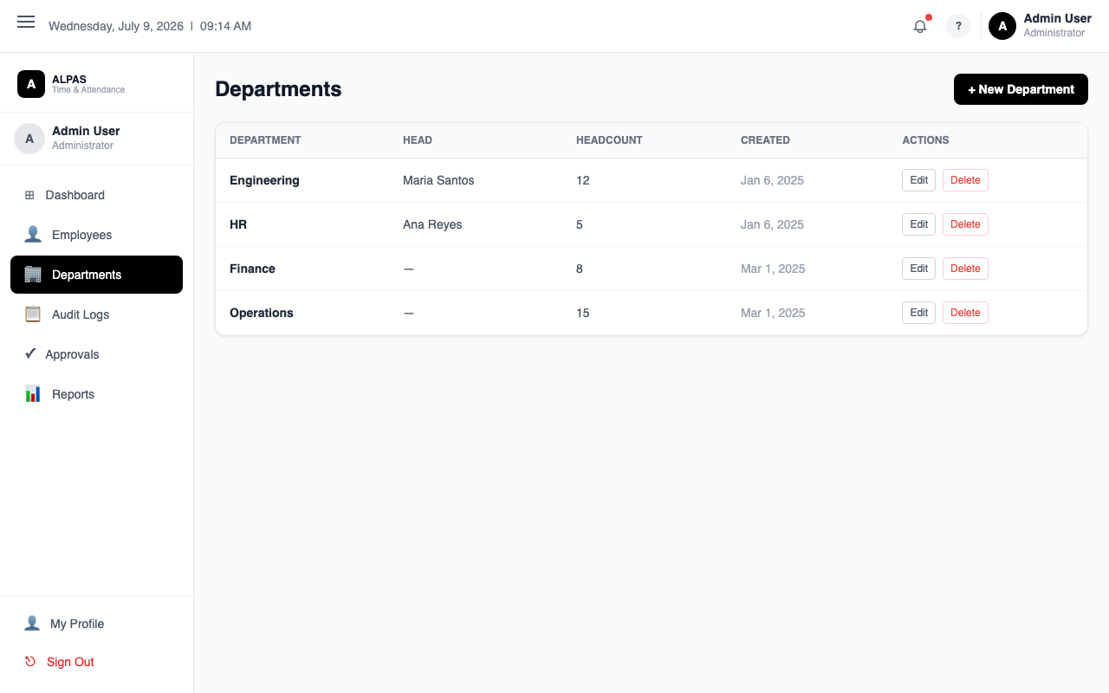
Department List — view all departments, their heads, and headcount
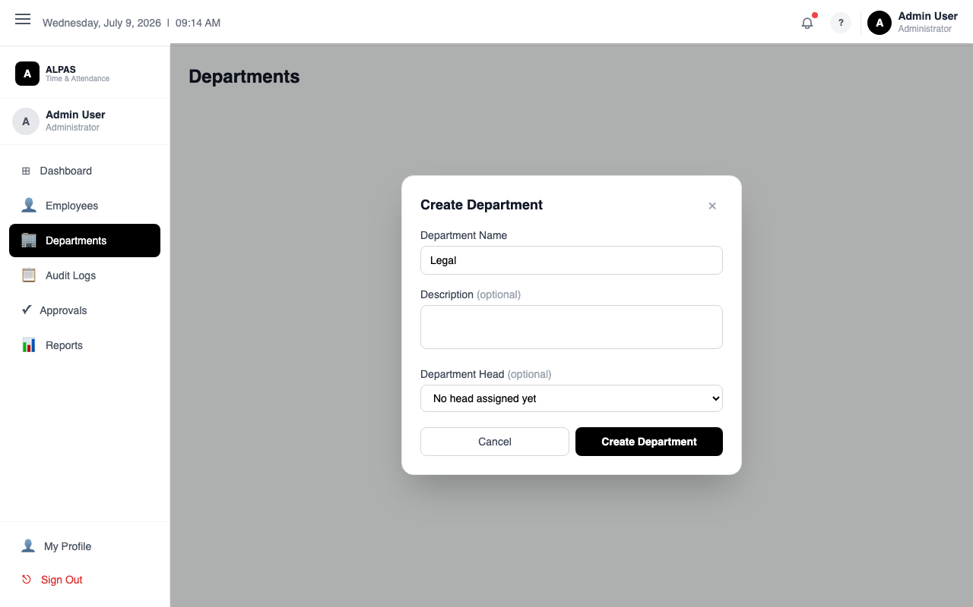
Create/Edit Department — name, optional description, and assign a department head
Navigation: Sidebar → Departments
This page is exclusive to Administrators.

Viewing Departments
Departments appear as cards showing the department name, description, staff count, and the assigned Department Head (or "Unassigned" in red if none is set).
[Insert Screenshot: Departments Page]

Creating a Department
- Click + New Department.
- Enter the Department Name (required) and an optional Description.
- Click Create.
- A department code is auto-generated from the name initials.
After creating, assign a head and add members.

Editing a Department
- Click Edit on the department card.
- A panel opens with two sections:
- Left: Name and description (editable). Click Save when done.
- Right: Current members list. Use the search box to find and add employees. Click Remove to remove a member.

Assigning a Department Head
- Click Assign Head on the department card.
- Select the employee to designate as head.
- Click Assign.
- Their role is automatically updated to Department Head.
Important: The employee must already be a member of the department. Add them via Edit first if needed.

Deleting a Department
- Click Delete on the department card.
- Confirm the deletion.
Blocked: A department cannot be deleted if it has active employees. Move or archive the employees first.

4. Audit Logs
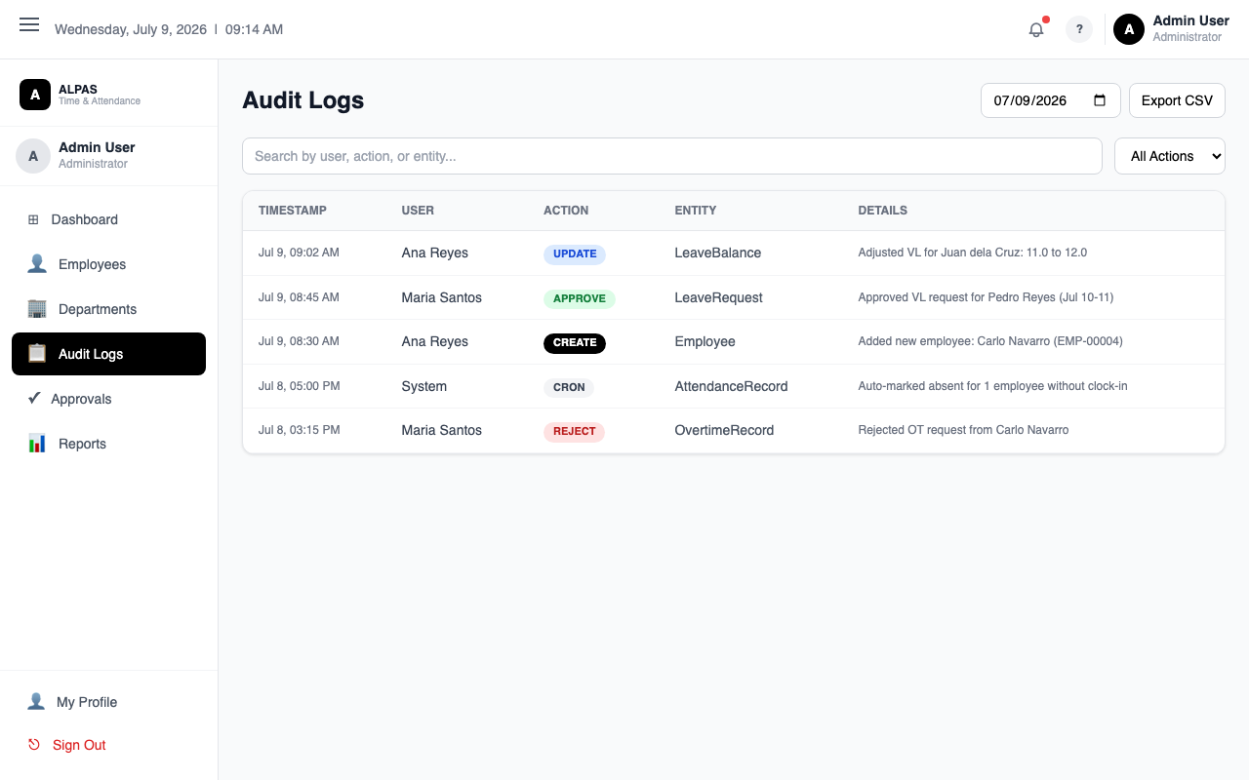
Audit Logs — timestamped record of every action taken in the system
Navigation: Sidebar → Audit Logs
Audit Logs record every significant action in the system — who did what, when, and from which IP address. These logs cannot be deleted.
What you will see:
Column | What It Shows
Action | Color-coded badge: CREATE, UPDATE, DELETE, LOGIN, LOGOUT, APPROVE, REJECT, PASSWORD_RESET
User | Who performed the action
Entity | Which record was affected
Timestamp | When the action occurred
IP Address | Where the request came from

Filtering:
- Use the Search bar to find logs by user name, email, or entity ID.
- Use the Action dropdown to filter by action type.
Viewing Details:
Click the expand button on any row to see:
- Before (red) — the record's previous values
- After (green) — the record's updated values
[Insert Screenshot: Audit Logs Page]
[Insert Screenshot: Expanded Audit Log Row]

5. Approvals and Reports
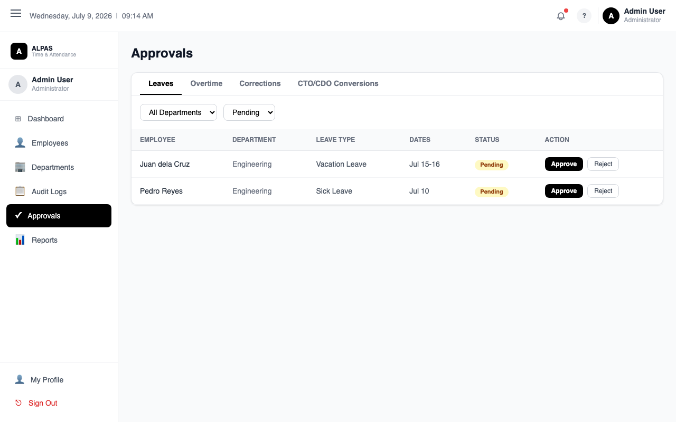
System-Wide Approvals — filter by department; approve or reject leaves, OT, and corrections
As Administrator, you have full approval authority across all departments — including approving requests from HR users. You are the final step in OT Conversion multi-step approvals (after Department Head and HR).
For Reports, you have access to the same Attendance, Leave, Overtime, and Absence reports as HR.
See the HR Manual, Sections 5 and 6 for detailed instructions on Approvals and Reports.
Note: You cannot approve your own requests.

6. System Reference

Automated Background Jobs
The system runs two scheduled tasks automatically — no action required from you:
Job | Schedule (Philippine Time) | Purpose
Absent Check | 2:00 PM on weekdays | Notifies employees who have not clocked in
Daily Maintenance | 8:00 AM every day | Expires outdated OT records, sends 7-day expiry warnings, runs monthly VL accrual on the 1st of each month

Vacation Leave Accrual
Every 1st of the month, Regular employees automatically receive 1.25 days of Vacation Leave. This runs as part of Daily Maintenance.

Overtime Rules
- Overtime is auto-calculated when an employee works more than 9 hours in a single day.
- Employees must file overtime within 15 days of the shift, or the record expires.
- Approved OT credits are valid for 6 months.
- CTO conversion minimum: 4 hours. CDO minimum: 8 hours.

Overnight Shift Support
- Employees can clock out until 6:00 AM the next day and the system matches it to the prior day's clock-in.
- For attendance corrections on overnight shifts, employees use the "Clock-out is on the next day (overnight)" checkbox.

Office GPS Radius
The system detects whether an employee is within 200 meters of the office. If within range, status is automatically set to On-Site. Outside the range, employees must choose WFH, OB, or On-Site manually.

Session Security
- Access tokens expire after 15 minutes and are silently refreshed.
- Refresh tokens expire after 7 days — users must log in again after that.
- Archiving or deactivating an employee immediately ends their session.

Password Policy
All passwords must be at least 8 characters and contain at least one uppercase letter, one lowercase letter, and one number.

Leave Balance Rules
- Emergency Leave and Sick Leave share a 15-day pool per year.
- LWOP (Leave Without Pay) does not require any balance and is always available.
- New employees cannot file most leave types until they have 6 months of tenure.

7. Frequently Asked Questions
Q: How do I give someone Admin access?
A: Go to Employees, find the user, click Edit, change their Role to Admin, and click Save.
Q: Can I undo an approval?
A: No — approvals are final. Use the Leave Balance Adjustment tool to manually correct balances if needed.
Q: A department has no Department Head. What happens?
A: Leave, OT, and correction requests from that department go directly to HR for approval.
Q: How do I trace who made a change to a specific record?
A: Go to Audit Logs, search by the employee name or entity ID, and expand the row to see before and after values.
Q: Can audit logs be deleted?
A: No — audit logs are permanent by design for compliance and accountability.
Q: What is the difference between archiving and deleting an employee?
A: Archive (recommended for resignations) soft-deletes the employee and keeps all their data but prevents login. Delete permanently removes the user account — use only for test accounts.

