ALPAS
Time & Attendance System

Department Head Manual
Managing your team — approvals, dashboards, and more

Version 1.0 · July 2026

ALPAS Time & Attendance System
As a Department Head, you have all Employee features plus the ability to approve or reject your team's requests. This guide covers your additional responsibilities.
Also see: The Employee Manual covers Login, Clock In/Out, Leave Filing, Overtime, Profile, and Notifications — all of which apply to you as well.

1. Your Role Overview
You are the first approver for your team's requests. HR may perform a final review after you for certain request types.
What you can approve:
- Leave requests from your team
- Overtime filing requests from your team
- Attendance correction requests from your team
- Overtime conversion requests (CTO/CDO) from your team
What you cannot approve:
- Your own requests (these go directly to HR)
- Requests from employees in other departments

2. Team Dashboard
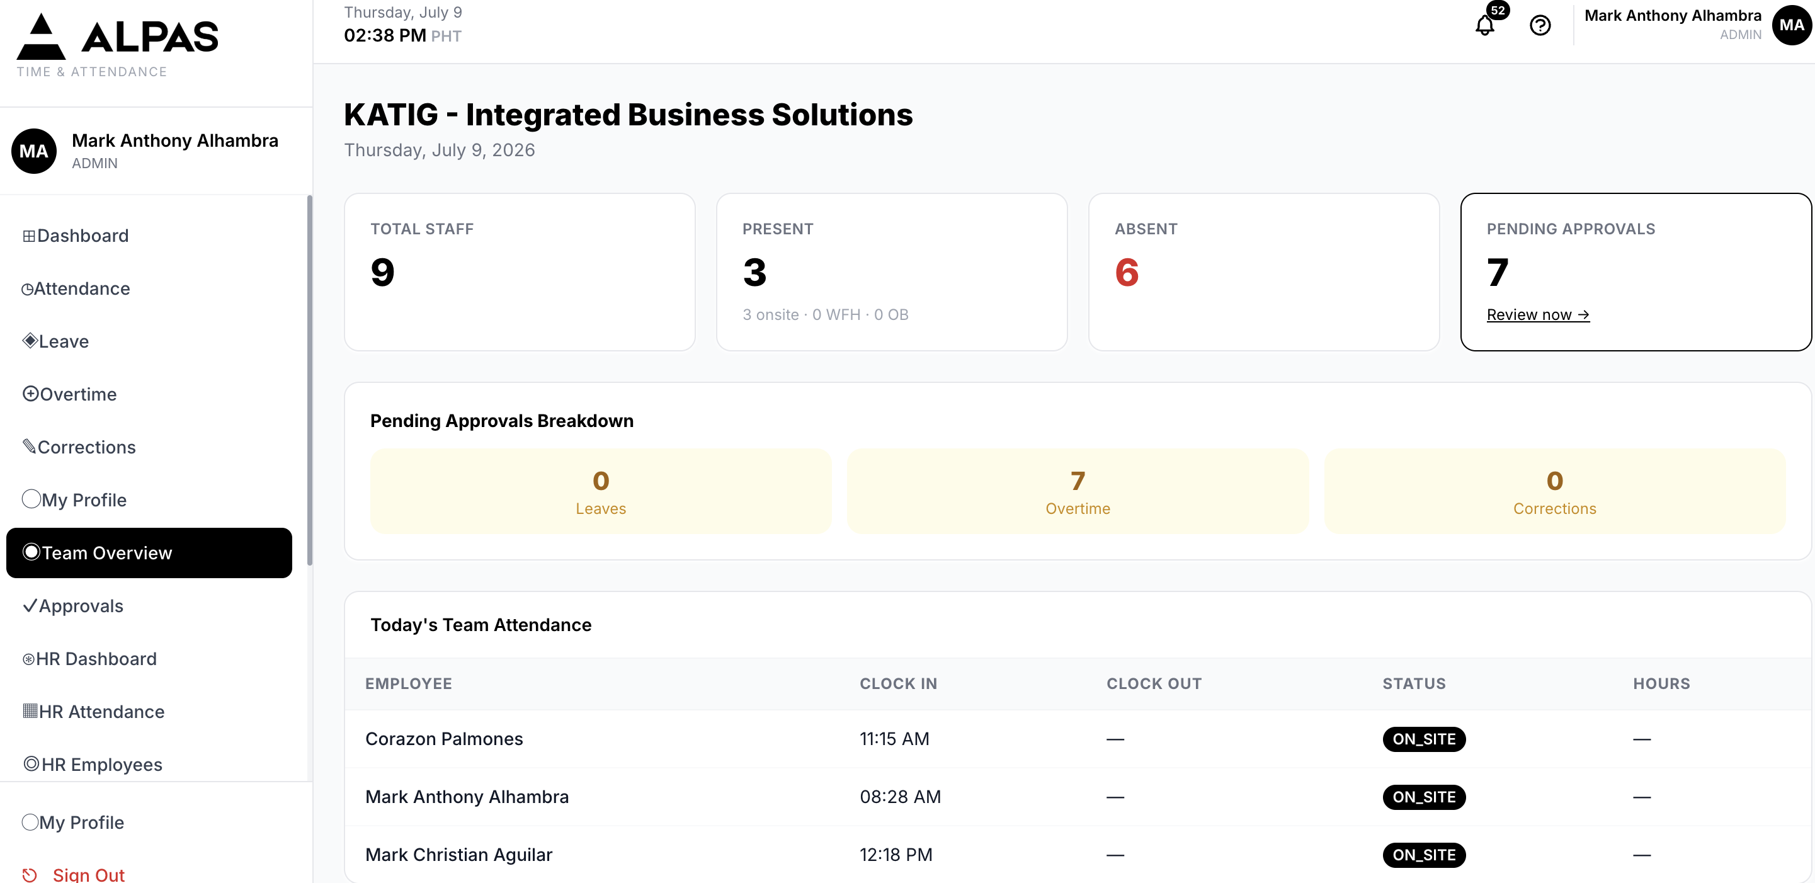
Team Dashboard — headcount stats and today's attendance at a glance
Navigation: Sidebar → Team Overview
What you will see:
Section | What It Shows
Total Staff | Number of employees in your team
Present | How many team members have clocked in today
Absent | How many have not clocked in (shown in red)
Pending Approvals | Total requests waiting for your review
Pending Breakdown | Cards showing how many Leaves, OT requests, and Corrections need action
Today's Attendance Table | Each team member's clock-in, clock-out, status, and hours for today

Tip: Click the Pending Approvals counter to jump directly to the Approvals page.

3. Approving or Rejecting Requests
Navigation: Sidebar → Approvals
The Approvals page has four tabs at the top. Click each tab to switch between request types:

Leaves Tab
What you will see: Pending leave requests from your team, showing employee name, leave type, dates, number of days, and reason.
Steps:
- Go to Approvals and click the Leaves tab.
- Review the request details.
- Click Approve or Reject.
- A small window appears. Enter notes (required when rejecting; optional when approving).
- Click Submit.
- The employee is notified automatically.
Note: Your own leave requests will not appear here — they go to HR directly.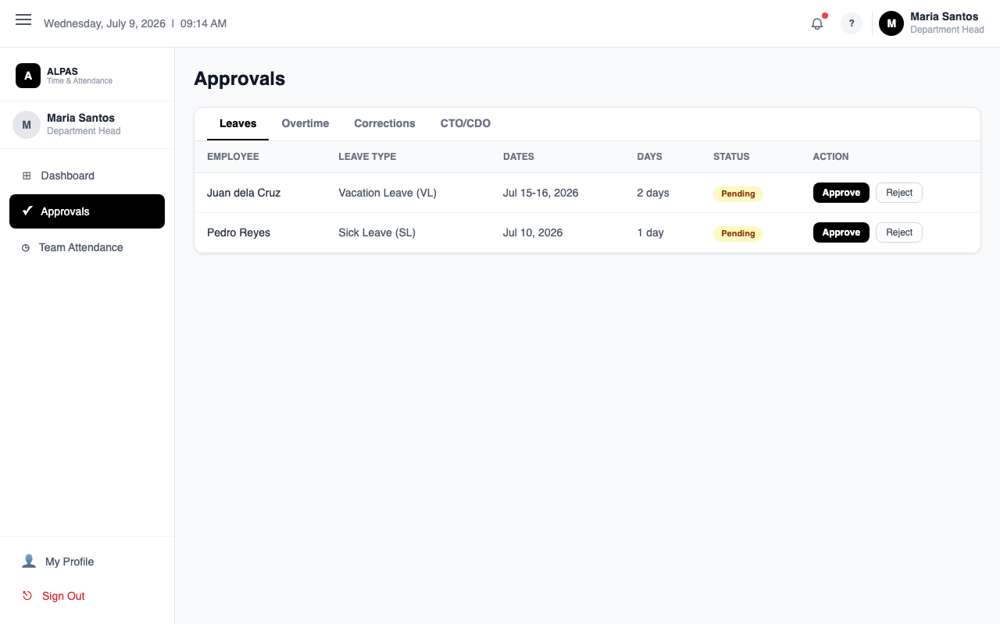
Approvals – Leaves Tab — view pending leave requests and Approve or Reject

Overtime Tab
What you will see: Filed overtime requests from your team, showing employee name, date, hours, and reason.
Steps:
- Click the Overtime tab.
- Review the hours and reason.
- Click Approve or Reject, add notes if needed, and click Submit.
Note: Approving an overtime request credits the employee with those hours. Credits are valid for 6 months.
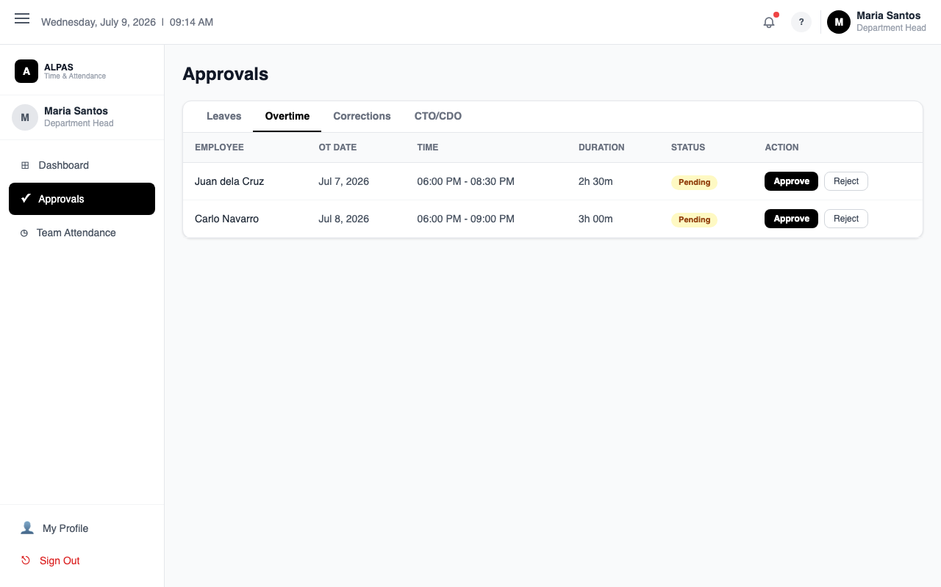
Approvals – Overtime Tab — review and action overtime requests

Corrections Tab
What you will see: Attendance correction requests from your team, showing the date, requested clock-in time, requested clock-out time, and reason.
Steps:
- Click the Corrections tab.
- Review the requested times and the reason carefully.
- If you approve, the attendance record is updated automatically to the corrected times.
- Click Approve or Reject, add notes if rejecting, and click Submit.
Tip: If a correction shows an overnight shift (clock-out time later than midnight), verify the dates make sense before approving.
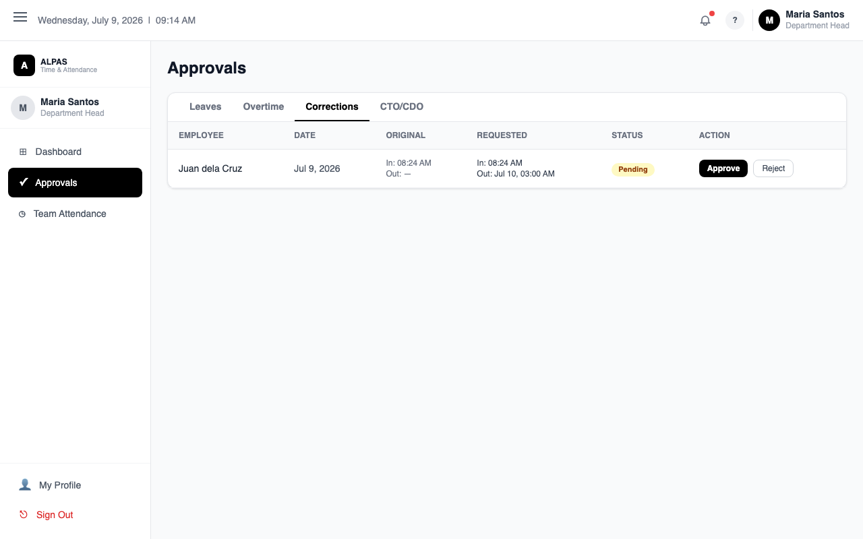
Approvals – Corrections Tab — compare original vs. requested times

OT Conversions Tab
What you will see: Requests from your team to convert overtime credits to CTO (Compensatory Time Off) or CDO (Credit Day Off).
Steps:
- Click the OT Conversions tab.
- Review the conversion type, scheduled date, and number of hours.
- Click Approve or Reject with notes.
Minimum hours required:
- CTO: at least 4 hours
- CDO: at least 8 hours
Requests below the minimum should be rejected.
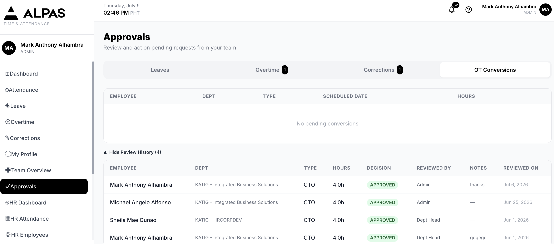

Viewing Review History
On each tab, toggle "Show Review History" to see requests you have already approved or rejected.

4. Frequently Asked Questions
Q: A request from my team is not appearing in my queue.
A: Your own requests are routed to HR and will not appear in your queue. Also check that the employee's department is correctly set to yours.
Q: Can I reverse an approval I already made?
A: No. Once approved or rejected, the decision is final in the system. Contact HR for manual corrections.
Q: An employee's hours are showing as negative on the dashboard.
A: Ask the employee to file an attendance correction and use the "Clock-out is on the next day (overnight)" checkbox. When you receive the correction request, verify the times and approve if correct.
Q: A team member says they cannot see a request they filed.
A: Drafts (unfiled overtime records) are private to the employee until they click "File OT". If the record is older than 15 days, it may have already expired.

