ALPAS
Time & Attendance System

HR Officer Manual
Employee management, leave, reports, and approvals

ALPAS Time & Attendance System
As an HR user, you have all Employee and Department Head features, plus tools to manage employees, monitor attendance system-wide, adjust leave balances, and generate reports.
Also see: The Employee Manual and Department Head Manual for features shared with those roles.

1. HR Dashboard
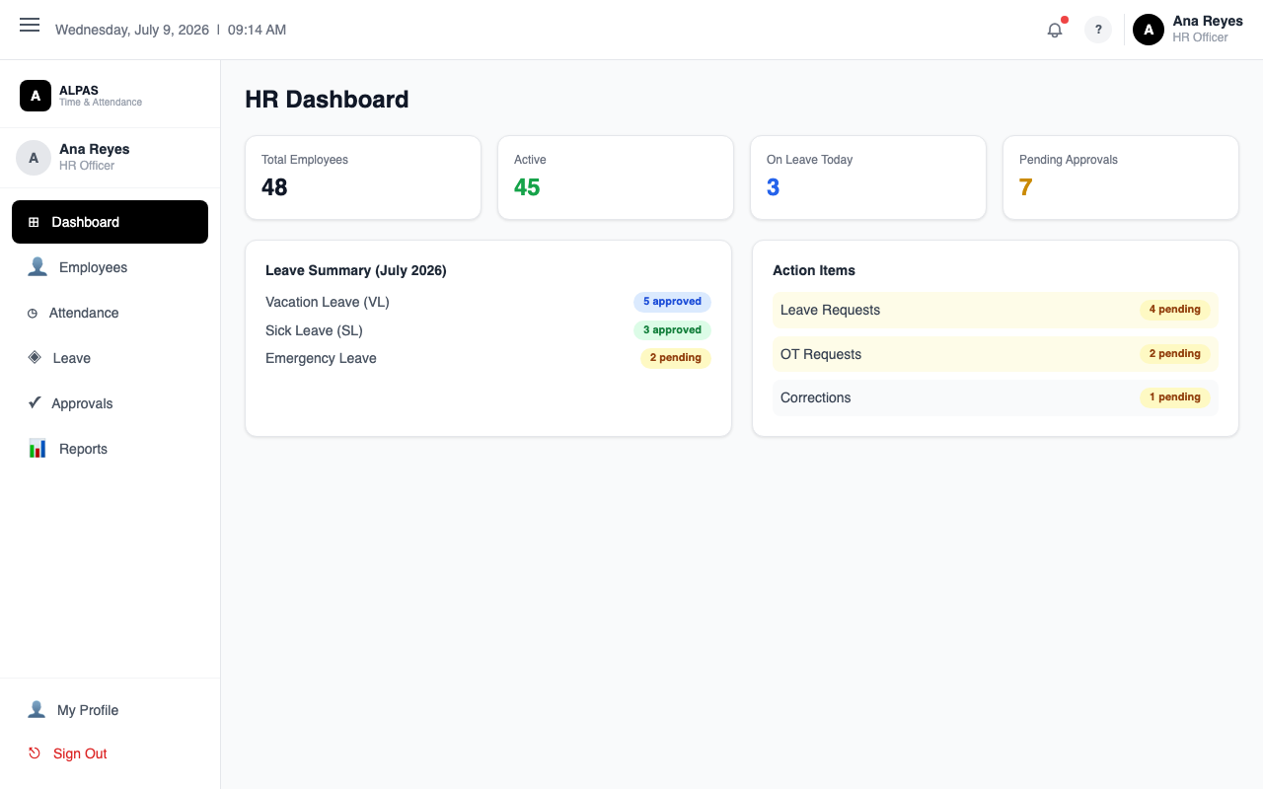
HR Dashboard — workforce totals, leave summary, and pending action items
Navigation: Sidebar → HR Dashboard
Section | What It Shows
Active Employees | Total employees in the system
Present Today | Breakdown: On-Site, WFH, OB
Absent Today | Employees with no clock-in (shown in red)
Pending Approvals | Total requests waiting for review across all departments
Attendance Breakdown Chart | Bar chart of today's statuses
Department Attendance | Progress bars: present vs. total per department
Schedule Summary | Approved leaves and OT conversions for the current period

[Insert Screenshot: HR Dashboard]

2. Employee Management
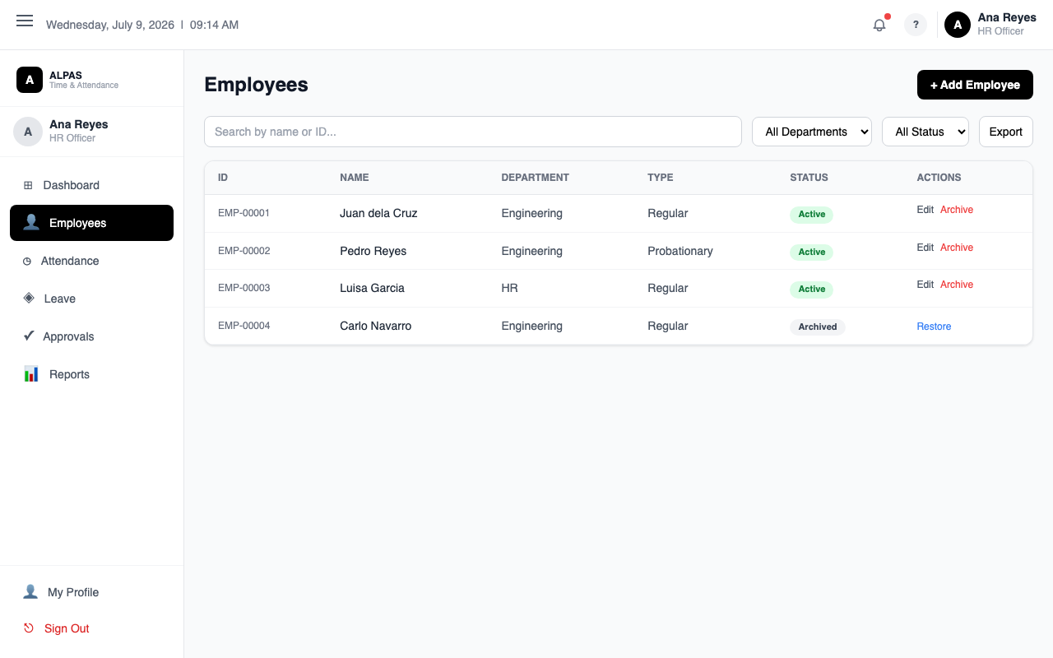
Employee List — search, filter by department or status, and manage records
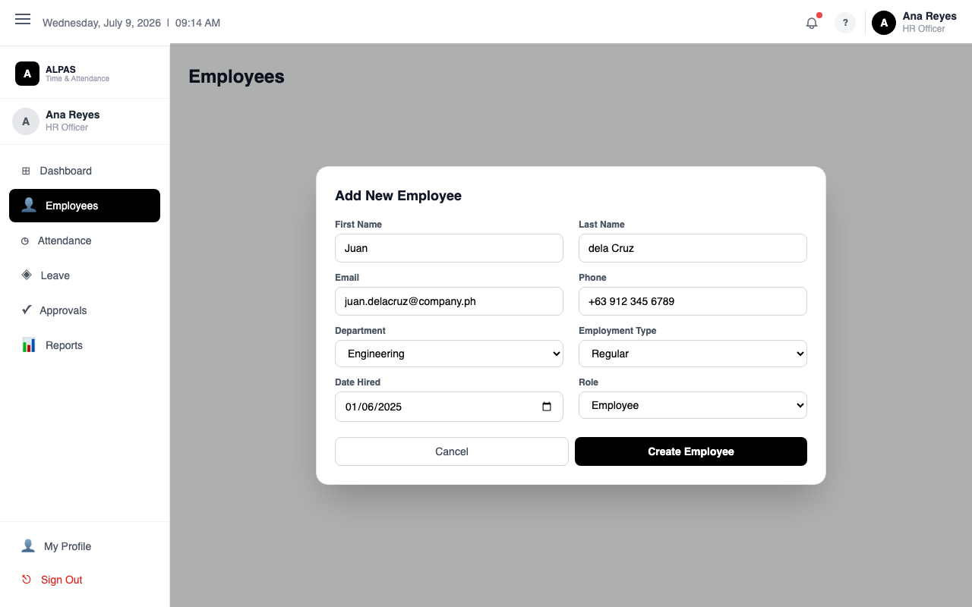
Add Employee Form — fill in personal info, department, employment type, and role
Navigation: Sidebar → HR Employees

Viewing Employees
- Use the Search bar to find employees by name, employee number, or email.
- Use the Department dropdown to filter by department.
- Toggle between the Active and Archived tabs to see resigned or archived employees.
[Insert Screenshot: Employee List]

Adding a New Employee
- Click + Add Employee.
- Fill in the form:
- First Name, Last Name, Email (required)
- Middle Name, Nickname, Gender, Birthday
- Mobile, Address, Department, Designation, Date Hired
- Role: Employee, Department Head, HR, or Admin
- Employment Type: Regular, Probationary, Contractual, or Intern
- Emergency Contact details
- Government IDs: SSS, PhilHealth, Pag-IBIG, TIN
- Click Save.
- A temporary password is shown — share it with the employee so they can log in.
- Leave balance records are created automatically for the new employee.
Tip: The employee number (EMP-XXXX) is generated automatically.
[Insert Screenshot: Add Employee Form]

Editing an Employee
- Click Edit on the employee's row.
- Update any fields as needed.
- Click Save.
Note: Changing an employee's role to Department Head automatically links them to their department.

Resetting an Employee's Password
- Find the employee.
- Click Reset Password in their actions.
- Enter a new password (min 8 characters).
- Click Reset. The employee is logged out and must sign in again.

Archiving an Employee (Resignation or Termination)
- Click Archive on the employee's row.
- Confirm the action.
- The employee is marked as Archived and can no longer log in. Their historical data remains in the system.
To restore: go to the Archived tab and click Restore.

Importing Employees in Bulk
- Click Template to download the Excel template.
- Fill it in with employee data.
- Click Import and upload your file.
- A summary shows how many were created and any errors.

Exporting Employees
Click Export to download the current employee list as an Excel file.

Managing Employee Documents
- Click an employee's name to open their profile.
- Go to the Documents section.
- Select a document type (201 File, Contract, ID, Other).
- Click Upload and choose a file (max 10 MB; PDF, Word, Excel, and image formats accepted).
- To download: click the document name.
- To delete: click Delete on the document row.

3. Attendance Monitoring
Navigation: Sidebar → HR Attendance
This page shows all employees' attendance records in one table.
Columns: Employee | Date | Department | Clock In | Clock Out | Status | Hours | OT
Filtering:
- Use the month selector to change the period.
- Use the Department dropdown to filter.
- Use the Employee search to find a specific person.
Exporting:
Click Export to download the filtered records as an Excel file.
[Insert Screenshot: HR Attendance Page]

4. Leave Management and Balance Adjustments
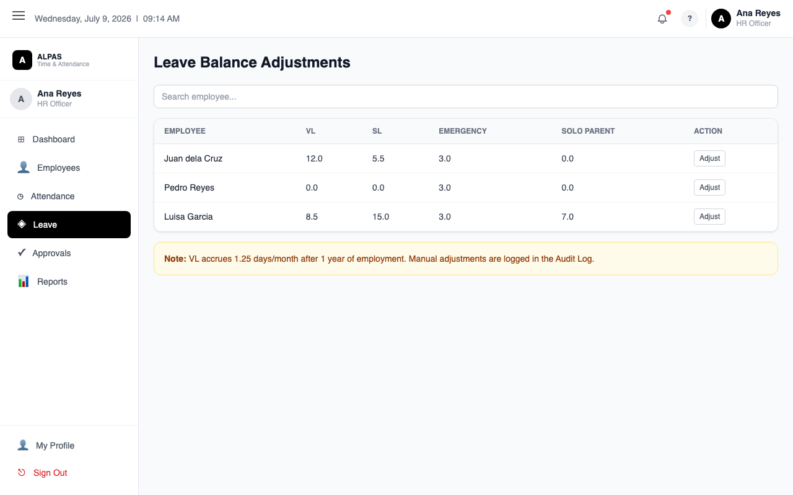
Leave Balance Adjustments — view and manually adjust balances per employee
Navigation: Sidebar → Leave Management
This page lets you view and manually adjust any employee's leave balance for any year.

Viewing a Leave Balance
- Search for an employee in the left panel and click their name.
- Their leave balances for the selected year appear on the right.

Adjusting a Leave Balance
- Click Adjust next to the leave type you want to change.
- Fill in the adjustment form:
- Action — Add or Deduct
- Amount — number of days
- Reason — required explanation
- Click Submit Adjustment.
- The change is recorded in the Adjustment History table below.
Note: Emergency Leave and Sick Leave share one balance pool of 15 days. Adjusting one affects both.
Tip: Use adjustments for special grants (birthday leave, loyalty leave) or to correct errors after payroll processing.
[Insert Screenshot: Leave Management Page]

5. Approvals
Navigation: Sidebar → Approvals
As HR, you act as both Department Head and final approver. You can approve requests from any department, including requests that were already reviewed by a Department Head.
The Approvals page has four tabs:

Leaves
Shows all pending leave requests system-wide. Review the type, dates, reason, and the employee's available balance. Click Approve or Reject, enter notes, and click Submit. On approval, the leave balance is deducted automatically.

Overtime
Shows all filed overtime requests. Approve to credit the overtime (valid for 6 months), or reject with a note.

Corrections
Shows all pending attendance correction requests. Approving one updates the attendance record and recalculates the employee's hours automatically.

OT Conversions
Shows all CTO/CDO conversion requests. Approve or reject per the minimum hour rules:
- CTO requires at least 4 hours
- CDO requires at least 8 hours
Note: You cannot approve your own requests.
Tip: Toggle "Show Review History" on any tab to see requests you have already reviewed.
[Insert Screenshot: Approvals Page]

6. Reports
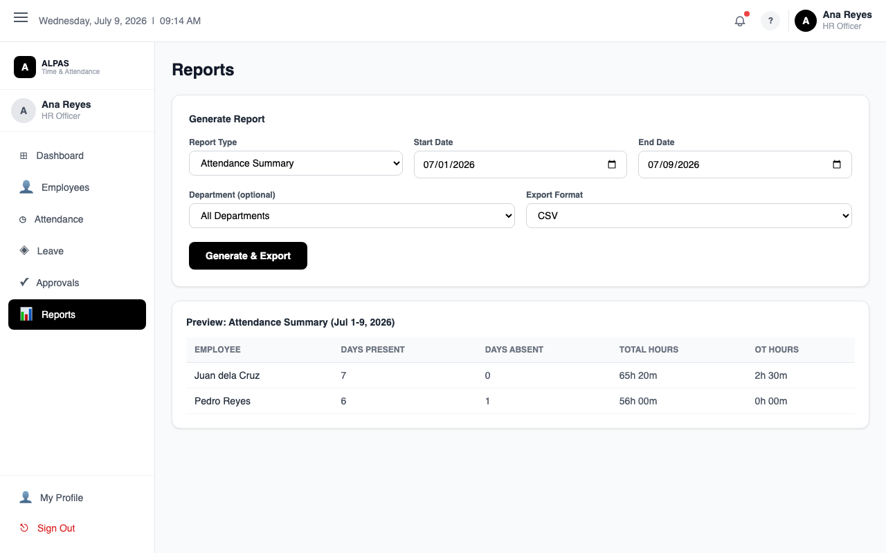
Reports — generate and export attendance, leave, or overtime reports by date range
Navigation: Sidebar → Reports
Generate and export data reports for management and compliance.
Report Types:
Report | What It Shows
Attendance | Daily attendance counts by status (On-Site, WFH, OB, Absent)
Leave | Daily approved leave counts by type
Overtime | Daily approved overtime counts
Absence | Attendance rate by employee and department

How to Generate a Report:
- Click Reports in the sidebar.
- Select a Report Type tab.
- Set the Date Range. Maximum: 92 days (approximately one quarter).
- Optionally filter by Department or Employee.
- View the chart and the summary table below it.
- Click Export to download as an Excel file.
[Insert Screenshot: Reports Page]

7. Frequently Asked Questions
Q: An employee's hours show as negative.
A: The clock-out was saved before the clock-in (common with overnight shift corrections filed without the overnight checkbox). Review their attendance and approve a correction with the correct next-day clock-out time.
Q: How do I see all pending approvals at once?
A: The HR Dashboard shows a Pending Approvals counter. You can also go directly to Approvals in the sidebar.
Q: Can I delete a leave request?
A: Leave requests cannot be deleted. Use the balance adjustment tool to correct a balance manually if needed.
Q: What happens when I archive an employee?
A: Their account is deactivated and they cannot log in. All historical data (attendance, leave, overtime) remains in the system. They appear in the Archived tab.
Q: How do I correct an attendance record directly?
A: Approve the employee's correction request from the Approvals page. You can also view the HR Attendance page and filter to that employee's records to check.

