ALPAS
Time & Attendance System

Employee User Manual

ALPAS Time & Attendance System
Welcome! This guide walks you through everything available to you as an Employee. No prior experience needed.

1. Logging In
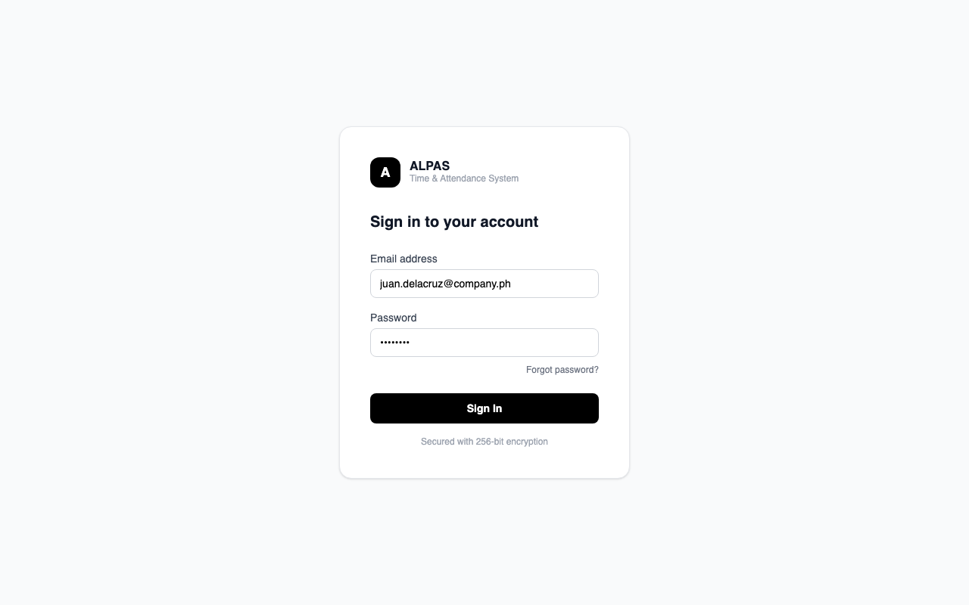
Login screen — enter your email and password to sign in
Purpose: Access the system using your company credentials.
Steps:
- Open the app in your browser tams.alpas.ph.
- Enter your company email address.
- Enter your password. Click the eye icon to show or hide it.
- Click Sign In.
- You will be taken to your Dashboard automatically.
Tip: If you see a spinner, the system is loading — wait a moment before trying again.
Common Error: "Invalid credentials" — double-check your email spelling and make sure Caps Lock is off.

2. Forgot / Reset Password
Purpose: Recover access if you forgot your password.
Steps:
- On the Login page, click Forgot password?
- Enter your company email address and click Send Reset Link.
- Check your email inbox (also check Spam). The link is valid for 1 hour.
- Click the link, enter your new password twice, and click Reset Password.
- You will be returned to the Login page.
Password requirements: At least 8 characters, must include at least one uppercase letter, one lowercase letter, and one number.

3. Your Dashboard
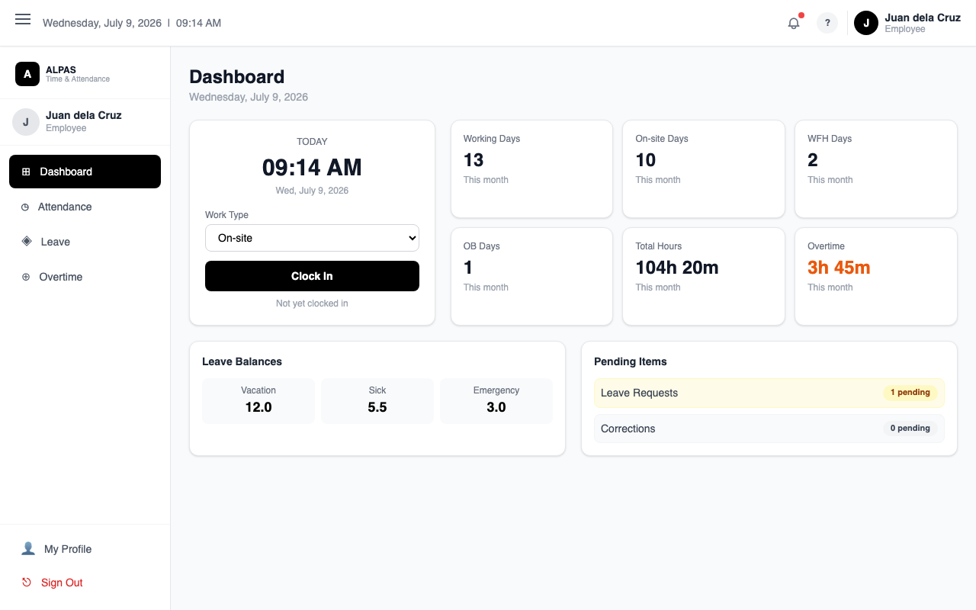
Employee Dashboard — clock widget, monthly stats, leave balances, and pending items
Purpose: See a quick summary of your attendance and status for today.
Navigation: After logging in you land here automatically, or click Dashboard in the sidebar.
Section | What It Shows
Clock Widget | Clock In and Clock Out buttons
Monthly Summary | Days On-Site, WFH, OB; total hours worked; overtime hours
Leave Balances | Days remaining per leave type
Overtime Credits | Approved overtime hours available to convert
Pending Actions | Count of pending leave or correction requests

4. Clock In and Clock Out
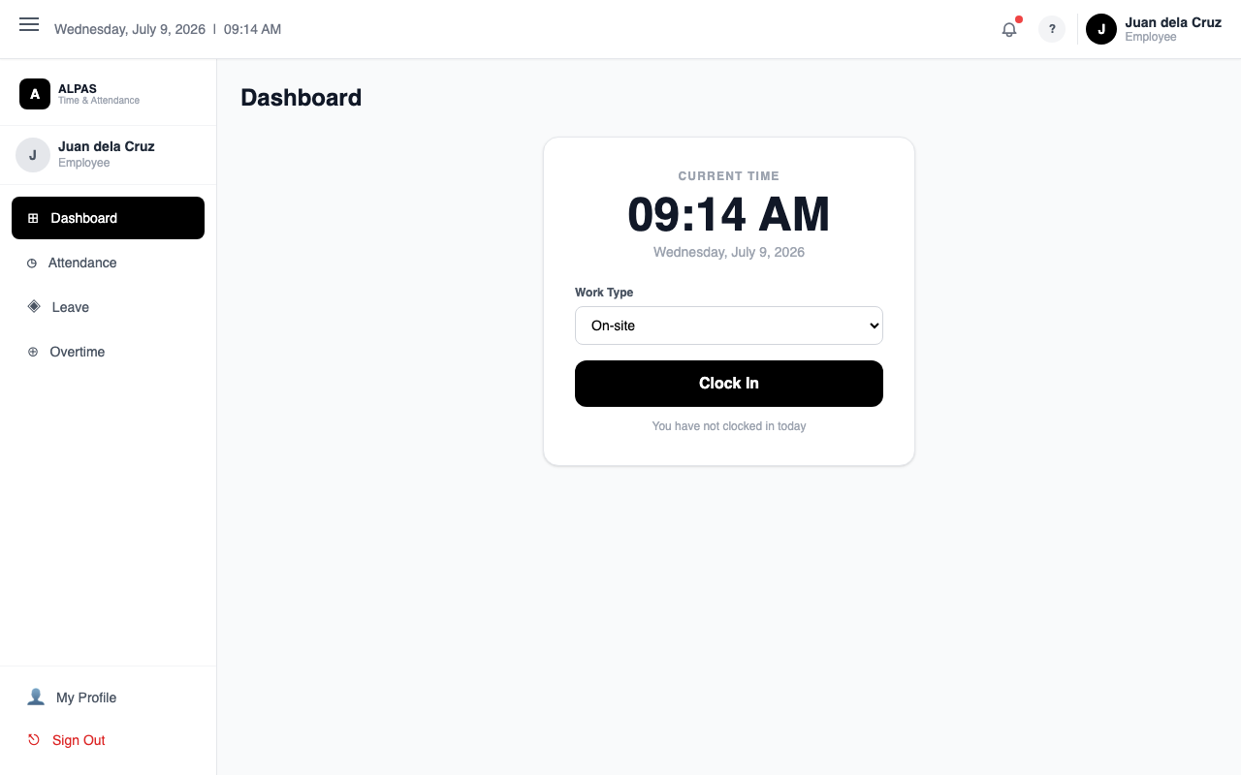
Clock In — select your work type then press Clock In
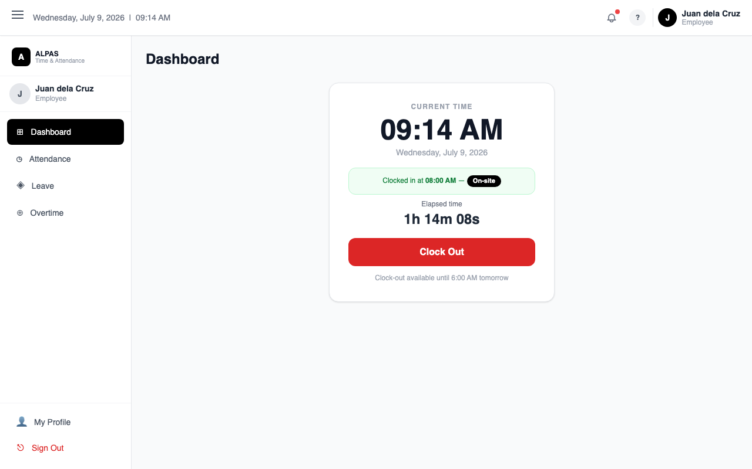
Clocked In — elapsed timer and Clock Out button

Purpose: Record your daily work hours.

How to Clock In
- Go to your Dashboard.
- Click Clock In in the Clock widget.
- Allow your browser to access your location if prompted.
- If you are within 200 meters of the office, your status is set to On-Site automatically.
- If you are outside the office, a menu appears — choose your work type:
- WFH — Working from Home
- OB — Official Business (off-site work)
- Click Confirm. Your clock-in time is saved.
Tip: Clock in the moment you start work — the system records the exact time you click.

How to Clock Out
- Go to your Dashboard.
- Click Clock Out in the Clock widget.
- Allow location access if prompted.
- Your total hours and any overtime are calculated and saved automatically.
Overnight Shifts: If you work past midnight and finish before 6:00 AM the next morning, you can still clock out using the app. The system automatically matches your clock-out to your previous day's clock-in.
Common Error — "No clock-in found for today": If you forgot to clock in, or if it is already past 6:00 AM the next day, use the Attendance Correction feature (Section 6).

5. Viewing Your Attendance
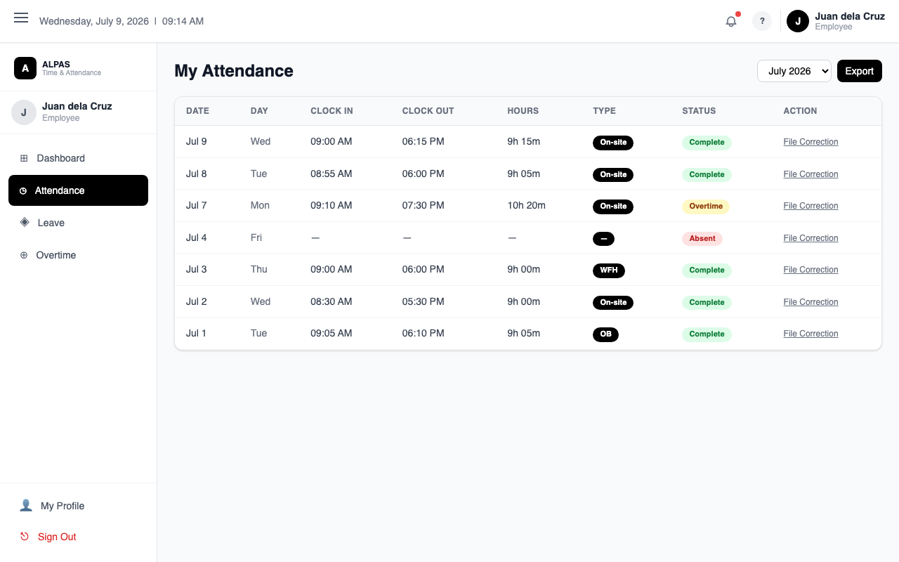
Monthly Attendance — view your clock-in/out records, hours, and status
Purpose: Review your daily clock-in and clock-out records for any month.
Navigation: Sidebar → Attendance
- Click Attendance in the sidebar.
- Use the month selector at the top right to view a different month.
- The table shows: Date, Clock In, Clock Out, Status, Hours Worked, and Overtime.
- To fix a wrong record, click the Correct link on that row.

6. Requesting an Attendance Correction
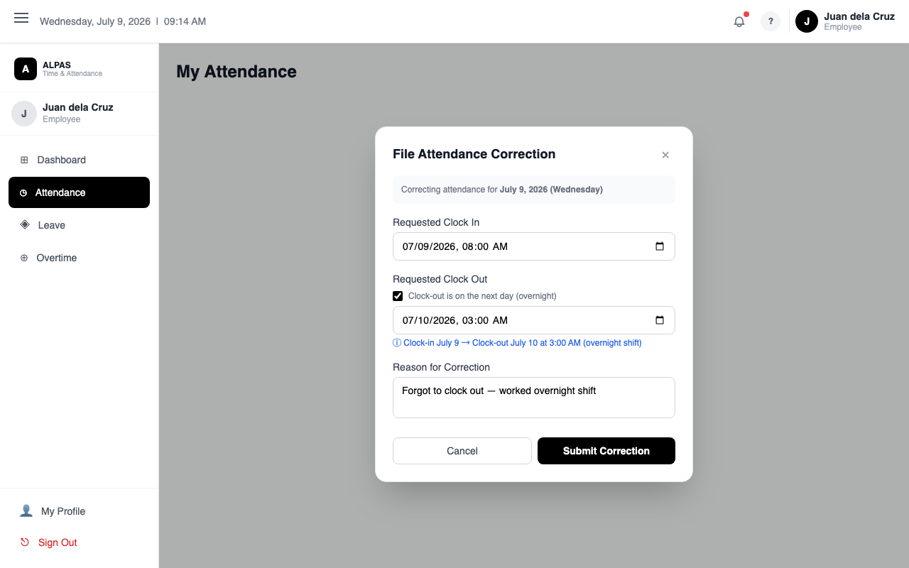
Correction Modal — check "overnight" to set a next-day clock-out time
Purpose: Fix an incorrect or missing clock-in or clock-out on a past working day.
Navigation: Sidebar → Attendance → click Correct on the record
Important: Corrections can only be filed for past dates. You cannot correct today or future dates. Wait until the next working day.
Steps:
- Go to Attendance and find the record that needs fixing.
- Click the Correct link on that row.
- The correction form appears with three fields:
- Corrected Clock In — enter the correct clock-in time.
- Corrected Clock Out — enter the correct clock-out time.
- Reason — explain why the correction is needed (required).
- For overnight shifts (you clocked out after midnight, on the next calendar day):
- Tick the checkbox labelled "Clock-out is on the next day (overnight)".
- The Clock Out picker will automatically switch to the next calendar day.
- Enter the correct time (for example, 03:00 AM).
- Click Submit Request.
- Your request is sent to your Department Head for review. You will be notified when it is approved or rejected.
Tip: Write a clear, specific reason. Vague reasons are more likely to be rejected.
Why does my Hours column show a negative number? This happens when the clock-out time was saved before the clock-in time — common in overnight shift corrections that did not use the overnight checkbox. File a new correction and use the checkbox to fix it.

7. Filing a Leave Request
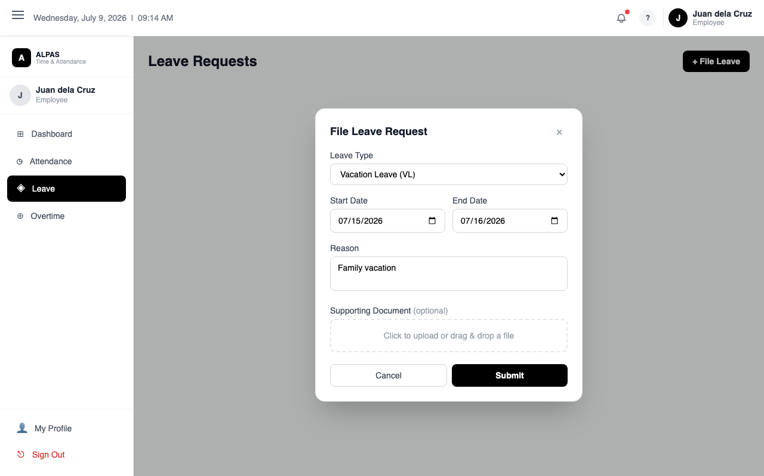
Leave Request Form — choose type, dates, reason, and optional supporting document
Purpose: Apply for approved time off using your leave credits.
Navigation: Sidebar → Leave → click File Leave
Steps:
- Click Leave in the sidebar.
- Click the File Leave button at the top of the page.
- Fill in the form:
- Leave Type — choose from the list below.
- Leave Duration — Full Day, Half Day Morning, or Half Day Afternoon.
- Start Date — first day of leave.
- End Date — last day of leave.
- Reason — brief explanation.
- Click File Leave.
- Your request goes to your Department Head for approval. You will be notified of the outcome.
Half-day leaves are only available for Vacation Leave, Sick Leave, and Emergency Leave. The start and end date must be the same day for half-day requests.

Leave Types:
Leave Type | Description
Vacation Leave (VL) | Personal time off
Sick Leave (SL) | Illness or medical appointments
Emergency Leave | Urgent personal or family situations. Shares the 15-day Sick Leave balance.
Pamilya Muna Leave (PML) | Family-related leave
Solo Parent Leave | For employees with a valid Solo Parent ID
Magna Carta Leave | For qualified medical procedures under RA 9710
Maternity Leave | For maternity purposes
Paternity Leave | For fathers upon the birth of a child
Bereavement Leave | Death of an immediate family member
Special Medical Leave (SML) | Prolonged illness
Leave Without Pay (LWOP) | Unpaid leave — no balance required, always available

Tenure Requirement: Most leave types require at least 6 months of employment. If you are under 6 months, only LWOP is available. A "File LWOP" button appears on the Leave page.
Common Error — "Insufficient balance": Emergency Leave uses your Sick Leave balance. They share a combined pool of 15 days. Check your available balance before filing.

8. Viewing Your Leave Balances
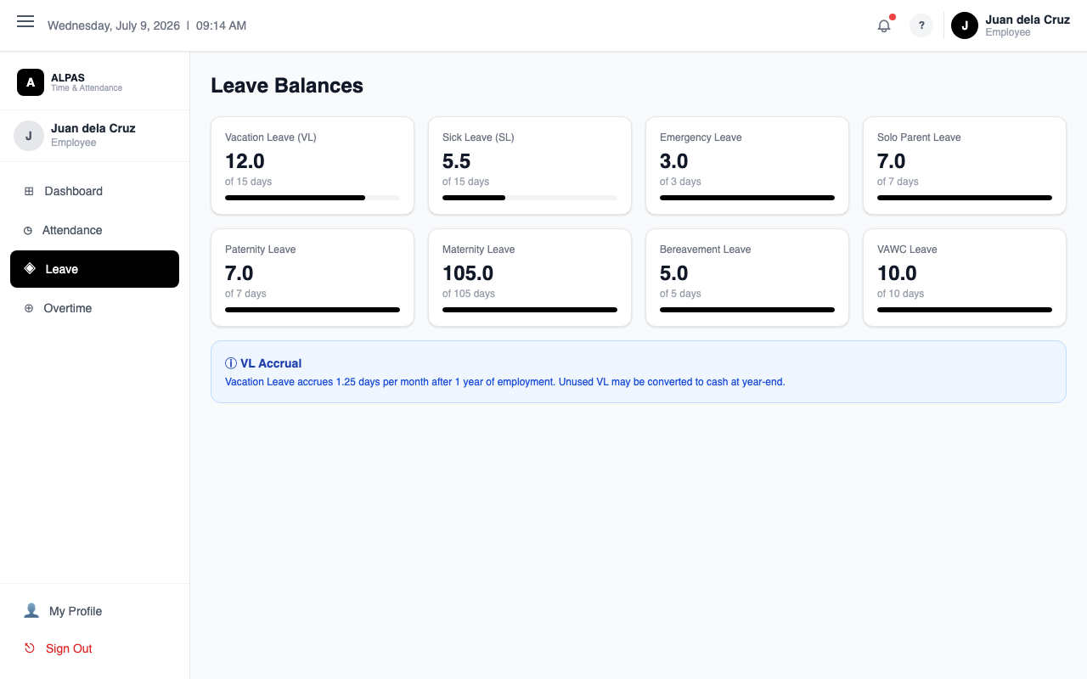
Leave Balances — remaining days per leave type with accrual progress
Navigation: Sidebar → Leave
The Leave Balances section shows a grid of all leave types with:
- Available Days — days you can still use
- Total Days — your full allocation for the year
- Pending Days — days waiting for approval (reserved from your available total)
To cancel a pending leave request:
Find the request in the leave history table below the balances and click Cancel. This only works while the status is Pending.

9. Overtime — Filing and Converting
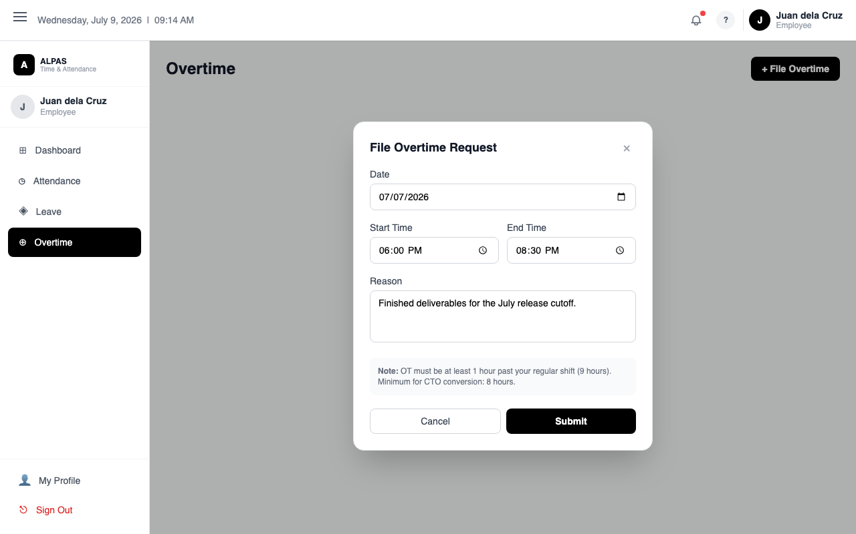
Overtime Filing — enter the OT date, start and end times, and reason
Purpose: Get credit for working more than 9 hours in a day.
Navigation: Sidebar → Overtime

How Overtime Is Recorded
When you clock out after more than 9 hours, the extra time is automatically saved as a Draft. Drafts are private — only you can see them. You must file a draft within 15 days or it expires permanently.

Step 1: File Your Overtime Request
- Click Overtime in the sidebar.
- In the Overtime Records table, find records marked DRAFT.
- Click File OT on the record.
- Enter a Reason for the overtime.
- Click Submit — your request is sent to your Department Head for approval.
Warning: Do not wait. Drafts expire after 15 days and cannot be recovered.

Step 2: Convert Approved Overtime to Leave Credits
Once your overtime is Approved, you can convert it:
- CTO (Compensatory Time Off) — minimum 4 hours required
- CDO (Credit Day Off) — minimum 8 hours required
Steps:
- Click Convert OT at the top of the Overtime page.
- Choose the conversion type: CTO or CDO.
- Pick a Scheduled Date — the day you plan to use it.
- Check the boxes next to the approved overtime records to include.
- Enter hours to convert, or leave blank to convert all.
- Click Convert — sent to your Department Head for approval.
Tip: Approved OT credits expire 6 months after approval. Convert before the expiry date shown in the table.
Status | Meaning
DRAFT | Saved but not yet filed
AWAITING HR | Filed, waiting for approval
APPROVED | Approved and ready to convert
REJECTED | Not approved
EXPIRED | Filing or credit window has passed

10. Viewing Your Corrections
Navigation: Sidebar → Corrections
This page shows all your submitted attendance corrections with their status (Pending, Approved, Rejected) and reviewer notes. If a correction is rejected, return to the Attendance page and file a new one with an updated reason.

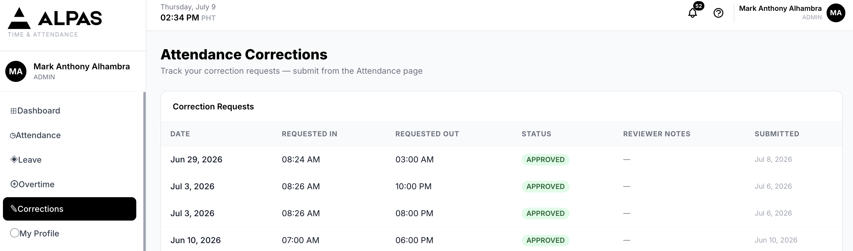

11. Your Profile
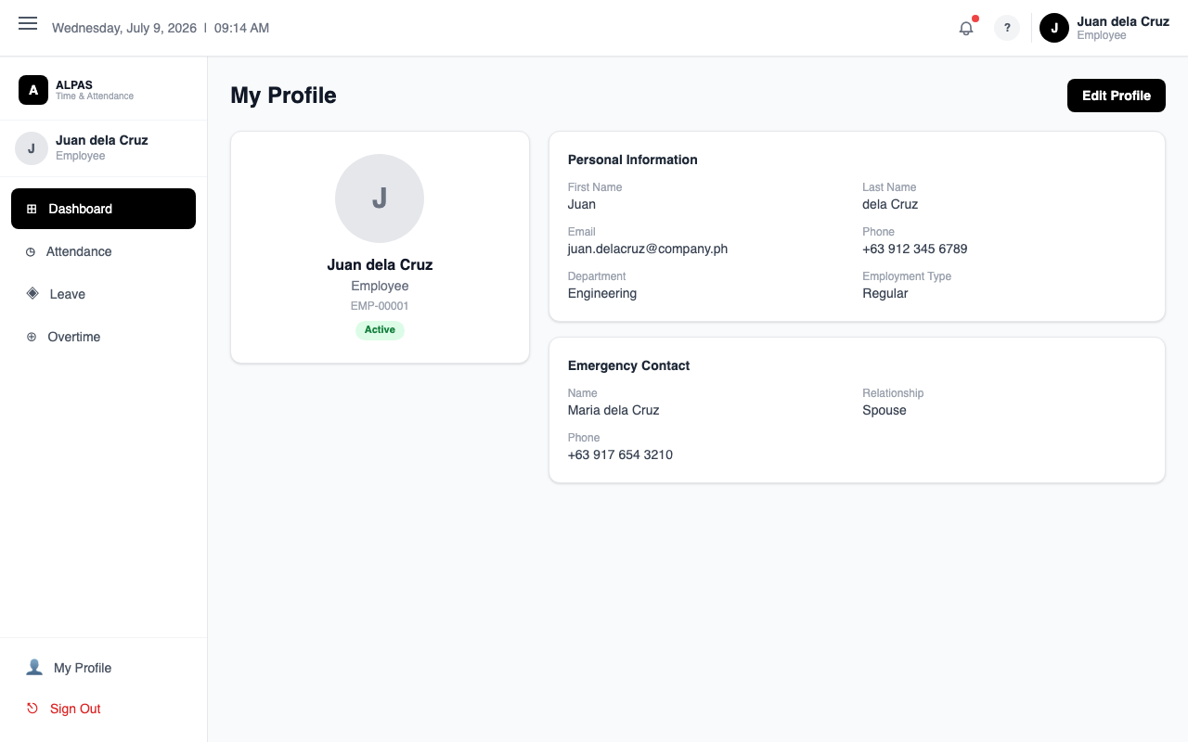
Profile Page — personal info, employment details, and emergency contact
Navigation: Sidebar → My Profile
Your profile shows your employee number, name, department, designation, contact info, emergency contact, and government IDs (SSS, PhilHealth, Pag-IBIG, TIN).
You can update your mobile number, address, and emergency contact directly. For other fields, contact HR.

Changing Your Password
- Click My Profile in the sidebar.
- Click the Change Password tab.
- Enter your Current Password.
- Enter a New Password (min 8 characters, must include uppercase, lowercase, and a number).
- Click Update Password.

12. Notifications
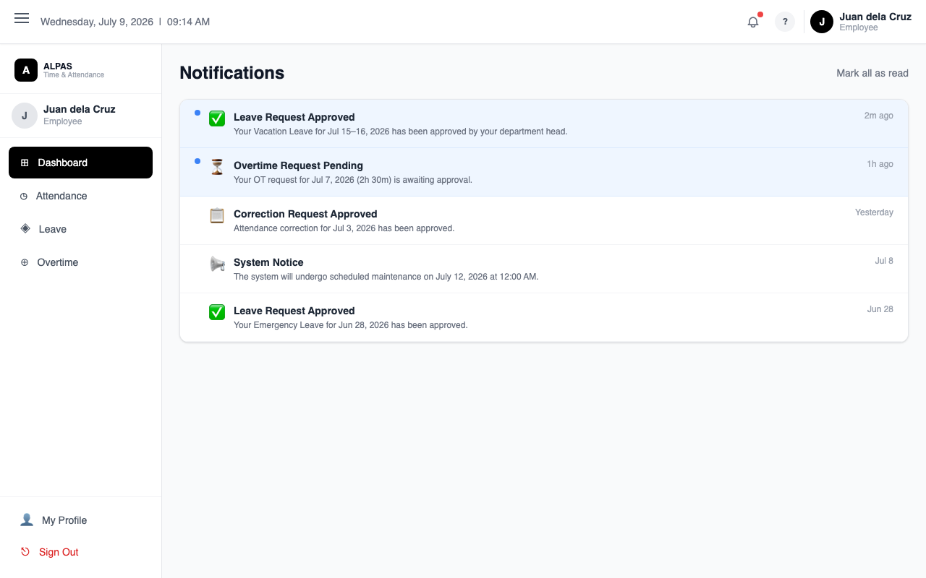
Notifications — approvals, pending items, and system announcements
Click the bell icon in the top-right header to view notifications. You receive notifications for:
- Leave, overtime, or correction requests approved or rejected
- OT conversion approved or rejected
- 7-day warning before overtime credits expire
- Daily absent reminder if you have not clocked in by 2:00 PM
Click Mark all read to clear the unread badge.

13. Logging Out
- Scroll to the bottom of the sidebar.
- Click Sign Out.
- You are returned to the Login page.
Tip: Always log out when using a shared or public device.

14. Frequently Asked Questions
Q: I forgot to clock in. What do I do?
A: Go to Attendance, find the date, click Correct, and submit a correction with a clear reason.
Q: My hours show as a negative number (e.g. -5.4h). Why?
A: The clock-out time was saved before the clock-in time — this commonly happens with overnight shift corrections that did not use the overnight checkbox. File a new correction and tick "Clock-out is on the next day (overnight)".
Q: The "File Leave" button is not visible.
A: You may have less than 6 months of employment. Use the "File LWOP" button instead. The Leave page shows when you become eligible.
Q: My overtime draft disappeared.
A: Drafts expire after 15 days if not filed. File as soon as possible after working overtime.
Q: Can I cancel an approved leave?
A: No — only Pending leaves can be cancelled from the app. Contact HR for approved leaves.
Q: Who approves my requests?
A: Your Department Head is the first reviewer. HR may perform a final review after that.

