Manual steps needed to correct implementation of LJC-219 task

1. Deploy git data
2. Setup -> Home -> fill as below  
   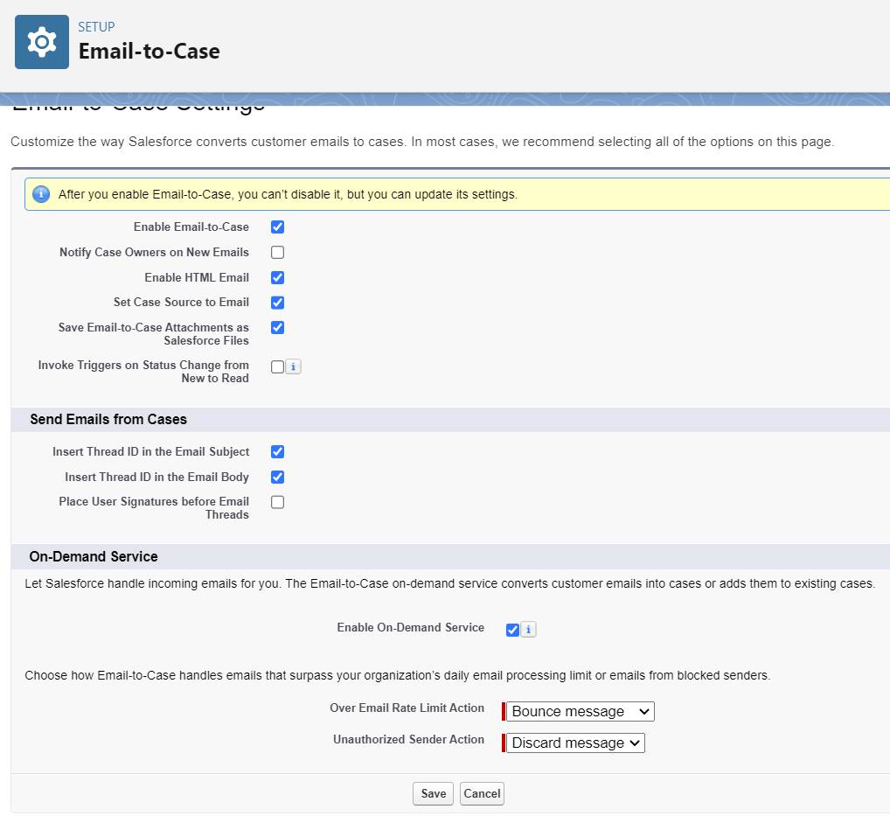  
   Save
3. The very same window (email-to-case) -> New email2case -> fill like below -> (routing Name: SignificantEmailToCaseForOnlineShop )  
   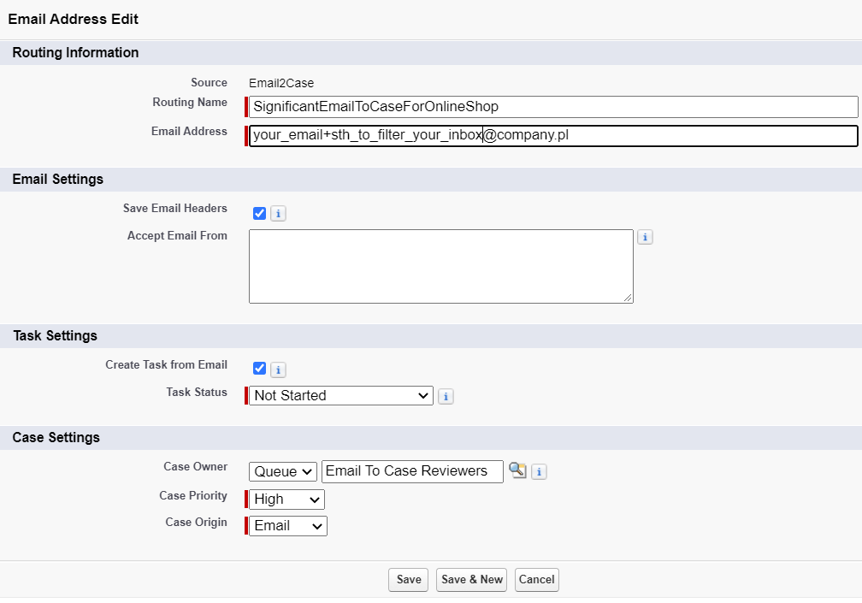  
   Save
4. Check your mailbox and verify email for your SF org
5. Copy your email service address. Adjust your email box to forward cases to this email.
6. You are done. Good for you!