Manual steps needed to correct implementation of LJC-246 task

# Perform on your integration org:

1. Setup -> Digital Experience -> settings -> Enable Digital Experiences  
   Save
2. Setup -> Digital Experience -> settings -> fill as below  
   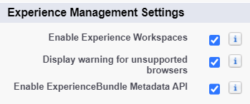  
   Save
3. Setup -> All sites -> New -> Customer Service -> get started -> fill as below  
   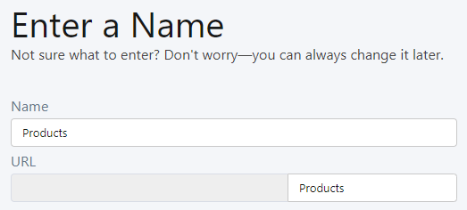
4. Create
5. Builder -> Setting -> General -> check public access as below  
   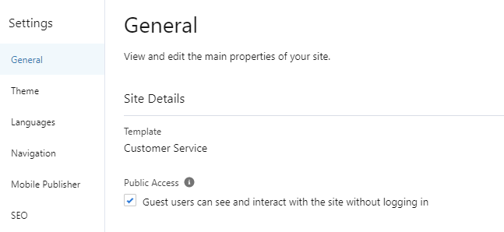
6. Deploy
7. Publish your page in the right upper corner   
   
8. Enjoy!