Manual steps needed to correct implementation of LJC-255 task

# Perform on your integration org:

1. Setup -> Web-to-case-> Make sure Web-to-case is enabled and fill as below (make sure your white spaces are correct, because otherwise client will receive multiple response)  
   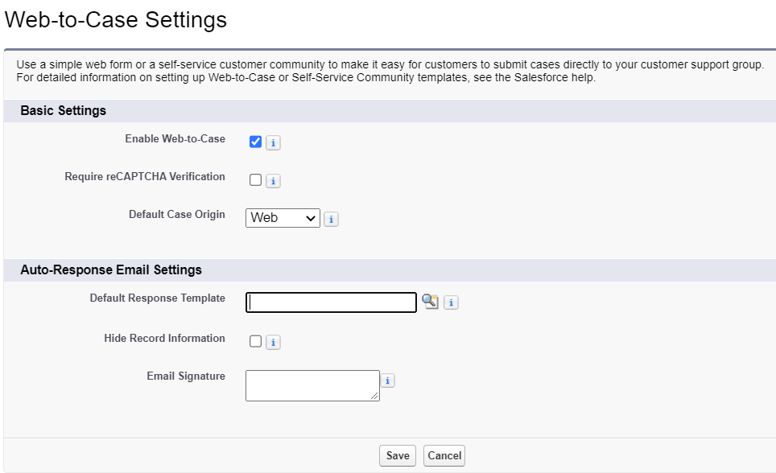  
   Save
2. Setup -> All sites -> Products -> Builder
3. Pages -> Contact Support
4. Click on Contact Support Form

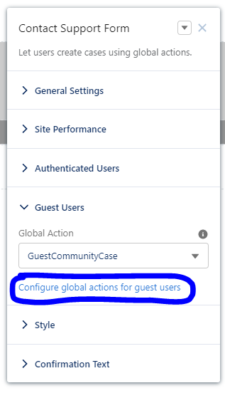

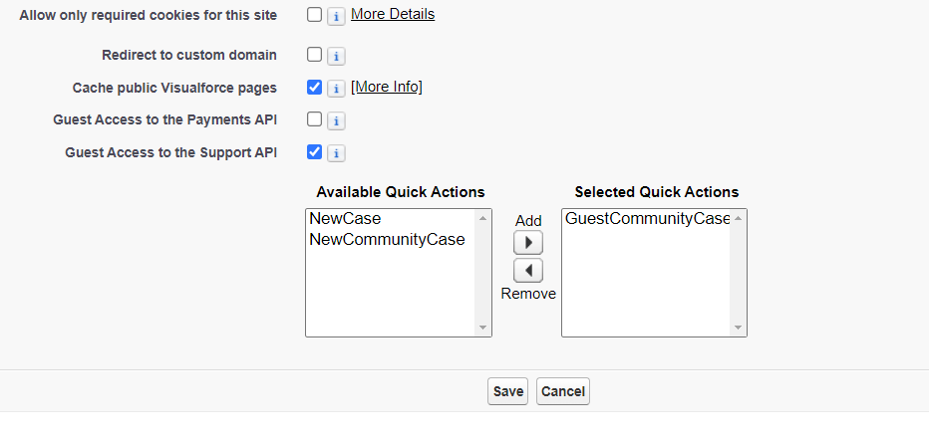

Save

1. Publish your page