Manual steps needed to correct implementation of LJC-309 task

# Perform on your integration org:

1. Deploy force-app\main\default\quickActions\  
   GuestCommunityCaseForOnlineStore.quickAction-meta.xml
2. Setup -> All Sites -> Builder -> Contact Support Page -> left click on Contact Support Form
3. Left click on Configure global actions for guest user 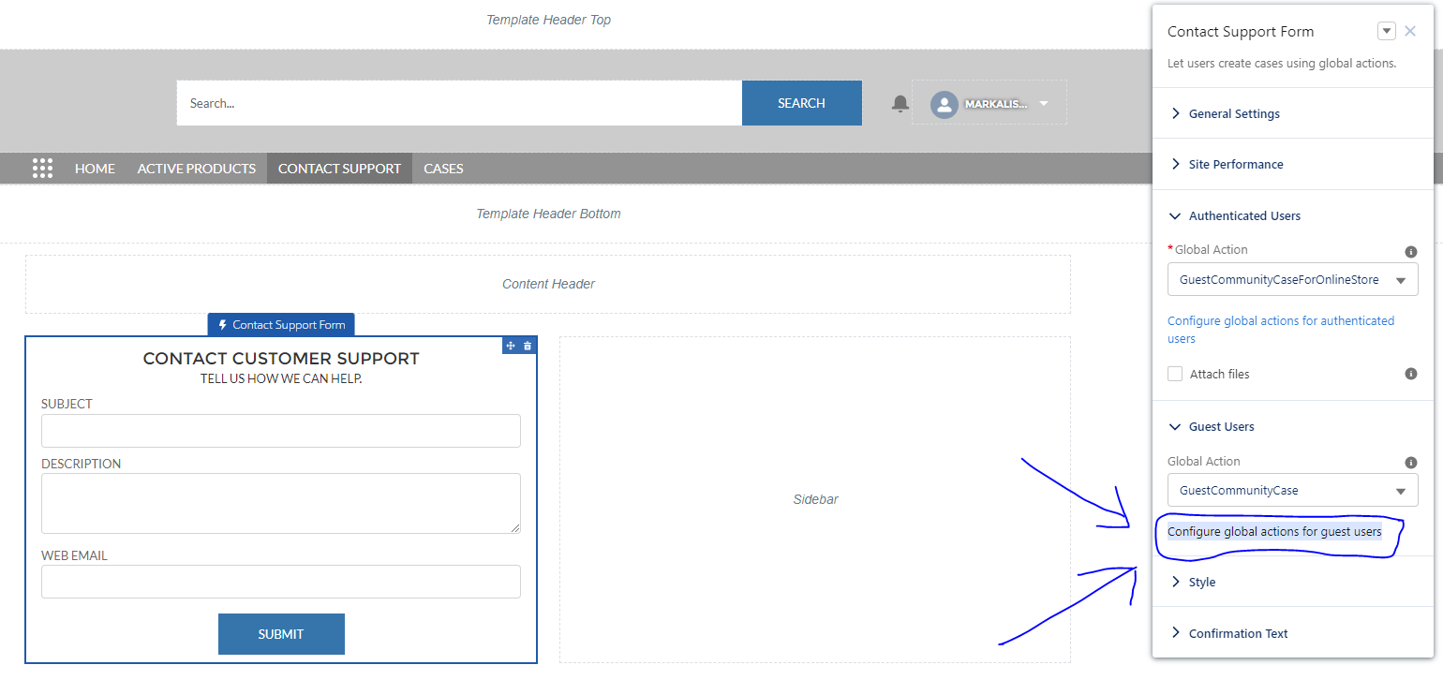
4. Add GuestCommunityCaseForOnlineStore to Selected Quick Actions  
   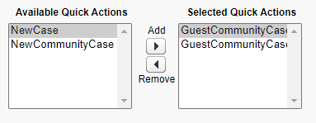  
   Save
5. Deploy the rest
6. Publish your page