I have created 5 sheets of schematic that is supposed to represent Paul’s original design. They are the:

* Power Supply
* Isolated Power Supply
* Triangle Generator
* The Step Generator
* The XY-Amp and DUT sockets
* There is also a 6th mechanical sheet with no electrical components on them.

This set of schematics have not been checked much by anyone else for “correctness”. I ask anyone who has some time to see if I made any mistakes translating the schematics for the Blog site to those shown in the pdf document. I used Altium to create these schematics. I will make any changes to them if mistakes are discovered.

**NOTE:** I have made some purposeful changes. These are described below.

This rest of this document describes the differences in my schematics and Paul V’s original schematics that he published. There are a few differences for several reasons. The reasons are:

1. Surface mount devices are used and some different components are necessary as the through-hole components were not available in surface mount or there was a clearly better surface mount option.
2. A few circuits were modified to make the load on the op-amps easier.
3. All of the op-amps have changed. You can in fact use the original op-amps if you can find them in surface mount.
4. I assumed that whoever makes this will probably have to buy all or most of the components so I selected components that are readily available.
5. The power supply uses transformers that are 120/240 compatible. All the secondary’s are dual. I assumed you wouldn’t have an appropriate transformer around the lab like Paul did.
6. I wired the Collector Supply transformer differently than Paul did. It uses a transformer that is center tapped and therefore the 2 voltages coming from the supply are ½ and 1 times the value of the transformer output voltage. The transformer is also mounted on the chassis and not the circuit board.
7. I added bypass capacitors to all integrated circuits.
8. The connectors on Paul’s schematic did not have the same number for plug and socket.

**Global changes:**

This is a 2 PCB design. There are 2 sets of schematics because of this. I may create a 3rd set with the entire circuitry of both boards shown to make it easier to see what is going on with the electronics.

One PCB is for the front panel components like rotary switches, toggle switches and pots. There is some circuitry on the front panel as well. It made more sense to have some circuitry close to the front panel components.

The second PCB is the main PCB. It has everything that the front panel does not.

There are 2, 3 and 4 pin connectors on the front panel and main PCB. They are used to connect the breaks in the circuitry between the front panel PCB and the main PCB. They have the same reference numbers on each board. So for example, P1 on the main board goes to P1 on the front panel board. You do not have to use connectors but if you want to they are included in the BOM. Note the connectors I tried didn’t work well as I didn’t buy the multi hundred dollar crimper. So I got rid of them. IO now have only wires directly soldered where the connectors were. There are There are some connectors with 0.2in pin spacing for the transformers. These work fine. There are some other connectors I will try but I haven’t yet.

The schematics combine some of Paul’s versions from the Blog

The part reference numbers are all different than Paul’s. I have used a scheme where the sheet of each schematic starts with a certain reference number. This helps locate components when comparing the schematic to the PCB. I also have modified connector references so they are consistent with the connectors from sheet to sheet.

Only the connectors share reference numbers. The 2 separate PCB’s don’t use the same reference numbers. For example there is only 1 R1 on 1 of the PCB’s There is no R1 on the other PCB.

In general all integrated circuits have bypass capacitors on the power supply pins. I won’t mention this again.

All of the op-amps are rail to rail output. Most are rail to rail input.

I used two ground symbols with different names for the Isolated ground and The schematic should not have changed for this.

I added test points sometimes with a 1K resistor to prevent accidental shorting of signal when the ground lead of the probe “accidently” drags across the PCB.

Some of the op-amps are single op-amps. This was done because the devision of the circuit for the front panel made sense to split up the op-amps based on the circuit and where it needed to be sent to the other PCB.

**WARNING:** I selected particular 1FORM and 2FORM relays. Use the ones selected as the pinouts of 1FORM and 2FORM relays can differ by manufacturer.

All switches on the front panel have a rectangular slots for the pins to be soldered directly to the front panel PCB. The rotary switches have round hole to solder them into the PCB.

Particular changes described in detail by schematic page:

**Front Panel:** I laid out the front panel to fairly closely mimic Pauls layout of his front panel. I choose an inexpensive enclosure from Hammond, RM2095M. The front panel fits the front panel of the enclosure. The drill guide has the edges of the front panel of this enclosure drawn on. You can of course shift the hole patterns around a little bit to meet your needs. The drill guide has hole positions for the various parts which stick through. I made my front panel on a mill. I used the dimensions to move the bit around and carefully position the holes where they needed to be. Most people don’t have a mill. So I suggest you tape the guide onto your front panel and as carefully as you can drill the holes where they are supposed to be. I cut little rectangles in the paper guide so I could tape it on the edges and in the middle so it wouldn’t move when drilling. You can of course drill larger holes than is required if you aren’t sure about drilling in the absolutely correct spot. I assume everyone has built stuff before and each of you has different abilities and techniques you like to use. I am not going to try to tell you how you should do things.

There are 2 different types of parts that don’t solder to the PCB. The pots and the banana jacks. The pots have a place for wires to solder that go to the popt’s that get mounted on the front panel. It was too hard to get pots that would mount to the PCB and stick out the right amount to be able to have the nuts put on. The other parts is the banana jacks. They directly screw to the front panel. What I did was put holes in the PC board where the electrical connection of the jacks was. This way I could solder a wire to the jack and have it come through the hole and get solder to a solder pad on the board. This is not ideal because once these are soldered you can’t remove the PC board from the front panel without unsoldering the 6 wires that go from each banana plug to the PC board. This save a ton of money so this is what it is. I drew a yellow line around the holes. Also you can see most of the circuitry in this picture.

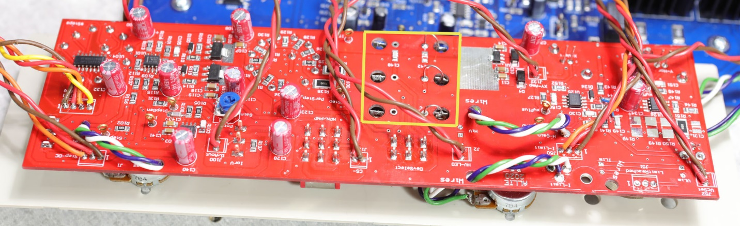

I made a front panel for Rev 1 and reused it for Rev 1b. Some of the holes moved so the picture you see is a front panel that has been “Frankensteined” to work for Rev 1b. I moved some LEDs so they aren’t sticking through this front panel because they aren’t in the right spot. The one that is sticking through isn’t in the right spot either.

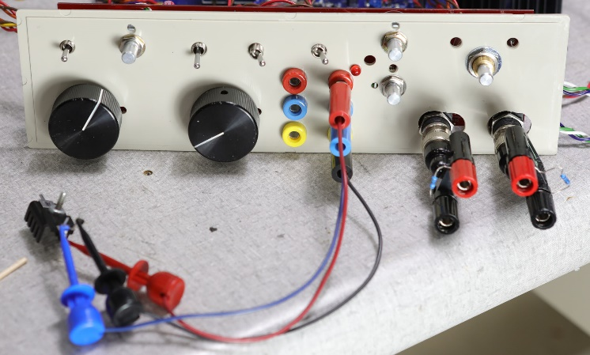I used E-Switch toggle switches because they were less expensive than some others and available on Digi-key. I designed the board to accept switches with the “PC pins” or the solder lug pins. One note. I used a 3pole 2 position switch for the NPN/PNP switch. It turns out that the 4th pole that Paul used wasn’t needed. Through several relays/switches the emitter is always connected to the Isolated ground so I just tied it directly there with no switching. It works fine this way. The add/oppose switch has a center off position for convenience. The A/B switch for which device you want to test has a center off position as well. Once again for convenience.

I choose rotary switches that can mount on the front panel PCB. These are the same rotary switches used on the German ELV KS7000. The 12 position rotary switches come with a ring to limit the number of positions from 1 to 12 so the PCB can accept 12 position switches in both locations. The parts used sort of have the same mounting height. Not really exactly the same. It is too hard to find things all the same height for less than a lot of money. I think it will work OK for most people. Some of the toggle switches can be purchased with different length offsets so they can have the nuts put on. I bought the ones in stock and accepted some shorter mounting switches. They can’t have the nuts installed. This didn’t bother me as there was plenty of support from other things

**Power Supply:** This schematic sheet starts with reference numbers 1.

I used dual primary and dual secondary transformers that are PCB mountable. This was an obvious choice considering this will probably be built by people in various countries with different power systems. I choose secondary voltages that allow full wave rectification as I believe full wave yields a better DC than half wave. The transformers are available worldwide so this shouldn’t be an issue. The full wave rectified DC voltages are different than what Paul originally used. He used half wave. Because of this there is an extra transformer.

The High voltage power supply could have been made with a switched secondary (series to parallel and back) giving more current capability as Paul considered but I choose to switch between 1 of 2 DC voltages without switching the secondary configuration as Paul actually made his. This can be changed if you really want to switch transformer connections using a relay. It all has to be done external to the PCB. The main collector/drain supply transformer is already mounted off the PCB in this design so it isn’t a huge change. This change could certainly be done to give more current (2 times) for the low voltage supply compared to the high voltage supply. Usually the higher voltage is twice the lower voltage ( for identical dual secondary transformers) so you could change the point where it switches from low to high away from 30V to something else if you want to.

I used a 2 capacitor 1 resistor transformer compensator as the Qusimoto article recommended. The values of the C and R are correct for the transformers I used as they are transformer dependent. The R’s and C’s are correct for the PC mounted transformers.

The 8mA current sink is made from a PNP transistor with a guaranteed gain of 300. The PNP Darlington is not available in surface mount. I went to a Wilson current mirror because of the lower gain transistor.

The 2-NPN (2N3904) compound transistor used to drive the relay coils have 2 resistors in it to guarantee there is enough current flowing in the first transistor to keep the gain high.

I split the DPDT relay (Current Sense resistor and CS voltage source) into 2-SPDT relays to make layout easier and help signal integrity.

Note: if you have identical currents for the low and high transistor voltages then you don’t have to populate the small relay which changes the current sense resistor. You can just hard wire the connection to the resistor spot you populate.

I added diodes to the regulators to alleviate current flowing backwards through the regulator chip at turn off.

I reversed Pauls diode D8 on the page Collector/Drain supply 2 as it was backwards. It is D5 on my power supply schematic page.

**Triangle Generator:** This schematic sheet starts with reference numbers 50. I added a second transistor to supply the voltage to the device under test. There was room and the devices don’t have to dissipate as much power. You do not have to use 2. Leave one out and short the emitter resistor of the remaining transistor.

I added 1N4148 diodes for voltage and current limiting where Paul used LED’s. I also have LEDs on the front panel. I did this because I was getting oscillations in the CS supply and moving the diodes to the main board eliminated wires in the control system path of the CS supply. The LEDs exist but are no longer part of the control system associated with the CS supply.

I put multiple versions of the current sense resistors so you could use any value you wanted for your design and you could put enough of them in to dissipate the power for your particular needs.

Of note. I have changed the resistor R63 for my particular design. This resistor allows me to set the maximum voltage that appears across the device under test. Paul had his set for the voltage his curve tracer was designed for. I chose a different voltage. I changed this resistor instead of the pot because it is easier to get exact value resistors compared to pot and the ratio of these 2 resistances controls the maximum output voltage for the Collector/Drain supply. I also added a fixed resistor, R81, in series with the pot. This limits the minimum voltage to something greater than 0. You can change this to a different value if you want a different minimum collector/drain voltage. I found when the resistor wasn’t there the triangle wave shape of the power supply oscillated when set to 0. I also added a resistor, R82, to the current setting pot as well for the same reason. You can change this value as well.

**Step Generator:** This schematic sheet starts with reference numbers 100.

I choose rotary switches that can mount on the PCB. These are the same rotary switches used on the German ELV KS7000. The 12 position rotary switches come with a ring to limit the number of positions from 1 to 12 so the PCB can accept 12 position switches in both locations.

I added 2 diodes and 4 resistors to the current buffer transistors that drive the step resistors. This is done to make it easier for the op-amp to drive the buffer. If you don’t want to do this just short the diode and emitter resistor locations and leave the 10K (R101 and R116) resistors out. This gives Paul’s original design. I also added some larger capacitors at the plus and minus power supplies feeding the transistor buffer. I added an RC network to the oputput of the power amp. This is usually done for stability in audio amps I also added a load resistor so when the resistor for the step is huge the amp still has a 5mA load for stability and noise considerations. None of these needs to be there I think it performs more reliably.

I used 1% 10K and 20K resistors in the R2R network instead of the SIP’s that Paul used. They are close together on the PCB so there shouldn’t be a significant temperature change across the resistors.

**XYAmp:** This schematic sheet starts with reference numbers 125. I changed the reference signal on the X and Y amps to be GND instead of device common. This makes more sense to me as the amps are supposed to multiply the signals with respect to GND not device common. The device common reference comes from the original ELV design.

I added a second op-amp stage to the horizontal channel to implement the gain adjustment which was done with 1 op-amp before. This gives a little more freedom to make the gain what you want if you don’t like how it is now and makes the differential input nature of the first stage always work the same independent of gain.

On this schematic page I wrote a table to show what gets connected when the PNP/NPN switch is thrown. It helps show how the Collector Supply gets connected and how the GND gets connected. This really helped my see what was going on in the circuit.

Mark Allie 7 Dec 2020

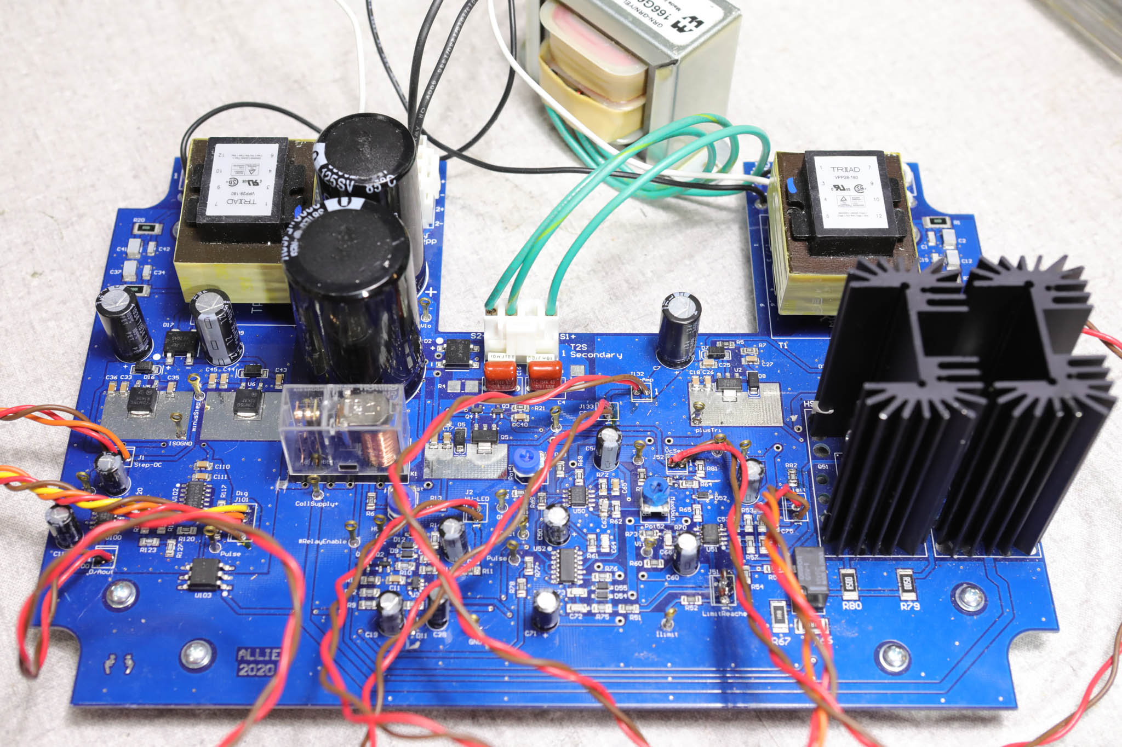

Main board.