**DiAVA**  
Installation Procedures

Table of Contents

(U) STEP 1: Manage Settings 1

(U) STEP 2: Manage Locations 3

(U) STEP 3: Assign Maintainer (first user) a location 3

(U) STEP 4: Manage Administrators 3

(U) If there are no users in the database then the first user to access the application, after install, will automatically be given “maintenance” privileges. All user after will be given “read-only” privileges by default.

The steps below are required on initial access to the application prior to use by users.

# (U) STEP 1: Manage Settings

The setting are automatically populated but must be updated with accurate data

* Access “Manage > Settings” 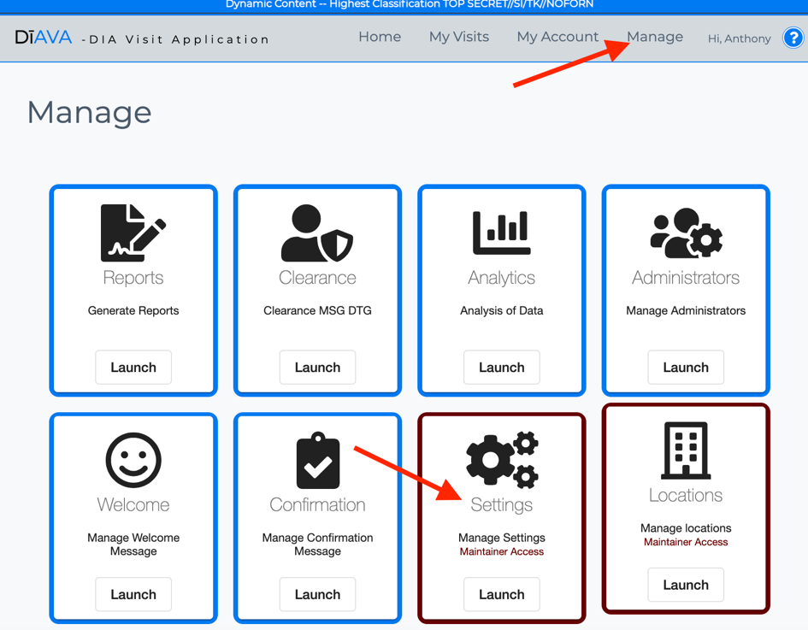
* Enter the “From” email address assigned to the application

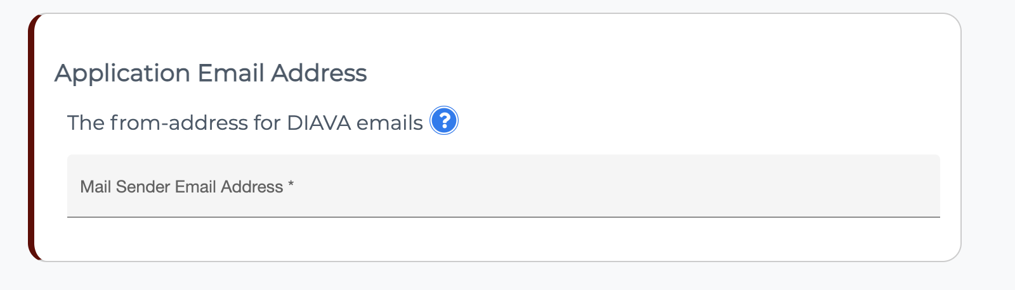

* Enter application time out
  + Application Idle Time = 600
  + Application Time Out Durations/Countdown = 50

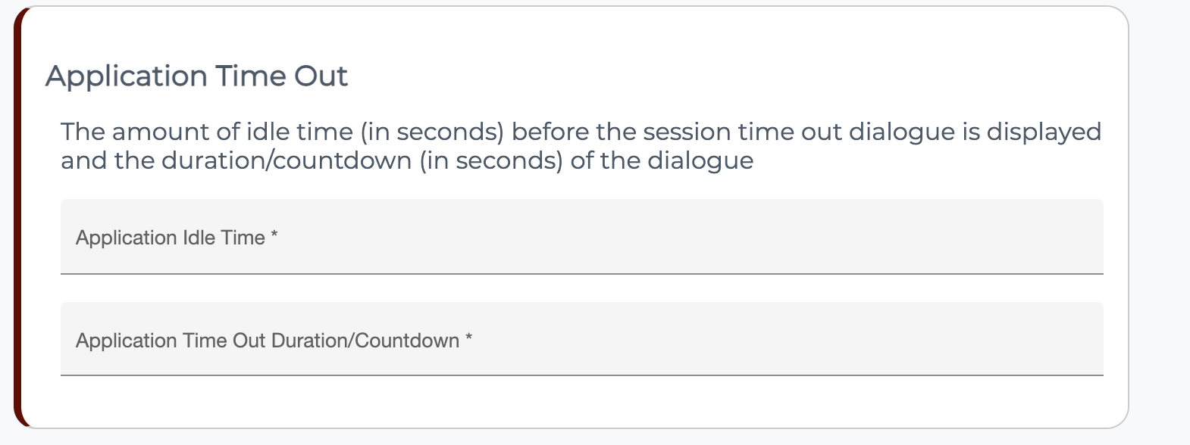

* Enter Application Welcome Message
  + Application Welcome Message = Welcome to DiAVA. Planning to go TDY to a combatant command? A Travel Notification is required before you travel. Notifications must be submitted 10 days prior to visiting a DIA office.
  + This statement “Notifications must be submitted 10 days prior to visiting a DIA office” is a mandatory requirement.

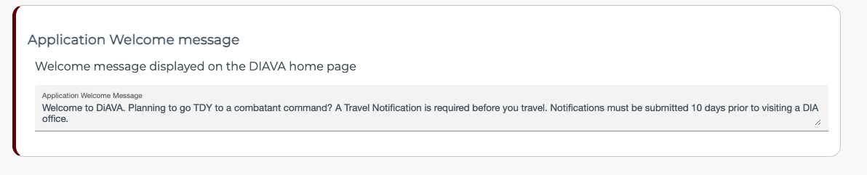

* Save changes

# (U) STEP 2: Manage Locations

* Access “Manage > Locations”

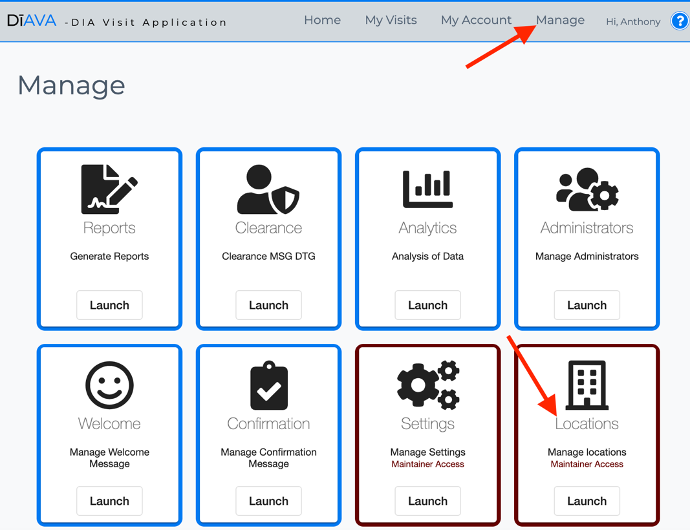

* Click “Add Location” and add all locations in the legacy application
* Make all locations active. Locations will not be available to the users until and admin is assigned.
* Add Latitude and Longitude for each location

# (U) STEP 3: Assign Maintainer (first user) a location

* The first user to access the app is automatically given “Maintainer” privileges but not assigned to a location. All maintainers must be assigned a location.
* Access “Manage > Users” and click the “Edit user” icon.



* Select any location from the list and click save

# (U) STEP 4: Manage Administrators

* Each location’s designated primary administrator needs to access the application for DiAVA to capture their PKI. Once the administrator has accessed the application, the maintainer is required to set the users privileges to administrator for that location.
* To assign a user administrator role for a specific location
  + Access “Manage > Users”

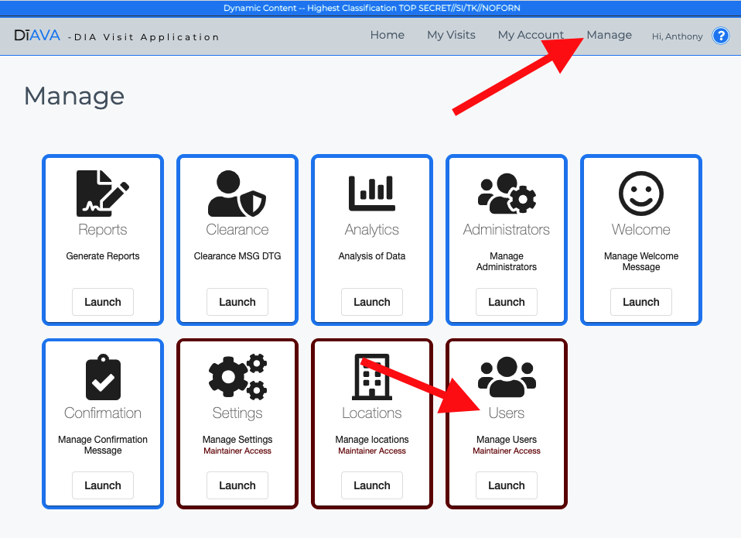

* + Select user from list or perform filter user by name
  + A dialog pop-up will appear and change the User Role to administrator from the dropdown list
  + Select the appropriate location
  + Enter JWICS email address if not already autocompleted. It is critical that the email address is accurate.
  + Click “Save”
  + Repeat for all administrators