**DiAVA**

User Guide

(U) Table of Contents

(U) Introduction 2

(U) Application User Roles 2

(U) Read Only Role 3

(U) Administrator Role 3

• (U) Manage function 4

o (U) Reports 4

o (U) Clearance MSG DTG 4

o (U) Analytics 4

o (U) Manage Administrators 4

o (U) Confirmation Message 4

o (U) Welcome Message 4

(U) Maintainer Role 5

• (U) Manage Settings 6

• (U) Manage Locations 6

• (U) Manage Users 6

(U) Submitting a Visit Notification 7

• **(U) On behalf of** 7

• **(U) Email confirmations** 8

(U) Update a Visit Notification 8

(U) Cancel a Visit Notification 8

# (U) Introduction

DiAVA is a tool that for travelers to submit a visit notification which notifies the destination location of the scheduled visit. It also provides web based historical reports as well as administrative functions for each individual destination location. This application uses PKI for authentication. No registration required to submit a visit notification.

# (U) Application User Roles

There are three user roles

* **Read Only**
  + Read only users can submit visits, cancel and update their own visits, update their own profile
* **Administrator**
  + Administrator have the same access as read only but can also manage the location that they are assigned to. Each location has an administrator assigned. Administrators can add additional administrators for their location, view reports for their assigned location, view analytics and manage Welcome and Confirmation messages. Additional details can be found in the Administrator role section.
* **Maintainer** 
  + Maintainer has the same access as read only and administrators but cannot manage Welcome or Confirmation messages for a location. A maintainer is NOT location specific and should only be given to technical support staff. This access should be limited to software engineers. Any changes made will impact the entire application and can cause an outage if misused.
  + In addition to read only and administrator access, maintainers can manage settings, manage locations, and manage users/roles. See Maintainer Role Section.

## (U) Read Only Role

Read Only role features

* **My Visits** – Will list all scheduled visits for that specific traveler. Past visits are not available to the traveler, only administrators or maintainers can view past (historical) records.
  + Allows traveler to Edit or cancel a visit. If a traveler cancels or updates a visit, a confirmation email is automatically sent to the traveler, all administrators assigned to that destination, and the POC that being visited.
* **My Account** – allows a user to update their profile information
* **Submit Visit Notifications** – allows a user to submit a visit notification. When a visit notification is submitted, a confirmation email is automatically sent to the traveler, all administrators for that destination, and the POC being visited.

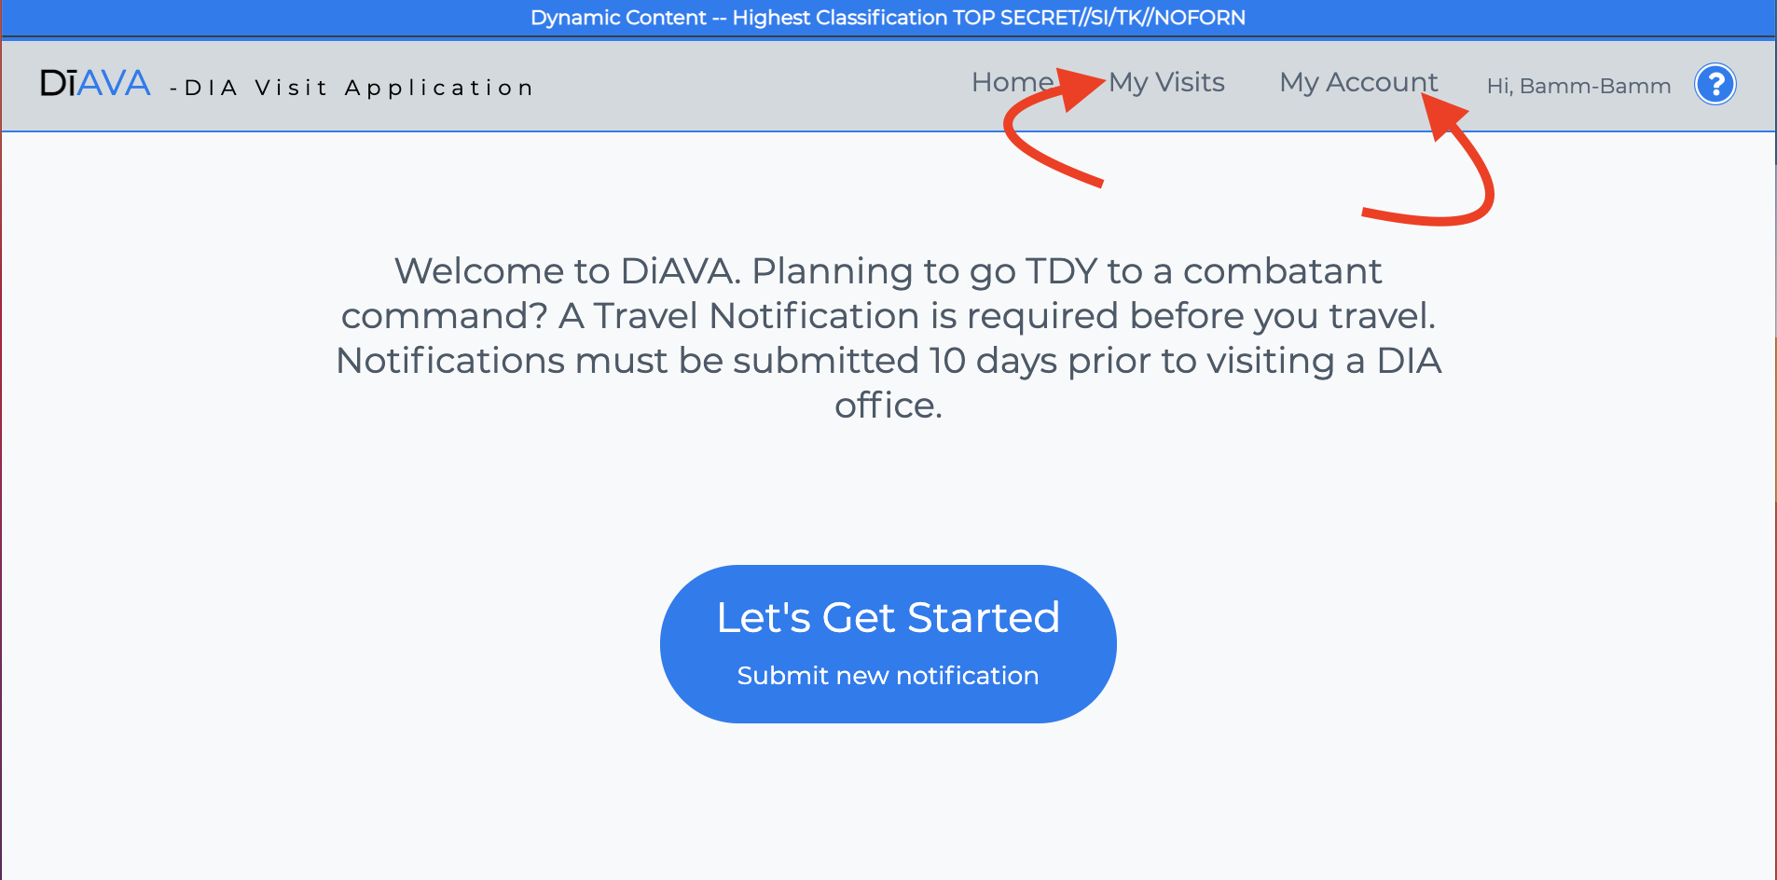

## (U) Administrator Role

Administrator role features

* Same functions as Read Only but also has access to the Manage functions

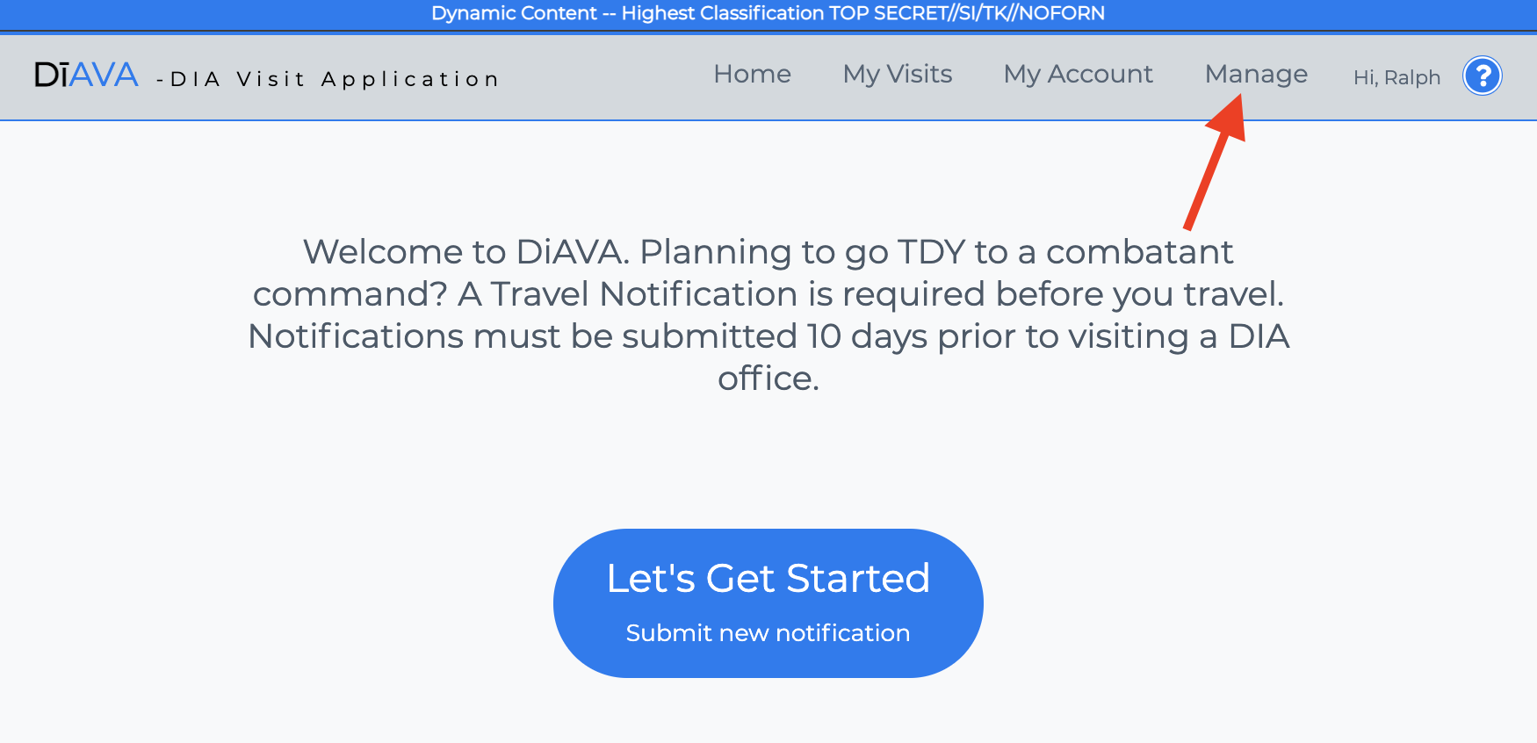

* (U) Manage function – manage functions are location specific. Administrators can only view data for the location that they are assigned to.

### (U) Reports

* + - Search by Notification ID or Name
    - Search by date range
    - Delete historical record. Current or future visits cannot be deleted. Only the traveler can update/cancel a pending visit
    - Export record to CSV
    - Printer Friendly View

### (U) Clearance MSG DTG

* + - Update Travelers Clearance MSG DTG

### (U) Analytics

* + - Location specific metrics

### (U) Manage Administrators

* + - List of all users assigned as administrators for that location
    - Add additional administrators
    - Remove administrators

### (U) Confirmation Message

* + - The Confirmation message is displayed after a visit notification is submitted
    - Leaving the message box blank will remove the message

### (U) Welcome Message

* + - The Welcome message is displayed on the submit new notification page
    - Leaving the message box empty will remove the message

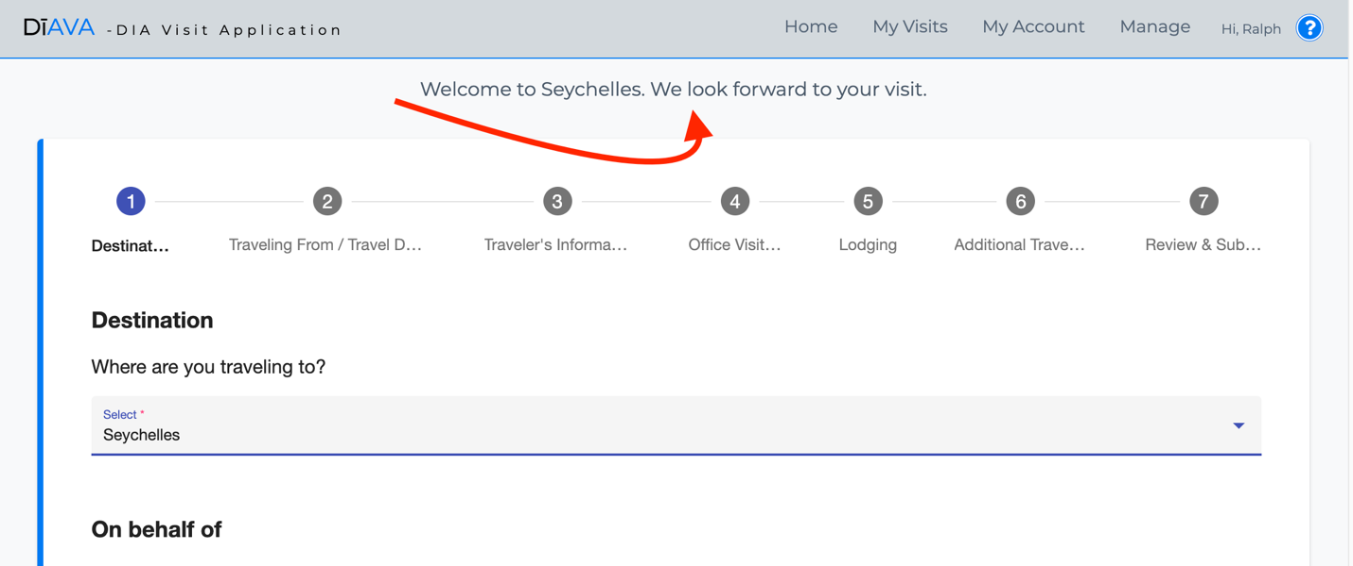

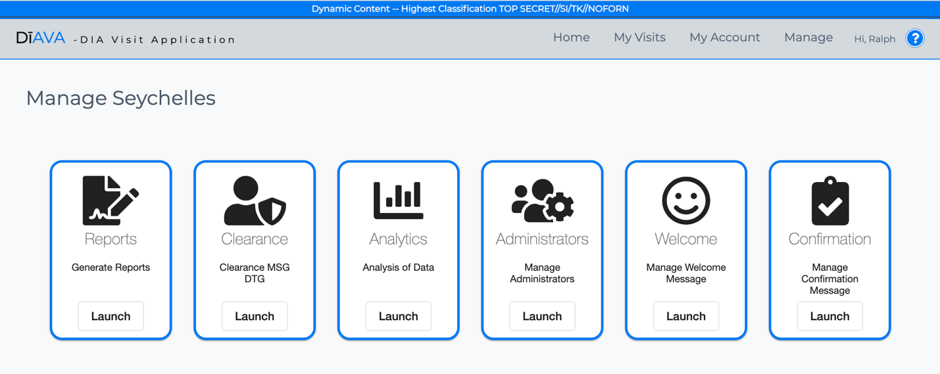

## (U) Maintainer Role

Maintainer role features

* Same functions as Read Only and administrator with the exception of Manage Welcome message and Manage Confirmation message. Only administrators have access to manage Welcome and Confirmation message because they are location specific. Maintainers have additional privileges and should be limited to software engineers. Maintainer has additional access to manage Settings, Locations and Users
* Generate Reports, Clearance MSG DTG, Analytics, and Manage Administrators is **NOT** location specific unlike administrator access is location specific.

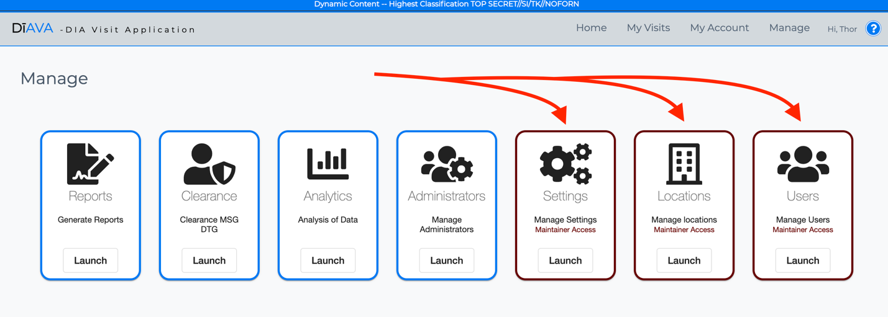

### (U) Manage Settings

* + Manage settings are configuration options for the application. These settings are global.
* (U) Manage Locations **-** Displays a list of locations that, if set to active and has at the minimum one administrator assigned, are options to visit when submitting a visit notiifcation
  + Add new locations. Once a location is added it cannot not be removed/deleted. It can be set to disabled
  + Edit a location allows you to change the name, set the active status, and modify the Lat / Long

### (U) Manage Users

* + User search
  + Delete user
  + Set user privileges
  + Set a maintainer to AdminAt
    - AdminAt is a feature that allows a maintainer to assume the role of an administrator for a specific location for testing / troubleshooting. This option is only available if a user is set to maintainer role.

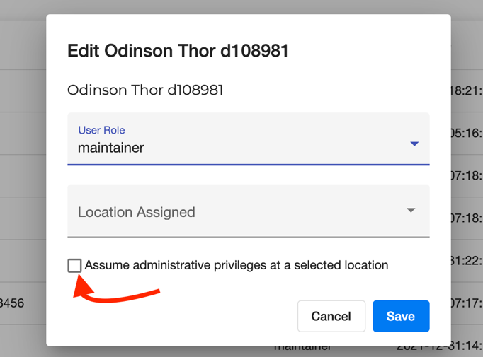

# (U) Submitting a Visit Notification

To submit a visit notification a user accesses the DiAVA home page and click the Let’s Get Started button.

* Click the Let’s get Started button

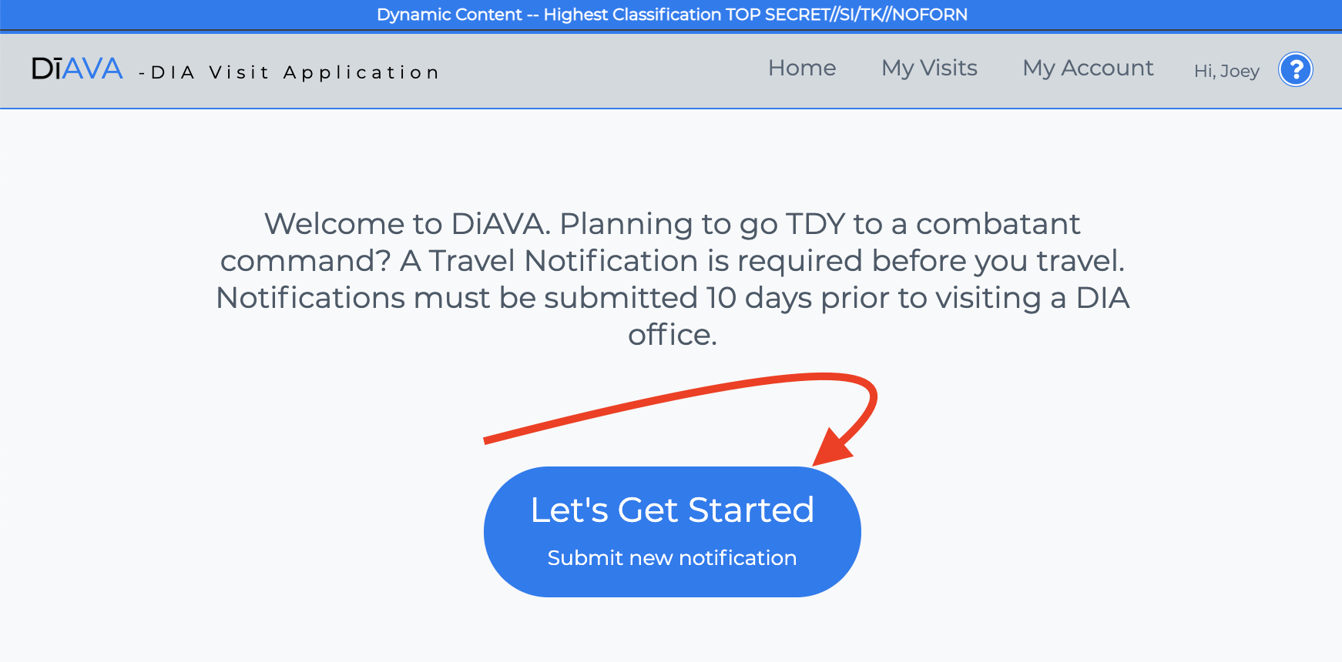

* Fill out the form steps 1 – 7
* **(U) On behalf of** – If a user is filling out this notification for someone else, then they would select yes. The person submitting the form, not the traveler, will be required to enter their email address. This visit will be owned by the person submitting the visit not the traveler. After the visit is submitted it will be listed in the My Visits of the person submitting the visit, not the traveler.

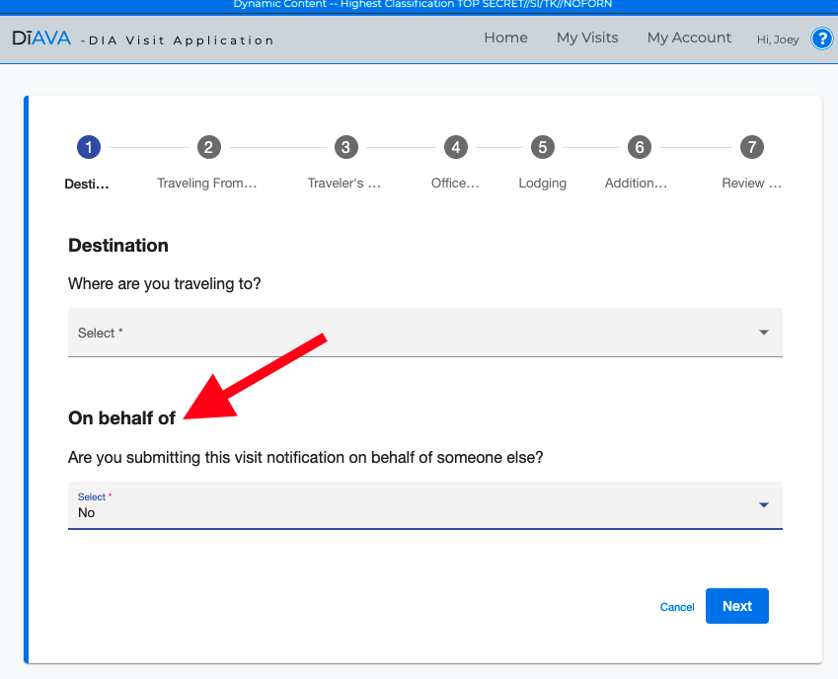

* **(U) Email confirmations** - Once the form is submitted an email confirmation will be sent to all parties involved. The user submitting the visit, the traveler (if on behalf of), all administrators assigned to the destination location, and the POC of the office visiting.

# (U) Update a Visit Notification

Only the traveler, the user that submitted the visit notification, can update a pending record. Historical records are not accessible by the user

* Click on My Visits to update to edit the record – an email confirmation will be sent stating that changes were made

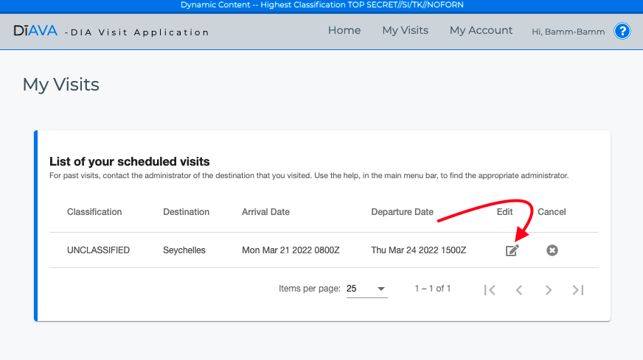

# (U) Cancel a Visit Notification

Only the traveler, the user that submitted the visit notification, can cancel a pending record. Historical records are not accessible by the user

* Click on My Visits to cancel a visit – an email confirmation will be sent stating that that the visit has been cancelled

