**Materials**

For the development of application PhilTech Learning Management System: A Web-Based Application with Grading System. a software requirements used were *Sublime Text 3* for the text editor; *PHP Hypertext Preprocessor* for the programming language; *My Structured Query Language (MySQL)* for the database; and *XAMPP* for the server and *Codeigniter 3.1.11* for the framework of the system development.

The following system specifications of the hardware are used: personal computer have the following specifications: *Intel Pentium N3540 processor at 2.16 gigahertz (GHz)* of clock speed, *1.9 gegabyte (GB) of double data rate 3 (DDR3) Random Access Memory (RAM),* *500 gigabyte (GB)* of hard disk, and installed *Windows 8 64-bit operating system (OS).*

**Method**

The development system cycle modified waterfall model method (Moon *et al.,* 2009). Waterfall model consists of 6 phases: requirements, analysis, program design, coding, testing and maintenance (Fig. 1). The model focuses in systematic grading progression between different phases. Each phase consists of set activities that must be accomplished and before going to the next phase. Once the phase completed, the next one may begin and so on. The output of previous phase serves as an input for the following phase. This waterfall model is allowing the researchers to return at the previous phase just in case of problem was encountered (Moon *et al.,* 2009).



Figure 1. Modified Waterfall Model (Moon *et al.,* 2009)

**Requirements.** This phase of primary goals in a proficiency-based grading system towards accurately reflect to the students of learning progress and achievement The purpose is to identify specific requirements needed for the system, an interview was conducted with the property custodian of the school. An interview sheet shown in Appendix 1 was formulated to obtain a deeper understanding of the processes involved and to know the needs of the client as well as the problem that they are facing in their process.

The researcher develop the system that job is to establish the performance since the students upload their essays, take quizzes online and fairly communicate learning progress.

**Analysis.** At this phase, all of the gathered data and information that are required in developing the grading system had been reviewed.

**INPUT PROCESS OUTPUT**





Figure 2. IPO diagram of the manual process

The manual process of grade recording the student encountered problems and it affects the whole school. There is an instructor assigned to manually check the grade of the student and its identity is unknown. One of the main problems is it the time consumed when the instructor is recording the grades of student in handbook to written and compute manually of their performance activities.

Another IPO diagram (Fig. 3) was drawn which shows the new process of taking grade recording using the developed system.

**INPUT PROCESS OUTPUT**











Figure 3. IPO diagram of the Philtech Learning Management System: A

Web-Based Application with Grading System

Also, the researchers also gathered information by reading local and international books, journals, related studies and textbooks in order to gain more knowledge about grade recording of the student.

**Program Design.** This phase consists of defining the software design, component, modules, interface and data to satisfy specified requirements. This phase shows several diagrams that will be outlined before proceeding to the implementation phase. The identified tools used to develop the system are as follows PHP: Hypertext preprocessorfor the programming language, MY Structured Query Language (MYSQL) for the database. The Entity Relationship Diagram as shown in Figure 4 presents the design of the system’s database as well as the relationship of one table to another.

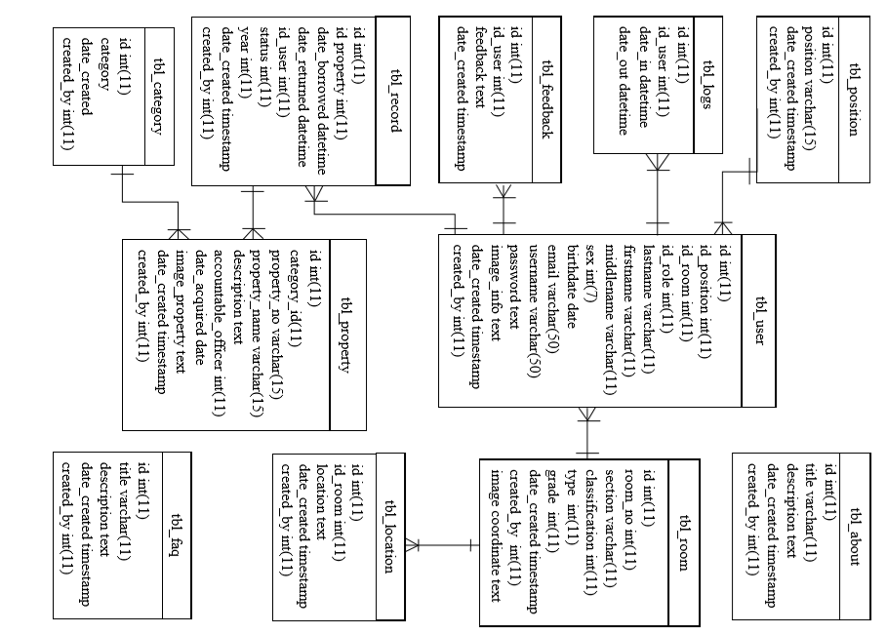

Figure 4. Entity Relationship Diagram (ERD) of the proposed system.

The Entity Relationship Diagram (ERD) is a graphical representation that shows relationships among the components within an information technology system (Rouse, n.d.). Figure 4 depicts the relation between each of the tables within the database by using connectors. The or “one-to-one or many”, indicates that one data from a table can handle many data in another table. There are 4 tables within the database namely tbl_users, it is use for storing data about the system user to ensure the security of every user, tbl_prop which keep records of every item, tbl_logs to have a record of the recent activity of the user, and tbl_history keeps the record of all item, borrowed items and the borrower, number that assign to each item, record of every room and record of the delivered items. The use case diagram (Fig. 5) illustrates the various ways of interaction of the users to the system.

















Figure 5. Use Case Diagram of the Philtech Learning Management System: A

Web-Based Application with Grading System

**Coding.** In this phase, the development of the system will began. The different tools that have been discussed in the design phase were used. During this phase, the system will be developed and acquired based on the detailed design specification that were reflected in the previous phases. The objective of this phase is to ensure that the system functions as expected. After drafting the modules and interface of the system, the coding of the system will be done. The coding of the system will be based on the objectives of the study.

**Testing.** After finishing the coding phase, the developed system had been assessed by the target client. Evaluation was performed for the system to determine the errors, suggest revisions, and add features that are useful to the users. The target client was also evaluated the system to determine if the system meets the objectives. This phase includes system testing and acceptance testing where the equality of each module was tested.

***System testing.*** An evaluation form (Appendix 2) adopted from the International Organization for Standardization (ISO) 25010. It tested the system’s functional suitability, security, usability, performance efficiency, reliability, compatibility, and portability.

A total of 30 respondents evaluated the system which is composed of the faculty members of Philippine Technological Institute of Science Arts and Trade (Philtech) – General Mariano Alvarez, Cavite. The researchers used convenience sampling technique. It is a type of non-probability sampling method that relies on data collection from population members who are conveniently available to participate in the study. The sampling technique was used because data collection can be facilitated in short duration of time (Dudovskiy, 2012).

The system was rated by the respondents from 1 to 5 where 1 means poor, 2 means fair, 3 means satisfactory, 4 means very satisfactory and 5 means outstanding. The answers of the respondents were then counted.

The weighted mean of each indicator was also computed using the formula of BYJU’S (2016).

∑x

N

where:

x = the mean

x = the score

N = the number of respondents

The researchers also computed for the standard deviation using the formula:

Standard deviation is the $S= \sqrt{\frac{\sum{}{\left(x-\underline{x}\right)}^{2}}{n-1}}$

where:

∑ = the sum of

x = the weights

$\underline{x}$ = the mean

n = the value

The results were then interpreted as shown in Table 1.

Table 1. Interpretation of mean ratings (Bicol University, 2012)

**WEIGHT RANGE DESCRIPTIVE INTERPRETATION**

4.21 – 5.00 Outstanding

3.41 – 4.20 Very Satisfactory

2.61 – 3.40 Satisfactory

1.81 – 2.60 Fair

1.00 – 1.80 Poor

***Acceptance testing.*** The admin officer of the Philtech tested the system using an evaluation form (Appendix 3) adopted from the ISO 25010. It tested the system’s effectiveness, performance efficiency, satisfaction, freedom from risk, and context coverage.

**Maintenance.** This is the final phase of the system wherein the developed system will be implemented by the proponents of the client. User manual will also be provided for the user of the system to avoid problem or confusion during the transition of manual process to actual facings. These are all agreed to be prepared for the span of the agreed time covered only. Lastly, upon the implementation of the system, it is expected that the different problems that the system may encounter in the future will be fixed.