**UNIVERSITY OF CALOOCAN CITY COMPUTER ENGINEERING DEPARTMENT**

Data Structure and Algorithm

Laboratory Project

Progress Report 3

|  |  |
| --- | --- |
| *Submitted by:* | *Instructor:* |
| Filjohn Delinia  Czer Justine Maringal Paul Justine Polestico  Mark Angel Talagtag | Engr. Maria Rizette H. Sayo |

SEPTEMBER 20, 2025



DSA UCC

# PROGRESS REPORT

**Date and Time Management**

The application now includes a calendar widget (tkcalendar.DateEntry) for selecting dates, along with separate inputs for start and end times using hour, minute, and AM/PM dropdowns. A built-in conflict detection system ensures that overlapping bookings are prevented.

**Data Persistence**

Integration with Excel via **pandas** allows the program to load existing bookings from *booking_requests.xlsx* and export the current queue back to Excel. It also includes column validation to guarantee the correct Excel format.

**Enhanced Logic**

An improved conflict-checking algorithm converts time into minutes and compares intervals for accuracy. Users can also delete requests directly from the queue, while queue management benefits from persistent storage and dynamic updates.

**Improved UI Components**

The interface uses **ttk.Combobox** for dropdowns, providing a modern look compared to OptionMenu. A scrollbar has been added to the request list for easier navigation, and the overall layout now uses grid alignment with consistent spacing for better readability.

**Structural Improvements**  
The entire app is encapsulated in a **BookingApp class**, making the design modular and easier to maintain. Logic, UI setup, and data handling are separated into clean, well-defined methods.

**Summary of Additions**

* **Input:** Date picker, start/end time selectors
* **Validation:** Time conflict detection
* **Data Storage:** Excel import/export
* **UI:** Scrollbar, modern widgets (ttk)
* **Functionality:** Delete request, persistent queue
* **Architecture:** Class-based design (BookingApp)

# INPUT AND OUTPUT

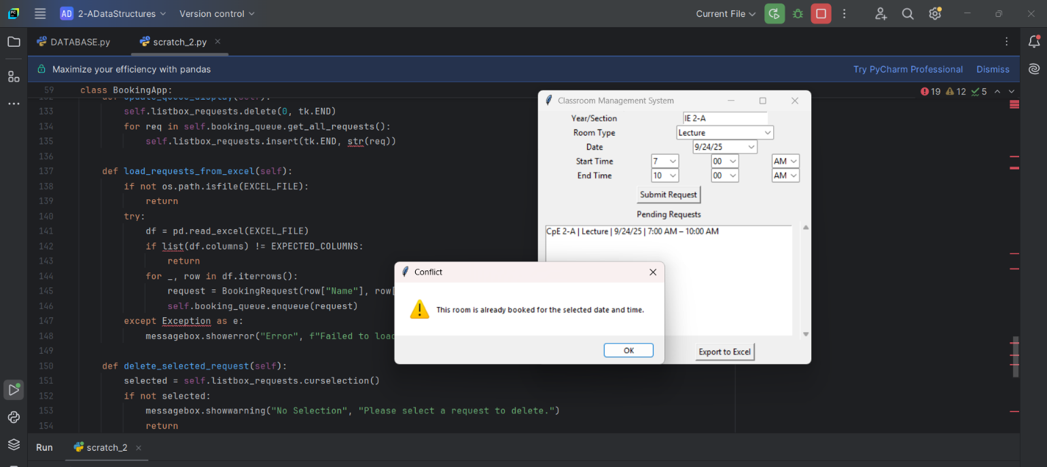

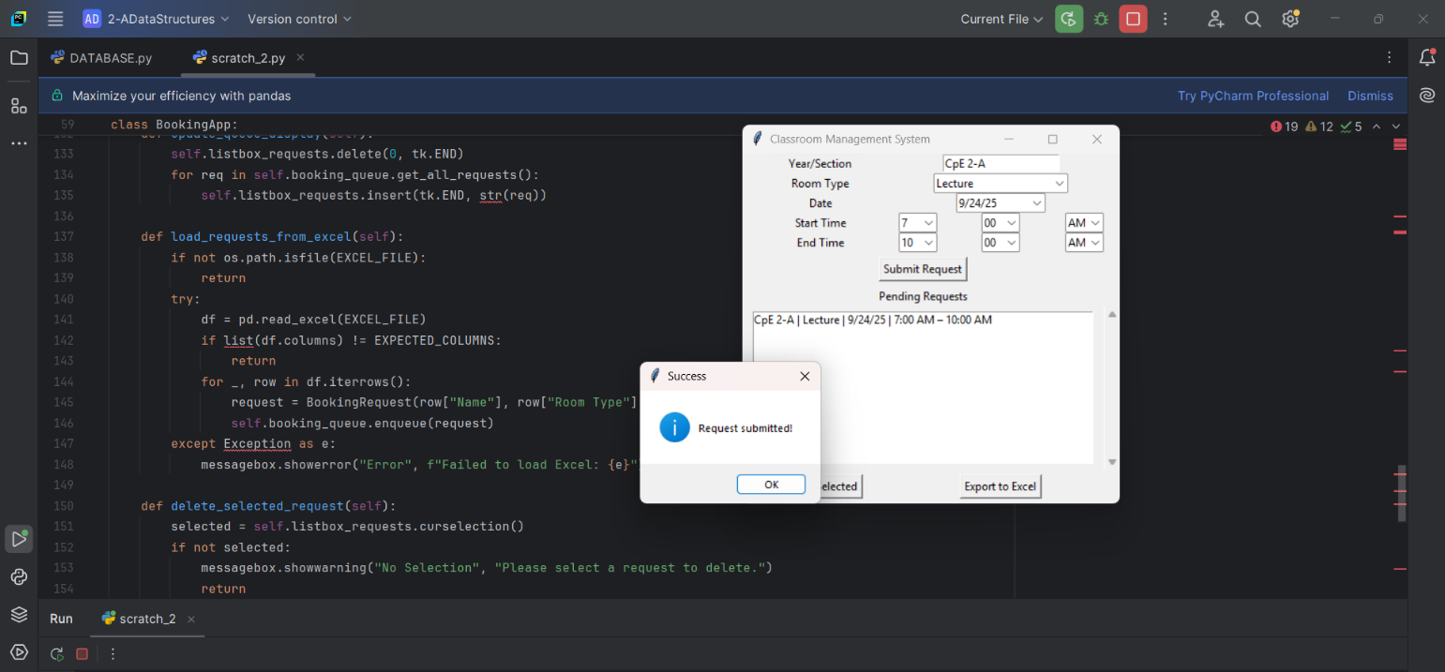

1