**Thony’s DIary**

**Overview**

A diary is a written or visual record with discrete entries organized by date that describes what happened over a day or other time. Though they still frequently use digital technology, diaries have historically been written by hand. A person's experiences, thoughts, and/or feelings may be recorded in a personal journal, but not observations on news stories about which the author is not personally knowledgeable. Diarists are people who keep diaries. In many facets of human society, such as government records (such as Hansard), commercial ledgers, and military records, journals kept for institutional purposes have a significant impact. A preprinted journal format may also be meant by the term in British English. People have been jotting down their personal thoughts since written language was created. Sometimes, diaries are kept as private mementos, and other times, the memories are passed down for the sake of posterity. Whatever your reasons for keeping a diary, you will surely appreciate the ease and convenience of an electronic diary. This type of digital journal is often considered better than paper calendars or daily planner books in terms of flexibility and convenience. Thony’s Diary is available to subjects via login to a website for daily observations and has the added benefit of improving data collection responses through reminders and alerts.

I made this website to make keeping track of daily activities simpler than writing them down by hand. I used to only think about how to create websites like this, but now that I've really done it, I realize how much fun and novel it is.

My target audience to use this website is a person who loves writing.

The programming language I used in this website is HTML, PHP, and CSS.

**Developer**

Mark Anthony M. Manzon

Website Designer and Developer

Contact Number: 09489671398 - TNT

Email: [manzonmarkanthony933@gmail.com](mailto:manzonmarkanthony933@gmail.com)

**Development Timeline**

PHASE 1 - PLANNING

October 20-23, 2022

While I'm still in the planning stage, I'm already considering the designs and whether the modules have the coding I may apply on each page. I started planning on October 20, 2022 and thought about how to start this project and what should I do first and last. I studied my modules and instructions before getting started because I didn't know how to do it and needed some guidance.

PHASE 2 - CODINGS

October 24-26, 2022

Because I'm not very good at coding, I have to hunt for a source in the previous modules and on Google. For me, the modules are really beneficial because there are other components that are actually required to make this website. I started building the website on October 24, 2022 and it's amusing because I immediately finished the log-in page. I'm looking forward to the following day to finish all the pages.

PHASE 3 - DESIGN AND LAYOUT

October 27-29, 2022

When it comes to designing, I want something more therefore I looked up more examples on Google. Since I initially found the css I downloaded from Google to be difficult to understand, I simplified it so that I could do so. On October 28, 2022, I saw that the others in CSS did not function, so I carefully researched it to see how it would work. However, I noticed that in every attribute in sublime, there were suggestions, so I tried them until they worked. When it succeeds, I am overjoyed.

PHASE 4 - Form PHP and Database integration

October 30 to November 3, 2022

October 24, I thought that my page 1 was use by my database I try to simulate it but there is still something missing so I am confused. October 31 I found a source that can be used so this is the one I used and it worked and at November 1-2, 2022 is the final checking of my website, I'm very happy because all the sacrifices are now finally done. November 3, 2022 this is the day to pass my final documentation late but surrender.

**Site Map**

Home

Gallery

Log Out

Diary Listing

Diary

**Codes**

Save in **Index.html**

<!DOCTYPE html>

<html lang="en">

<head>

<title>Page 1: Log in</title>

<link rel="stylesheet" type="text/css" href="style.css">

</head>

<body>

<br><br><br><br><br><br>

<form action="login1.php" method="post">

<div class="login">

<fieldset>

<div class="imgcontainer">

<img src="angela.jpg" alt="Avatar" class="avatar">

</div>

<label for="text">Username</label><br><br>

<input type="text" id="uname" name="uname"><br><br>

<label for="pin">Password</label><br><br>

<input type="pin" id="pin" name="pin"><br><br>

<button type="submit">Log in</button>

<br><br>

<input type="checkbox" id="check">

<span>Remember me</span>

<br><br>

<a href="#">Forgot Password?</a>

</fieldset>

</form>

</div>

</body>

</html>

Save in **style.css**

body

{

margin: 0;

padding: 0;

background-color:gray;

font-family: 'Arial';

text-align: center;

}

.imgcontainer {

text-align: center;

margin: 24px 0 12px 0;

background-repeat: no-repeat;

background-position:right top;

background-attachment: scroll;

}

img.avatar {

width:30%;

border-radius: 50%;

}

.login{

width: 350px;

overflow: hidden;

margin: auto;

border-color: none;

margin: 20 0 0 450px;

padding: 10px;

background: lightgray;

border-radius: 0px ;

}

label{

color: black;

font-size: 20px;

}

#Uname{

width: 300px;

height: 30px;

border: none;

border-radius: 3px;

padding-left: 8px;

}

#Pass{

width: 300px;

height: 30px;

border: none;

border-radius: 3px;

padding-left: 8px;

}

button{

background-color:yellow;

width: 180px;

height: 35px;

border-radius: 10px;

padding-left: 2px;

color: black;

}

h3{

text-align: center;

color: black;

padding: 0px;

}

span{

color: black;

font-size: 17px;

}

a{

float: center;

background-color: lightgray ;

color: black;

}

Save in **login1.php**

<?php

session_start();

$server_name="localhost";

$username="root";

$password="";

$database_name="p3finalexam";

$conn=mysqli_connect($server_name,$username,$password,$database_name);

if(!$conn){

die("Connection Failed:" . mysqli_connect_error());

}else "Connected";

if(isset($_POST['uname']) && isset($_POST['pin'])){

function validata($data){

$data = trim ($data);

$data = stripslashes($data);

$data = htmlspecialchars($data);

return $data;

}

$uname = validata($_POST['uname']);

$pin = validata ($_POST['pin']);

if (empty($uname)){

header("location: login2.php?error=uname Required");

exit();

} else if (empty($pin)) {

header("location: login2.php?error=pin Required");

exit();

}

else {

$sql = "SELECT * FROM login WHERE userName='$uname' AND pword='$pin' limit 1";

$result = mysqli_query($conn,$sql);

if (mysqli_num_rows($result) === 1) {

header("location: page2.html");

} else {

header("location: login2.php?error=Incorrect Username and Password, Please Try Again!!!");

exit();

}

}

}

else {

header("location: login2.php");

exit();

}

Save in **access.php**

<?php

session_start();

$server_name="localhost";

$userid= "id";

$username="root";

$password="";

$database_name="p3finalexam";

$conn=mysqli_connect($server_name,$username,$password,$database_name);

if(!$conn)

{

die("Connection Failed:" . mysqli_connect_error());

}

Save in **page2.html**

<!DOCTYPE html>

<html>

<title>Page 2: Profile</title>

<meta charset="UTF-8">

<meta name="viewport" content="width=device-width, initial-scale=1">

<link rel="stylesheet" href="https://www.w3schools.com/w3css/4/w3.css">

<link rel='stylesheet' href='https://fonts.googleapis.com/css?family=Roboto'>

<link rel="stylesheet" href="https://cdnjs.cloudflare.com/ajax/libs/font-awesome/4.7.0/css/font-awesome.min.css">

<link rel='stylesheet' href='https://cdn.jsdelivr.net/npm/bootstrap-icons@1.7.2/font/bootstrap-icons.css'>

<link href='https://css.gg/games.css' rel='stylesheet'>

<link rel="stylesheet" href="style1.css">

<style>

html,body,h1,h2,h3,h4,h5,h6 {font-family: "Roboto", sans-serif}

</style>

<body class="w3-gray">

<!-- Page Container -->

<div class="w3-content w3-margin-center" >

<!-- The Grid -->

<div class="w3-row-padding">

<!-- Left Column -->

<div class="w3-third">

<div class="w3-light-grey w3-text-black w3-card-4">

<div class="w3-display-container">

<img src="p1.jpg" style="width:100%" alt="Avatar">

<div class="w3-display-bottomleft w3-container w3-text-white">

<h2>Thony</h2>

</div>

</div>

<div class="w3-container">

<p><i class="fa fa-male fa-fw w3-margin-right w3-large w3-text-teal"></i>MARK ANTHONY M. MANZON</p>

<p><i class="fa fa-male fa-fw w3-margin-right w3-large w3-text-teal"></i>Male</p>

<p><i class="fa fa-arrow-right fa-fw w3-margin-right w3-large w3-text-teal"></i>20 years old</p>

<p><i class="fa fa-home fa-fw w3-margin-right w3-large w3-text-teal"></i>Brgy. Pesa Bongabon, Nueva Ecija</p>

<p><i class="fa fa-arrow-right fa-fw w3-margin-right w3-large w3-text-teal"></i>Student ID: 01-2021-03834</p>

<p><i class="fa fa-arrow-right fa-fw w3-margin-right w3-large w3-text-teal"></i>3rd Year College</p>

<p><i class="fa fa-arrow-right fa-fw w3-margin-right w3-large w3-text-teal"></i>BS in Information Technology</p>

<p><i class="fa fa-arrow-right fa-fw w3-margin-right w3-large w3-text-teal"></i>School: Phinma Araullo University</p>

<p><i class="fa fa-arrow-right fa-fw w3-margin-right w3-large w3-text-teal"></i>School Year: 2020-2025</p>

<p><i class="fa fa-envelope fa-fw w3-margin-right w3-large w3-text-teal"></i>arma.manzon.au@phinmaed.com</p>

<p><i class="fa fa-phone fa-fw w3-margin-right w3-large w3-text-teal"></i>09489671398</p><hr>

<p class="w3-large"><b><i class="fa fa-asterisk fa-fw w3-margin-right w3-text-teal"></i>Skills</b></p>

<p>Singer</p>

<div class="w3-light-grey w3-round-xlarge w3-small">

<div class="w3-container w3-center w3-round-xlarge w3-teal" style="width:70%">70%</div>

</div>

<p>Dancer</p>

<div class="w3-light-grey w3-round-xlarge w3-small">

<div class="w3-container w3-center w3-round-xlarge w3-teal" style="width:60%">60%</div>

</div>

<p class="w3-large w3-text-theme"><b><i class="fa fa-globe fa-fw w3-margin-right w3-text-teal"></i>Language</b></p>

<p>Tagalog</p>

<div class="w3-light-grey w3-round-xlarge">

<div class="w3-round-xlarge w3-teal" style="height:24px;width:100%"></div>

</div>

<br>

</div>

</div>

<!-- End Left Column -->

</div>

<!-- Right Column -->

<div class="w3-twothird">

<div class="w3-container w3-card w3-white w3-margin-bottom">

<h5 class="w3-text-black w3-padding-0">

<aside class="left">

<ul>

<li><a class="active" href="http://localhost/FINALS/page2.html">Home</a></li>

<li><a href="http://localhost/FINALS/page3.html">Gallery</a></li>

<li><a href="http://localhost/FINALS/diary.html">Diary</a></li>

<li><a href="http://localhost/FINALS/index.html">Log Out</a></li>

</ul>

</aside>

<h5><b>About Myself</b></h5>

<p>Hi! I'm <b>Anthony</b> but you can call me <b>Thony Gonzaga</b>, as of now I am student of <b>Phinma Araullo University, 3rd year college</b> a future <b>Programmer</b> that's help to other <b>Information Technology Students</b> someday.<br><br>

I am a responsible, good citizen of every filipino, I can smile even when I'm hurting, fighter of every challenges of life and also i am the one of people pleaser na inuuna ang kasiyahan ng iba bago ako 🙃 but still fighting ❤️ . I am confident with my thinking analysis that I can convince people with my points. I am self-reliant, well behaved and above all, a person of strong character. I take initiative whenever the situation arises and come off with flying colours.<hr>

<h5><b><p>Background Music</p></b></h5>

<audio controls autoplay loop>

<source src="m1.mp3"></audio>

<h5><b><p>Video that describe to me</p></b></h5>

<iframe width="560" height="315" src="https://www.youtube.com/embed/JFb1ne3M4Q8" title="YouTube video player" frameborder="0" allow="accelerometer; autoplay; clipboard-write; encrypted-media; gyroscope; picture-in-picture" allowfullscreen></iframe>

<h4><p>Click the links on my Social Media Accounts </p></h4>

<i class='bi bi-tiktok'><a href="https://www.tiktok.com/@anthony_manzon"></i><button> https://www.tiktok.com/@anthony_manzon</button></a><br>

<a href="#" class="fa fa-facebook"></a><a href="https://www.facebook.com/itsmethony03062002"><button>https://www.facebook.com/itsmethony03062002</button></a><br>

<a href="#" class="fa fa-instagram"></a><a href="https://www.instagram.com/thony_manzon"><button>https://www.instagram.com/thony_manzon</button></a><br>

</body>

</html>

Save in **style1.css**

.left {

float: left;

width: 310px;

margin: 0;

padding: 1em;

text-align: center;

}

ul {

list-style-type: none;

margin: 0;

padding: 0;

}

li a {

display: block;

color: #000;

padding: 10px;

text-decoration: none;

}

li a.active {

background-color: teal;

color: white;

}

li a:hover:not(.active) {

background-color: #29292a;

color: white;

}

.fa-facebook {

background: #3B5998;

color: white;

padding: 10px;

font-size: 15px;

width: 40px;

text-align: center;

text-decoration: none;

margin: 5px 2px;

}

.fa-instagram {

background: orange ;

color: white;

padding: 10px;

font-size: 15px;

width: 40px;

text-align: center;

text-decoration: none;

margin: 5px 2px;

}

.bi-tiktok{

background: white ;

color: black;

padding: 10px;

font-size: 15px;

width: 40px;

text-align: center;

text-decoration: none;

margin: 5px 2px;

}

Save in **login2.php**

<?php

include_once("access.php")

?>

<!DOCTYPE html>

<html lang="en">

<head>

<title>Login Form</title>

<link rel="stylesheet" type="text/css" href="style.css">

<title>Log in</title>

</head>

<body>

<form action="login1.php" method="post">

<br><br><br><br><br><br>

<div class="login">

<fieldset>

<label for="text">Username:</label>

<input type="text" id="uname" name="uname"><br><br><br>

<label for="pin">Password:</label>

<input type="pin" id="pin" name="pin"><br><br><br>

<button type="submit">Login</button>

</fieldset>

<?php if(isset($_GET['error'])){?>

<p class="error"><?php echo $_GET['error']; ?></p>

<?php }?>

</form>

</div>

</body>

<style>

p{

color: red;

}

</style>

</html>

Save in **page3.html**

<!DOCTYPE html>

<html lang="en">

<head>

<meta charset="UTF-8">

<meta http-equiv="X-UA-Compatible" content="IE=edge">

<meta name="viewport" content="width=device-width, initial-scale=1.0">

<title>Page 3: Gallery</title>

<link rel="stylesheet" href="https://cdnjs.cloudflare.com/ajax/libs/font-awesome/5.15.3/css/all.min.css">

<style>

body {

margin: 0;

box-sizing: border-box;

font-family: arial, sans-serif;

background-color: lightgray;

}

.left {

float:left;

width: 70px;

margin: 0;

padding: 1em;

}

.content {

margin-left: : 190px;

border-left: 1px ;

padding: 1em;

overflow: hidden;

}

ul {

list-style-type: none;

margin: 0;

padding: 0;

}

li a {

display: block;

color: #000;

padding: 10px;

text-decoration: none;

}

li a.active {

background-color: teal;

color: white;

}

li a:hover:not(.active) {

background-color: #29292a;

color: white;

}

</style>

</head>

<body>

<aside class="left">

<ul>

<li><a class="active" href="http://localhost/FINALS/page2.html">Back</a></li>

</ul>

</aside>

<main class="content">

<table>

<h2>Solo lang muna tayo:)</h2>

<p>Being gay isn't easy, but I always remind myself never give up, never surrender.</p>

<img src="p2.jpg" width="240px" height="240px" border="2" >

<img src="p3.jpg" width="200px" height="240px" border="2" >

<img src="p4.jpg" width="250px" height="240px" border="2" >

<img src="p5.jpg" width="245px" height="250px" border="2" >

<img src="p6.jpg" width="240px" height="240px" border="2" >

<img src="p9.jpg" width="220px" height="260px" border="2" >

<img src="p11.jpg" width="220px" height="280px" border="2" >

<img src="p12.jpg" width="240px" height="240px" border="2" >

<img src="p14.jpg" width="240px" height="240px" border="2" >

<h2>Friends</h2>

<p>Good Freinds are like stars.You don't always see them, but you know they're always there.</p>

<img src="p7.jpg" width="230px" height="280px" border="2" >

<img src="p15.jpg" width="250px" height="250px" border="2" >

<img src="p16.jpg" width="260px" height="250px" border="2" >

<h2>Family</h2>

<p>the most important in this world are my friends, family especially to god that my strength and my weaknessess </p>

<img src="p8.jpg" width="200px" height="250px" border="2" >

<h2>Background Music</h2>

<div>

<audio width="20" height="10" controls>

<source src="Don't Know What To Do _ Mark Carpio.mp3" ">

</audio>

<audio width="20" height="10" controls>

<source src="Friend Of Mine - Odette Quesada (REYNE COVER).mp3" ">

</audio>

<audio width="20" height="10" controls>

<source src="To The Bone - Pamungkas (Lyrics) 🎵.mp3" ">

</audio>

</div>

</body>

</html>

Save in **style2.css**

body

{

font-family: 'Arial';

background-color:gray;

text-align: center;

}

.login{

width: 300px;

overflow: hidden;

margin: auto;

margin: 20 300px;

padding: 20px;

background:lightgray;

border-radius: 10px ;

}

.left {

float:left;

width: 70px;

margin: 0;

padding: 1em;

}

ul {

list-style-type: none;

margin: 0;

padding: 0;

}

li a {

display: block;

color: #000;

padding: 10px;

text-decoration: none;

}

li a.active {

background-color: teal;

color:white;

}

h1{

text-align: center;

color: white;

padding: 0px;

}

h3{

text-align:left;

}

label{

color: black;

font-size: 20px;

}

button{

background-color:black;

width: 300px;

height: 35px;

border-radius: 10px;

padding-bottom:0px;

color: white;

}

Save in **diary.html**

<!DOCTYPE html>

<html lang="en">

<head>

<link rel="stylesheet" type="text/css" href="style2.css">

<title>Page 4: Diary Entry</title>

</head>

<body>

<aside class="left">

<ul>

<li><a class="active" href="http://localhost/FINALS/page2.html">Back</a></li>

</ul>

</aside>

<form action="diary.php" method="post">

<h1>Diary</h1>

<div class="login">

<label for="text">Topic:</label><br>

<input type="text" id="top" name="top">

<h3>Choose Category:</h3>

<label for="cat">(Home/Personal/School/Peers)</label><br>

<input type="text" id="cat" name="cat">

<label for="con"><h3>Content</h3></label>

<textarea id="con" name="con" rows="15" cols="38"> </textarea><br>

<label for="date">Date:</label>

<input type="date" id="date" name="date"><br><br>

<button type="submit">Submit</button>

</form>

</div>

</body>

</html>

Save in **diary.php**

<html>

<style>

header {

text-align:center;

font-family: courier new;

font-size: 30px;

}

body{

background-color:lightgray;

text-align:center;

}

#head{

text-align: center;

font-family: courier new;

font-size: 80px;

color: black;

background-color:none;

height: 100px;

}

.topnav {

background-color:none;

overflow: hidden;

}

/* Style the links inside the navigation bar */

.topnav a {

float: left;

color: white;

text-align: center;

padding: 14px 16px;

text-decoration: none;

font-size: 15px;

}

/* Change the color of links on hover */

.topnav a:hover {

background-color: red;

color: black;

}

/* Add a color to the active/current link */

.topnav a.active {

background-color:teal;

color: white;

}

b{

font-size: 25px;

color: black;

}

</style>

<br><br><br>

<header id = "topnav">Diary Listing </header><br>

<body class = "form1">

<div class = "top">

<h2><b></b></h2><br><?php echo $_POST["top"]; ?>

<div class = "cat">

<b></b><br> <?php echo $_POST["cat"]; ?> </div>

<div class = "con">

<i><b></b></i><br> <?php echo $_POST["con"]; ?></div>

<h5><b></b></h5><br> <?php echo $_POST["date"]; ?>

<br>

<br>

<br>

<div class="topnav">

<a class="active" href="http://localhost/FINALS/diary.html">Back</a>

</div>

</body>

</html>

**Database**

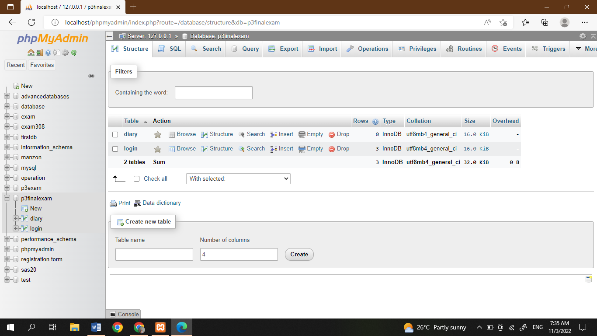

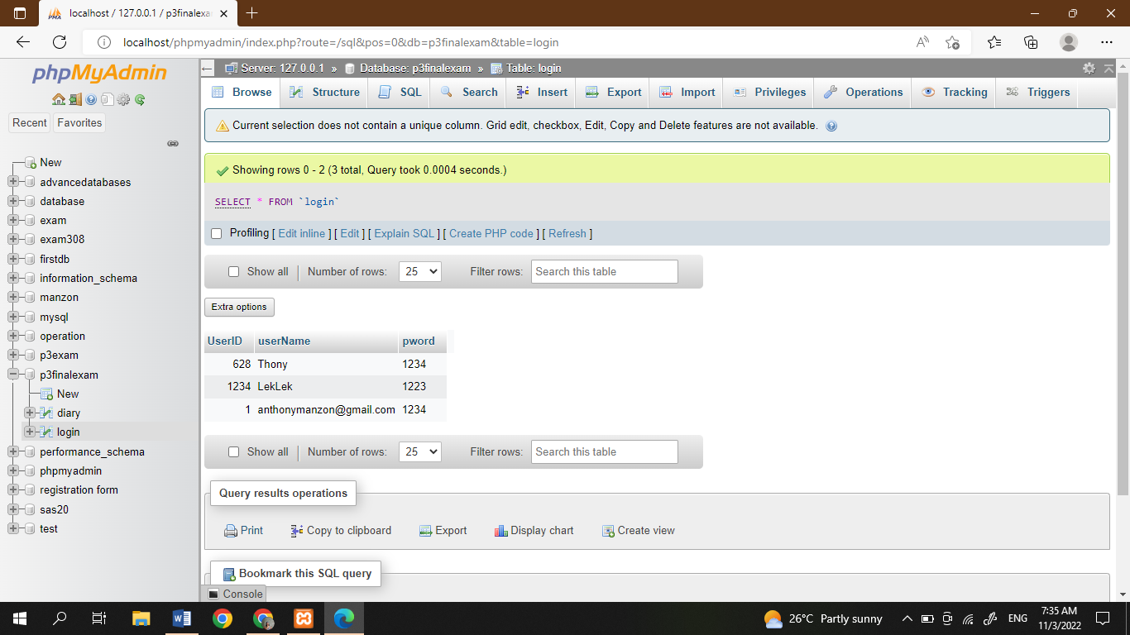

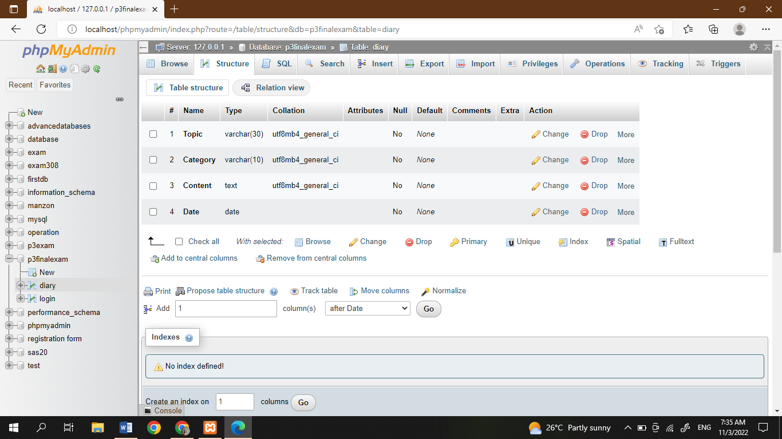

**Screenshot Output of Codes**

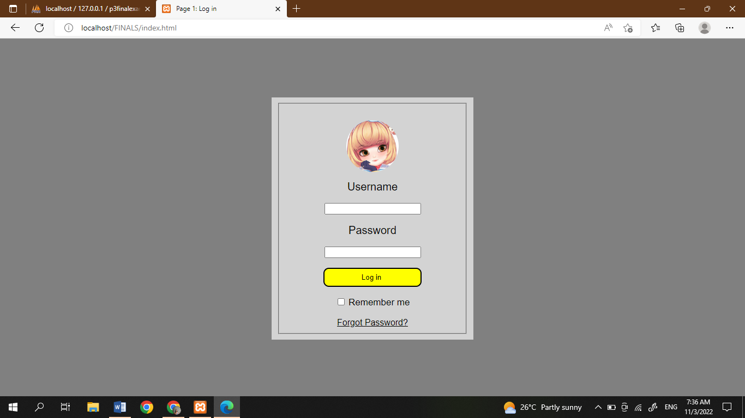

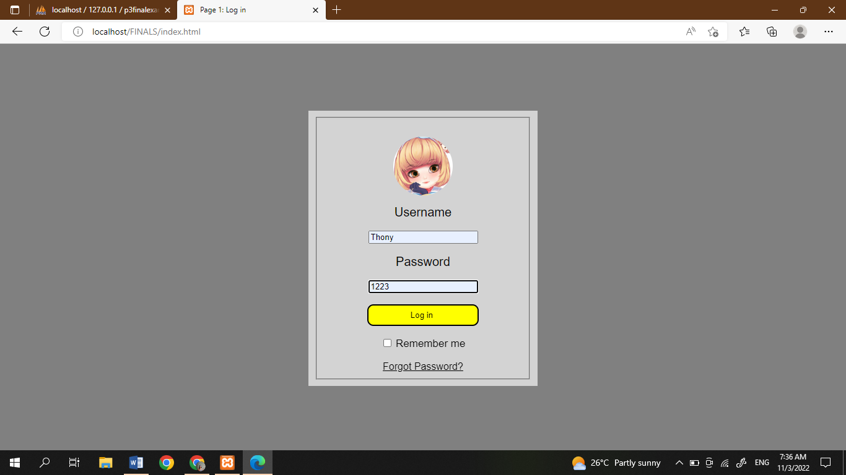

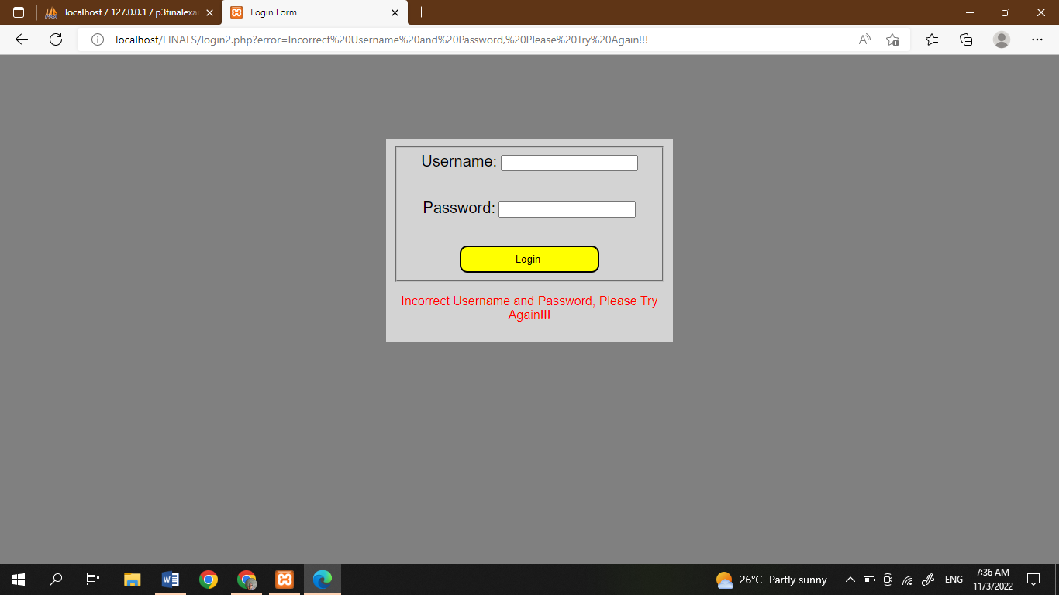

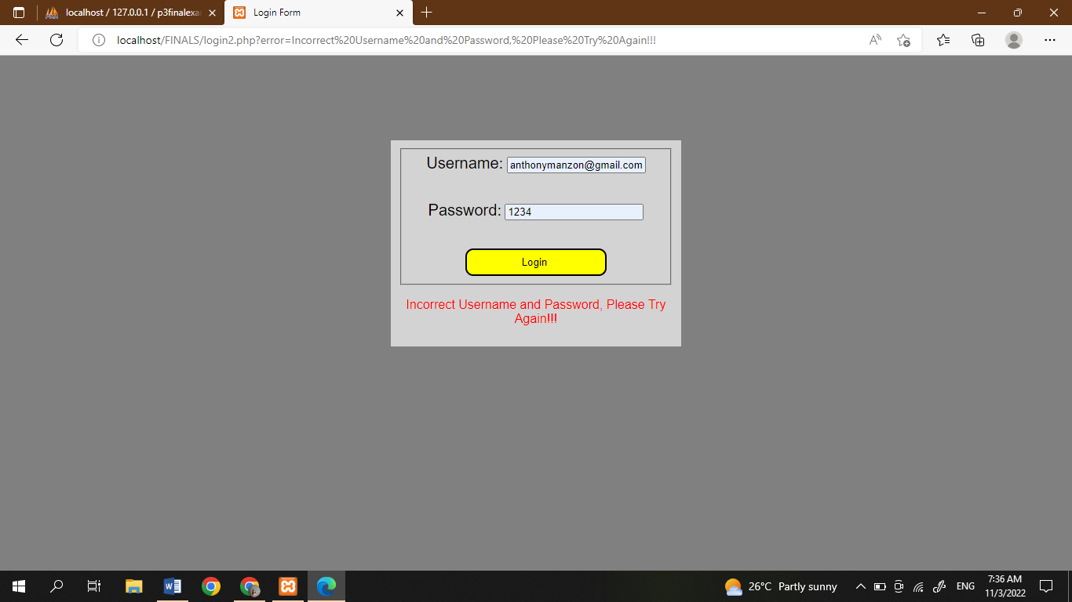

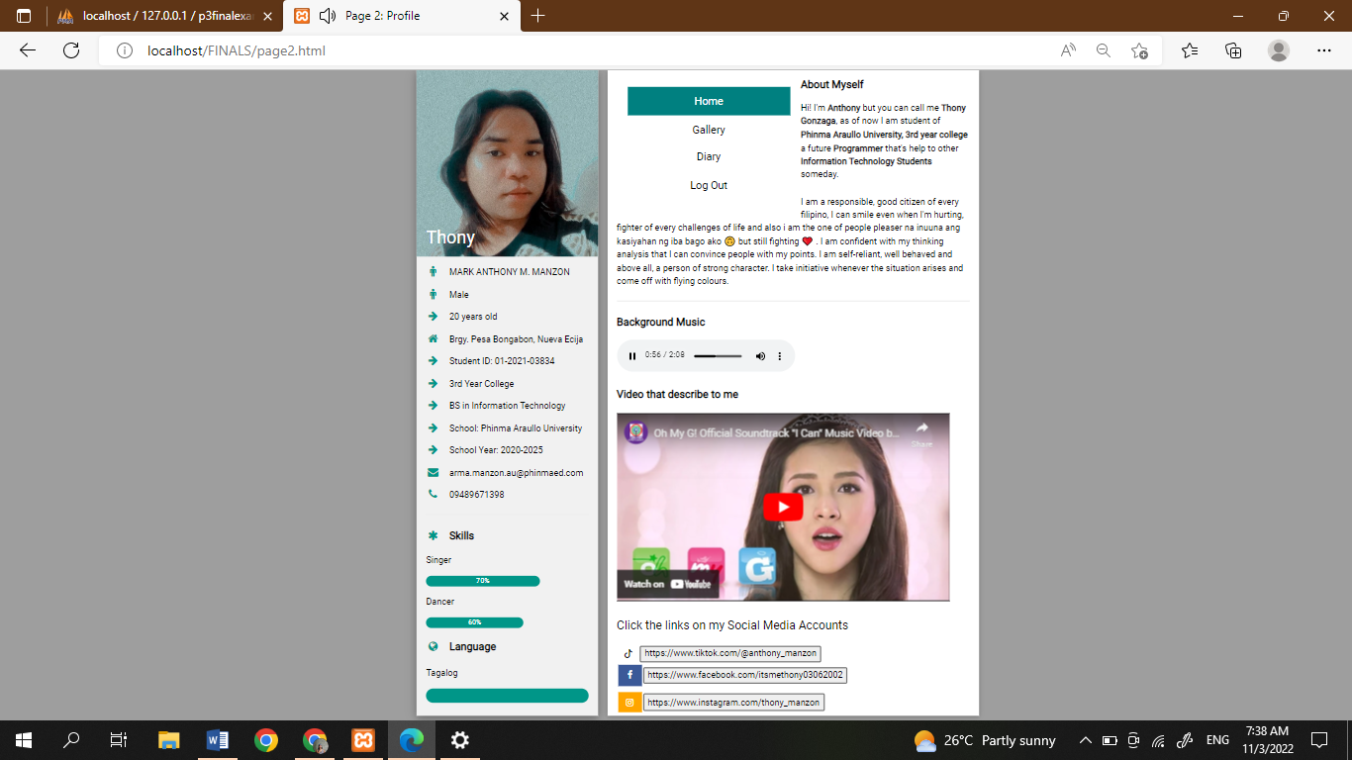

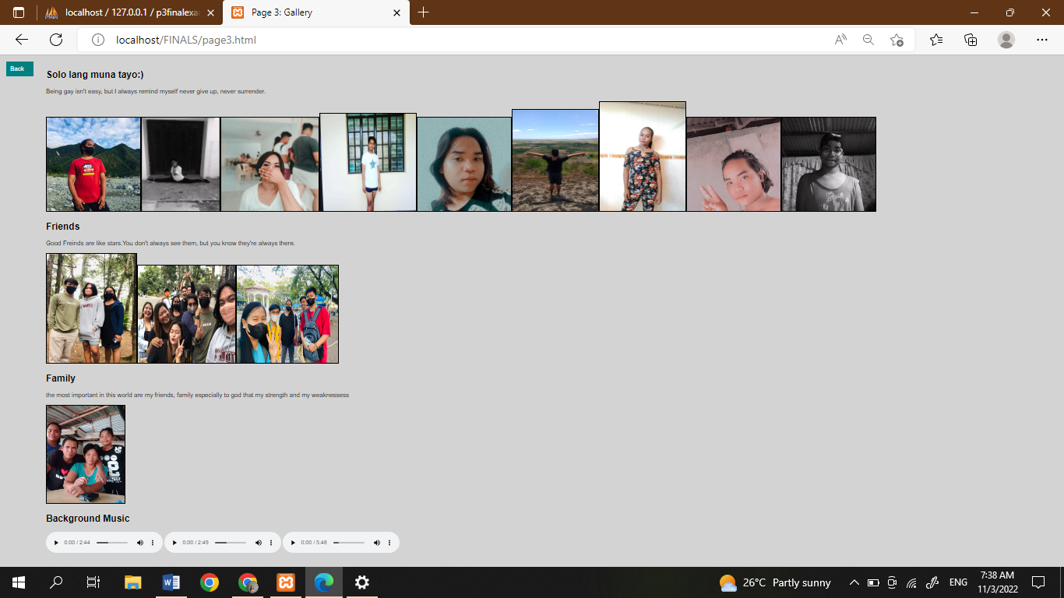

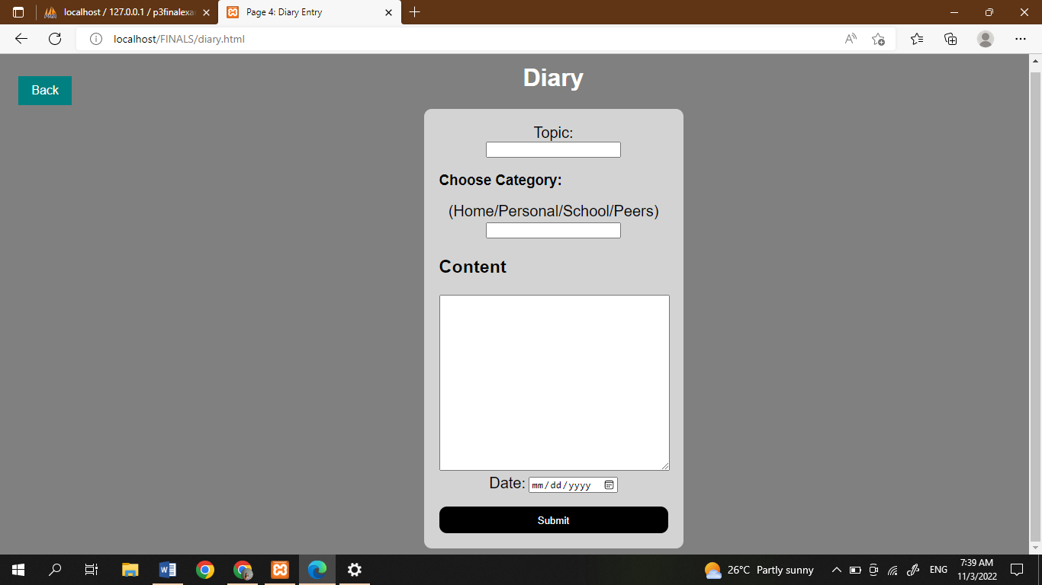

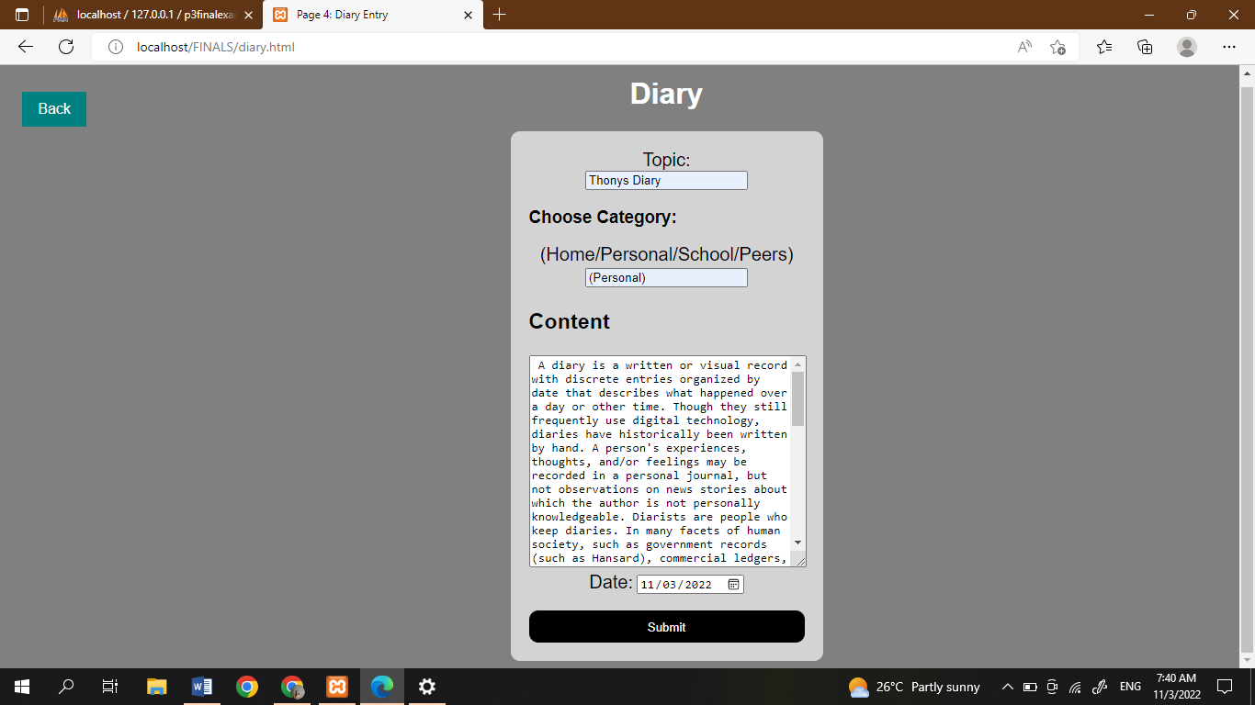

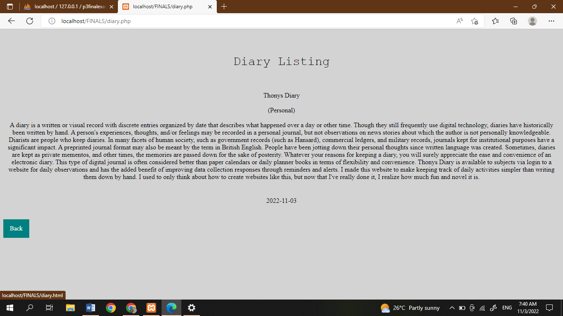

Click the log out and you will go to the page 1 or Log in page

