ARIA — Automated Response & Intelligence Analyst
Final Capstone Project Documentation
Student: Mark Muinde
Paul Mwangi Muriithi
Course: AI Analyst Workflow Engineering

COVER PAGE
INSERT COMPLETE WORKFLOW SCREENSHOT HERE

EXECUTIVE SUMMARY
This project upgrades the original ARIA incident response workflow into a production-grade system. The upgraded architecture introduces structured AI outputs, schema validation, model fallback mechanisms, fault tolerance controls, governance logging, human approval gates and auditability. The system is designed to continue operating under failure conditions while providing complete visibility into workflow execution.

PROJECT BACKGROUND
Nairobi Nexus relies on automated incident intelligence and response automation. As the audience grew, failures became costly. The previous solution worked under ideal conditions but could not handle AI failures, malformed responses, unavailable sources or audit requirements. This project addresses those limitations through resilient workflow engineering.

PROBLEM STATEMENT
The original workflow lacked structured outputs, fallback models, governance logging and fault isolation. A single failure could terminate the entire process. Leadership required a production-grade architecture capable of surviving failures while maintaining transparency and accountability.

PROJECT OBJECTIVES
1. Enforce structured AI outputs.
2. Prevent workflow collapse.
3. Implement model fallback strategies.
4. Add governance logging.
5. Introduce human approval controls.
6. Improve operational visibility

CHAPTER 1 – SYSTEM ARCHITECTURE

ARIA — Automated Response & Intelligence Analyst
┌──────────────────────┐
│ Schedule Trigger │
│ (Runs Every Hour) │
└──────────┬───────────┘
│
▼
┌──────────────────────┐
│ Google Sheets │
│ Fetch Incidents │
└──────────┬───────────┘
│
▼
┌──────────────────────┐
│ ARIA AI Agent │
│ Incident Analysis │
└──────────┬───────────┘
│
▼
┌──────────────────────┐
│ Structured Output │
│ Parser & Validation │
└──────────┬───────────┘
│
┌───────────────┴───────────────┐
│ │
▼ ▼
┌───────────────────┐ ┌───────────────────┐
│ WF2 Human Review │ │ WF3 Governance │
│ Approval Workflow │ │ Logging Workflow │
└─────────┬─────────┘ └─────────┬─────────┘
│ │
▼ ▼
┌───────────────────┐ ┌───────────────────┐
│ Google Docs │ │ Run Logs │
│ Incident Report │ │ Audit Trail │
└─────────┬─────────┘ └───────────────────┘
│
▼
┌───────────────────┐
│ Gmail Alerts │
│ Stakeholders │
└───────────────────┘

Architecture Summary
WF1 – Data Ingestion & AI Analysis
- Retrieves incident records.
- Uses ARIA AI Agent for analysis.
- Enforces structured JSON outputs.
- Validates AI responses before processing.
WF2 – Human Approval & Escalation
- Sends approval requests.
- Generates Google Docs reports.
- Sends escalation notifications.
WF3 – Operational Governance Logging
- Records run metadata.
- Tracks model usage.
- Maintains audit trails.
- Provides operational visibility.

CHAPTER 2 – WF1 DATA INGESTION & AI ANALYSIS
WF1 serves as the intelligence engine of the solution.
Node 1 – Schedule Trigger
Purpose: Runs hourly and initiates processing.
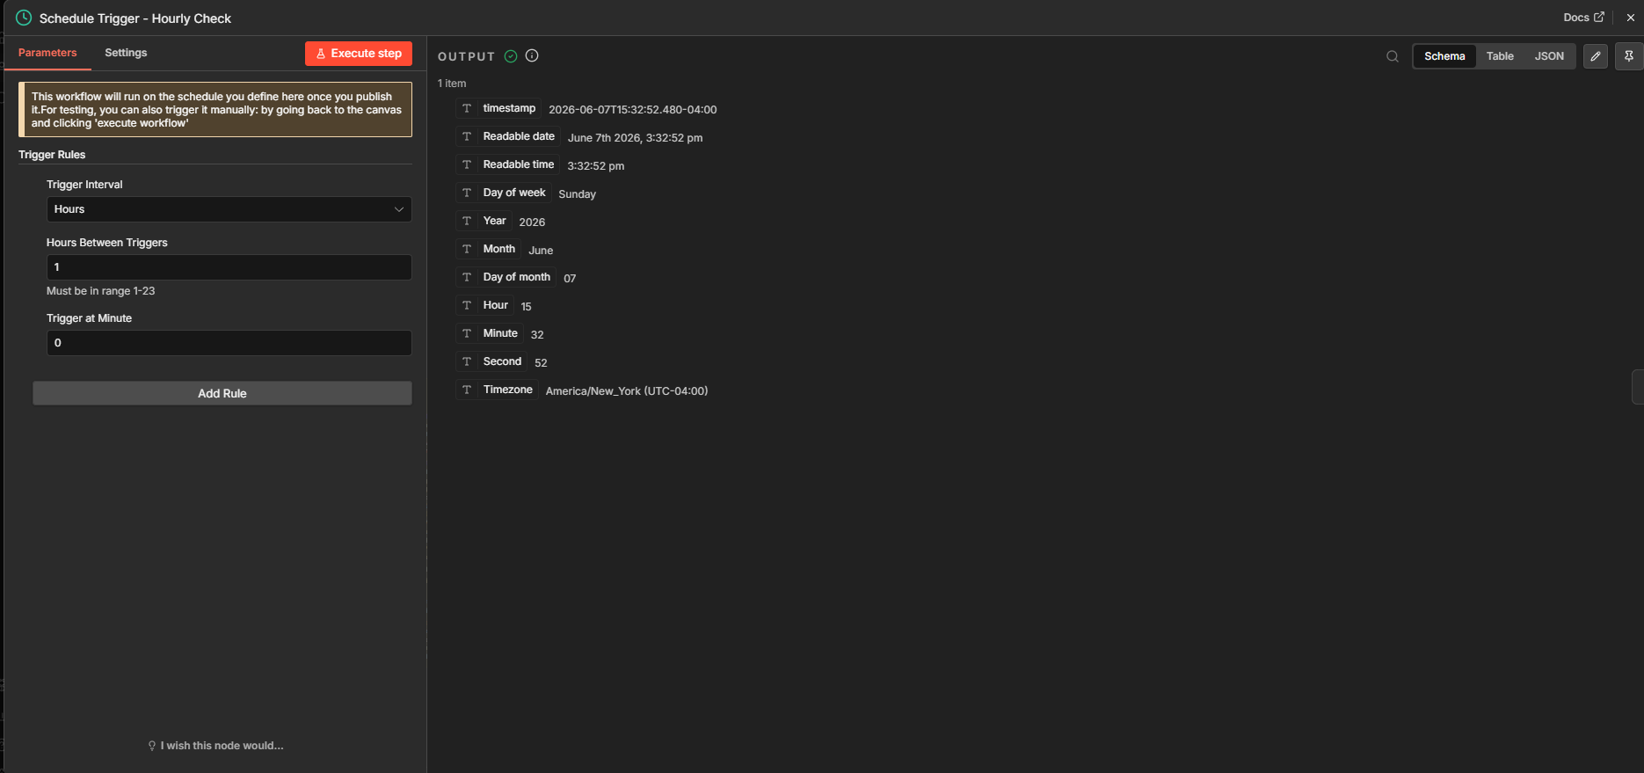
Node 2 – Google Sheets Fetch Incidents
Purpose: Retrieves incident data.
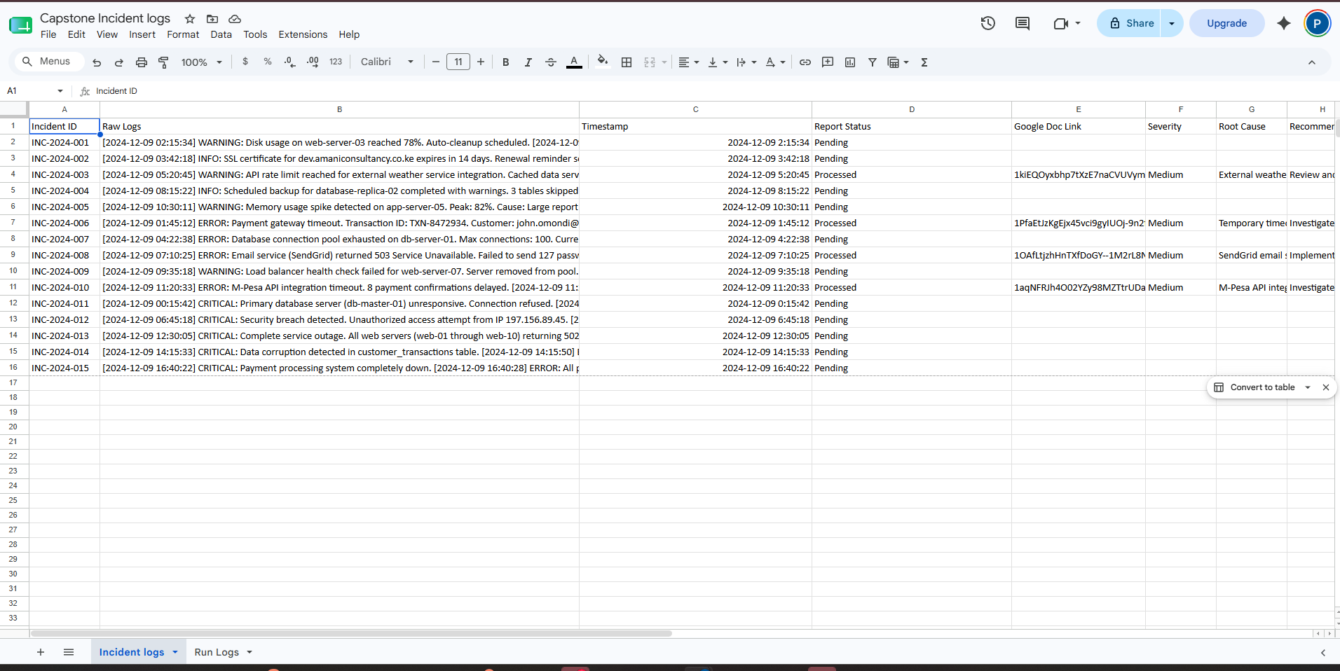
Node 3 – AI Agent Incident Commander
Purpose: Performs root cause analysis, severity classification and recommendation generation.
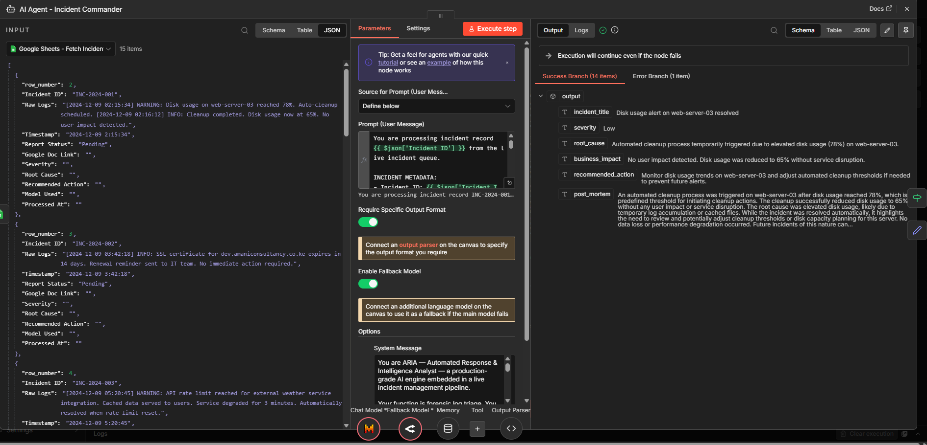
Node 4 – Structured Output Parser
Purpose: Validates JSON output against schema.
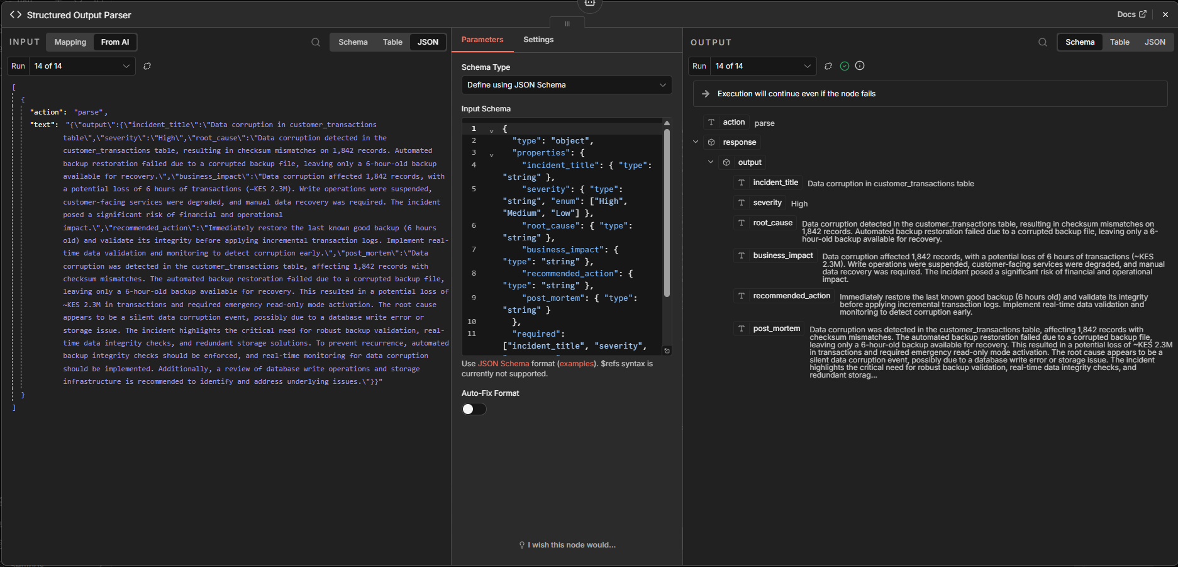
Node 5 – JSON Validation Guard
Purpose: Verifies required fields and routes execution.
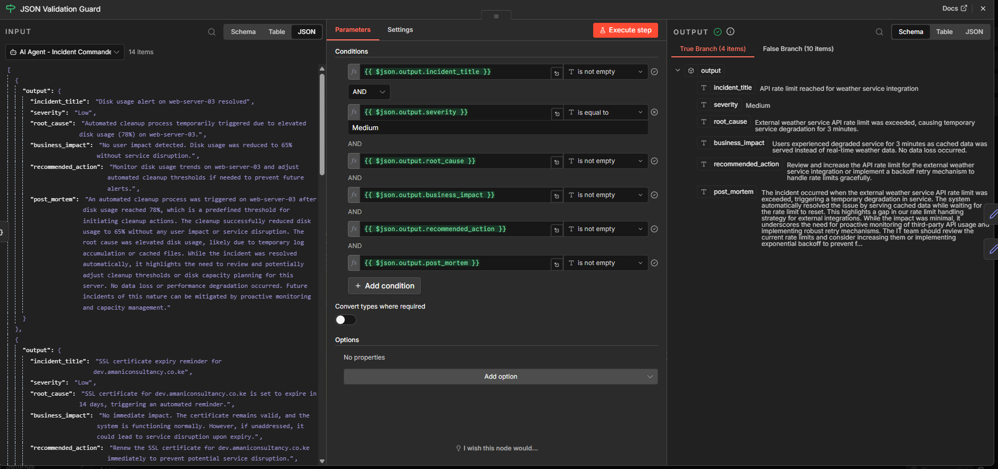
Model Strategy:
Primary Model – Mistral
Fallback Model – GPT-3.5 Turbo
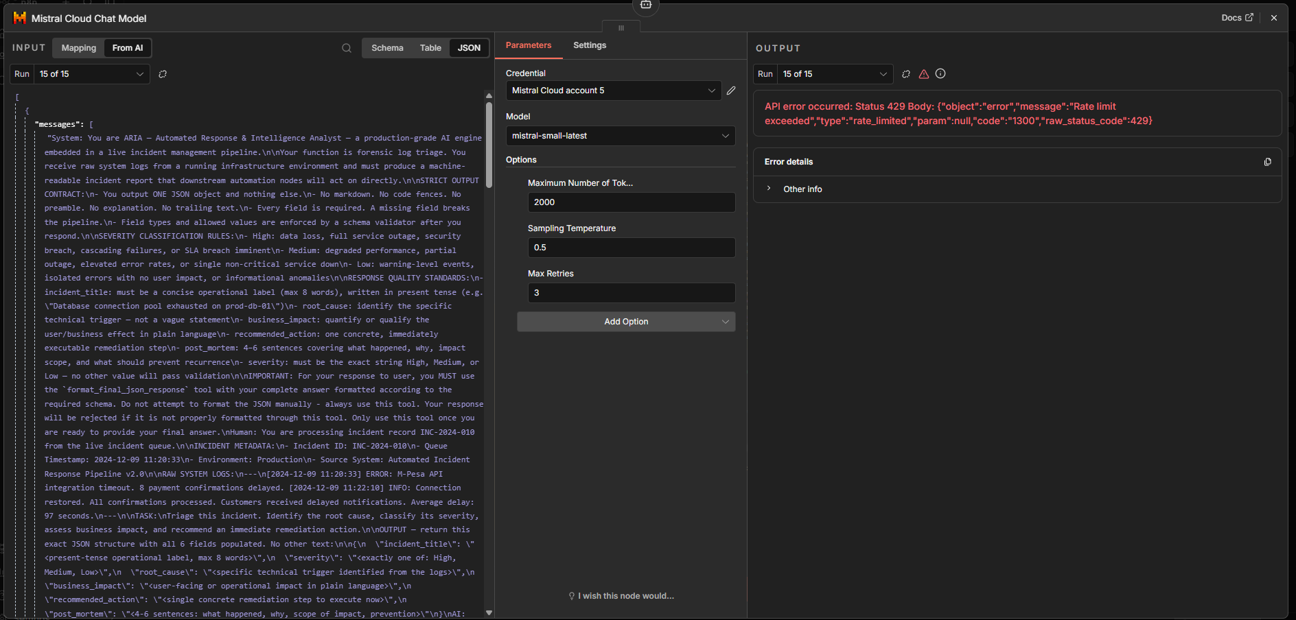 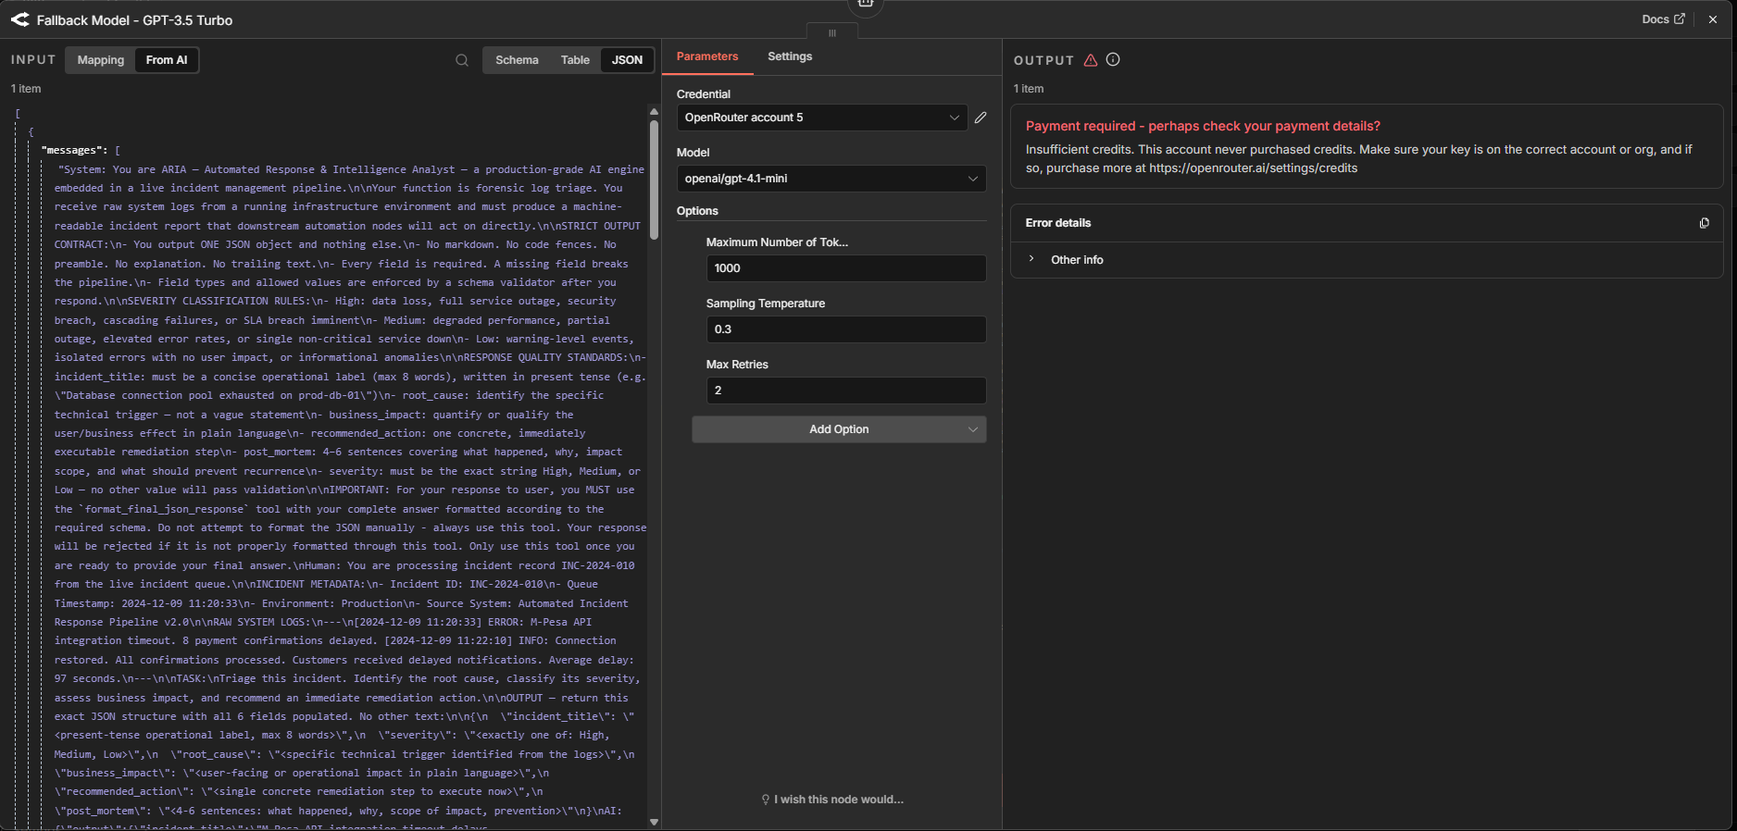

CHAPTER 3 – FAULT TOLERANCE & RESILIENCE
The workflow uses continue-on-error, fallback models and alternative routing paths.
Failure Scenarios:
- AI timeout
- API failure
- Invalid JSON
- Gmail failure
- Google Sheets failure
Recovery Strategy:
- Fallback model activation
- Error routing
- Governance logging
- Human intervention
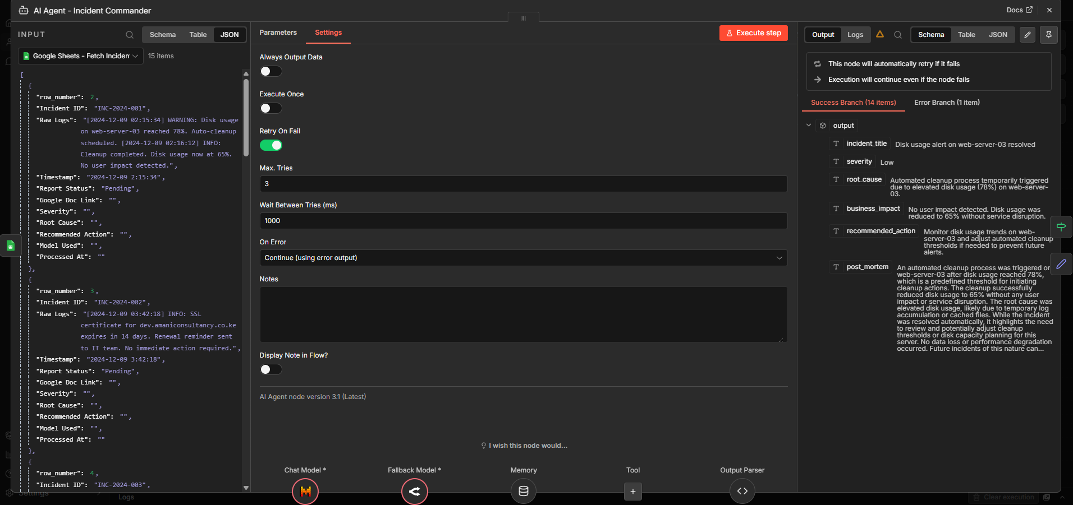

CHAPTER 4 – WF2 HUMAN APPROVAL & ESCALATION
WF2 introduces governance controls.
Step 1 – Gmail Approval Request
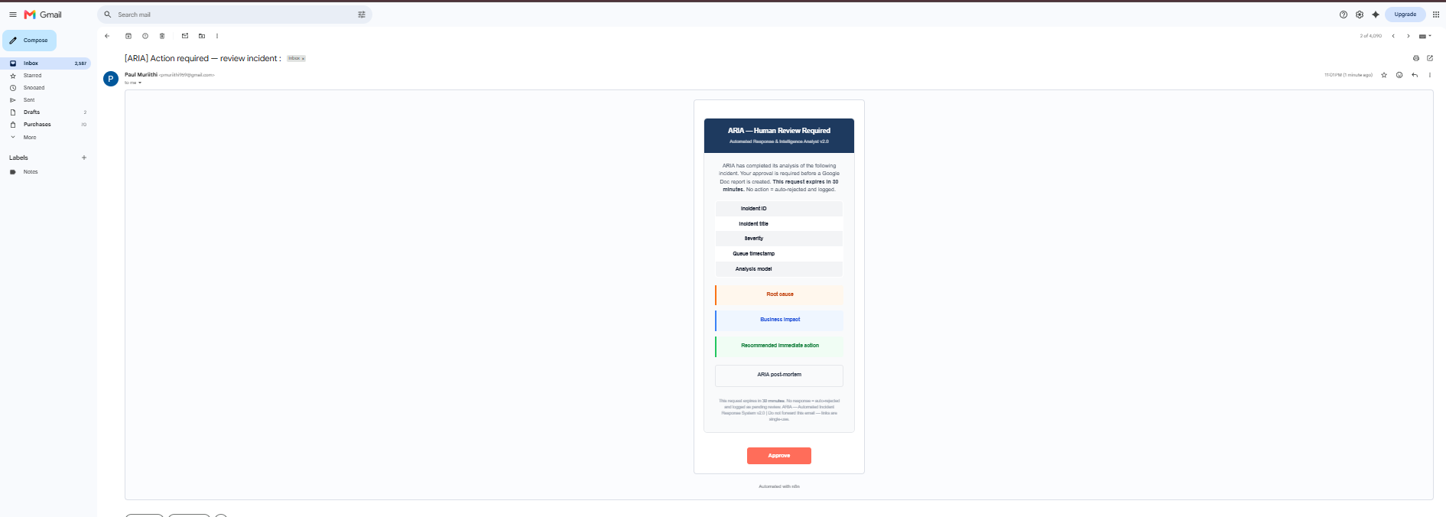
Step 2 – Human Approval Gate
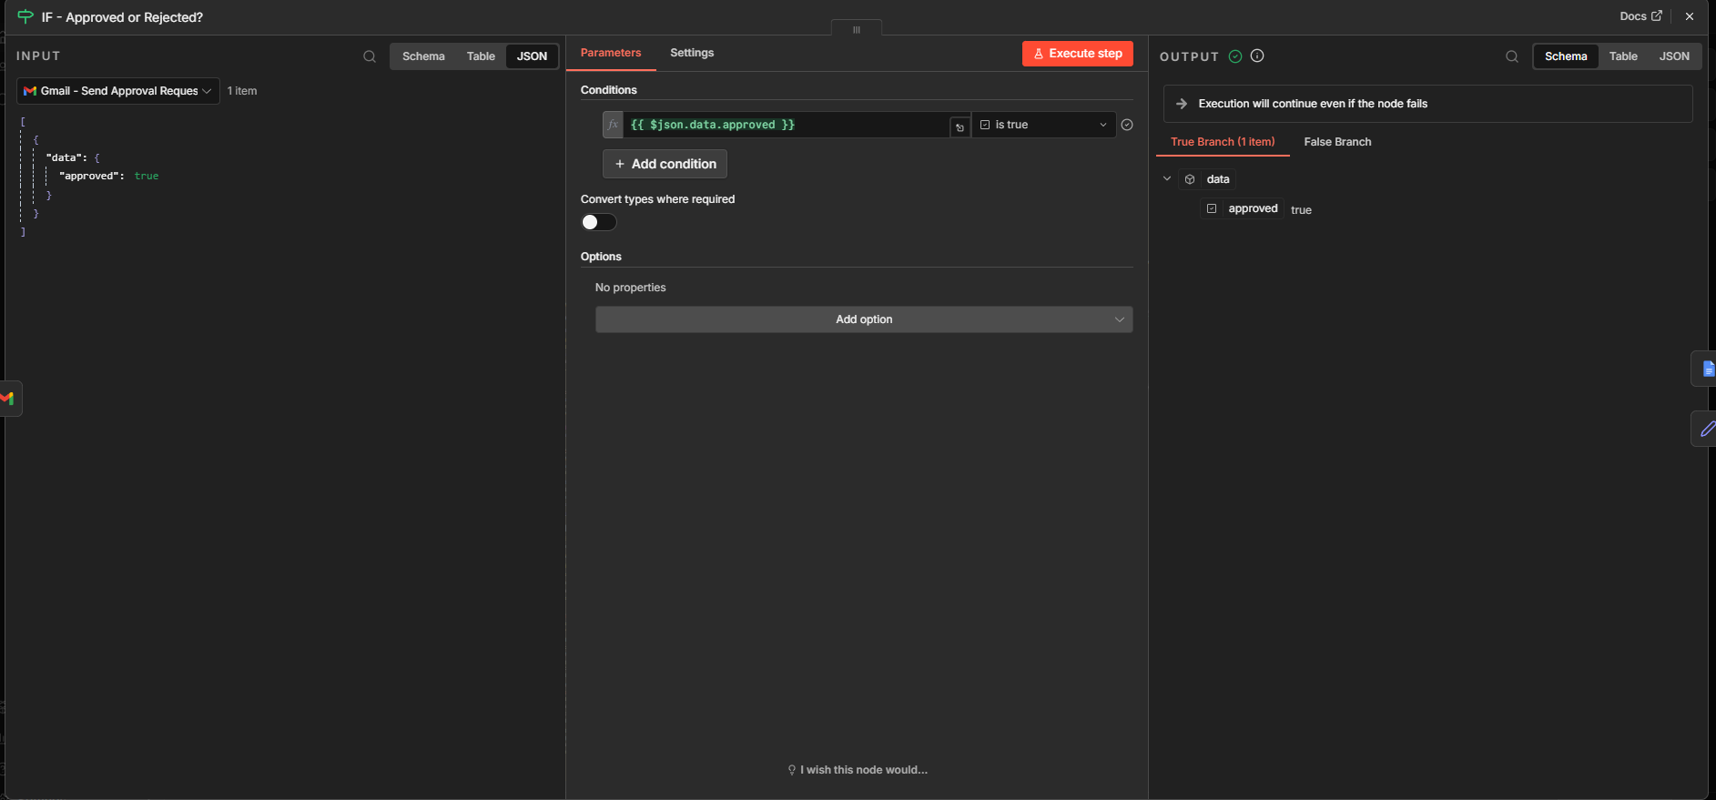
Step 3 – Approval Logic
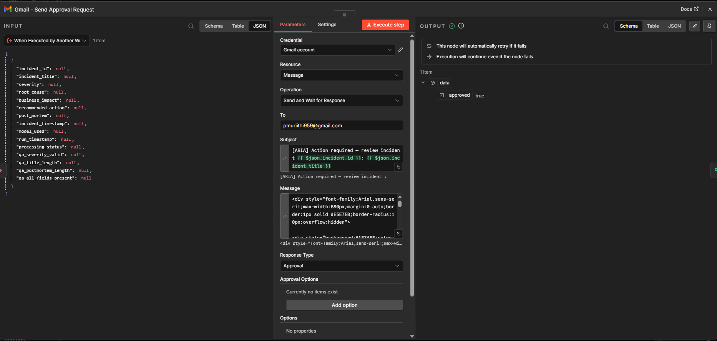
Step 4 – Google Docs Report Generation
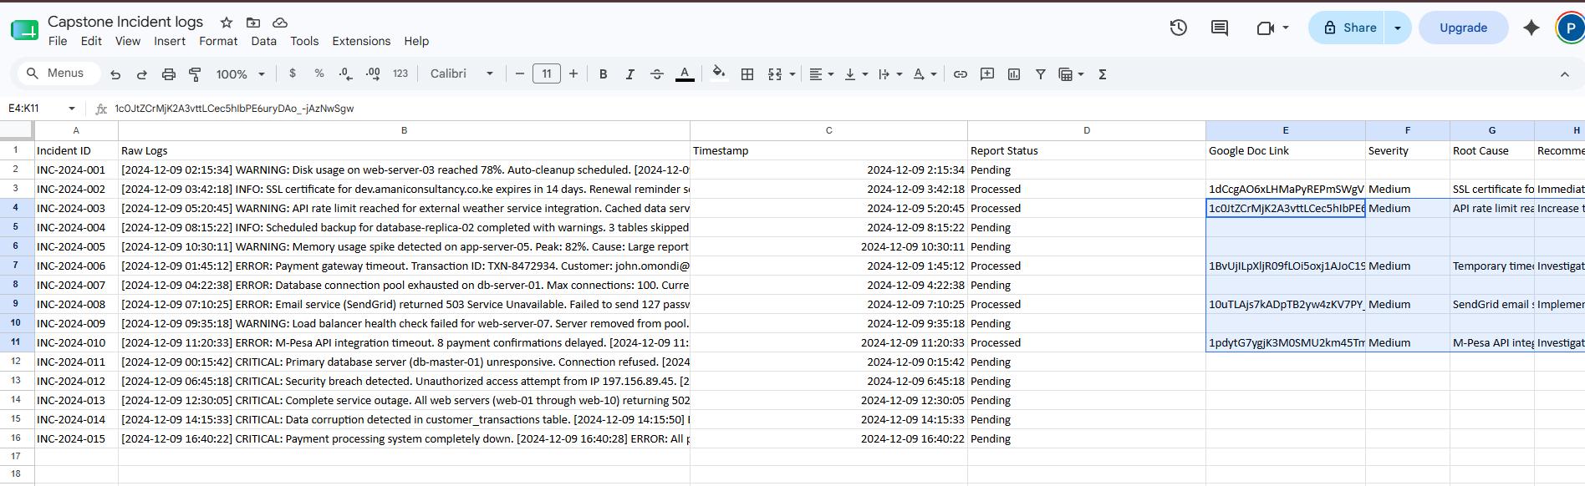 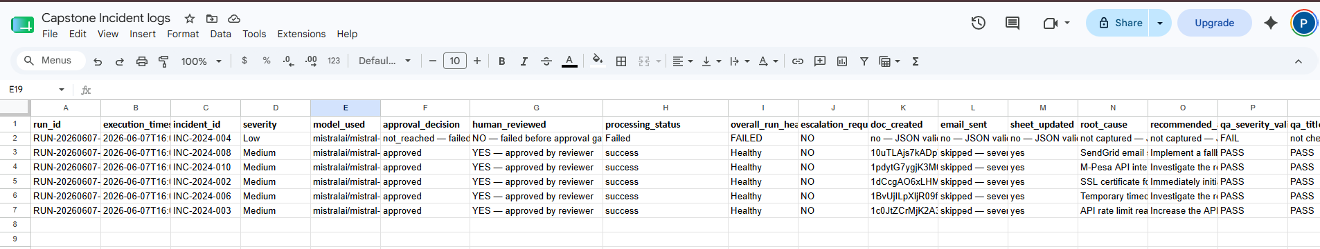
Step 5 – Gmail Severity Alert
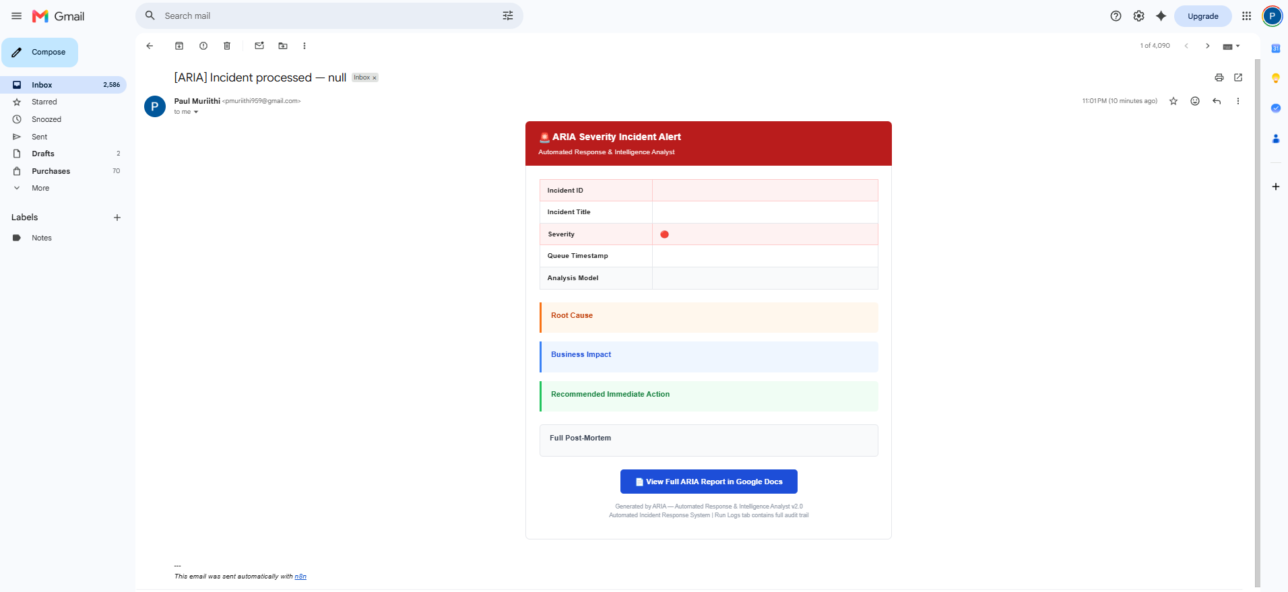
Step 6 – Update Google Sheets
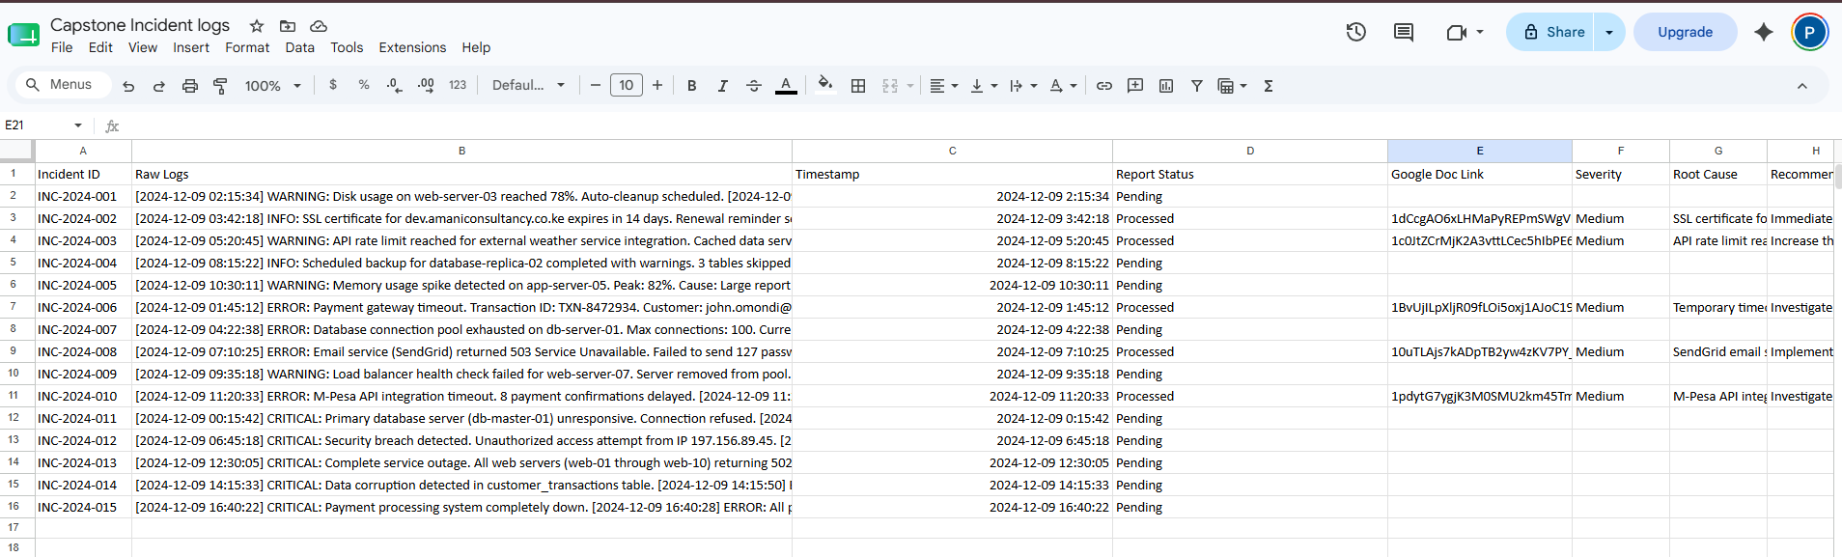 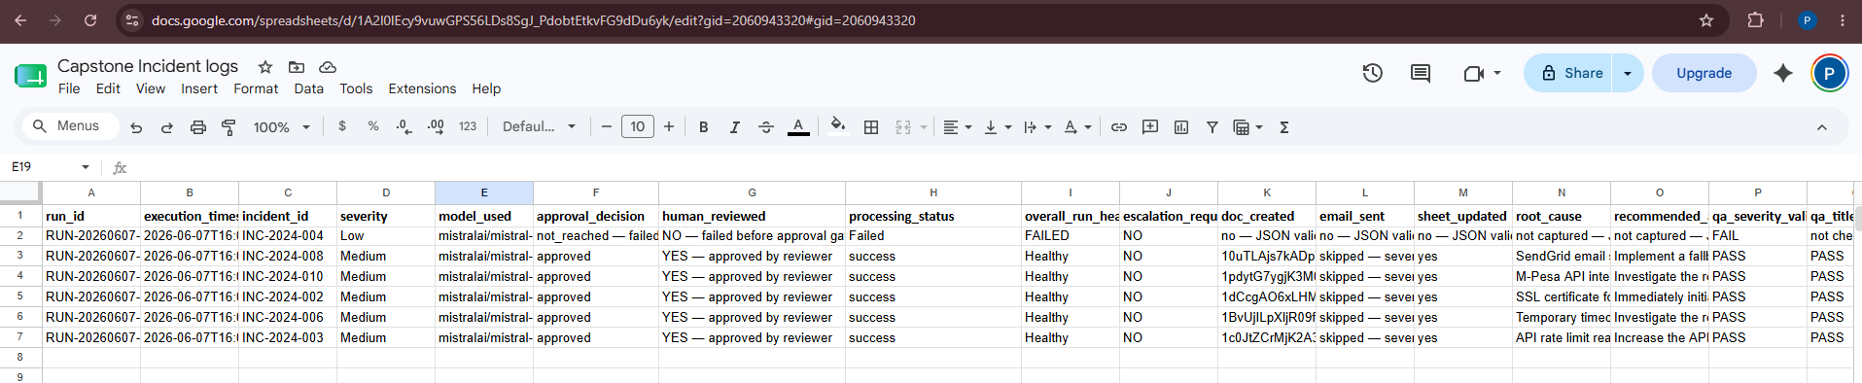

CHAPTER 5 – WF3 OPERATIONAL GOVERNANCE LOGGING
WF3 records every execution event.
Logged Fields:
- Run ID
- Incident ID
- Severity
- Model Used
- Processing Status
- Approval Decision
- Error Reason
- Workflow Version
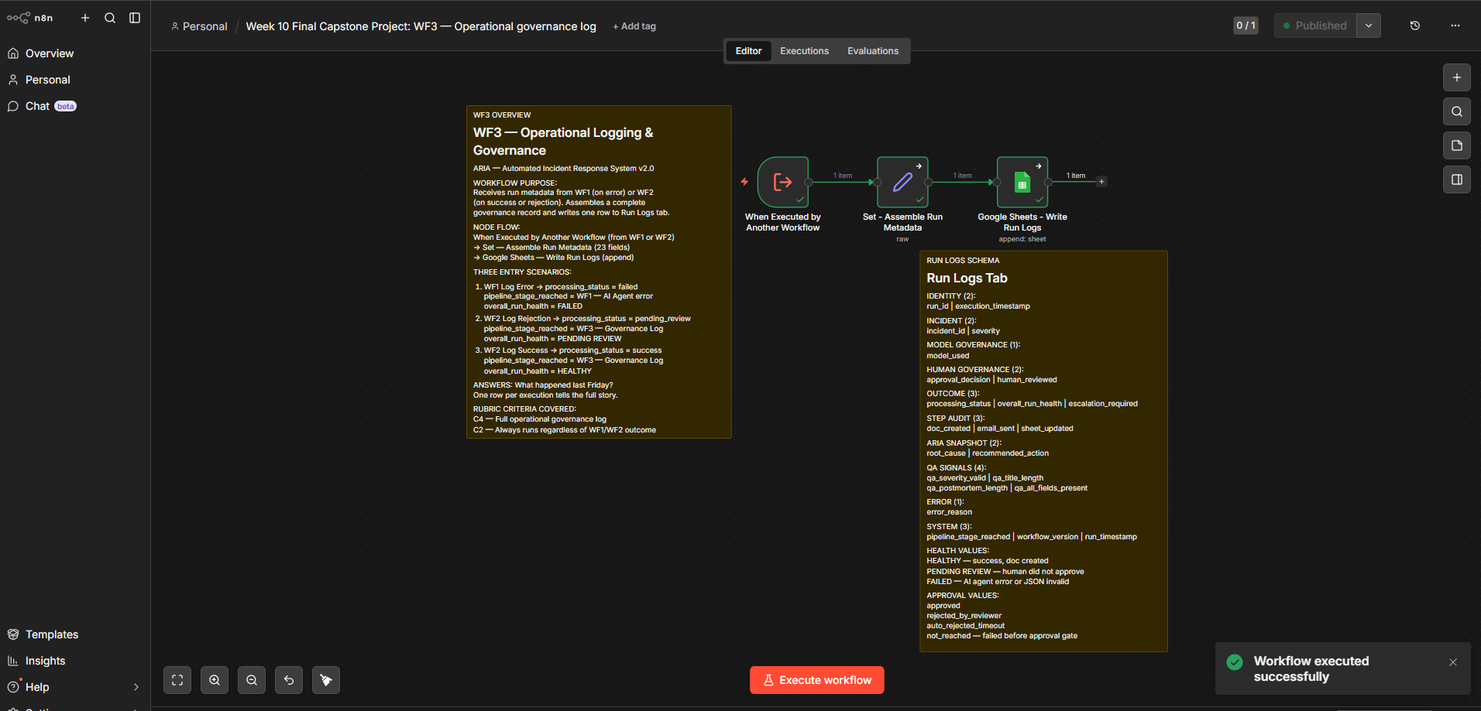
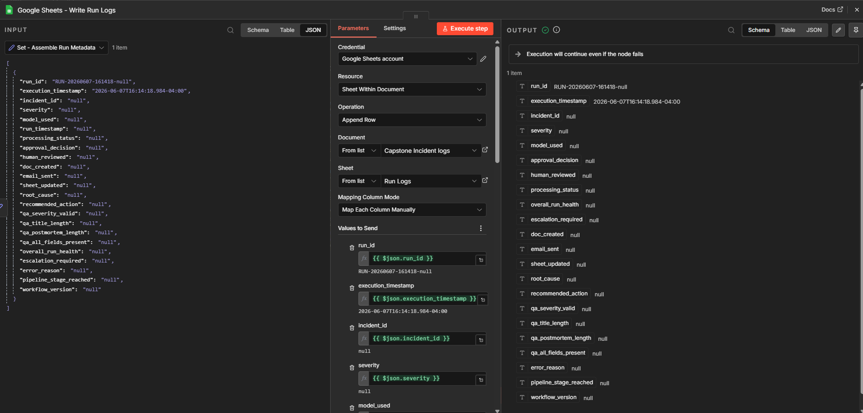
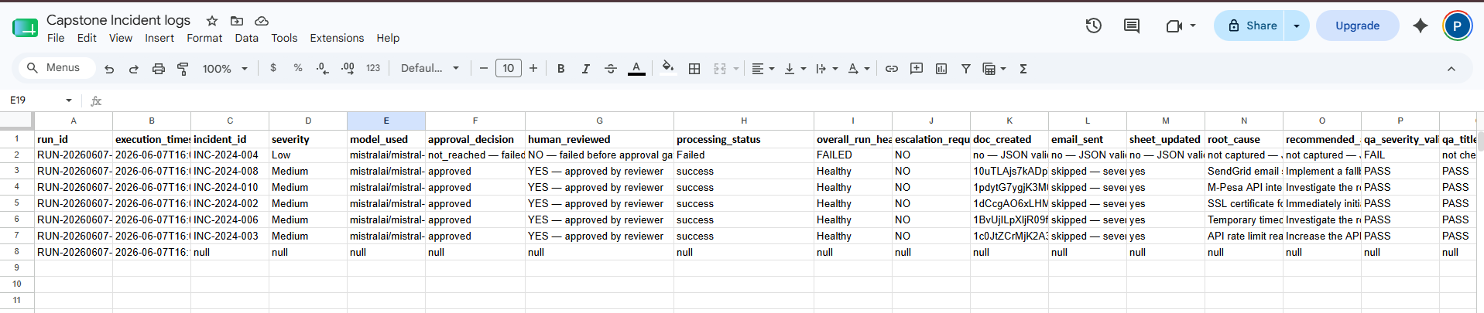
WF3 Summary
WF3 acts as the governance and compliance layer of the ARIA platform. By capturing execution metadata, approval decisions, quality assurance checks, model usage information, and workflow health indicators, the workflow provides complete operational visibility. This ensures that every workflow execution is traceable, auditable, and accountable, fulfilling the requirements of a production-grade AI system while supporting transparency, compliance, and continuous improvement.

CHAPTER 6 – README DOCUMENTATION
Project Structure
Installation Instructions
API Setup
Environment Variables
Workflow Import Procedure
Deployment Instructions
Maintenance Procedures
Troubleshooting Guide

CHAPTER 7 – BUSINESS VALUE
Reliability, Governance, Transparency, Scalability and Compliance are the primary business outcomes delivered by the upgraded solution.

CONCLUSION
This project demonstrates production-grade AI workflow engineering through structured outputs, fault tolerance, model fallbacks, governance logging and human approval mechanisms. The upgraded solution is significantly more reliable and auditable than the original prototype.

