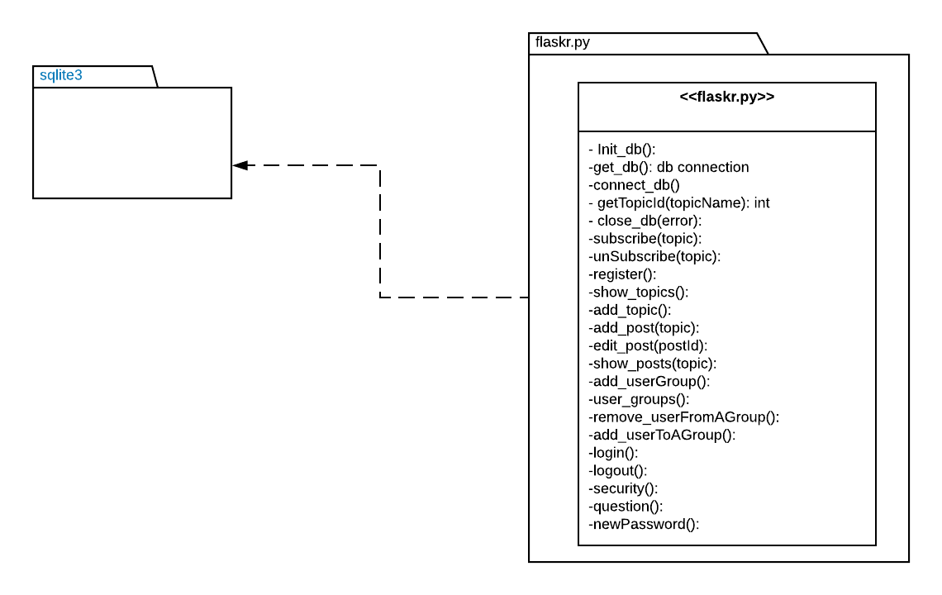The interface is basically the main interface where it calls functions from all the other intefaces, the init_db() is called to initialize the database through the flask command flask initdb, the get_db() function is called from all the other interfaces to get a connection to the centeral database, the connect_db() connects to the db which is called bu the get_db() function, the getTopicId() takes a topic name as an arguement and return that topic Id, it is used in multiple places in the interface.

The close_db(error) function takes an error as the argument if there is any and closes the database connection, the subscribe(topic) and ubSubscribe(topic) function gets the necessary data and calls the rigth function from the subscription interface, the register() login () and logout() are calling the loginInterface passing in the needed data for them, showtopic() is the home page which calls is multiple functions rom the other interfaces and gets the all the data it needs, pass it to the jinja template to use it show all the topics that the user sholud be seing.

Add_topic() is the call to add a new topic to the db, add_post() adds a new post to the database, edit post() can be only called from the user who created the post and allows editing of the post in the database, show_posts() gets the topic from the url and shows all the posts accociated with that topic, add_userGroup() calls the userGroupinterface and asks it to create a new group disccution, the user_groups(): calls in the userGroupInterface and gets the page where the used can add edit the group disccusions, add_userToAGroup() and remove_userFromAGroup(), calls the userGroupInterface calling the necessary functions accordingly to add a new user to a group or to remove one.

Finally secuirity() question() and newPassword() are the functions used to reset your password and they call the passwordReset interface to do all the work passing in the needed things.

Testing the flaskr.py is going to be directly connected to the data base because it does not have its own interface.