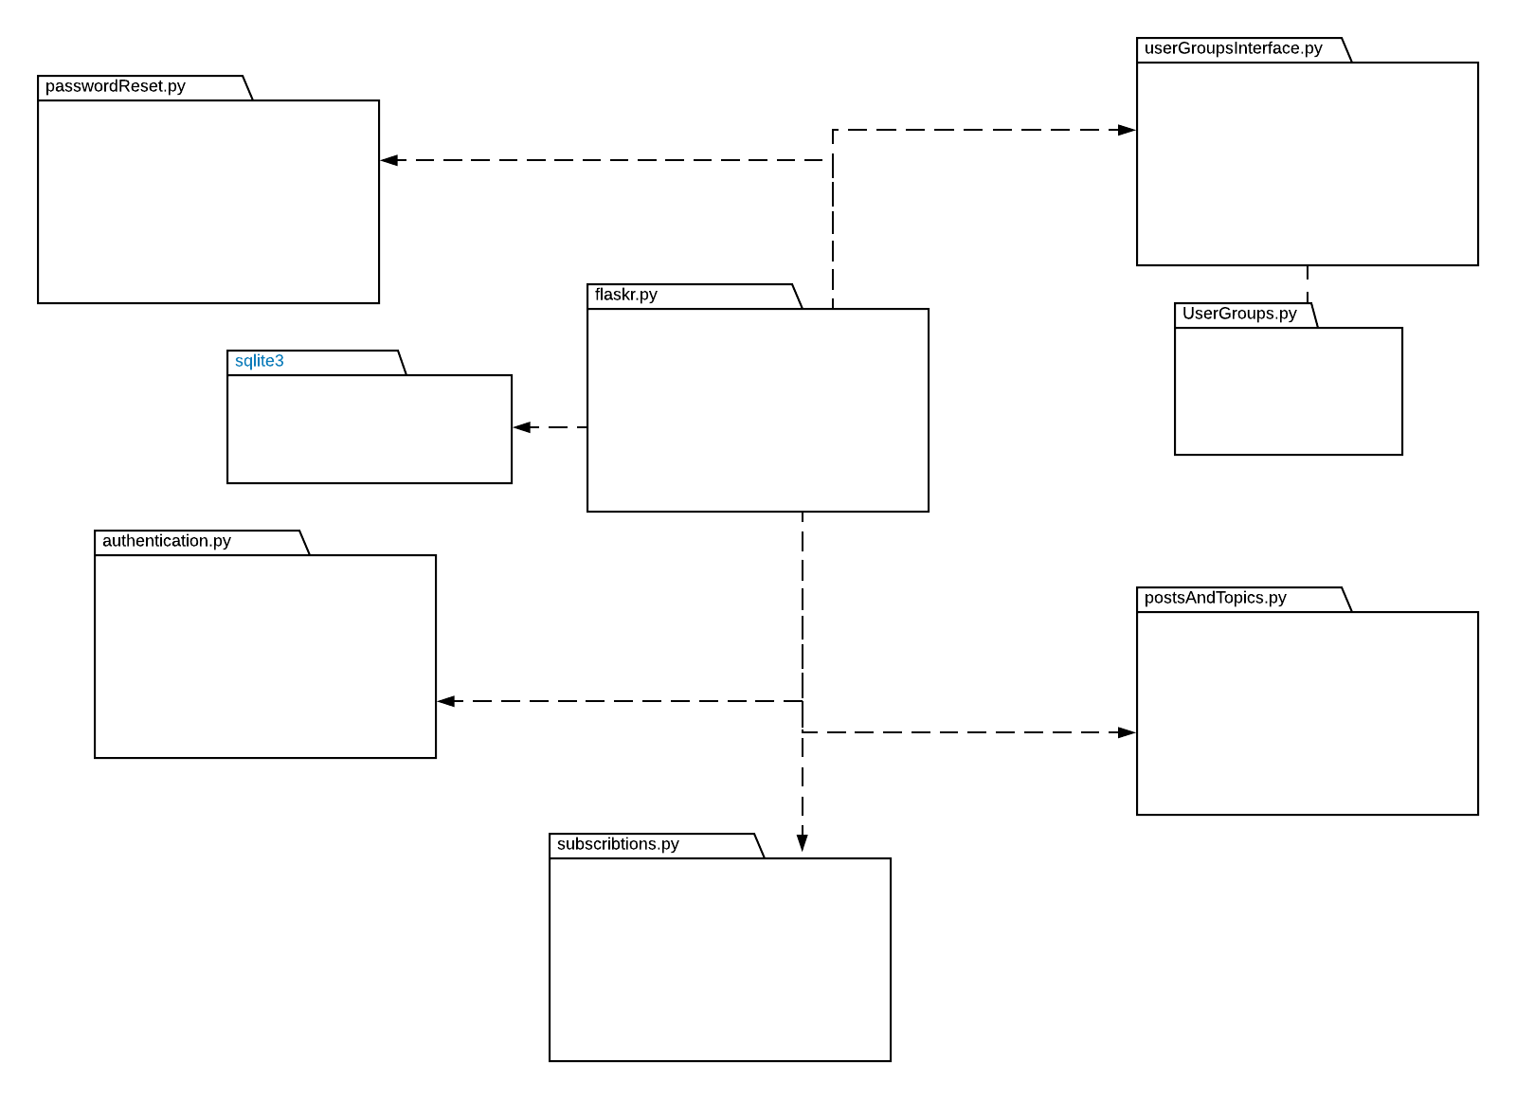Application Structure

the application will have a file that uses all the modules interfaces to make the necessary calls and get the needed data to run the application, the main file will be hooked to a data base that runs ona schema, ths schema will unclude all the tables needed for all the modules to work together.

Each interface will is related to a members code, indivdualiy they will run on dummy data, to make them completly independent, but when combined togher they will run through the data they get from the other interfaces, each interface will only interact with the main flaskr.py file and from their it will connect with the other interfaces to get the needed data.

There was no post craetion and topic creation interface because it was the centeral point of the application and all interfaces where directly going to interact with it, so instead of having it own interface we made it the main interface and have all the others talk to it.