Sicnote
Video Game
Genre:rpg, rhythm, fighting

Theme: autonomy over your actions

PRODUCTION

Characters are built using billboarding, 2D sprite art that always rotates to face the camera, instead of full 3D models. Saves a huge amount of development time over rigging and animating a 3D character for every single person in the game.
The game will have a sizeable amount of dialogue with real voice acting, friends are voicing characters for free (i will force them)and the quality will be high regardless.
Full hand-drawn animation gets used sparingly, only for the biggest emotional beats in the story. Keeps it special and actually achievable.

Exploring: 3D, fighting 2D the fighting will be sort of like a rhythm game and it will have small inconsequential minigames along the way.

Every person in this story is equivalent to a note in standard musical notation.

Some notes are granted higher power and prowess when they are born. These notes are dubbed “gifted children”. These select few individuals control the world of Sicnote, because they have a special ability to influence others decisions. This leads to the entire world being more like a puppet show for the gifted children and their whims, rather than an actual society of functional people.

Nobody knows the gifted children possess this unique ability except for the gifted children themselves.

The reason for our MCs entire plot is her finding out about this ability through a gifted that ambushed her sister talking over the phone not realising MC was listening. The gifted accidentally revealed the secret of her power.

This power shall be called tyrannical hypnosis.

The power works by sending invisible electric waves through the air to interfere with a person's neurons, inputting info that shouldn't be there and controlling their decisions.

Our MC finds an ancient top secret book about this in her attic. It talks about the real canonical history of their Sicnote world, not the lies in their school history books. It goes on and on about the actual imperial wars and the tyrannical hypnosis effect on people. It reveals to her that scribing a black sigil on her back can nullify the effects of the tyrannical hypnosis. However, this effect may only be correctly activated if it's drawn on by someone you are close with. This book is only ½ of a collection, the other book features the rest of the details.

Our MC finds a way to scribe this sigil onto her back, despite not knowing all of the details, she just knows she has to get revenge for her sister and free the world.

The other book details the effects of the sigil on the scribed person, how it slowly spreads its black ink all around giving you heightened perception and acrobatic skills and strength, that is the way the leveling system will be explained in game. It will also explain how the black sigil will slowly consume you whole and lead to your death, slowly crumbling your body away.

AESTHETIC

Make the backgrounds of every fight absolutely insane

Must be very colorful
Heavy inspiration from old vintage retro game systems, old digital media and style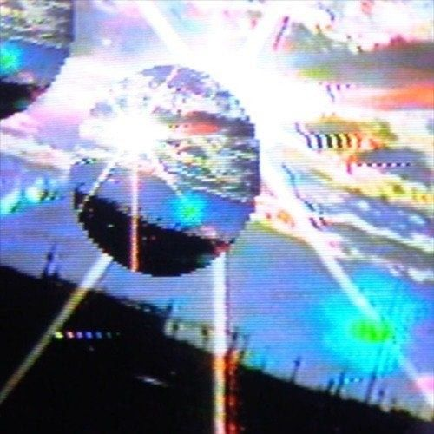
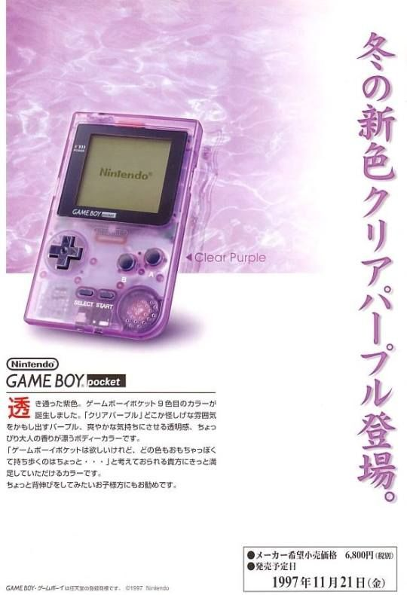

THE MUSIC:

The chapters have their own genres of music, such as: rock, hiphop, alt rock, breakcore, pop

ITEMS

Your equippable items are your outfit, they give unique charms and abilities.

CHARACTERS

Main character is a 64th note

Her name is Misa

Kind, very fast due to her nature, shyish,, misunderstood, left out, other notes dont rly like her cuz she's hard to harmonize with, very independent and doesn't really like physical touch and things like that, has red hair.

whole note = slow, lasts 4 beats

half note = 2 beats

quarter note = 1 beat

eighth = 0.5 beats

sixteenth = 0.25

thirty-second = 0.125

Sixty-fourth = 0.0625

This is why long notes are older and kinda senile and short notes are fast, characters in this universe don't age.

FIGHTING

Fighting against a fast note(32 or 64) the fight will be a rhythm game (you need an accuracy of 90% to win)
Lore about it: The way you beat a fast note is by being faster than them, that's why it's a rhythm game, being faster than them tires them out and frees them from their tyrannical hypnosis. Notes in this world are very averse to conflict and try to resolve in any way they know how that isn't violent. The mind control forces them into a behaviour that isn't theirs and when you free them, they pass out (giving up) this however does not stop them from being hypnotized again in the future.

Fighting against a note that isn't hypnotized will be a fighting game.

ENDING

The sigil's effects are what our MC's ending is built around. As it slowly consumes her, this becomes the actual ending of the game, she sacrifices herself for the betterment of the world. Since the whole game is about autonomy, her choosing this fate herself instead of letting the sigil quietly take her is the final expression of the theme.

STILL IN PROGRESS:

Wwhether her death and the destruction of the ancient monuments (below) happen as the same act or as two separate events near the end.

ORIGIN OF THE GIFTED

Being gifted comes from where you're born. There are a handful of ancient spots scattered around the world, they seem completely normal on the surface but secretly harbor power, maybe underground. Any note born on one of these spots is inscribed with tyrannical hypnosis.

STILL IN PROGRESS:

nobody in the world knows where these spots actually are. It's undecided whether or how our MC finds out, this could be revealed to her later on by someone or something, and might be a good way to pad the playtime toward the 10 hour mark.

TYRANNICAL HYPNOSIS AS AN INFECTION

Tyrannical hypnosis works less like a power someone chooses to use and more like an infection, anyone who has it WILL use it, they can't really help it. This means the gifted aren't purely evil, they're trapped by what they were born into just as much as everyone else is trapped by them.
Since it can't be cured, the only way to actually end it is to destroy it at the source, meaning the ancient monuments themselves. Doing this stops any more gifted from ever being born and frees everyone currently under the effect, restoring their autonomy for good.

EMOTIONAL AUTONOMY (SECONDARY THEME)

Autonomy in this world isn't only about being controlled from outside. Some people simply can't control their own emotions either, like someone who can't will away their sadness or depression on their own. This won't run through the main plot, it'll live in optional side content and side characters, which also helps stretch playtime toward 10 hours without bloatingdown the core story.

Fight idea

Specific fight idea: our MC fights an opponent who is fighting an emotional battle and not being controlled.The usual rhythm-fight win condition, hitting the accuracy threshold that makes the opponent pass out, doesn't trigger here. Our MC doesn't understand why the girl won't go down even after doing everything that's worked before. The fight ends when the enemy goes all out attacking, forcing our MC to switch to blocking instead of attacking. Blocking uses the exact same rhythm-timing inputs as attacking, just repurposed, so there's no need for a separate tutorial. After a few seconds of enduring the attacks without retaliating, the enemy tires herself out crying and the fight ends. Would include a fully hand drawn cutscene here too. Could double as the moment a new ally joins the group.

