Weekly Individual Plan
See the CxGuide_WeeklyIndividualPlan.doc for details on how to use this template.
Name
Period | mm/dd/yy – mm/dd/yy
Projects
Status

Miniature Milestones
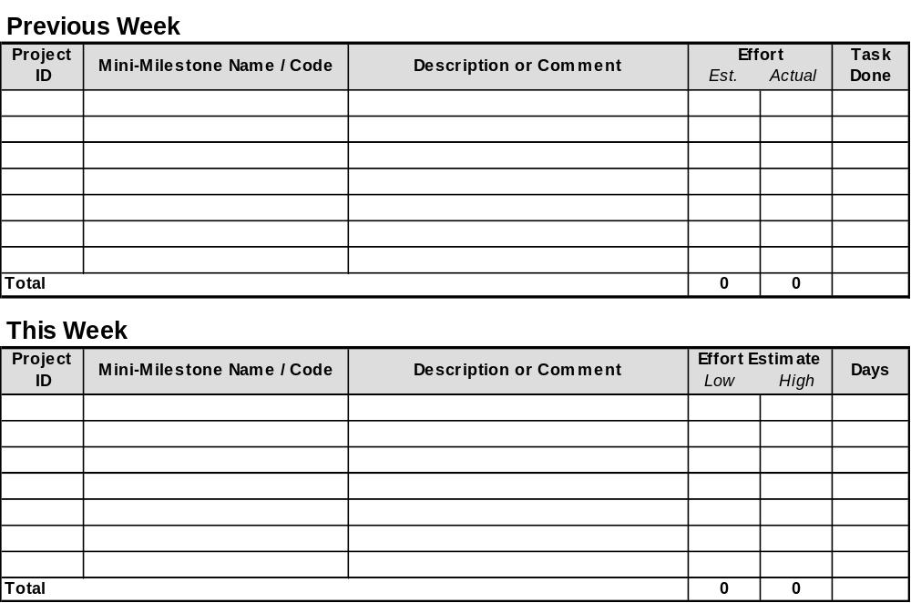

Individual Risks
Rank | Risk | Current Resolution

Near-Term Planning
Priority | Task Name and/or Description

