Project Management
CxOne Standard
0000.doc
April 18, 2003



Advancing the Art and
Science of Commercial
Software Engineering
Contents
1 Introduction 1
1.1 Overview 1
1.1.1 What is a Project? 1
1.1.2 CxOne Project Management 1
1.2 Background 2
1.3 Supporting Other Standards 2
2 CKA Organization 3
2.1 Project Management Root 3
2.2 Chartering 3
2.3 Planning 3
2.4 Estimation 3
2.5 Tracking And Control 3
2.6 Issue Management 3
2.7 Risk Management 3
2.8 Team Structure 3
3 Chartering 4
3.1 Purpose 4
3.2 Overview 4
3.3 Relationships 4
4 Planning 5
4.1 Purpose 5
4.2 Overview 5
4.2.1 Creating the Project Plan 5
4.2.2 Software Lifecycles and Project Planning 5
4.2.3 Project Plans as Models 5
4.3 Key Content 6
4.3.1 Project Plan Packaging 7
4.3.2 Groups of Project Plans 7
4.4 Project Plan Relationships 7
4.5 Reuse and the Project Plan 7
5 Estimation 8
5.1 Purpose 8
5.2 Overview 8
5.2.1 Estimates, Targets, and Control 8
5.2.2 Uncertainty in Estimates 9
5.2.3 Macro and Micro Estimation Techniques 9
5.2.4 Counting, Computing, Judging 9
5.2.5 Use of Multiple Techniques 9
5.2.6 Phased Estimation 9
6 Tracking and Control 10
6.1 Budget, Schedule, Feature, Quality 10
6.2 Key Artifacts 10
6.2.1 Work Plans 10
6.2.2 Schedules 10
6.2.3 Status Reports 10
6.3 Tracking and Control vs. CAM 10
7 Corrective Activity Management 11
7.1 Purpose 11
7.2 Overview 11
7.2.1 CAM Items 11
7.2.2 A PMBOK view of CAM 12
7.2.3 Using CAM to Manage the Project 12
7.2.4 Using Database Tools with CAM 12
7.3 CxOne CAM Materials 13
8 Team Structure 14
8.1 Purpose 14
8.2 Overview 14
8.2.1 Standard Project Positions 15
8.2.2 Custom Project Positions 15
8.3 External Project Roles 16
Copyright Notice
© 2000-2002 Construx Software Builders, Inc. All Rights Reserved.
For further information or support visit www.construx.com.

Introduction
This standard documents CxOne’s organization of project management practices, knowledge, artifacts, and materials.

Overview
Project management includes the inception, estimation, and planning of a project along with tracking, controlling, and coordinating the project’s execution. CxOne’s goal for project management is to strike an optimal balance between planning and execution.
Chartering starts the project. Planning defines the lifecycle and provides blueprints for executing the project. Estimation ensures work plans and targets are feasible. Tracking and control practices manage the planned work. Corrective activity management handles work not explicitly planned. Risk management occurs both explicitly and implicitly as part of all project decisions and activities.

What is a Project?
CxOne adopts the PMBOK’s description of a project as:
A temporary endeavor undertaken to create a unique product or service.
CxOne supports projects that include software development. Some projects will consist almost exclusively of software development, while others will produce systems in which software plays one or more roles. Project size may span from a few staff-hours to hundreds of staff-years. Software projects may support products or services to a wide variety of domains.

CxOne Project Management
CxOne defines project management as the ongoing planning and directing of work on a software project. As the diagram below illustrates, CxOne makes a broad simplifying distinction between planned and unplanned work, and assumes both must be actively managed for projects to succeed. Unplanned work represents unforeseen work or work that is not precisely or explicitly planned ahead of time (see section 6, Corrective Activity Management).
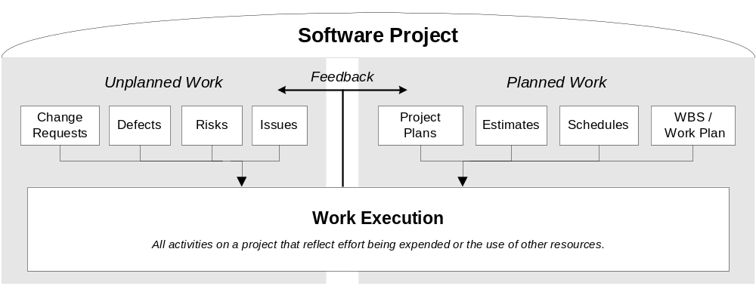
Figure 1-1: CxOne Project Work Model

Background
CxOne project management materials are synthesized from many sources including the Steve McConnell’s works, Construx project experience, PMBOK, SWEBOK, IEEE standards, other industry sources and literature. CxOne organization, terminology, and packaging of project management knowledge and deliverables provide a complete, readily scalable, and easy to use distillation of project management concepts.

Supporting Other Standards
CxOne project management materials support the following standards:

Steve McConnell’s Books
CxOne’s project management materials support the concepts of McConnell’s Software Project Survival Guide and Rapid Development.

Rational Unified Process (RUP)
CxOne project management materials are compatible with the project lifecycle, concepts, and methods defined by Rational’s Unified Process.

Agile Movement (including Extreme Programming - XP)
CxOne principles and materials may be employed to bolster projects utilizing Extreme Programming or other techniques typically associated with “agile methodologies”.

CMM and CMMI
CxOne project management materials provide value to organizations at any level of the CMM and CMMI (staged). If you are at CMM levels 1 or 2, these materials provide a framework for getting projects to CMM level 3 and higher. If using CMMI (continuous) see 15504.

ISO/IEC 15504 (SPICE)
CxOne project management materials provide value to organizations at any level of 15504 management practices. CxOne provides a framework for level 3+ performance in the management process category (MAN).

PMBOK
CxTemp_ProjectPlan supports the knowledge areas and processes of the PMBOK.

SWEBOK
CxTemp_ProjectPlan and CxTemp_ProjectCharter cover the SWEBOK’s project management areas.

IEEE Software Standards
CxTemp_ProjectPlan supports IEEE 1058 Software Project Management Plan and IEEE/EIA 12207 (also ISO/IEC 12207) Software Project Lifecycle standards.

DOD-178B
CxOne materials support management of projects for creation of level A software.

CKA Organization
Project management is a deep area of CxOne This section provides a brief overview of the project management folders in the project management sub-CKA.

Project Management Root
The Project folder is the root for all CxOne management materials focused on project management (as opposed to external or organizational management).

Chartering
Starting a project, focused on the project charter. See section 3 for more details.

Planning
Includes project plan materials along with business schedule, WBS, and other top-level planning support. See section 4 for more details.

Estimation
Materials supporting estimation activities and artifacts.

Tracking And Control
Tracking and control of a project’s planned work. Includes work planning, detailed scheduling, earned value management, and status reporting materials. See section 6 for more details.

Issue Management
Materials to support management of unplanned project issues. See section 5 for more details.

Risk Management
Risk management is CxOne’s central project management activity. Most risk management in CxOne is intrinsic, i.e., performed as part of other processes. Materials to support extrinsic project risk management are contained here. See section 5 for more details.

Team Structure
A defined team structure provides efficient staff collaboration. CxOne provides a template for project team structure and detailed checklists for different project roles. See section 8 for more details.

Chartering
The project charter is used to incept and define a project, control project inception activities, and delegate authority to execute a project.
This section provides an overview of CxOne project charter concepts and terminology. For more information, see the CxOne chartering materials and CxOneTermsAndAcronyms.

Purpose
Inception can be a long, poorly defined, and inefficient phase of a project. McConnell coined the phrase “fuzzy front end” to describe the period between a project being an idea in someone’s head, to being truly staffed and underway. Time and other resources lost at the front of a project are just as valuable as those lost at the end. Refining project inception can be a huge win for reducing overall project schedules.
The project charter provides a vehicle to move a project through the fuzzy front end as efficiently as possible.

Overview
CxOne defines the start of a project as the creation of the project charter. The creation of the charter is usually an iterative process that involves starting some project work to investigate opportunities, explore risks, test feasibility, and create initial plans. Although the charter is a living artifact that should be updated as necessary during the project, there should be a clear point at which the charter phase is considered complete and the actual project begins.
See CxGuide_ProjectCharter and other CxOne chartering materials for more details.

Relationships
During the charter phase, work will often occur to start drafting a project plan along with work on requirements and feasibility prototyping. Often several refinements of a project charter are necessary to refine the business case, build consensus among stakeholders, and win approval for the project.

Planning
CxOne provides materials for creating project plans and supporting artifacts such as estimates, work plans, schedules, and other specific plans.
This section provides an overview of CxOne project planning concepts and terminology. For more information, see the CxOne planning materials and CxOneTermsAndAcronyms.

Purpose
Project planning defines how a project will accomplish its goals. This includes defining the details of those goals (i.e., schedule, budget, feature, quality, etc.), mechanisms for planning, tracking, and controlling project work, as well as details of how the work will be carried out (i.e., lifecycle, staffing, technical processes, etc.).

Overview
The term project plan refers to the root artifact from which all other project planning flows. A project plan is often a document, and will often delegate detailed descriptions to other artifacts (e.g., a project plan with references to a CM plan, quality plan, business schedule, etc.). The term “project plans” is often used to refer to the project plan, schedules, work plans, supporting plans, and any other planning artifacts as a group.

Creating the Project Plan
CxOne requires that a project plan be created, that it is a living plan, and that the plan matches the reality of the project. There is no cookie-cutter for creating project plans; the precise nature and content of project plans can vary widely between projects. CxOne defines the areas a project plan needs to cover to ensure project success. CxTemp_ProjectPlan and supporting materials guide the creation of your project’s planning blueprint.

Software Lifecycles and Project Planning
Software development lifecycles are closely intertwined with project planning. CxOne defines standard project lifecycles in the process CKA. The selection and customization of lifecycles for projects is part of project management.

Project Plans as Models
A model is an abstract representation of a problem space. Modeling is used implicitly in many software activities, and often used explicitly in requirements and design. CxOne encourages explicit consideration of modeling when addressing project management challenges. One of the ways to think of project planning is the creation of models that will be used to understand and control the project.

Key Content
The key elements of a project plan are shown below. “Software Development Plan” is often used as a synonym for “Project Plan” on software focused projects.
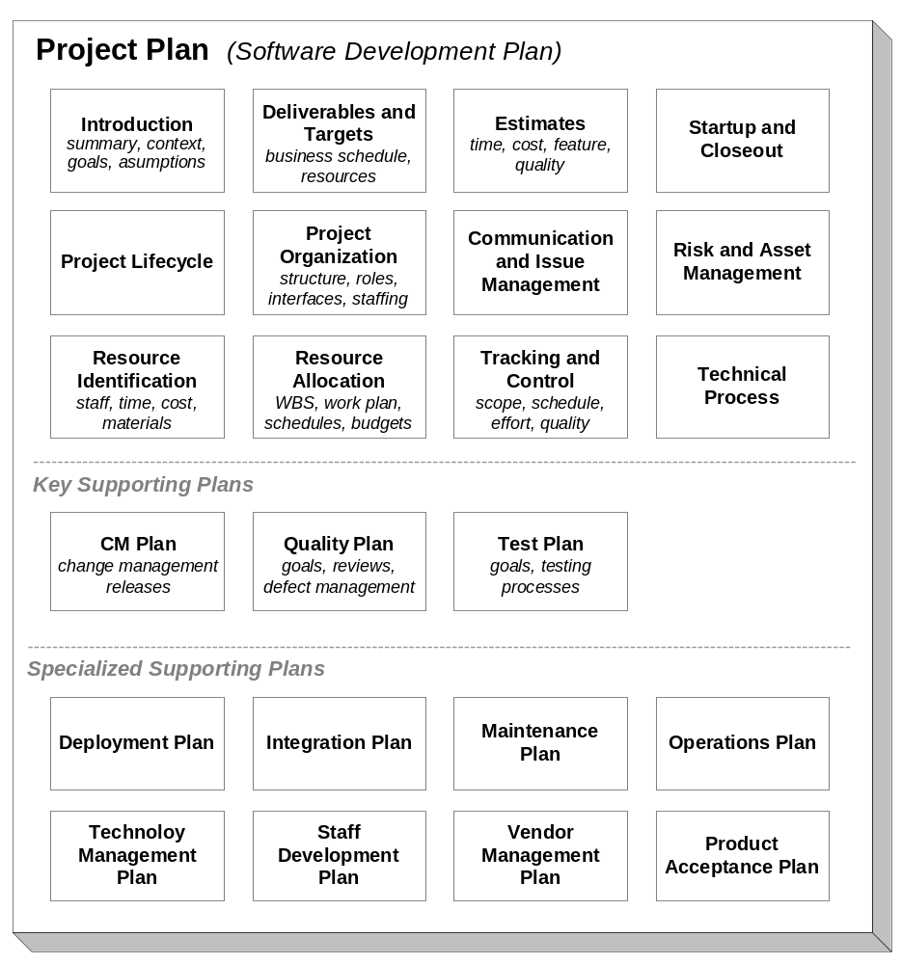
Figure 4-1: CxOne Project Plan Content
CxOne requires that the areas shown in Figure 4-1 be addressed by project planning.
Due to the varied needs of projects, the precise content, level of detail, organization, presentation, and packaging of a project plan is not dictated by CxOne. Rather a set of tools are provided that support creation and execution of project plans. Projects should aggregate, repackage, adapt, and extend CxOne planning materials to best meet their needs.

Project Plan Packaging
Depending on the nature and scope of a project, the content of a project plan may be contained in one or many documents. The top half of the project plan structure diagram indicates elements of a project that are usually part of the project plan itself. The bottom half (boxes with the word “plan” in them) indicate subjects that normally have stand-alone plans created.
The smallest projects (several staff days or less) may have a single page document covering all aspects of project planning. Very large projects (20 staff years or more) may capture planning in many artifacts. Most projects will have a balance between these two extremes.

Groups of Project Plans
Projects may be decomposed into a hierarchy or web of subprojects, creating a hierarchy or web of project plans. A project plan should clearly describe its relationship to any other peer-, parent-, or child-projects.
Plans should avoid content duplication and must be consistent with each other. Groups of projects are often organized into a hierarchy. When traversing down a hierarchy the detail should increase. Higher level plans should summarize the plans below them. In a web structure, links between projects should be made clear.

Project Plan Relationships
Project planning flows directly from the project charter. Planning is often begun as part of the chartering process. The charter ultimately defines the scope, goals, and resources for a project. Plans provide a detailed description of how the charter is to be executed.
All project artifacts should be traceable to and in sync with the project plan. Project artifacts should not duplicate, but may elaborate on, information in the plan.

Reuse and the Project Plan
In organizations with mature, stable, and well understood processes, project planning can leverage significant reuse when defining how work will be executed. As an example, in organizations utilizing CxOne, project plans can refer to CxOne materials for descriptions of technical and managerial processes, focusing on detailing the unique aspects of the project.

Estimation
Estimation is predicting future characteristics or outcomes from current information. Estimation capability may be improved by improving estimation techniques, improving current information, and improving how estimates are used. CxOne provides support for all three of these improvement paths.
This section outlines some key CxOne estimation concepts and terminology. For more information, see the CxOne estimation materials and CxOneTermsAndAcronyms.

Purpose
Software estimation is used to determine the resources (usually time and effort) necessary to produce a given functionality or to determine the amount of functionality that can be produced given fixed resources. These predictions allow creation of plans, validation of feasibility, setting of tracking and control baselines. Solid estimates are critical to successful management of all project phases. Mature estimation practices allow organizations to become very sophisticated at managing their feature, budget, schedule, and quality.

Overview
Accurate estimation is a challenge for software projects. Estimation affects and is intertwined with many aspects of projects, from the most detailed technical level (e.g., how much code will do X) to the broadest managerial level (e.g., how to best convey a realistic delivery schedule to the CEO). There are many practices related to estimation. Many work well, but some of the most commonly used practices are ineffective.
Creating estimates involves probabilistic modeling. Thinking of estimates as models reinforces that estimates are approximations, that multiple views of an estimate increases confidence in its accuracy, and that an estimate is only as good as the information used to create it.
CxOne defines several fundamental ideas for estimation. Estimates must be differentiated from targets. Estimates will always involve uncertainty. CxOne separates software estimation practices into two broad categories, project estimates and task estimates. Within these two categories there are a set of overlapping practices that CxOne recommends using for various estimation challenges. To apply these practices, CxOne advocates phased estimation.

Estimates, Targets, and Control
Projects usually have both estimates and targets, and the two are often confused. An estimate is a prediction of what is possible or likely. A target is a management goal used as the basis for control. The statement “project A must cost no more than X and be delivered by Y” may be a valid business target, but is not an estimate; it is a constraint on the project. Estimates should be used to set realistic targets and are part of the process of managing to targets, but they need to be clearly differentiated from targets.
Scheduling is time-focused control activity that is often confused with estimation. Schedules are a detailed plan for controlling project work to meet targets. Good schedules are derived from estimates, but are not themselves estimates.

Uncertainty in Estimates
Estimates seek to predict the future. By definition the future is unknown. CxOne requires that estimation practices must account for uncertainty. Handling uncertainty is integrated into CxOne and includes practices such as, treating estimate values as ranges or associating values with probabilities, differentiating between precision and accuracy,* using multiple estimation techniques, and modifying techniques as context changes (see Phased Estimation below).

Macro and Micro Estimation Techniques
Macro estimates are aggregate size, effort, time, budget, and quality predictions dealing with an entire project or significant part of a project (also called project estimates or top-down estimates). Micro estimates are size, effort, and/or time predictions for tasks that an individual or small group will execute (also called task estimates or bottom-up estimates). Macro estimates are normally created at the whole-project level, whereas micro estimates are normally created at the task level. Macro estimates provide the foundation upon which lifecycle, managerial, and technical processes chosen in the project plan are based. Micro estimates support the management of detailed project work, and can be rolled up into macro estimates.

Counting, Computing, Judging
The less an estimator actually has to estimate (or judge), the more accurate the estimate is likely to be. The Construx estimation approaches emphasize counting work products that can be counted (such as lines of code, function points, use cases, etc.), computing from calibrated data for items that cannot be counted, and using the estimator’s judgment only as a last resort.

Use of Multiple Techniques
Expert estimators typically use multiple techniques to estimate the same item, and then look for convergence or spread among the results of the different techniques.

Phased Estimation
Phased estimation is an estimation strategy that mitigates many risks caused by the cone of uncertainty. Phased estimation utilizes different estimation techniques during different phases of the project. This allows projects to optimize their estimates to their realities, i.e., that less detail is available early in the project than is available later in the project. Typically, macro techniques are used early in a project, and micro techniques are used later. On small projects, micro techniques may be used exclusively. See CxBest_PhasedEstimation for more details.

Tracking and Control
The term tracking and control refers to techniques, practices, and activities that provide visibility into the state of a project and ensure that it proceeds according to plan. This section discusses key CxOne tracking and control concepts.

Budget, Schedule, Feature, Quality
Effective project management requires tracking and control in four dimensions:
Budget. The cost of the project, often managed as staff effort.
Schedule. The timeline for project activities and deliverables.
Feature. What and how much system functionality will be delivered.
Quality. The extent to which work and deliverables meet project and system goals.
Most project success criteria depend on balancing these four dimensions. Not managing in all four dimensions simultaneously creates serious risk to project goals.

Key Artifacts
Key tracking and control artifacts are listed below. Project plans and estimates are key inputs, providing the baselines against which projects are planned and tracked.

Work Plans
CxOne work plans capture the decomposition of project work along with effort estimates and earned value tracking based on that decomposition. See CxGuide_EarnedValueWorkPlan and CxTemp_EarnedValueWorkPlan for more details.

Schedules
CxOne business schedules define targets to be managed to. CxOne detailed schedules map the work plan onto calendar time and are used to manage staff allocation, fine-grained dependencies, and the project’s critical path.

Status Reports
Status reports summarize and disseminate the state of a project.

Tracking and Control vs. CAM
Tracking and control manages planned work. Corrective Activity Management (CAM) manages unplanned work. Unplanned work includes unexpected work, work related to manifested risks, defects, or changes, and work at a smaller-grain detail level than project plans.
As discussed section 1, the line between tracking and control and CAM is blurred and varies depending on a project’s context and practices. CAM details are discussed in the next section.

Corrective Activity Management
Not all work on a project can be foreseen or precisely planned. Corrective Activity Management (CAM) captures the common elements of managing the unplanned work resulting from change requests, defects, risks, and issues. Construx developed CAM to provide a single lightweight model to manage work arising from these different sources, maximizing reuse and efficiency. The term CAM is unique to CxOne.
This section provides an overview of CxOne CAM concepts and terminology. For more information, see CxPattern_CamDatabase and CxOneTermsAndAcronyms.

Purpose
Corrective activities are the actions required to assure alignment of project planning with project performance and project goals. Corrective activity management synchronizes actual performance with planned performance or vice versa. It also ensures that the project activities and planning are in sync with stakeholder goals.
As shown previously in Figure 1-1, corrective activities represent work (or potential work) not defined in the current plan. We use the term “unplanned” as a convenient way to refer to this work, but that term is a simplification. The key idea is that the work must be addressed for the project to be successful and that the details necessary to track and control the work are not explicitly defined in the work plan, although buffers may be allocated for it.
Where line between planned work (using work plan and schedules) and unplanned work (CAM) is drawn is part of project planning. This decision is heavily influenced by lifecycle, project size, and management style.

Overview
Change management, defect management, issue management, and risk management are corrective activities. CAM is CxOne’s model for managing project work arising from change requests, defects, issues, and risks.
The processes and tools for managing these four corrective activities share significant commonality, which is why CAM was developed. CAM does not imply that these four items are the same or that all aspects of managing them can or should be handled through CAM. Rather, CAM is a useful abstraction for tracking and controlling these items.

CAM Items
CxOne models corrective activities using the following common classifications:
Classification | Description
Change Requests | Potential modification of planned feature, schedule, or budget.
Defects | Product or artifact not matching requirements or goals. Rework.
Issues | Unplanned work that will impact the project if not addressed.
Risks | Something that could happen that will negatively impact the project.

A PMBOK view of CAM
The PMBOK discusses the five project management process groups shown below:
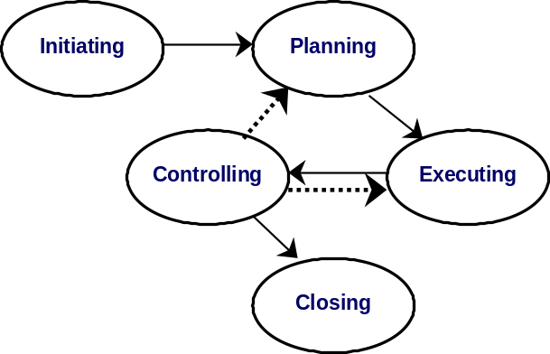
Figure 5-1: PMBOK Project Process Model
Executing processes carry out the plan defined by planning processes. Controlling processes monitor and measure progress, identify any variances or risks (either with the plan or with the stakeholders view of whether project goals are being met), and initiate corrective action.
Corrective activity management is represented by the dotted lines flowing out of the controlling process group. To align the goals and performance, corrective activities can either update the plan or affect execution. CAM consists of ensuring that all corrective activities are efficiently defined, communicated, tracked, executed, and verified.

Using CAM to Manage the Project
The amount of unplanned project work is controlled by the lifecycle and project management practices. Depending on the breadth and depth of planning, much of a project’s work may be managed through CAM mechanisms. In general the larger and more complex a project, the more detailed planning should be. Small informal projects with evolutionary prototyping lifecycles may utilize CAM for the majority of their project management. Larger, more formal projects will utilize CAM to handle exceptions to planning.
The depth of CAM detail on a project should be balanced by diminishing returns from excess overhead. For example, defects that are self-identified and fixed immediately would normally not be captured as CAM items. Many day-to-day issues that crop up and are resolved do not need to be tracked by CAM mechanisms.

Using Database Tools with CAM
Due to the number of details to be tracked, database tools often facilitate the management of CAM items. As an example, most projects use defect tracking databases, which often expand to handle items that aren’t really defects but have a similar management lifecycle. CxOne abstracts commonality from the different CAM activities into a single parent pattern, CxPattern_CamDatabase. Specifics related to the management or database configuration for each of the four CAM types are provided in specialized patterns. CAM is designed to allow a combination of one or more databases to track items and assumes very basic tool support, so projects can optimize processes to their needs and available tools.

CxOne CAM Materials
CxPattern_CamDatabase provides general details about CAM implementation. This pattern provides the core details about setting up a database tool and surrounding processes to manage identified change requests, defects, risks, and issues.
Each type of CAM activity has unique specialization of the general CAM database pattern and other materials associated with it. These can be found in the following locations:
Knowledge Area | CKA Location
Change Management | ConfigurationManagement/ChangeManagement
Defect Management | Quality/DefectManagement
Issue Management | EngineeringManagement/Project/IssueManagement
Risk Management | EngineeringManagement/Project/RiskManagement

Team Structure
The staffing structure of a project, defined by roles and responsibilities, provides guidance for how people will carry out project work. This section provides an overview of CxOne roles and responsibilities concepts and terminology. See the materials in the roles folder for more details on specific roles.

Purpose
Ultimately software projects boil down to people working together to complete tasks. When groups of people work together on complex endeavors it is useful to decompose work and ensure there are clear points of responsibility for critical aspects of work.

Overview
The diagram below describes CxOne positions for a typical software development project. These positions are commonly referred to as “hats”. On smaller projects, engineers wear multiple hats and often will perform work as an engineer for other leads even if they are wearing a lead hat. Even on a two (or even one!) person project, calling out these responsibilities and using them to force thinking from different perspectives can be useful.
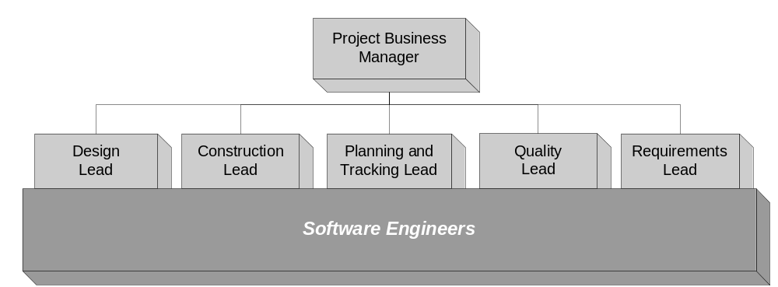
Figure 6-1: Project Team Structure
The responsibilities for managing work are split between a group of technical leads and the project business manager (PBM). Using an analogy with the movie industry, the PBM can be thought of as the producer (handles business issues), and the group of technical leads can be thought of as sharing the duties of a director (handles technical execution).
Front-line work on the project is carried out by a pool of engineers. Depending on the project and organization, this pool may be a group of cross-trained people that share responsibilities, or specialists may be provided from different areas to work under specific leads.

Standard Project Positions
The following roles are considered the nominal oversight structure for a project. If a project has specific needs for technical leadership in other areas, project business managers should create specific lead positions for the project’s needs (see next section).
Standard Project Role Description
Position | Responsibility
Project Business Manager | Responsible for successful business outcome of the project. In charge of project staffing, acquiring resources for the project, personnel issues, top-level work assignments, and stakeholder interaction.  Is the top decision maker on the project, but normally defers technical decisions to the appropriate technical lead. Resolves disputes between project participants. Responsible for coordinating the activities with the stakeholders, project sponsor, and project reviewers.
Planning and Tracking Lead | Directs overall flow of technical work on the project. Directly responsible for project planning and overseeing the execution of work breakdown, estimation, scheduling, and tracking.
Requirements Lead | In charge of eliciting, defining, maintaining, and tracing detailed product requirements. If necessary, separate sub-leads for UI design, documentation, and other areas may be assigned.
Quality Lead | Plans and directs all quality assurance and quality control activities including reviews and testing. Sub-leads may be assigned as appropriate.
Design Lead | Responsible for the system architecture and overseeing design activities. As appropriate may assign sub-leads for functional areas of the product or for technical specialties such as database, graphics, driver, distributed processing, communications protocol, etc.
Construction Lead | Responsible for construction, integration, product builds, development environment, and deployment. As appropriate, may assign sub-leads for functional areas, environment, integration, deployment, etc.
Software Engineers | A pool of software engineers that can be assigned various tasks on a project based on ability and interest. On many projects engineers will perform activities for more than one lead, and leads of one area may work as an engineers in a different area.

Custom Project Positions
Creating additional specialized lead positions on a software project allows for specific project needs to be more effectively met, because each areas has its own visible lead position. This structure allows distribution of lead responsibilities to take the best advantage of staff capabilities while providing many opportunities for professional development.
The project business manager should be careful to ensure that the splitting of responsibilities is balanced against efficiency of decision making. Requiring every lead to be involved in every decision will not likely be the most efficient way to run the project.

External Project Roles
The diagram below describes the CxOne model for external interfaces on a typical software development project. The project business manager is the focal point for communication in and out of the project, although it is quite likely that many other communication channels will develop between team members and stakeholders outside the project.
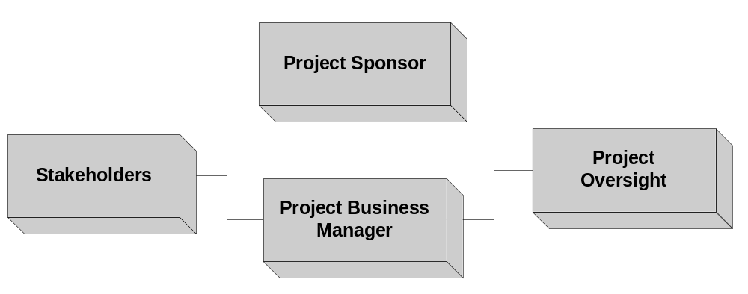
Figure 6-2: External Project Interfaces
External Project Positions
Position | Responsibility
Project Sponsor | The project sponsor is part of inception, approves resources for the project, directly oversees the project business manager, and is responsible for the project meeting the goals of all stakeholders.
Project Oversight | Experienced and objective technical and management oversight from individuals who are not directly involved in the project. Examples include a SEPG, a project reviewer, external consultant, etc.
Stakeholders | Any individual or organization that is explicitly recognized as being directly or indirectly affected by the project outcome.

* Precision refers to how many significant digits a value has. Accuracy refers to how close to the mark a value is. In estimation, false precision is the enemy of accuracy, and accuracy is what makes estimates high-quality. An estimate of “2-3 weeks” appears less impressive than an estimate of “11 days.” However, depending on the situation the former estimate is often a more accurate representation of what is known than the latter.
Feature and quality may be combined and called performance (e.g., see CxTemp_ProjectCharter).

