[ Project ]
Project Estimate
0000.doc
Draft X
February 21, 2003
[ Organization Name ]
[ Paste Your Organization’s Logo Here ]

Contents
1 Analysis 1
1.1 Summary 1
1.1.1 Schedule 1
1.1.2 Effort [or Cost] 2
1.1.3 Scope [or Feature] 2
1.1.4 Quality 2
1.2 Assumptions and Constraints 2
1.3 Estimating Techniques 2
1.3.1 [Technique 1] 2
1.3.2 [Technique n] 2
1.4 Tools 2
1.4.1 [Tool 1] 2
1.4.2 [Tool n] 3
1.5 Data 3
1.5.1 [Data Set 1] 3
1.5.2 [Data Set n] 3
2 [Technique 1] 4
2.1 Overview 4
2.1.1 Strengths 4
2.1.2 Weaknesses 4
2.1.3 Assumptions 4
2.2 Results 4
2.3 Conclusions 4
3 [Technique n] 5
3.1 Overview 5
3.1.1 Strengths 5
3.1.2 Weaknesses 5
3.1.3 Assumptions 5
3.2 Results 5
3.3 Conclusions 5
4 Estimates vs. Actuals 6

Analysis
The analysis section should provide a summary of all the estimation information known at the current time, generally a summary of at least expected time and money. Subsequent document sections will provide more detail on the results summarized here.

Summary
A plot like the one below is very useful for summarizing a group of estimates for a project created using different techniques. Double click the chart and scroll up to put your own data into it.
Plot of Estimate Results
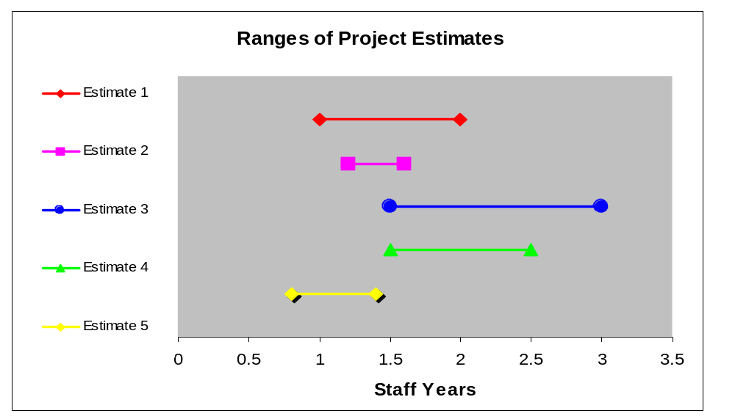
This section should call out and discuss convergence or divergence between the different techniques used, and provide an amalgamated range or expected case with a defined uncertainty for each dimension being estimated. For example, ”expected effort is 20-26 staff months”.
Be sure to avoid unwarranted precision when reporting estimates!

Schedule
Briefly summarize the findings of the estimates in regards to calendar time.

Effort [or Cost]
Summarize the findings of the estimates in regards to effort or direct costs.

Scope [or Feature]
If functionality is not being held fixed, discuss estimates of what the expected range of functionality is that will be delivered

Quality
(Optional) - Describe estimated quality level. Ideally this is quantified using data from previous projects. For example, “expected sev 1 defects discovered will be 200-300”..

Assumptions and Constraints
Cover the assumptions and constraints that went into creating the estimates. Often this section can refer to the assumptions and constraints defined in the project plan and charter. Generally, schedule, feature, or cost is often held fixed with the other 2 variables being estimated. This should be noted to make sure the difference between estimates and targets are noted in this document.

Estimating Techniques
The following estimation techniques were employed to synthesize this project estimate.

[Technique 1]
Summarize the technique and its outputs. The technique will be described in detail in a later section of the document.

[Technique n]

Tools
The following tools were used on preparing this estimate.

[Tool 1]
Discuss any unique tools used to support the estimation process. Purpose of this section is to inform reader of what estimates relied on the tool and any noteworthy background information about the tool.

[Tool n]

Data
The following historical data was used in preparing this estimate.

[Data Set 1]
Discuss any historical data brought to bear in the estimation process. Describe its history, quality, and the amount of expected applicability to this project.

[Data Set n]

[Technique 1]
Describe each estimation technique or activity in detail with each top level section.

Overview
Describe the context, details, and execution of the technique..

Strengths
Discuss the relative strengths of this approach.

Weaknesses
Discuss the relative weaknesses.

Assumptions
Describe assumptions unique to this approach.

Results
Provide detailed data resulting from the estimate.

Conclusions
Provide analysis of the estimate results, and discuss any noteworthy relations to other techniques.

[Technique n]

Overview

Strengths

Weaknesses

Assumptions

Results

Conclusions

Estimates vs. Actuals
(Optional) - Depending on how far the project has progressed, and the management processes being used to control it, it may make sense to include this section to analyze the performance of previous project estimates to actual performance.
If included, this section is intended to provide perspective on the quality of the current estimate. It is not intended to replace detailed project tracking and control.

