Sea Launch
Project Plan
0000.doc
Revision 2
February 21, 2003
ACME, Inc.

Contents
1 Introduction 1
1.1 Overview 1
1.2 Deliverables 1
1.3 Business Schedule 2
1.4 Resources 2
1.5 Assumptions and Constraints 2
1.6 Risks and Assets 2
1.7 Terms and Acronyms 2
2 Project Lifecycle 3
2.1 Lifecycle Map 3
2.1.1 Construction Stage Lifecycle 3
3 Management Structure 4
3.1 Project Organization 4
3.1.1 External Interfaces 4
3.1.2 Roles and Responsibilities 4
3.1.3 Staffing 4
3.2 Risk Management 5
3.2.1 Top Risk Monitoring 5
3.2.2 CAM Database 5
3.3 Issue Management 5
3.4 Communication 5
E-mail 5
Formal Meetings 5
Formal Status Reporting 5
Informal Meetings and Phone Calls 6
Instant Messaging 6
CAM Databases 6
3.5 Startup 6
3.6 Closeout 6
4 Planning and Control 7
4.1 Estimate 7
4.2 Resource Identification 7
4.2.1 Effort 7
4.2.2 Time 7
4.2.3 Cost 7
4.3 Resource Allocation 8
4.3.1 Work Breakdown Structure 8
4.3.2 Work Plan 8
4.3.3 Schedule 8
4.4 Tracking and Control 8
5 Technical Process 9
5.1 Software Engineering 9
5.1.1 Management, CM, Quality, and Testing 9
5.1.2 Requirements 9
5.1.3 Design 9
5.1.4 Construction 9
5.2 Technology 10
5.2.1 Technology Management 10
5.2.2 Development Environment 10
5.2.3 System Technology 10
6 Supporting Plans 11
6.1 Configuration Management 11
6.2 Quality Assurance 11
6.3 Testing 11
6.4 Deployment 11

Introduction
This project plan is the top level controlling document for the Sea Launch project. See the Sea Launch Project Charter for information about why Sea Launch has been chartered, background for the project, and the context for this plan.
Sea Launch leverages ACME software development practices, which are based on CxOne. See the ACME and CxOne documentation for details of practices referenced in this plan.

Overview
Sea Launch is an infrastructure building project that is critical to the long-term success of the company. The project will support the vision of enabling ACME to become the “one stop shopping center for all our customers entertainment needs” by:
- Delivering a replacement release in which no new functionality is available, but the necessary infrastructure to support new product types will be in place.
- Incrementally delivering new product types to the marketplace.
It will be the focus of our development department for the next year.

Deliverables
For each external release, the following deliverables will be available. The first milestone column indicates the first project milestone where tangible deliverables will be available:
Deliverable | Description | First Milestone
System Software | Working software that satisfies system requirements. | M2
Deployment Framework | A framework that enables the internal IS department to deploy the software to our customers. | M3
Administration Software | Software utilities and tools that support the main system. | M2
Migration Utilities | Tools to migrate existing customer data. | M3
Supporting Software and Data | Software used to support development of the main system, especially automated testing. | M2
Source Code | Source code required to build the product, tools, the deployment framework, test applications, etc. | M2
Product Documentation | The product work products produced during the phase. e.g. design documents, entity-relationship diagrams, etc. | M1
Project Documentation | The project work products produced during the phase. | M1

Business Schedule
The figure below outlines the top-level schedule for Sea Launch.
Initial Planning  Q1 2001 | Technical Foundation  Q2-Q3 2001 | Replacement Release  Q4 2001 – Q1 2002 | Feature Release 1  Q2 2002 | Feature Release 2  Q3 2002

The table below defines the top level milestones for the schedule:
Milestone Number | Milestone Name and Description | Scheduled Completion
1 | Initial Planning – Requiremetns analysis, architecture, and project planning. . | 3/15/01
2 | Technical Foundation – Finalization of business requirements, functional requirements, and UI design. Completion of architecture and high-level design. Supporting framework for application functionality is completed. | 9/01
3 | Replacement Release – Core functionality of the system is built and delivered, system is cutover into operations. | 3/02
4 | Feature Release 1 - Completion of any features delayed from M3, addition of new features based on feedback from operations. | 6/02
5 | Feature Release 2 – Addition of new features based on feedback from operations. | 9/02

Resources
Sea Launch will tie up the entire R&D department until the replacement release phase. 10-20% of the IS department’s effort will be required over that period.

Assumptions and Constraints
See the Sea Launch Charter.

Risks and Assets
See the Sea Launch Charter.

Terms and Acronyms
See Sea Launch Terms and Acronyms.

Project Lifecycle
Sea Launch will use a staged delivery lifecycle. This lifecycle was chosen so that ACME can introduce at least one new product type to our customers by Q1 2002. The challenges of the project are stable and understood well enough that up-front planning, requirements, and design work should be able to complete without risk of significant rework.
See chapter 36 of Rapid Development for an overview of staged delivery.

Lifecycle Map
The project will have three major phases, planning/design, initial delivery, and operational support. These phases will be broken down into a series of stages that will map major groupings of project activities to the business schedule. The relationship of the project’s lifecycle phases and stages to the business schedule milestones is shown below.
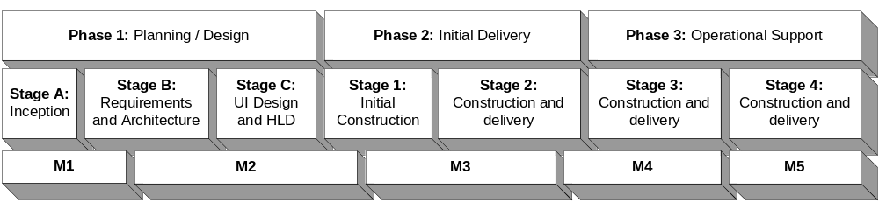
Figure 2-1: Lifecycle Map
Each stage will have a series of incremental cycles that converge and release the project internally. The details of the construction stages is shown below. The details of planning stages will be focused on creation of specific requirements, design, and planning deliverables.

Construction Stage Lifecycle
Each milestone in the construction stages will follow the lifecycle process in Figure 2-2:
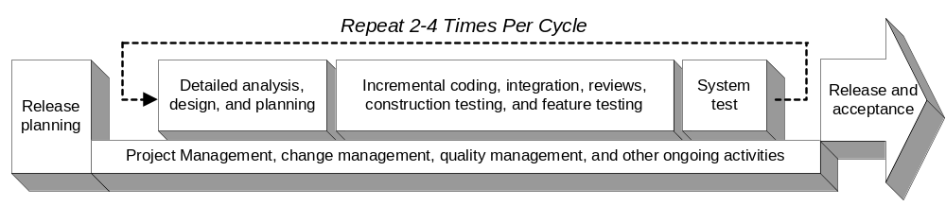
Figure 2-2: Milestone Delivery Lifecycle
Release planning defines the work plan for the stage. Detailed analysis and design captures any remaining work necessary to begin construction. Coding, integration, and testing constitutes all detailed activities to build and deliver functionality. System test includes final integration, convergence, stabilization, and verification of the entire system.

Management Structure
The project’s management structure defines how the project will organize resources and what infrastructure will be used to manage the project.

Project Organization
The section covers project organization and staffing.

External Interfaces
Figure 2.1 described the important external interfaces for the Sea Launch project.
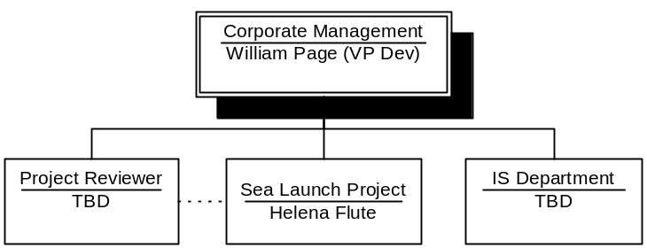
Figure 2.1 Sea Launch Project Interfaces

Roles and Responsibilities
Project roles and responsibilities will follow the CxOne standard project team structure as described in CxStand_ProjectManagment, with the following exceptions:

Staffing
Staffing of project roles will be as follows:
Role | Staff Member | Start Date | End Date
Project Manager | Helena Flute | 4/01 | 7/02
Planning and Tracking Lead | George Abergavenny | 4/01 | 5/02
Requirements Lead | John Alencon | 4/01 | 5/02
Quality Lead | Bianca Baptista | 5/01 | 6/02
Design Lead | Toby Belch | 6/01 | 5/02
Construction Lead | Thomas Cranmer | 6/01 | 6/02
Development Engineer | Anne Page | 6/01 | 4/02
Development Engineer | John Colevile | 8/01 | 3/02
Development Engineer | Tony Denny | 8/01 | 3/02
Development Engineer | Hugh Evans | 9/01 | 1/02
Quality Engineer | Thomas Clifford | 8/01 | 5/02
Quality Engineer | Alice Ford | 9/01 | 1/02

Risk Management
Risks management on the Sea Launch project will be primarily through intrinsic risk management including lifecycle selection, technical and management processes, proactive issue management, and staff capabilities. Extrinsic risk management activities are listed below.

Top Risk Monitoring
The current top risks to Sea Launch will be tracked in the Sea Launch Risk List. This risk list will identify and prioritize the most significant risks to project success.
A summary of the top risks will be included in the weekly Executive Status Report.

CAM Database
All risks in the top risk list, and any other noteworthy project risks will be tracked using the project’s CAM database as per CxPattern_IssueManagementDatabase.

Issue Management
Issues will be managed utilizing the project’s CAM database as per CxOne’s CxPattern_IssueManagementDatabase.

Communication
The following major types of communication will be used on the project:.

E-mail
E-mail will be a primary method of non-critical communication among team members.

Formal Meetings
Weekly status meetings will be held throughout the project. Tactical, design, and other meetings will be held on an as needed basis.

Formal Status Reporting
Weekly status reports will be generated during the project. Detailed milestone status reports will also be created.

Informal Meetings and Phone Calls
Time sensitive and high-bandwidth (or back and forth) discussions should be held as informal drop ins or phone calls between participants.

Instant Messaging
The project will experiment with instant messaging as an alternative to e-mails and informal meetings.

CAM Databases
CAM databases will provide a formal communication mechanism for coordinating unplanned work, as per CxPattern_CamDatbase. Issues, risks, and change requests will share a CAM database. Defects will be placed in another database.

Startup
Sea launch will utilize existing ACME development environments and startup processes. Staff training should not be necessary. The current system source code as a baseline for development.

Closeout
Standard ACME post-mortem and CM activities will be used to close out the Sea Launch project. Each milestone will perform a mini post-mortem upon completion.

Planning and Control
Planning and control covers the management plans for executing work and how project execution will be controlled to meet project goals.

Estimate
See the Sea Launch Project Estimate for the top-level estimates used to drive project planning. Detailed task estimates will be captured as part of the work plan.
Precision and accuracy of all estimates will be refined as the project progresses.

Resource Identification
The resources used to achieve project goals are described in this section.

Effort
Aggregate effort on Sea Launch will ramp to a peak staffing level of 12 FTE’s, when all staff will be on board and working full time on the project. Beginning in Q1 2001 staffing will begin to ramp. The expected staffing profile looks like:
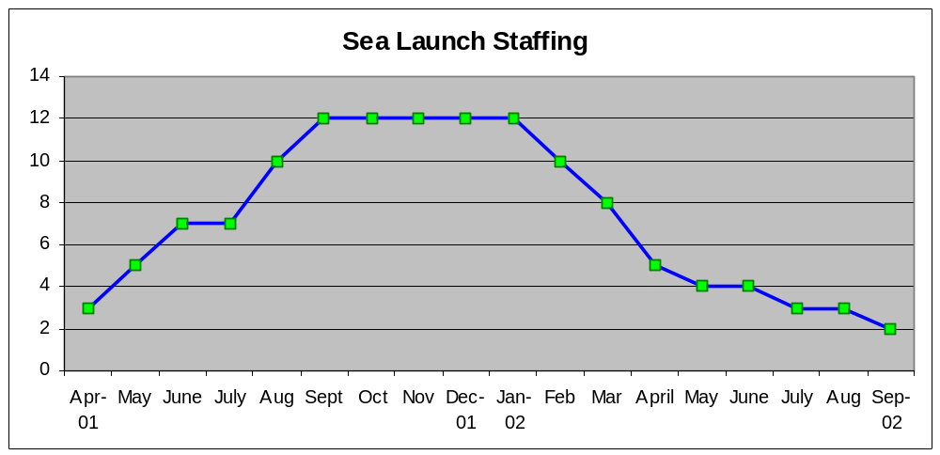

Time
See the business schedule for details current time budget. The business schedule is based on the time constraints discussed in the Sea Launch Charter, with Q1 2002 as replacement system and significant short-term maintenance complete by Q3 2002.

Cost
See Sea Launch Charter for details. To summarize internal cost, the Sea Launch project is allocated a maximum of $1.0 million in 2001 and $.5 million in 2002.

Resource Allocation
This section describes how the project’s resources will be allocated to achieve project goals.

Work Breakdown Structure
The project’s WBS is defined as part of the work plan.

Work Plan
See Sea Launch Work Plan. The work plan captures the WBS, is the basis for earned value management, and will provide task inputs for detailed scheduling.

Schedule
See the business schedule in the plan introduction for details on top-level schedule. The work plan provides a rough view of the detailed scheduling of activities. If necessary, further detailed scheduling of milestone activities will occur incrementally for each milestone, using the work plan tasks as input to the schedule.

Tracking and Control
Project tracking and control will rely on the CxOne and ACME processes. This section lists the major mechanisms for tracking and controlling the project. See CxOne and ACME organizational documentation for more details on these mechanisms.
Milestones. The project will use both the major release milestones, and shorter development milestones to track progress against plan.
Work Plan. Contains the WBS task breakdown, bottom-up estimates, and is used for earned value management in combination with effort tracking.
Effort Tracking. All project work will be tracked with hourly precision against the WBS defined by the work plan.
Weekly Tracking and Planning. The state of the project will be analyzed, status reported, and planning updated each week. The work plan will be the focus of this activity. It will also include the weekly status meeting and generation of the status report.
CAM. Corrective Activity Management will be used to manage unplanned work.
Daily Builds. During construction stages daily build and automated smoke testing of the entire system will occur, providing visibility into the state of the system.
MWBA. Management by Walking Around. All project members, especially leads, will engage in information collaboration and communication during the project to execute plan, communicate status, and resolve issues.

Technical Process
The project’s technical processes define the details of how the project will execute engineering and technology related work to achieve project goals.

Software Engineering
Sea Launch will utilize ACME engineering infrastructure. See ACME and CxOne documentation for more details. This section covers focus points for this project.

Management, CM, Quality, and Testing
Technical processes related to management, configuration management, quality, and test activities are captured by the respective project plans.

Requirements
In addition to standard requirements practices, the following will be emphasized:
Requirements Scrubbing. Detecting and eliminating unnecessary product feature at the requirements stage will be a major focus for the project. Due to other project constraints, when in doubt, feature needs to be pared or delayed.
Use Case Modeling. Use case driven modeling will be used to capture the majority of business requirements.
UI Prototyping. User interface prototyping will be the preferred way to capture user interfaces and a large portion of the functional requirements.

Design
Standard ACME design processes will be used.

Construction
In addition to standard requirements practices, the following will be emphasized:
Fully Automated Unit Test. This project will experiment with fully automating all unit test coverage on the project, and integrating it into the daily build process.

Technology
The following technology environment, tools, and methods will be used to complete work on Sea Launch.

Technology Management
No new technology should need to be selected for this project, but if necessary, CxOne’s technology management materials will be utilized to formally evaluate and select the best technology solution to meet the project’s goals.

Development Environment
ACME’s standard developer workstation image will be used. See the ACME Developer Image for details of which specific software tools this entails.

System Technology
The end system will run in ACME’s standard operational environment, which is a combination of Linux and Windows platforms. See ACME IT Environment for details.

Supporting Plans
The following plans directly support the project plan.

Configuration Management
The configuration management processes are described in the Sea Launch Configuration Management Plan.

Quality Assurance
The quality assurance effort is described in the Sea Launch Quality Plan.

Testing
The test effort is described in the Sea Launch Test Plan.

Deployment
Sea Launch will be deployed by ACME internal IS department. Contact Oliver Martext for details on the deployment and operations plans.

