Risk Management Database
CxOne Pattern
0000.doc

February 21, 2003

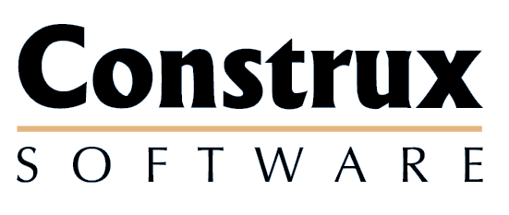

Advancing the Art and
Science of Commercial
Software Engineering
Contents
1 Introduction 1
1.1 How to Use the Pattern 1
2 Risks 2
2.1 Unique Aspects of CAM Risk Items 2
2.2 Risks vs. Issues 2
2.3 Risk Lifecycle 3
3 Field Overview 4
4 Role Specializations 6
4.1 Submitter 6
4.2 Sponsor 6
4.3 Owner 6
4.4 Lead or Manager 6
5 Field Specializations 7
5.1 How Addressed 7
Copyright Notice
© 2000-2002 Construx Software Builders, Inc. All Rights Reserved.
For further information or support visit www.construx.com.

Introduction
This pattern outlines how to implement a risk tracking database and surrounding workflow. CxOne handles the tracking of risks as part of Corrective Activity Management (CAM) along with managing change requests, defects, and issues. See CxStand_ProjectManagment for more details.
Although designed to use terminology that is reasonably self-evident to an experience software engineer, this document relies on CxPattern_CamDatabase to define workflow and the details of the risk management fields.

How to Use the Pattern
The information in this pattern can be used whole, in part, or with modifications as part of a project’s risk management solution. Normally this document and its parent, CxPattern_CamDatabase will be used together to set up a CAM database.
Depending on the sophistication of your database tool and your project needs, risk management can run from a separate database or in combination with tracking for other CAM items. See the following CxOne patterns for additional information on CAM databases.
CxOne CAM Database patterns
Pattern | Description
CxPattern_CamDatabase | Detailed definition of workflow and all CAM database fields.
CxPattern_ChangeManagementDatabase | Additional support specific to change requests.
CxPattern_DefectManagementDatabase | Additional support specific to defects.
CxPattern_RiskManagementDatabase | Additional support specific to risks.
CxPattern_IssueManagementDatabase | Additional support specific to issues.

Risks
Risks are possible future events that can negatively impact a project. Risk management is a deep and mature project management discipline. CAM does not replace the fundamental activities of risk management. Instead, CAM provides a mechanism that allows the details associated with identified risks to be managed in a lightweight fashion.
If your project or organization already utilizes sophisticated risk management techniques and database tools, it will most likely not make sense to use CAM risk management techniques. CAM risk management will likely be redundant with your other processes.
If you are capturing risks in documents or spreadsheets, CAM provides and infrastructure to support the tracking and management of risk details.

Unique Aspects of CAM Risk Items
Risks differ from other CAM items in that they often enter a monitoring state either during or after being addressed. Monitoring means that active mitigation is not yet warranted, but that it may be if the risk’s threat increases.
Risks also differ because their resolution will not always be cut and dry. Often the resolution of a risk means the probability of its occurrence or the severity of its impact have been reduced to the point where it is no longer a concern. This means CAM risk items may be closed even though the risk in question may not be completely eradicated.

Risks vs. Issues
Risks should be used to deal with possible future events, and mitigate the probability or severity of negative impact upon the project. If a risk has already manifested itself, it is most likely too late for risk management; the risk has already become one or more issues.
This line is not black and white, but in general risk mitigation should focus on reducing the impact of risks that have not occurred. If the risk has occurred, dealing with it is part of project management. In CxOne this means that dealing with the impact of the risk will either already be part of project planning, or will be handled as CAM issues.
Sometimes risks will manifest while mitigation is ongoing. Judgment should be used to pick the most efficient mechanism for managing work in these cases (i.e., just see the mitigation plan through, log new issues, change project planning, etc.).

Risk Lifecycle
Figure 2-1 captures a high-level view of risk defect workflow, abstracted from the CAM workflow described in CxPattern_CamDatabase..
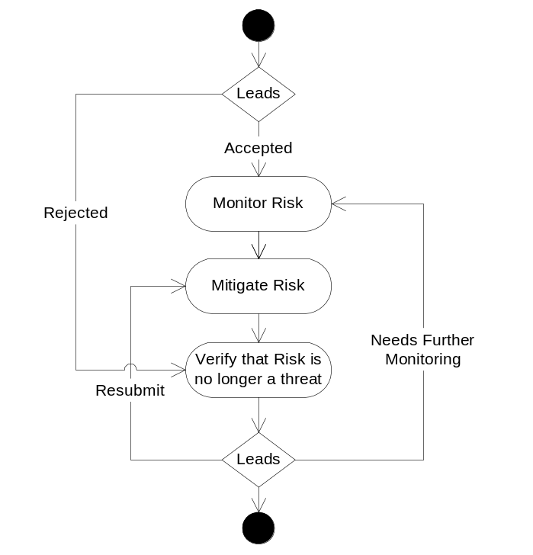
Figure 2-1: Risk Lifecycle

Field Overview
This section lists the database fields that are useful for performing risk management on most software projects. The detailed definitions for each field are in CxPattern_CamDatabase.
In most cases, the information provided in CxPattern_CamDatabase fully defines field behavior related to risk management. The table below captures notes where specialization to handle risk management is useful. Behavior specializations for roles are discussed in section 3, any detailed specializations for fields are covered in section 4.
Risk Management Database Fields
♦ | Field required to meet minimal management requirements of most projects.
♦ | Useful field for most projects.
◊ | Possibly useful for depending on goals and unique circumstances

Fields |  | Specialization Notes
Attributes
Title | ♦ | Brief, unique, summary title.
Description | ♦ | Detailed description of the risk, including justification of the probability and impact.
Item Type | ♦ | Used when combining multiple CAM types in a single database.
How Addressed | ♦ | See section How Addressed below for values optimized for risk management.
Resolution | ♦ | This field may be used to store what the resolution should be before the risk is addressed. Once addressed it becomes a description of what the resolution was.
Notes | ♦ | Notes tracking history and information about this item.
ID | ♦ | Unique database ID.
Related Items | ♦ | Reference to related items.
Submit Date | ♦ | Not critical, but useful and often provided by tool automatically.
Closed Date | ♦ | Not critical, but useful and often provided by tool automatically.
Severity |  | Not used.
Probability | ♦ | Capture the probability a risk will occur.
Impact | ♦ | The estimated impact if the risk manifests.
Exposure | ♦ | The expected impact, from multiplying probability and impact.
Resources
Submitter | ◊ | May be omitted for risks since management or lead often enters the record based on other project activities.
Sponsor | ♦ | Since risks are normally handled as part of project management, other possible names for this field could be Lead or Manager.
Owner | ♦ | The person in charge of the mitigation activities.
Tracking & Control
State | ♦ | Risks use the default state workflow. Risks are often monitored before active action occurs, so risks may spend some time parked in the resolution pending state with a How Addressed value of monitor.
Due Date | ♦ | Date by which mitigation plan needs to be completed. In some cases, the resolution for risks won’t be an eradication of the risk, it will be a reduction of it to an acceptable impact level.
Next Action Date | ♦ | Used to plan, communicate, and track detailed work on the risk.
Next Action | ♦
Milestone to Resolve | ♦ | Sometimes useful addition or substitute to Due Date.
Priority | ♦ | Priority has less importance with risks as Due Date often is used to drive when work will be done.
Estimated Effort | ◊ | Depending on management process, may be useful here.
Actual Effort | ◊ | Can be used for in-process estimation of effort spent on risks.
Version Found |  | Not used.
Version Resolved |  | Not used.
Metrics
How Injected |  | Not used.
How Detected |  | Not used.
When Injected | ◊ | May be useful to analyze how risk lifecycles map onto project lifecycle phases.
When Detected | ◊
When Resolved | ◊
Milestone Submitted | ◊ | May be useful to analyze how risks map onto project milestones.
Milestone Resolved | ◊
WBS ID | ♦ | Can be used to isolate work plan areas more prone to defects.
System Area | ♦ | Useful to pinpoint sources of risk.

Role Specializations
This section covers any special behavior related to CAM roles when managing risks. All CAM roles are described in CxPattern_CamDatabase.

Submitter
Submitter is an optional field for risks, because due to their unstructured nature risks are usually entered with the coordination of a lead or manager. This is to ensure an risk doesn’t overlap a CAM item already present, or is part of planned work the submitter is not aware of.

Sponsor
The sponsor ensures the risk is managed in a timely manner, consistent with the project’s goals. Additionally, this person verifies the risks are addressed to the satisfaction of the project stakeholders. Typically, the sponsor is either project manager or a technical lead. When a risk is monitored, it is the sponsor’s responsibility to perform the monitoring.

Owner
The owner is the person responsible for addressing and possibly resolving the risk in a timely manner consistent with the project goals.

Lead or Manager
Leads and managers will often be closely involved with risks during their entire lifecycle. Unlike other CAM items, risks are possible future impacts to the project. Management needs to ensure that the level of risk on the project does not threaten the success of the project.

Field Specializations
This section describes details for any risk fields which may be significantly specialized beyond the field descriptions in CxPattern_CamDatabase.

How Addressed
Value: See below
Modification: Lead
This field represents the decision about how to manage the risk. This field is set when the State field is set to Addressed. This field should not be used in place of good descriptive information in the Resolution field.
Values for How Addressed risks field
Value | Description
TBD | Risk not addressed yet
Monitor | This state is used with risks that are being actively monitored, but for which an active mitigation plan has not yet been engaged.
No Mitigation | The risk will be ignored for the project, i.e., no active mitigation will occur. No mitigation is called acceptance in PMBOK terms.
Active Mitigation | The risk was accepted and some form of active mitigation will occur to resolve the risk. This is extrinsically handling the risk in CxOne terms. Active mitigation is called mitigation in PMBOK terms.
Modify Plans | The risk has been accepted for resolution, and the active mitigation will be handled by updating project planning. This is intrinsically handling the risk in CxOne terms. Modify plans is called avoidance in PMBOK terms.
Rejected | Risk was rejected as not being a valid project risk.
Logged as Another Type | The risk was determined to be improperly identified as a risk, and has been entered as a different CAM type.
Duplicate | Risk is a duplicate of another record.

