Executive Status Report
Week 7 – July 30 to August 3, 2001 (Report issued August 6, 2001)

Key Questions
Status | What is the current project status? | Yellow
Schedule | Will target dates be missed? | No
Feature | Has the feature scope changed? | No
Effort | Has the effort changed? | No
Quality | Are there quality problems? | No
Risks | Have any new risks been identified? | No
Issues | Are there any issues requiring sponsor involvement? | No

Summary
Overview | The project is in yellow status because of problems to date finding resources; this should be resolved by next week.  Preparing for the M2 confirmation / M3 kickoff meeting which is scheduled for Nov 21st. The business transform team is on track to pass one record through the framework with in the next two weeks.
Tracking Information | Currently in the 5th week of milestone 2. On track to meet the M2 deadline.  To date 137 work packages are closed, 45 are open, and 497 are remaining  The SPI or schedule performance index is at .98 (> 1.0 is good). The CPI or cost performance index (a.k.a. staff hours) is at 2.44 (> 1.0 is good)
Notable Events | Resource balancing plan was put into place. The only position we are short today is the Business Transform product tester.  Project management consultant visited last week to help with estimation.
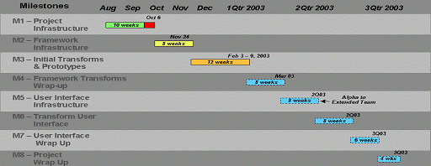

Top Project Risks
- Staff Availability – Appropriate staff are not available to fill all project positions. Working to reassign staff from other projects.
- Delayed Hardware Delivery – Delayed delivery of hardware for server deployment will delay system coming online. Searching for temporary backup hardware.

