Software Project Survival Guide

Overview
CxOne is a lightweight, adaptable, flexible process infrastructure that can be used on a variety of projects. This CxOne process flow discusses how to use CxOne resources to run a project as described in Steve McConnell’s Software Project Survival Guide (SPSG).

Background
The SPSG project is run using a staged delivery lifecycle in which the software progresses through the waterfall model steps of defining the software concept, analyzing requirements, and creating an architectural design. It then proceeds to do detailed design, coding, debugging, and testing within each stage, creating a releasable product at the end of each stage.
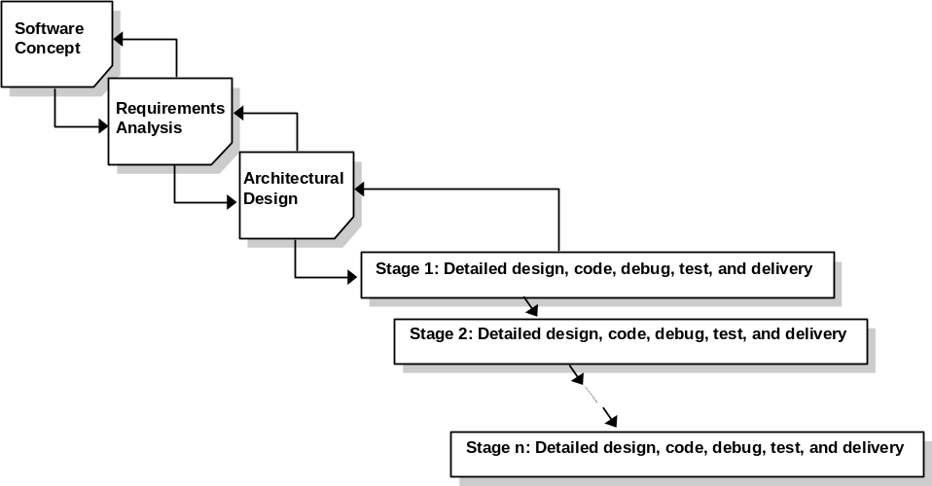
Figure 1: Staged Delivery Lifecycle

How to Use
CxOne checklists, templates, and guides may be used to implement the project process outlined in Software Project Survival Guide. This document contains a mapping of the relevant CxOne documents to SPSG on the basis of:
- Each chapter in SPSG
- Each topic discussed in SPSG
- The sequence of activities on project

Materials by Chapter
CxOne materials are mapped to Software Project Survival Guide on a chapter by chapter basis.
Chapter | Chapter Name | CxOne Resources
6 | Hitting a Moving Target | Software Configuration Management Process Standard  Change Control Plan Template and Checklist
7 | Preliminary Planning | Software Project Plan Guide, Template, and Checklist  Top 10 Risk List Pattern  Quality Plan Template and Checklist  Estimation Checklist
8 | Requirements Development | Requirements Standard  Software Requirements Specification Template and Checklist  Business, Functional, and Non-Functional Requirements Checklists  Requirements Modeling Checklists  Windows User Interface Checklist
9 | Quality Assurance | Quality Plan Template and Checklist  Test Plan Template and Checklist  Review Standards, Templates, and Checklists  Software Problem Report and Change Request Checklists
10 | Architecture | Software Design Specification Guide, Template, and Checklist
11 | Final Preparations | Estimation Checklist
12 | Beginning of Stage Planning | Software Project Plan Guide, Template, and Checklist  Top 10 Risk List Pattern  Quality Plan Template and Checklist  Estimation Checklist
13 | Detailed Design | Design Templates and Checklists
14 | Construction | Construction Standard, Templates, and Checklists
15 | System Testing | Test Case Specification Template and Checklist  Test Summary Report Template and Checklist  Software Problem Report and Change Request Checklists
16 | Software Release | Release Sign-Off Template  Release Checklist
17 | End of Stage Wrap-Up | Software Project Log Template and Checklist
18 | Project History | Software Project History Template and Checklist

Materials by Topic
CxOne materials are mapped to Software Project Survival Guide on a topical basis.
Topic | CxOne Resources
Project Planning | Project Charter Guide, Template, and Checklist  Software Project Plan Guide, Template, and Checklist  Top 10 Risk List Pattern  Estimation Checklist
Configuration Management/Change Control | Software Configuration Management Process Standard  Change Control Plan Template and Checklist  Software Problem Report and Change Request Checklists
Requirements Development | Requirements Standard  Software Requirements Specification Template and Checklist  Business, Functional, and Non-Functional Requirements Checklists  Requirements Modeling Checklists  Windows User Interface Checklist
Quality Assurance | Quality Plan Template and Checklist  Test Plan Template and Checklist  Review Standards, Templates, and Checklists
Architecture | Software Design Specification Guide, Template, and Checklist
Detailed Design | Design Templates and Checklists
System Testing | Test Case Specification Template and Checklist  Test Summary Report Template and Checklist  Software Problem Report and Change Request Checklists
Software Release | Release Sign-Off Template  Release Checklist
Process Improvement | Software Project Log Template and Checklist  Software Project History Template and Checklist

Materials by Software Project Survival Guide Workflow
Figure 2 and Figure 3 outline the workflow for the initial planning and stages on a software project as run using the Software Project Survival Guide. CxOne materials are then mapped to each workflow.
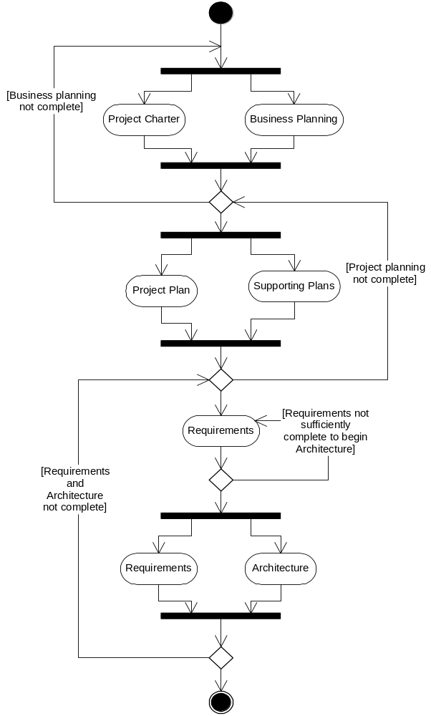
Figure 2: Initial Planning Workflow
The following CxOne materials support the initial planning phase.

Business Planning
- Project Charter Guide, Template, and Checklist

Project Planning
- Software Project Plan Guide, Template, and Checklist
- Top 10 Risk List Pattern
- Estimation Checklist
- Software Configuration Management Process Standard
- Change Control Plan Template and Checklist
- Software Problem Report and Change Request Checklists

Requirements
- Requirements Standard
- Software Requirements Specification Template and Checklist
- Business, Functional, and Non-Functional Requirements Checklists
- Requirements Modeling Checklists

Design
- Software Design Specification Guide, Template, and Checklist

Quality Assurance
- Quality Plan Template and Checklist
- Test Plan Template and Checklist
- Review Standards, Templates, and Checklists
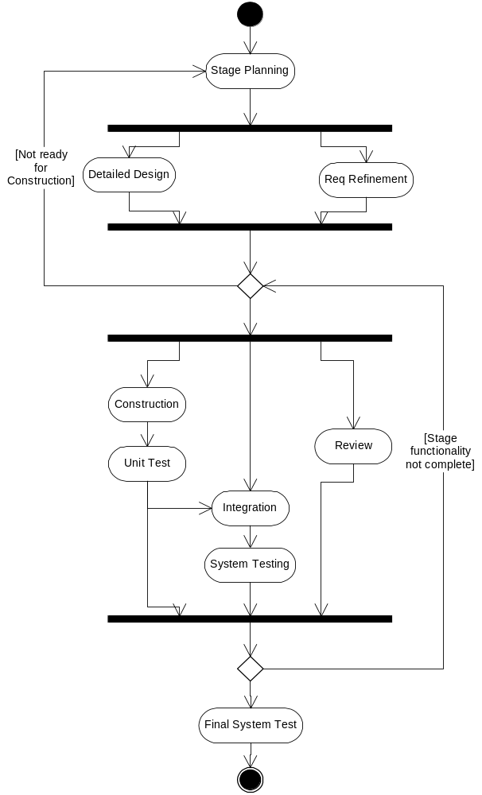

Figure 3: Stage Workflow

The following CxOne materials support each stage.

Design
- Design Templates and Checklists

Construction
- Construction Templates and Checklists

Testing
- Test Case Specification Template and Checklist
- Test Summary Report Template and Checklist
- Software Problem Report and Change Request Checklists

Software Release
- Release Sign-Off Template
- Release Checklist

Process Improvement
- Software Project Log Template and Checklist
- Software Project History Template and Checklist

